**VMWARE LAB: INTERNAL SET UP OF AD, DHCP, DNS, FTP, WEB.**

**CREATED BY: GIDEON CARL ROBLE**

**Table of Contents**

1. Introduction 4

2. VMware Network Creation 4

3. INSTALLING SERVER 2019 AND WINDOWS 10 CLIENT 4

3.1 Installing Windows Server 2019 in VMware 4

3.2 Installing Windows 10 in VMware 5

4. Server VM Setup (Windows Server) 6

4.1 Active Directory (AD) 6

5. DNS Server 11

6. DHCP Server 12

7. WEB Server 13

8. FTP Server 15

8.1 configuring ftp permission 17

9. Mail Server (hMailServer & thunderbird) 18

10. RDP & RDP assistance 22

11. Allowing user to login in the server 25

12. CLIENT MACHINE CONNECTING TO DOMAIN 26

# 1. Introduction

This document is a beginner-friendly guide for setting up a virtual internal network using VMware. The project includes a Server VM providing services like Active Directory, DNS, DHCP, FTP, Web, and Mail, and a client VM that connects to the domain and uses these services. Each section includes simple examples and explanations to help understand the purpose of each service and how it works.

# 2. VMware Network Creation

To allow VMs to communicate only with each other (and not the internet), we create an isolated virtual network in VMware.

Steps:  
1. Open 'Virtual Network Editor' in VMware.  
2. Create a NAT Network (e.g., VMnet8).  
3. Disable DHCP (we will configure our own server).  
4. Set the subnet to 192.168.181.0/24.

# 3. INSTALLING SERVER 2019 AND WINDOWS 10 CLIENT

## 3.1 Installing Windows Server 2019 in VMware

Step 1: Prepare the ISO File

- Download the official Windows Server 2019 ISO from Microsoft:  
<https://www.microsoft.com/en-us/evalcenter/evaluate-windows-server-2019>

Step 2: Create a New Virtual Machine in VMware

1. Open VMware Workstation/ESXi  
2. Click 'Create a New Virtual Machine'  
3. Choose 'Typical (recommended)' setup  
4. Select 'Installer disc image file (ISO)' and choose your ISO  
5. Choose 'Microsoft Windows' > 'Windows Server 2016 or later (64-bit)'

Step 3: Configure VM Settings

- Assign 2–4 GB RAM, 2 vCPUs, and 60–100 GB disk space  
- Use NAT Network

Step 4: Start the VM and Begin Installation

1. Power on the VM and boot into the setup  
2. Select language, time, keyboard, and click 'Install Now'  
3. Choose 'Windows Server 2019 Standard (Desktop Experience)'  
4. Accept license, select Custom install, choose disk  
5. Complete installation and reboot

Step 5: Finalize Setup

1. Set the Administrator password  
2. Log in to the server desktop  
3. The server is now ready for role configuration

For comprehensive guide you can follow it on this link:

<https://www.myitsolutionspg.com/blogs/windows-servers/microsoft-windows-server-2019-installation-step-by-step-guide>

## 3.2 Installing Windows 10 in VMware

Step 1: Prepare the ISO File

- Download the Windows 10 ISO:  
<https://www.microsoft.com/software-download/windows10ISO>

Step 2: Create a New Virtual Machine

1. In VMware, create a new virtual machine  
2. Select the Windows 10 ISO  
3. OS Type: 'Microsoft Windows' > 'Windows 10 x64'  
4. Assign 2–4 GB RAM, 1–2 vCPUs, and 60 GB disk  
5. Use NAT or Bridged networking

Step 3: Install Windows 10

1. Boot the VM into setup  
2. Select language, time, keyboard  
3. Click 'Install Now' and enter a product key or skip  
4. Choose 'Windows 10 Pro', accept license, Custom install  
5. Select disk and complete installation

Step 4: Complete OOBE (Out-of-Box Experience)

1. Choose setup preferences  
2. Create a local user  
3. Finish initial configuration

For comprehensive guide you can follow it on this link:

<https://iritt.medium.com/setting-up-a-windows-10-on-vmware-for-your-cybersecurity-lab-524438f7617d>

# 4. Server VM Setup (Windows Server)

## 4.1 Active Directory (AD)

Active Directory is like a phone book for your network. It stores user accounts, passwords, and what users are allowed to do.

To install AD, you need to go to the Server Manager and click the “Add roles”

Then you will proceed on to the next page.

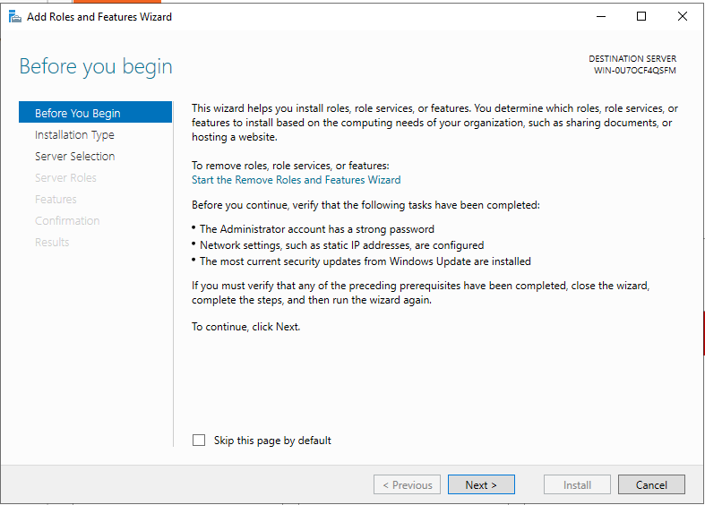

In this page, you just need to click the next button until you are in the server roles and features

When you are this page you will select the services, you want. For now, we will be installing the service of Active Directory Domain services.

Then on the results you will be asked to install all the features incorporated on the selected service.

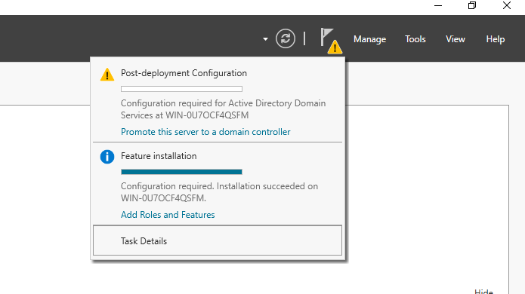

After the installation of the service, you will be seeing a warning sign on the flag button. Click the flag button then select the “Promote this service to a domain controller” this will enable the server to have a capability as domain controller.

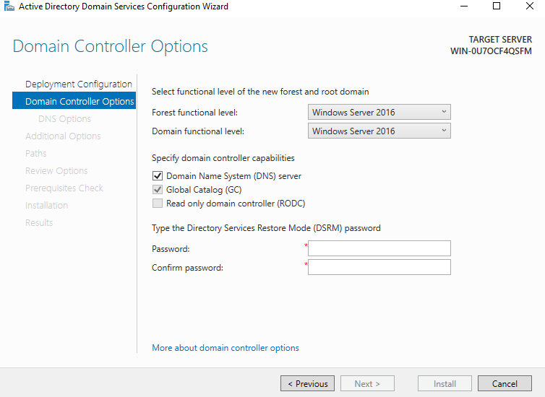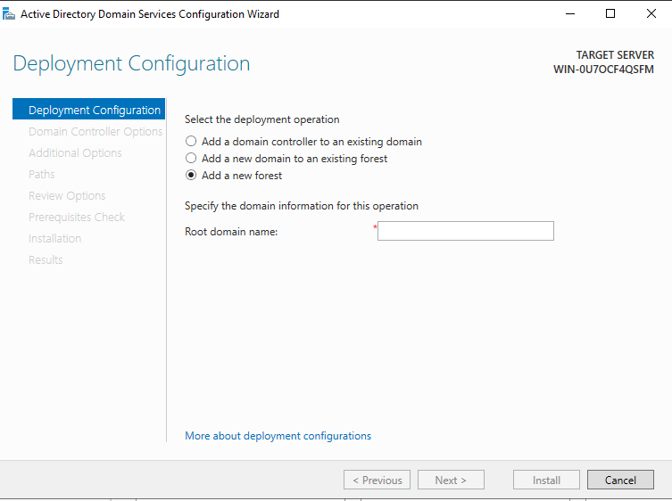After selecting it you will now be directed to this page which will process the deployment of the service. Select the Add new forest as this is a new domain we are creating. On the “Root domain name” input your desire domain name example is “local.domain”.

On this page you will be asked to input a password for the DSRM. This used for recovering or repairing Active Directory on a domain controller in case the AD is not working properly.

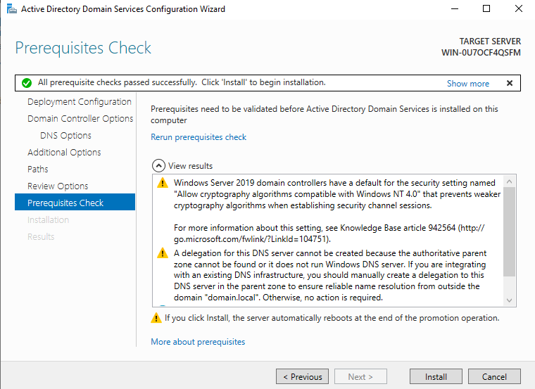After all the configuration performed you will be directed to this interface where your server is ready to deploy as Domain Controller. Click install, after the installation your server machine will restart.

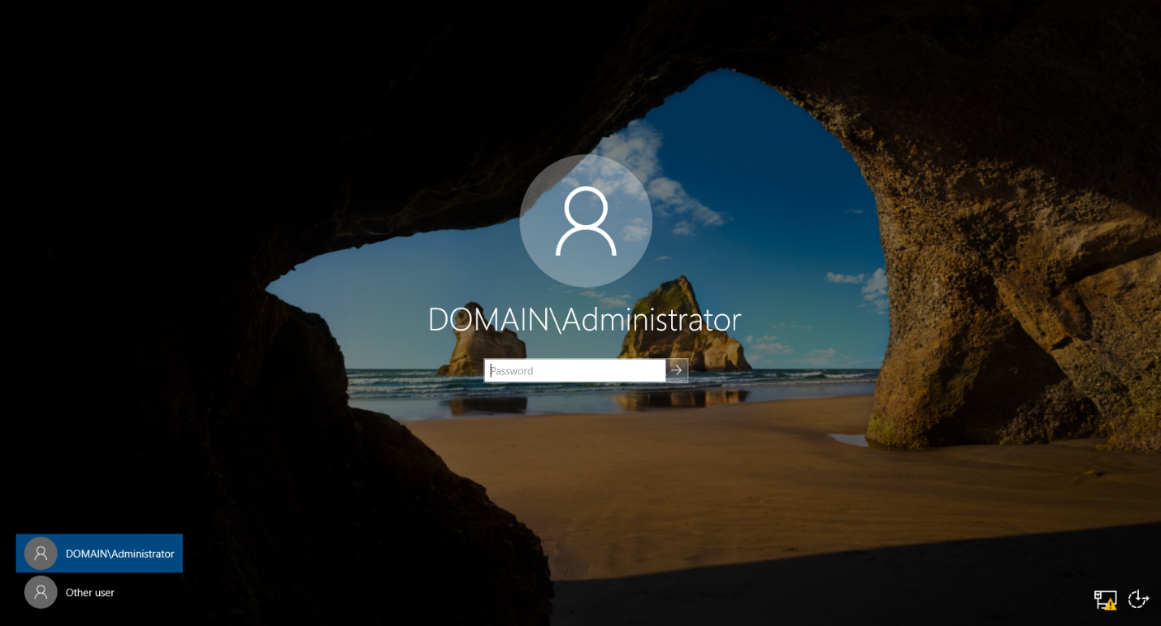

This interface confirms that we have a successful deployment of AD on our server machine.

# 5. DNS Server

DNS translates domain names to IP addresses. It’s like the contacts app on your phone where names point to numbers.

You need to download the DNS service on server manager. The process is the same as what with downloading AD.  
*Note: Sometimes when your network is configured correctly DNS is automatically configured*

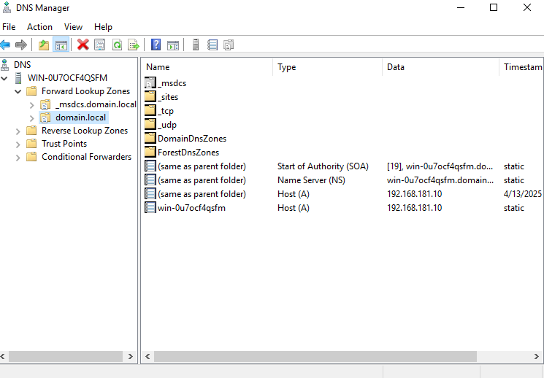

This the interface of the DNS manager if it is already configured.

However, if you want comprehensive guide on how to do it.

You can follow the guide on this link:

<https://jotelulu.com/en-gb/support/tutorials/how-to-install-dns-on-windows-server/>

# 6. DHCP Server

DHCP automatically gives out IP addresses to devices, like a teacher assigning seats in a classroom.

Steps:  
1. Add DHCP role via Server Manager.

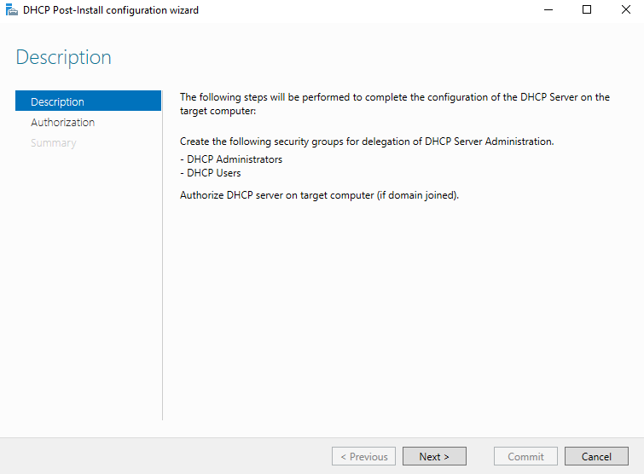3. Select the “Complete DHCP configuration” and continue the post installation configuration.

On the post installation you don’t need to click any button just click the next.

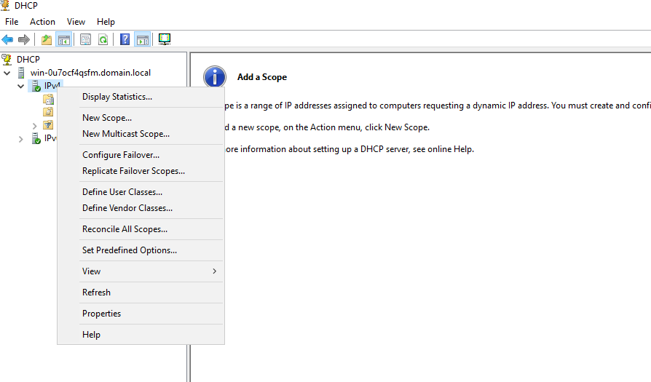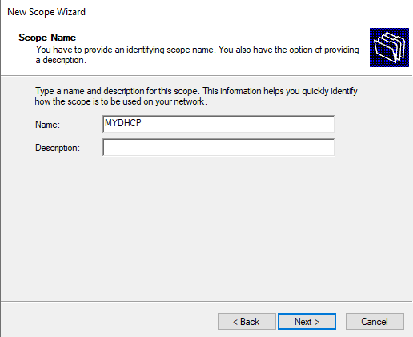4. Go into the DHCP manager when you are there right click on the IPV4 and click the “New Scope” Create a name first for the scope the create a scope with range 192.168.10.100 to 192.168.10.200.

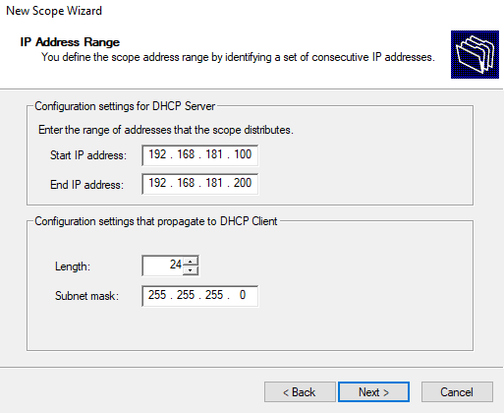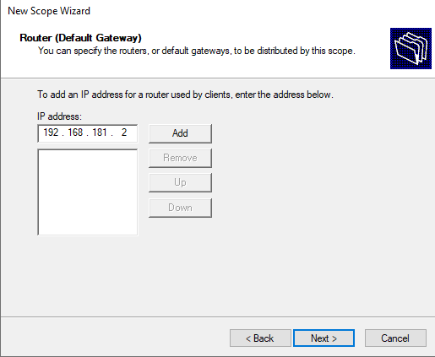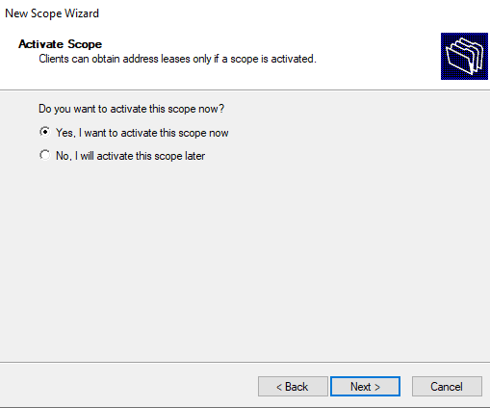

5. Set default gateway and DNS to 192.181.10.2 and 192.168.181.10  
6. Activate the scope then finish the set up.

# 7. WEB Server

A web server delivers websites. We use IIS to host a simple webpage.

Steps:  
1. Install IIS role the same that we did on AD, DNS, DHCP. Then go to the ISS manager to configure the server

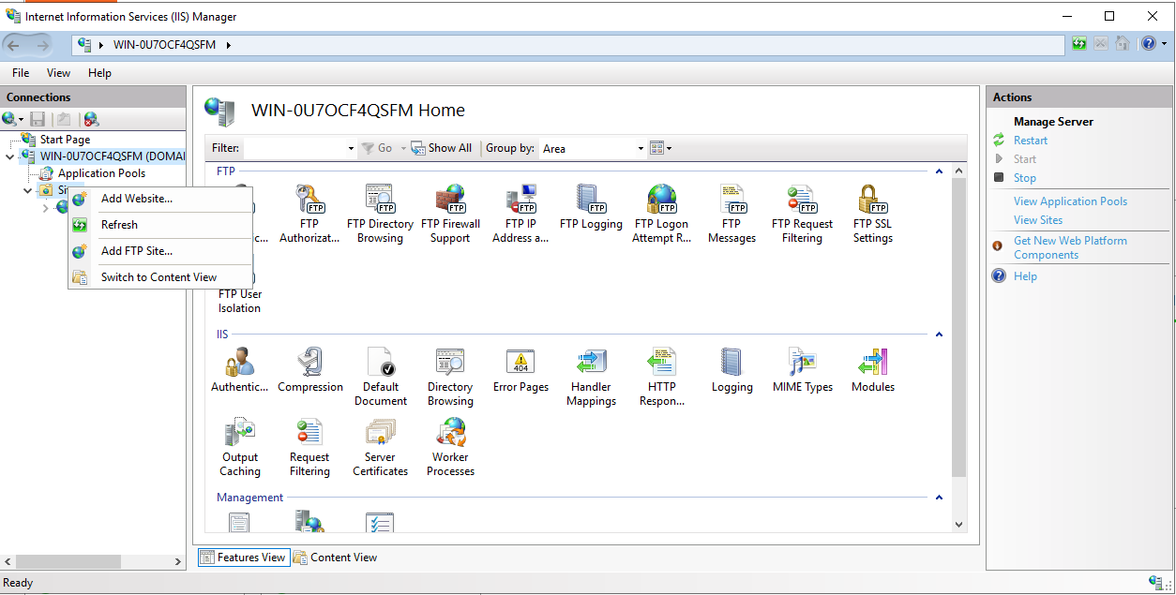2.On the manager right click the “site folder” then click the add website

3. On the add website fill up the forms.

Site name: Your desire name for your website

Physical path: create a simple index.html file and save it on C:\inetpub\wwwroot\MyWebsite

Binding: Type is “http” IP address “192.168.181.10” Port: “80”.

Host name: “www.web.domain.local”

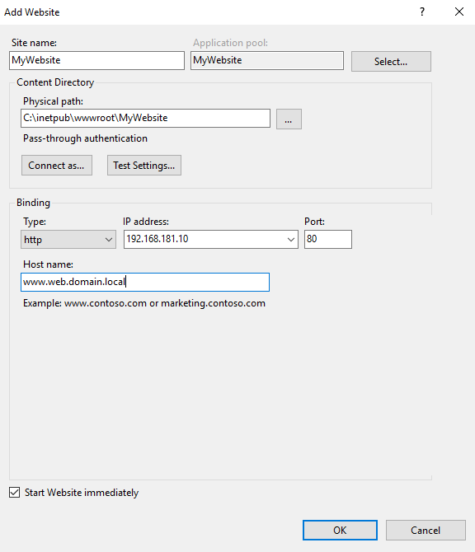

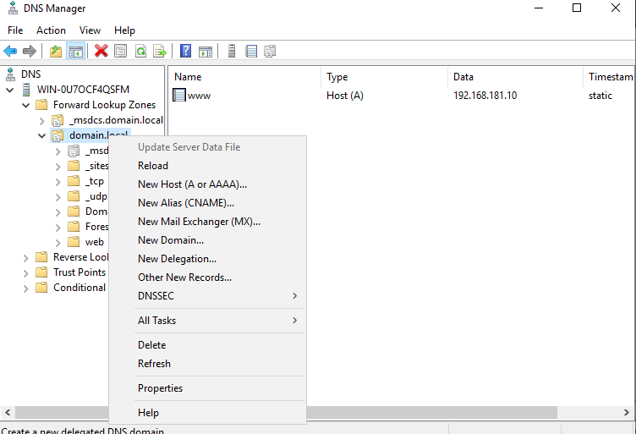3. We need to put this on our DNS for easy access. Go to the DNS manager and right click the domain and click the “New Host”

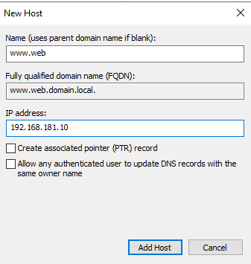3. On the new host. Configure the setup. The name should be **www.web** as the FQDN automatically has the “domain.local” which means it already directed to the local domain no need to add the whole address of the site. Click the add host and that’s it. Try accessing the site the server browser then try it on the client machine.

# 8. ftp Server

FTP lets you transfer files between computers on the network.

Steps:  
1. Add FTP role via IIS.

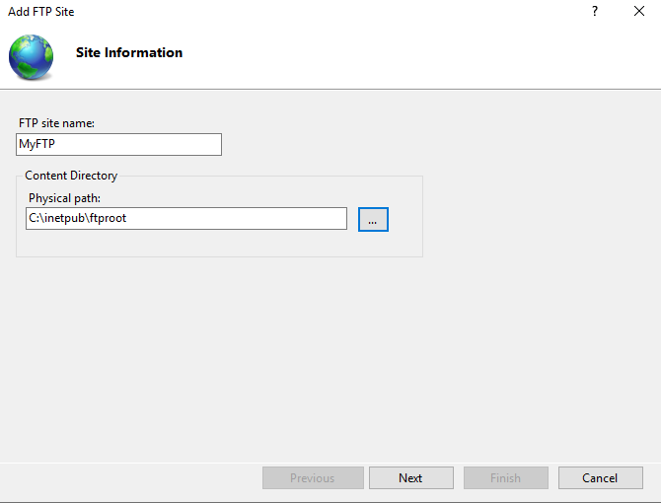2. Configure the FTP site and physical path on your desire folder

3. Configure the binding settings the port should be 21 and ip address should be 192.168.181.10.

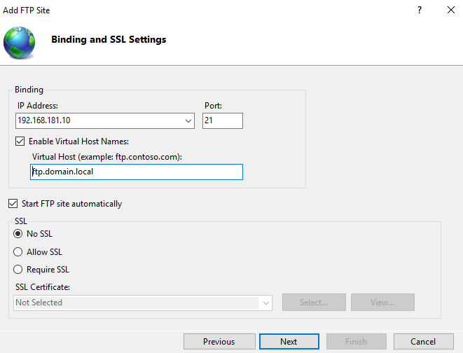

This is only

optional

4. Then test the file browser to check if FTP is working.

## 8.1 configuring ftp permission

**FTP Permissions Configuration**

* sample1 and sample2 can only access their own folders.
* sample2 can **view (read-only)** the contents of sample1’s folder but **cannot modify** them.
* sample1 cannot access sample2’s folder at all.

Create Folders

Go to the FTP root directory (e.g., C:\inetpub\ftproot) and create:

* sample1
* sample2

**Set-up NTFS Configuration**

Right-click on each folder and modify **Security** settings as follows:

**For Sample Folder 1**

* **Remove inheritance**:
  + Go to **Properties > Security > Advanced > Disable inheritance**.
  + Choose **Convert inherited permissions into explicit permissions**.
* **Set permissions**:
  + Remove all other users/groups except Administrators and SYSTEM.
  + Add:
    - sample1: **Full Control**
    - sample2: **Read & Execute**, **List folder contents**, **Read**
      * Make sure Write and Modify are **unchecked** or **Denied**

**For Sample Folder 2**

* **Remove inheritance** (same as above).
* **Set permissions**:
  + Remove all others except Administrators and SYSTEM.
  + Add:
    - sample2: **Full Control**
    - sample1: **Remove entirely** (do **not** add them)
* **Open IIS Manager** > Your FTP site > **FTP Authorization Rules**.

**Configure FTP in ISS**

Add the following **rules**:

* **Allow sample1** → Access to /sample1 → **Read and Write**
* **Allow sample2** → Access to /sample2 → **Read and Write**
* (Optional) If needed, allow sample2 read access to /sample1 here too (but permissions are still controlled by NTFS)

That’s it FTP permission on the said folder is now configure.

# 9. Mail Server (hMailServer & thunderbird)

1. Download and Install hMailServer  
   • Go to: <https://www.hmailserver.com/download>  
   • Download the latest stable version.  
   • Run the installer:  
   • Choose Full installation (Server + Administrative Tools)  
   • During install, create a database password when prompted (write it down)  
   • At the end, leave “Run hMailServer Administrator” checked

This is a link where will guide you to fully download the hMailServer: <https://www.hmailserver.com/documentation/v5.4/?page=howto_install>

1. Once you fully install the server, this is the next you need to do:

* This where you going to create a user account that you will need later to set-up Thunder bird account.
* Click the Add button then proceed on creating an account with corresponding name and password.

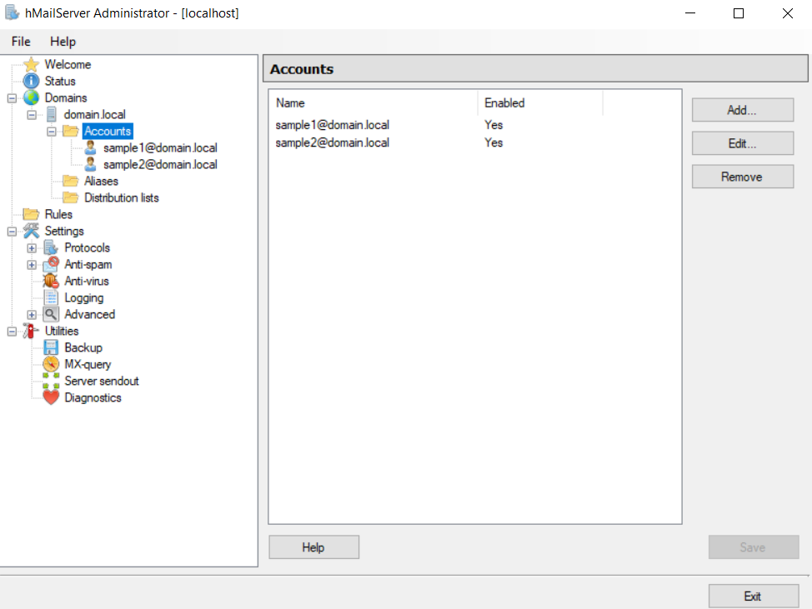

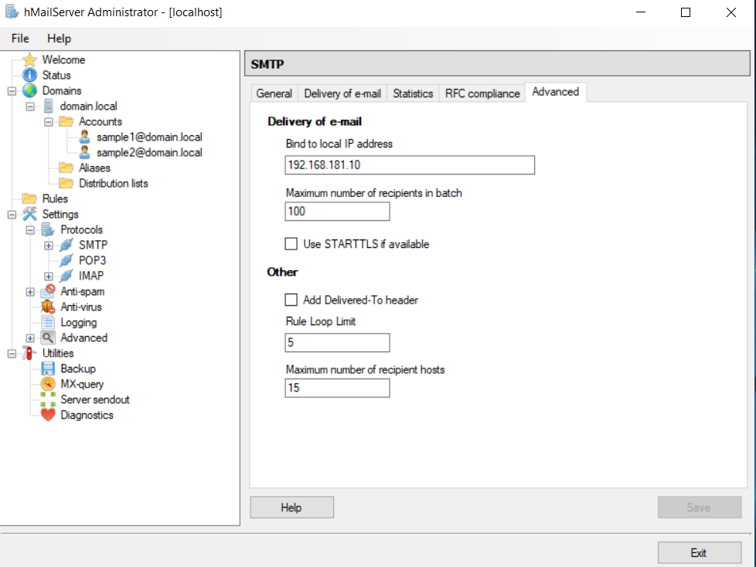5. Set Up SMTP, POP3, IMAP  
  
These are already enabled by default. Just confirm:  
• Go to Settings > Protocols  
• Ensure:  
• SMTP: enabled  
• POP3: enabled  
• IMAP: optional (recommended for modern clients)  
  
7. Open Ports in Windows Firewall  
• Open Windows Defender Firewall > Advanced Settings  
• Create Inbound Rules for:  
• TCP 25, 110, 143, 587

After setting up the hMailServer you need to set up the thunderbird account on the client machine

1. Download Thunderbird  
• From: <https://www.thunderbird.net>  
  
Once downloaded, you can now add the account you created on the hMailServer on to the Thunderbird.

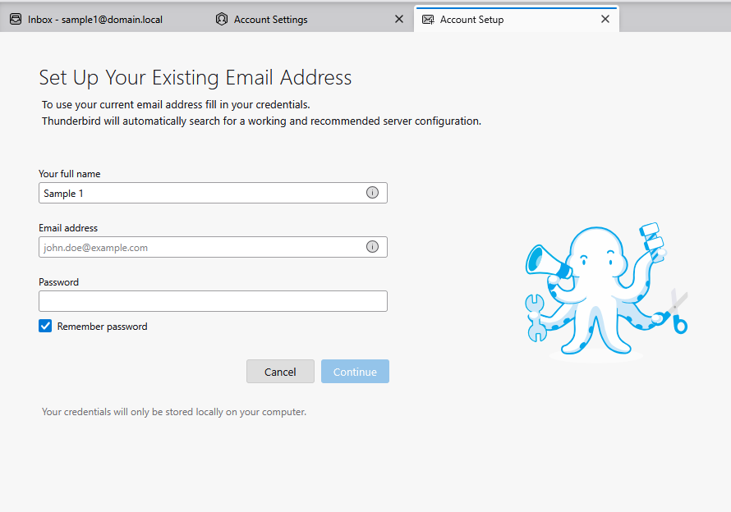  
Input your fullname this will not create any error as long as the email address is correct. Now, input the email address and the correct password.

Now click the continue and it will check on the server if there is an account associated with the inputted user.

When all the configuration is correct this interface will show-up.

# 10. rdp & rdp assistance

To Enable the RDP and RDP assistance you need to configure the GPO here’s how:

**STEP 1:**

Open Group policy management on the domain controller:

* Run: gpmc.msc using Windows key +R

On your Organization Unit the “default domain controller” right click and the proceed on clicking the edit button:

After that, you need to follow this following to enable the RDP :

**Navigate to: Computer Configurations > Administrative Templates > Windows Components > Remote Desktop Services > Remote Desktop Session Host > Connections**

* **Enable: Allow users to connect remotely using Remote Desktop Services**

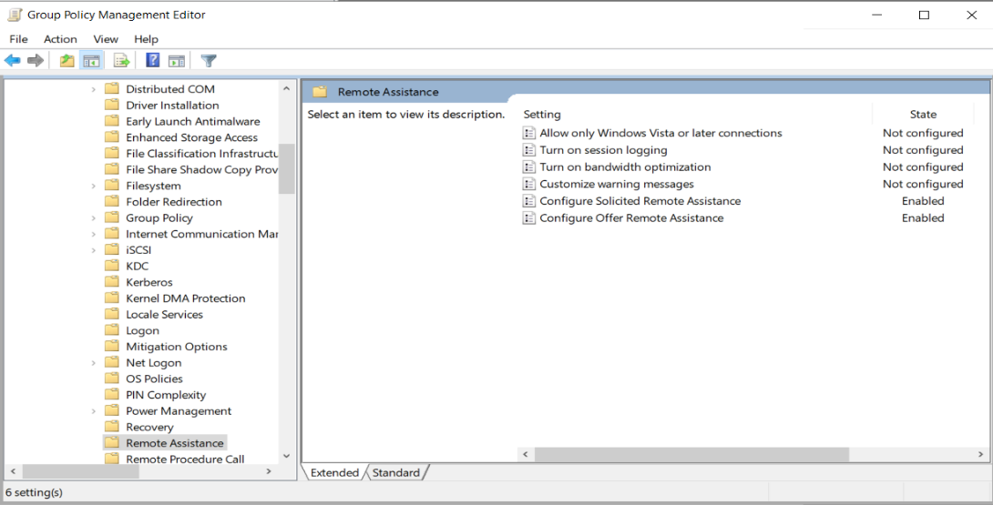Next is configure RDP Assistance, same navigation. Here’s the guide:

**Navigate to: Computer Configurations > Administrative Templates > System > Remote Assistance**

* Enable: Configure Offer Remote Assistance
* Set to Enable
* Choose: Allow helpers to remotely control the computer
* Click show and Add: DOMAIN\Administrator

Part 2: Allow RDP in Windows Firewall

Navigate to:  
  
**Computer Configuration > Policies > Windows Settings > Security Settings > Windows Defender Firewall > Inbound Rules**

Ensure rules for:  
Remote Desktop - User Mode (TCP-In)  
Remote Assistance (RA Server TCP-In)  
are enabled.

You can also push a script using GPO like:  
  
netsh advfirewall firewall set rule group="remote desktop" new enable=Yes  
netsh advfirewall firewall set rule group="remote assistance" new enable=Yes

# 11. Allowing user to login in the server

Allow a domain user (e.g., sample1) created in Active Directory to log in interactively to the Windows Server 2019 (Domain Controller) via the VMware console.  
  
Important Notes  
By default, only Administrators can log in locally to a Domain Controller (DC).  
Regular users (like sample1) need explicit permission to log in locally (via console or RDP).  
We'll modify Local Security Policy or use Group Policy to allow this.  
  
I. Prerequisites  
1. Active Directory is installed and configured on the Windows Server 2019.  
2. You have created a domain user (e.g., sample1) under:  
**Active Directory Users and Computers > domain.local > Users**  
3. Server is connected to network and you can log in as Administrator.  
  
II. Create and Verify Domain User (if not already created)  
Open Active Directory Users and Computers (dsa.msc).  
Right-click on Users > New > User.  
Create the user sample1:  
Username: sample1  
Password: Set and uncheck “User must change password at next login” if you want to skip that prompt.  
Click Finish.  
  
III. Allow the Domain User to Log In Locally to the Server  
Because this is a Domain Controller, local login rights are restricted.  
Option 1: Use Local Security Policy (secpol.msc)

Press Windows + R, type secpol.msc, and press Enter.  
Navigate to:  
**Local Policies > User Rights Assignment > Allow log on locally**  
  
Double-click it:  
Click Add User or Group.  
Type the username: domain\sample1(e.g., domain.local\sample1)  
Click OK > Apply.

# 12. CLIENT MACHINE CONNECTING TO DOMAIN

1. Open System Properties

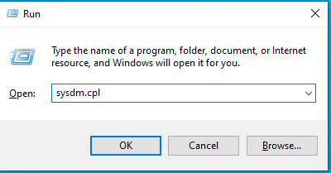 - Press Windows + R, type sysdm.cpl, and press Enter

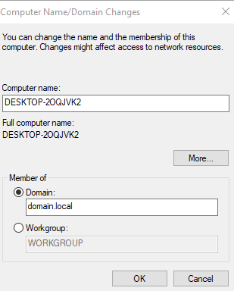 - In the 'System Properties' window, click on the 'Computer Name' tab  
 - Click the 'Change...' button to rename the computer or change domain settings

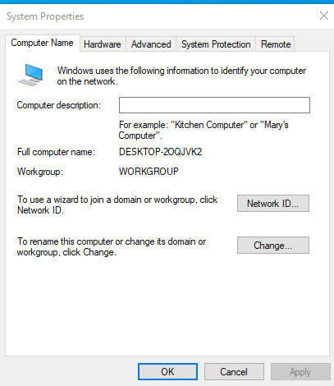

2. Authenticate to the Domain

- A prompt will appear asking for domain credentials  
 - Enter the username and password of a domain account with permission to add devices (e.g., Administrator)  
 - If successful, a message will appear: 'Welcome to the domain.local'

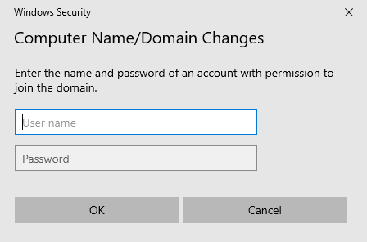

3. At the login screen, click 'Other User'  
 - Enter your domain account in the format DOMAIN\username (e.g., corp\jdoe)  
 - Enter the domain password and log in

