 南昌大学实验报告
学生姓名： 王浩 学 号： 8002117168 专业班级： 软件工程1704班
实验类型：■ 验证 □ 综合 □ 设计 □ 创新 实验日期：2019/5/10 实验成绩：

- 实验项目名称：
第八章课后习题
二、实验要求
1.在First.jsp中输入username和userpass，表单提交给Second.jsp.假设用户名和密码是“abc”和“123”，则转到Third.jsp，显示问候语“***，你好”，否则转回First.jsp，原来用户输入的用户名要保留，并有提示信息：“用户名和密码错误，请重新输入”，适用本章的技术实现。
2.利用Ajax技术实现表单输入信息的验证，以用户注册界面为例，在注册界面中需要对用户名和密码进行验证，其中用户名是唯一的，不能重复，而两次输入的密码必须相同，只有这样的输入才是有效的，要求用户名的格式为：字母开头，后跟字母或者数字，长度最少为6位，密码由数字组成，长度在6-10。
三、主要仪器设备及耗材
Pc Eclipse
- 实验内容和步骤
第一题：
- 先导入jstl需要的依赖包
- 写First.jsp:
<%@ page language="java" import="java.util.*" pageEncoding="utf-8"%>
<%@taglib prefix="c" uri="http://java.sun.com/jsp/jstl/core" %>
<html>
<body>
<form action="Second.jsp" method="post">
请输入用户名：<input type="text" name="userid" value="${sessionScope.userid}"><br/>
请输入密码:<input type="password" name="userpwd"><br>
<input type="submit" value="提 交"><br>
</form>
<c:if test="${param.flag!=null&&param.flag==1}">
${sessionScope.logininfo}
</c:if>
</body>
</html>
- 写出中间控制跳转的Second.jsp:
<%@ page language="java" contentType="text/html; charset=UTF-8"
pageEncoding="UTF-8"%>
<%@ taglib prefix="c" uri="http://java.sun.com/jsp/jstl/core" %>
<!DOCTYPE html PUBLIC "-//W3C//DTD HTML 4.01 Transitional//EN" "http://www.w3.org/TR/html4/loose.dtd">
<html>
<head>
<meta http-equiv="Content-Type" content="text/html; charset=UTF-8">
<title>检测界面</title>
</head>
<body>
<%
request.setCharacterEncoding("utf-8");
%>
<c:choose>
<c:when test="${param.username == 'abc' && param.pwd=='123'}">
<jsp:forward page="third.jsp"></jsp:forward>
</c:when>
<c:otherwise>
<%request.setAttribute("error", "账号密码错误！请重新输入。") ;%>
<jsp:forward page="first.jsp"></jsp:forward>
</c:otherwise>
</c:choose>

</body>
</html>
- 写出最后一个Third.jsp:
<%@ page language="java" contentType="text/html; charset=UTF-8"
pageEncoding="UTF-8"%>
<!DOCTYPE html PUBLIC "-//W3C//DTD HTML 4.01 Transitional//EN" "http://www.w3.org/TR/html4/loose.dtd">
<html>
<head>
<meta http-equiv="Content-Type" content="text/html; charset=UTF-8">
<title>登陆成功界面</title>
</head>
<body>
${param.username}，你好！
</body>
</html>
第二题：
- 在webRoot下新建js/ajax.js文件为创建XMLHttpRequest对象和发送请求提供方便。
var httpRequest=null;
function createXHR(){
if(window.XMLHttpRequest){ //Mozilla,Safari,Opera,IE7等
httpRequest = new XMLHttpRequest();
}else if(window.ActiveXObject){
try{
httpRequest = new ActiveXObject("Msxml2.XMLHTTP"); //IE较新版本
}catch(e){
try {
httpRequest = new ActiveXObject("Microsoft.XMLHTTP");//IE较老版本
}catch(e){
httpRequest = null;
}
}
}
if(!httpRequest){
alert("fail to create httpRequest");
}
}

function sendRequest(url,params,method,handler){

createXHR();
if(!httpRequest) return false;
httpRequest.onreadystatechange = handler;

if(method == "GET"){
httpRequest.open(method,url+ '?' + params,true);
httpRequest.send(null);
}
if(method == "POST"){
httpRequest.open(method,url,true);
httpRequest.setRequestHeader("Content-type","application/x-www-form-urlencoded");
httpRequest.send(params);
}
}
- 写出form.html，实现展示层
<!DOCTYPE html>
<html>
<head>
<title>表单验证</title>
<meta http-equiv="content-type" content="text/html; charset=UTF-8">
<script type="text/javascript" src="js/ajax.js"></script>
<script type="text/javascript">
function formcheck(){
var url="formcheck";
var userid=document.getElementById("userid").value;
var userpwd=document.getElementById("userpwd").value;
var userpwd_1=document.getElementById("userpwd_1").value;
var params="userid="+userid+"&userpwd="+userpwd+"&userpwd_1="+userpwd_1;
sendRequest(url,params,'POST',showresult);
}
function showresult(){
if (httpRequest.readyState == 4) {
if (httpRequest.status == 200) {
var info=httpRequest.responseText;
document.getElementById("result").innerHTML=info;
}
}
}
</script>
</head>
<body>
请输入用户名：<input type="text" name="userid" id="userid" onblur="formcheck()"/><span>(字母开头，后跟字母或数字，长度至少6位)</span><br/><br/>
请输入密码 ：<input type="password" name="userpwd" id="userpwd"/><span>(由数字组成，长度在6~10位)</span><br/><br/>
请再次输入密码 ：<input type="password" name="userpwd_1" id="userpwd_1"/><span>(重复刚才输入的密码)</span><br/><br/>
<input type="button" value="注册" onclick="formcheck()"/>
<div id="result"></div>
</body>
</html>
3.写出servlet：formcheck.java实现控制层，并且在servlet中我们假定a12345和b12345这个用户已经存在：
package Servelet;
import java.io.IOException;
import java.io.PrintWriter;
import javax.servlet.ServletException;
import javax.servlet.annotation.WebServlet;
import javax.servlet.http.HttpServlet;
import javax.servlet.http.HttpServletRequest;
import javax.servlet.http.HttpServletResponse;
/**
* Servlet implementation class Formcheck
*/
@WebServlet("/formcheck")
public class Formcheck extends HttpServlet {
private static final long serialVersionUID = 1L;
/**
* @see HttpServlet#HttpServlet()
*/
public Formcheck() {
super();
// TODO Auto-generated constructor stub
}
/**
* @see HttpServlet#doGet(HttpServletRequest request, HttpServletResponse response)
*/
protected void doGet(HttpServletRequest request, HttpServletResponse response) throws ServletException, IOException {
// TODO Auto-generated method stub
doPost(request,response);
}
/**
* @see HttpServlet#doPost(HttpServletRequest request, HttpServletResponse response)
*/
protected void doPost(HttpServletRequest request, HttpServletResponse response) throws ServletException, IOException {
// TODO Auto-generated method stub
response.setContentType("text/html;charset=UTF-8");
PrintWriter out = response.getWriter();
request.setCharacterEncoding("UTF-8");
String userid=request.getParameter("userid");
char u[]=userid.toCharArray();
if(u[0]<'A'||(u[0]>'Z'&&u[0]<'a')||u[0]>'z'){
out.println("用户名需要字母开头");
}
if(u.length<5){
out.println("用户名至少6位");
}
else{
for(int i=1;i<u.length;i++){
if(u[i]<48||(u[i]>57&&u[i]<64)||(u[i]>90&&u[i]<97)||u[i]>122){
out.println("用户名格式不对");
}
}
if("a12345".equals(userid) || "b12345".equals(userid)){
out.println("用户名已存在");
}
else{
String userpwd=request.getParameter("userpwd");
String userpwd_1=request.getParameter("userpwd_1");
if(!"".equals(userpwd) && !"".equals(userpwd_1)){
char []p=userpwd.toCharArray();
int flag=1;
if(p.length<5||p.length>9){
out.println("密码必须为6~10位");
}
else{
for(int i=0;i<p.length;i++){
if(p[i]<'0'||p[i]>'9'){
out.println("密码必须由数字组成");
flag=0;
break;
}
}
if(userpwd.equals(userpwd_1)&&flag==1)
out.println("注册成功");
else if(flag==1){
out.println("两次输入的密码不一致，注册失败");
}

}
}
}
}
}
}
五、实验数据及处理结果
1.
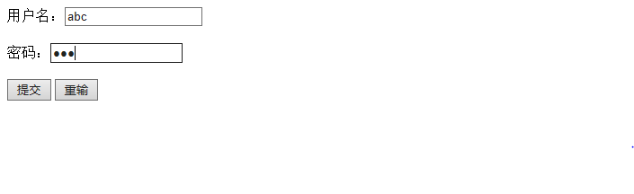
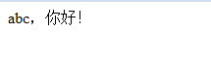

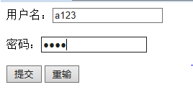
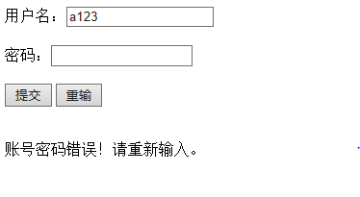

2.
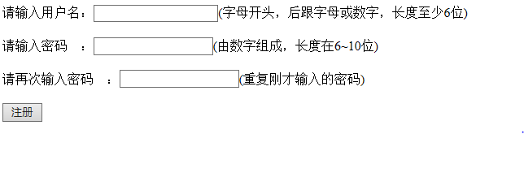
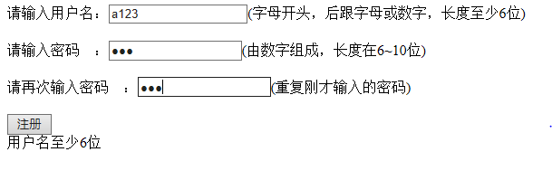
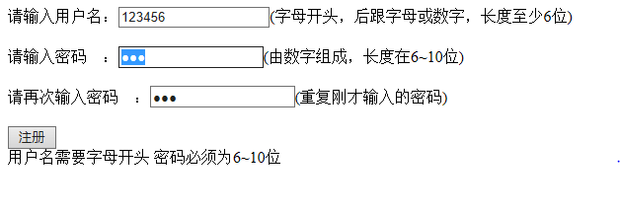
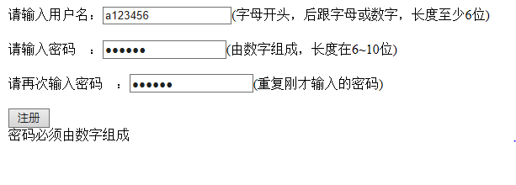
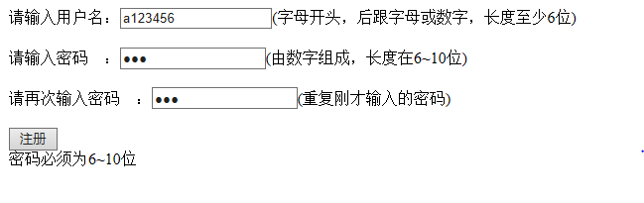
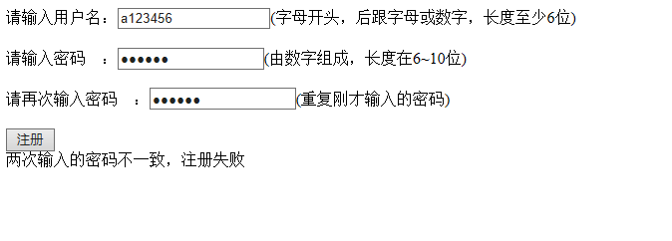
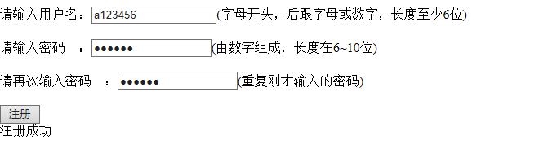
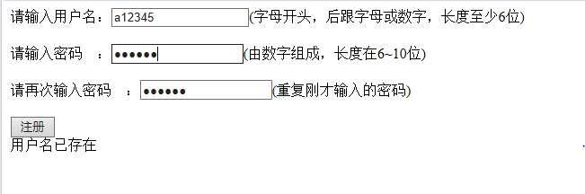
六、思考、讨论或体会或对改进实验的建议

