User document By  
  
Ryan Sadar  
Connor Fox  
Anmol Shrestha  
Emey Long

Under the guidance of

Lecturer : Shannon

Table of Contents

**1.0 Introduction** **3**

1.1 audience description 34

1.2 Purpose Statement 4

1.3 Document Usage Description 4

1.4 Conventions 5

**2.0 Introductory Kit** **5**

2.1 Total road incident cost calculator overview 5

2.2 Getting started 6

**3.0 TRICC user manual** **6**

3.1The Website 6

3.2 Welcome and Navigation 7

3.3 Calculator (Main Application) 9

3.4Web forum application using user input to calculate the Total Costs associated with a Road Incident through various calculations 10

3.5 Research page 10

3.6 Resources page 11

**4.0 Installation Guide** **12**

**5.0 System Administrator Guide** **12**

**6.0 Appendices** **12**

# 

# 1.0 Introduction

## 1.1 audience description

The calculator recognises the differences in operations and business structure across different sectors. To this end, tailored solutions and calculations are provided for the Manufacturing and Services sector, State and Local Government sector, Health and Emergency Services and Other Community Services and Not-for-Profit organisations.

The total road incident cost calculator is aimed towards a broad audience.

Users of this webpage are only required to know basic computer skills to operate the calculator.

Users of this calculator would include   
  
 **Banks**: banks would want to know the number of fatalities as the people who had the unfortunate incident could have borrowed a loan in the name of their vehicle which means if the vehicle gets totalled it is a loss to the bank as there will be no asset for the bank to seize if the customer is unable to repay the loan.

**Insurance companies** - the insurance companies would be interested in this calculator as it will help them understand the total amount of road fatalities and the costs it creates. With each accident that happens the insurance company undergoes revenue losses as they have to pay the insured customer.

**Hospitals** - they have to keep updates on how many fatalities occur as it determines how the hospitals have to manage their resources such as staff, accommodation etc.. The calculator will allow the hospital to be effective in maximising profits by having the necessary resources when required by giving a calculation of the total fatalities.  
When this is done the hospital will not lose revenue as they will be prepared to face the circumstance rather than back down.

**Government** - the government will be using this calculator to determine the number of fatalities to make adjustments to many things :  
How the road safety rules should change   
What needs to be done to prevent fatalities occurring in the future.  
By bringing these mentioned adjustments into action the government can contribute to reducing the costs of losing lives as well as damage to private and public properties hence minimising the risk of future fatalities.

**Car dealerships**: car dealerships would like to know how many car accidents occur in order to calculate how they should bring the shipments and how often they should bring in the shipment to keep up with the demand of motor vehicles in relation to the number of vehicles that are destroyed in the accidents that take place.

<https://www.nrspp.org.au/cost-calculator/>

## 1.2 Purpose Statement

Total Road Incident Cost Calculator was designed to provide organisations with an estimate of the direct and indirect costs associated with a road accident.

The calculator has three main sections:

1. The input is where the users are able to enter the type of sector or number of road incidents a year of the organisation.
2. The calculator uses the information to calculate the direct and indirectly. Its concludes a number of key indicators about frequency of incidents involving fleets and overall claim rate of vehicles.
3. The final output of the calculator then presents the overall financial which indicates the severity of incidents.

## 1.3 Document Usage Description

The document contains:

1. **Introduction**  
   A brief introduction to the project domain, its purpose and the intended users
2. **Software Design Scope**  
   This section covers the major functions of the system, its benefits and design constraints
3. **Reference Documents**  
   This section covers the supporting documentation regarding the system design software used and referencing third party software and tools used for developing the system
4. **User stores**  
   This section covers the User Stories of the application, flow of interactions of the system and wireframes.
5. **Object-Oriented Design**This section breaks down the system architecture into smaller subsections so that they are more easily understood.
6. **Software Release Report**This section covers the procedure for usability testing and system testing reports
7. **Additional User Interface Design**  
   This section contains any additional interfaces of the input, output and communication between the user and system.

# 

## 1.4 Conventions

The conventions used to create this User Document includes heading, sizing, spacing, font selection, font size, section division, navigation throughout the document. The document was created to ease the users to see the purpose behind the website which is mentioned in this document with several headings and sub-headings to allow them to understand the whole bit of this project. Each topic in these documents can be navigated through a one-click on the table of contents.

Every headings and sub-headings have got its own unique number and description which is easy to understand and follow. Table of Contents consists page numbers with the section headers which can be reached with a one-click in the respective headers.

# 2.0 Introductory Kit

## 2.1 Total road incident cost calculator overview

The total road incident cost calculator is a software solution that makes it easier for other bodies to calculate total road incidents and make assumptions to plan a better future on the roads.  
This website will help in identifying and hopefully eliminating the road accidents that are occurring on the roads as this calculator helps organisations to find out direct and indirect costs associated with road incidents. This software will be compatible 100% on desktops and laptops more than on smartphones as smart phones are restrictive in terms of accessing certain options.   
The system can be broken down into several layers and they are:  
Using a company product and financial information, it explains the hidden costs of road accidents to the company

This would be used by the company to tell how much of their product should be sold for them to break even or cover the costs of road incidents.  
  
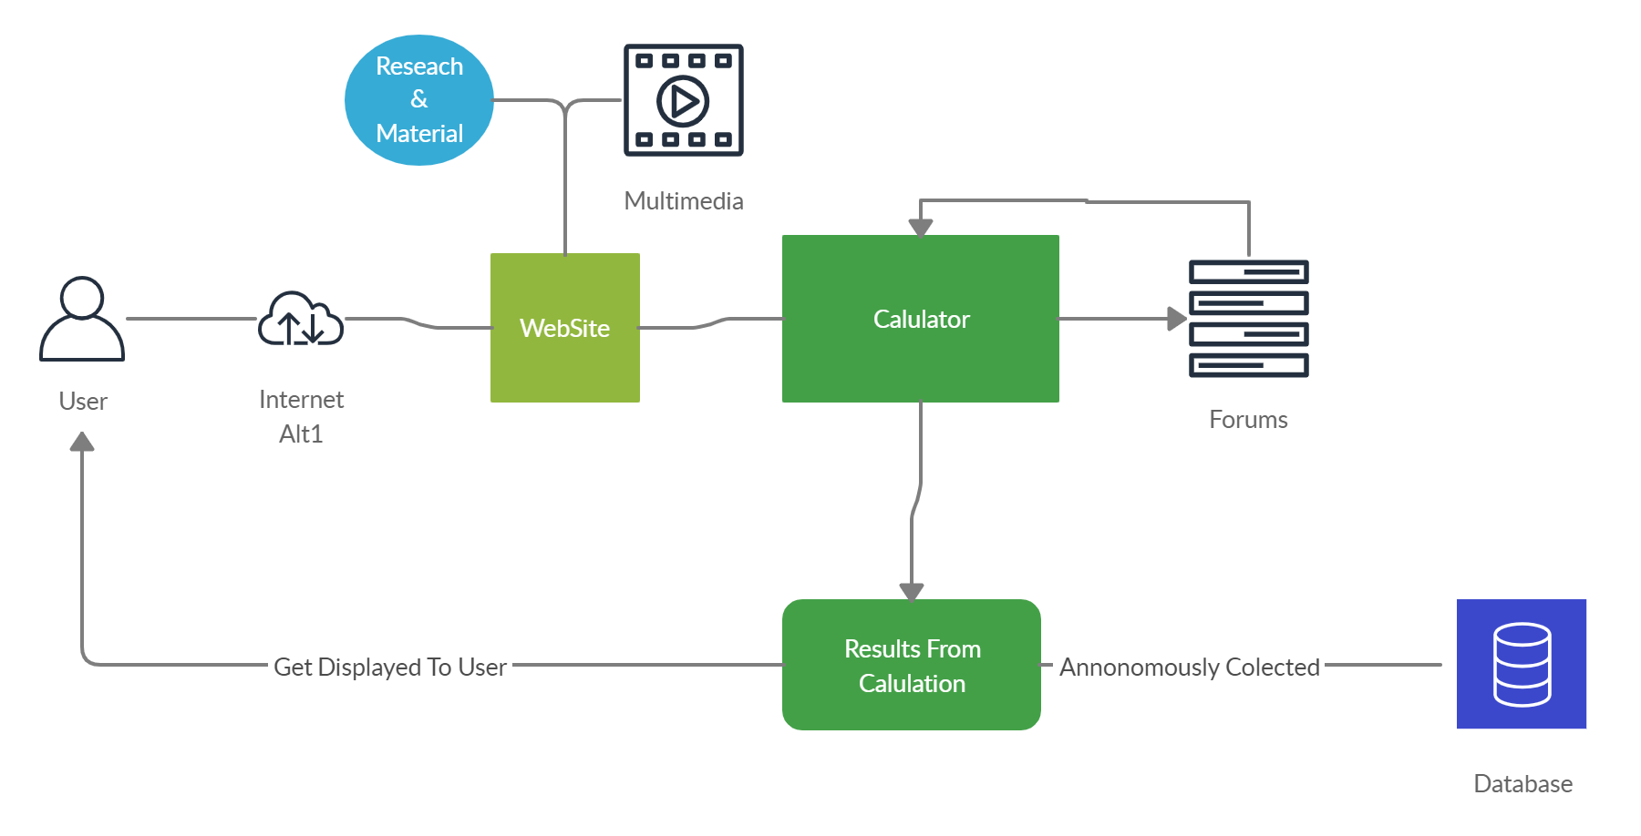

Figure 1. Total road incident cost calculator overview

## 2.2 Getting started

To get started first you need to visit NRSPP.org.au (<https://www.nrspp.org.au/cost-calculator/>)  
Once in the page you will be presented with the home page or welcome page.  
Upon completion you will be directed to the page data entry  
Next to the calculations page .  
And finally to the final outcome page.  
This webpage will be designed in a user friendly manner such that individuals will find it easy to use the calculator  
The following slides will allow you to get a better understanding of how to navigate through the webpage.

# 3.0 TRICC user manual

## 3.1The Website

The Total road incident cost calculator website was designed to provide organisations with an estimate of the direct and indirect costs associated with a road incident.   
The calculator shows an estimate of total incident cost in simple terms while outlining how much each incident could cost the organization in terms of lost revenue and service provision.  
By doing the things mentioned above

## 3.2 Welcome and Navigation

This is the first page the client will be directed to when the website is opened



Figure 2. Welcome

we have data entry page in this page you have to enter   
Annual unit of sale  
Annual claims data  
Total number of vehicles  
Annual total distance travelled by fleet  
Annual fleet insurance premium  
Premium per vehicle  
Premium per vehicle  
Excess per claim  
Return on   
Gross annual turnover   
Profits from  
Average unit costs of   
Grey fleet

Figure 3. Data entry

## 3.3 Calculator (Main Application)

After the welcome page the User navigates to the calculator page:

The First Calculator page has a drop-down menu which allows you to choose the sector that you are in.  
And below that it allows you to type in your main revenue earner.  
The page looks like the following



Figure 4. Calculator (Main application)

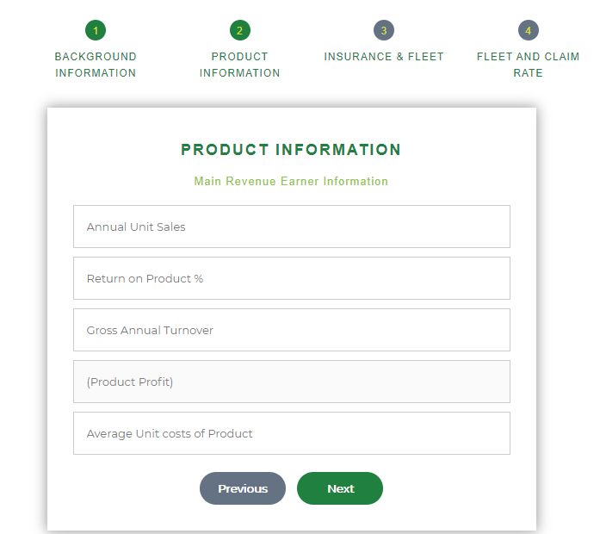

Figure 4.1 Calculator (Product page)

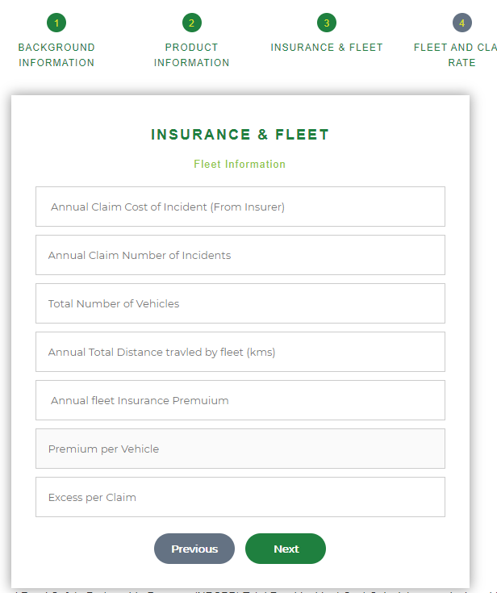

Figure 4.2 Calculator (Fleet Information)



Figure 4.3 Calculator (Grey Fleet)

## 3.5 Research page

This is the research page where user can know all the information about the road incidents and statistic

Road incident information

Statistic



Figure 5. Research page

## 3.6 Resources page

This resources page where we can

See the video guides how to use calculator

Examples

Education videos

# 

Figure 6. Resources page

# 4.0 Installation Guide

For the user to have complete and uninterrupted access to the webpage you are required to have an updated web browser and a stable internet connection.

# 5.0 System Administrator Guide

We have listed the steps to guide you through the calculator on the website. First and foremost, anyone can access the website by going on the NSRPP site. The website consists of two major functions one which is the most important part; road incident cost calculator and another is all the research resources and documentation part.

The calculator part continues as follows in different steps. The landing page would have the options to choose the sector by dropdown menu and the main revenue earner can be inputted by the user from the keyboard.

Step 1) Choose the sector you work in from a drop-down list

and input the main revenue earner which is a String value.

Step 2) After the submission of the data inputted you will be directed to data entry page where you have to enter   
Annual unit of sale in numbers(Amount in number)  
Annual claims data in numbers(Amount in number)  
Total number of vehicles(In number)  
Annual total distance travelled by fleet(In number)  
Annual fleet insurance premium(Amount in number)  
Premium per vehicle(Amount in number)  
Excess per claim(Amount in number)  
Return on (percentage)  
Gross annual turnover(Amount in number)   
Profits from(Amount in number)  
Average unit costs of (Amount in number)  
Grey fleet(In number)

Step 3) The calculations page is where we will enter all   
Direct costs (Amount in number)  
Indirect costs (Amount in number)  
Estimated total costs for managed fleet (Amount in number)  
Estimated total costs for all vehicles (Amount in number)

The documentations and remaining part of the websites can be browsed via pressing the index bar at the top of each page by choosing which page you want to visit and could see the relevant information regarding it. Such as if you are looking for research on the calculator. You could press the research in the index bar and can search for the calculator research about whatever you are after.

# 6.0 Appendices

|  |  |  |
| --- | --- | --- |
| Figure Number | Figure Name | Section |
| Figure 1 | Total road incident cost calculator overview | 2.1 |
| Figure 2 | Welcome | 3.3 |
| Figure 3 | Navigation | 3.3 |
| Figure 4 | Calculator (Main application) | 3.3 |
| Figure 4 | Calculator (Product Page) | 3.3 |
| Figure 4 | Calculator (Fleet Information) | 3.3 |
| Figure 4 | Calculator (Grey Fleet) | 3.3 |
| Figure 5 | Research page | 3.6 |
| Figure 6 | Resources page | 3.7 |