Multimedia

1. Most videos and audios try to answer a religious question, sometimes it is an interaction or debate, this form is very helpful for the website owner to express clearly.
2. These files help people understand what the site try to express. To some extent, these audios and videos have the same effect as online course (Just imagine students learn calculus on YouTube), so it doesn't distract people from the theme.

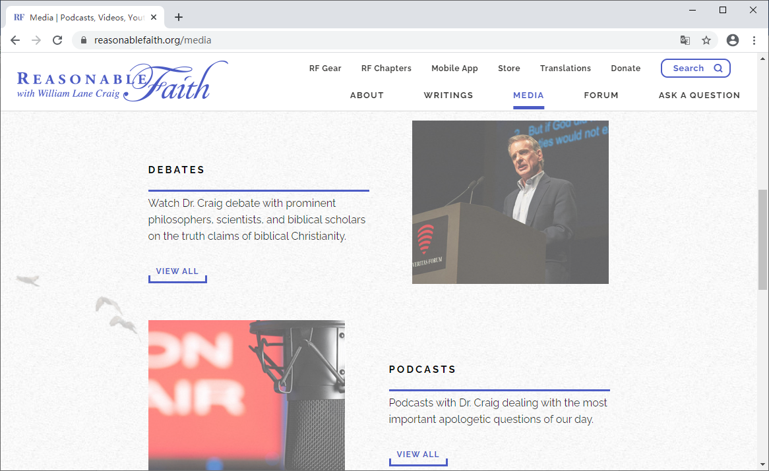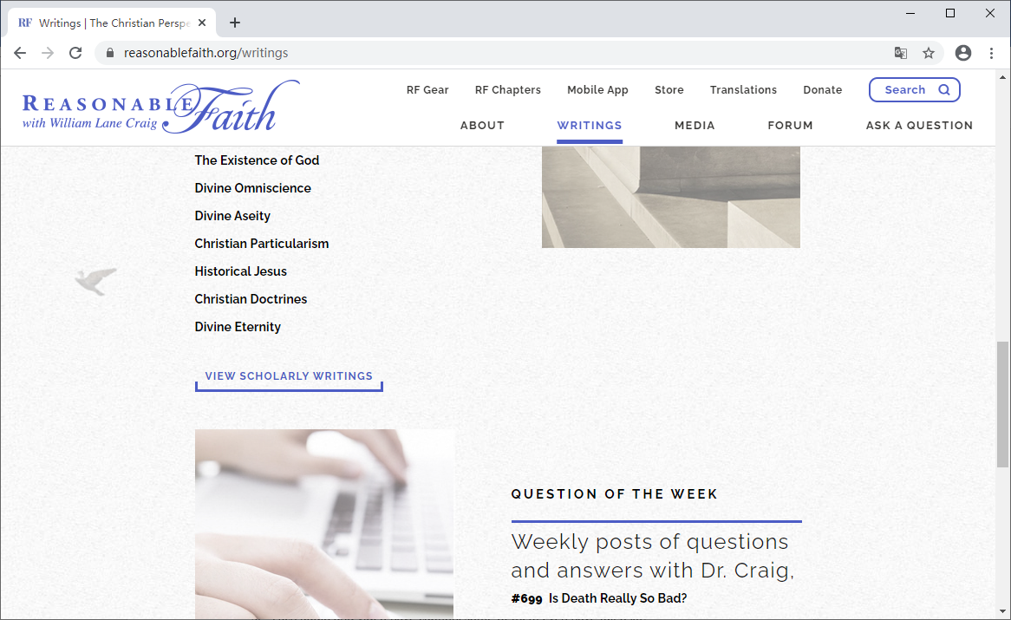

Picture about item 1 and 2.

1. Each audio and video have caption, some of them even have full text.

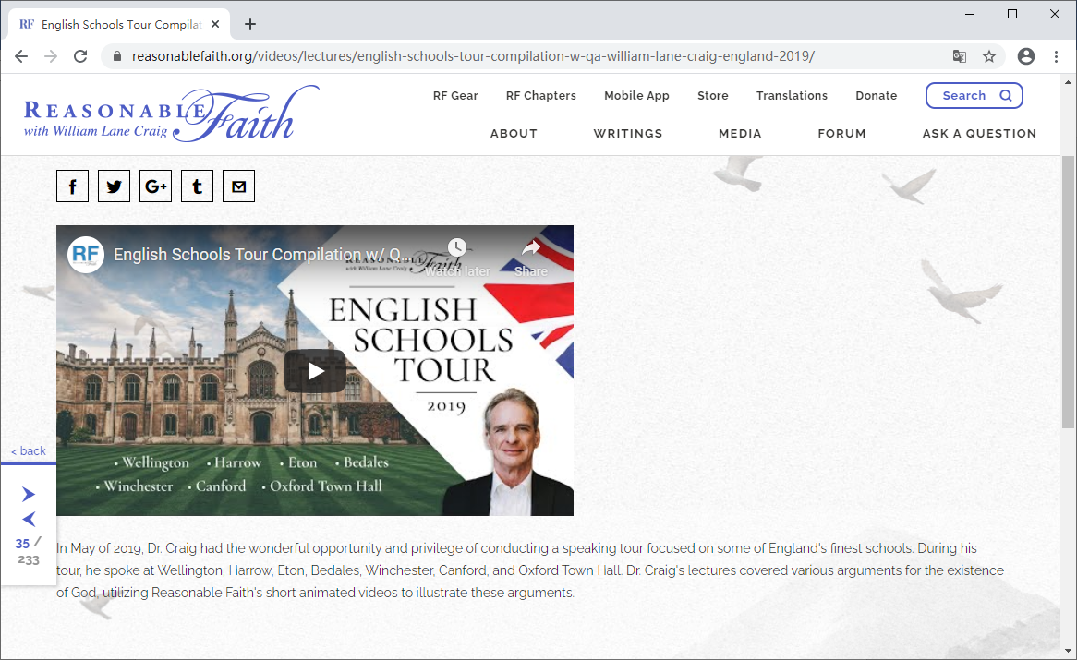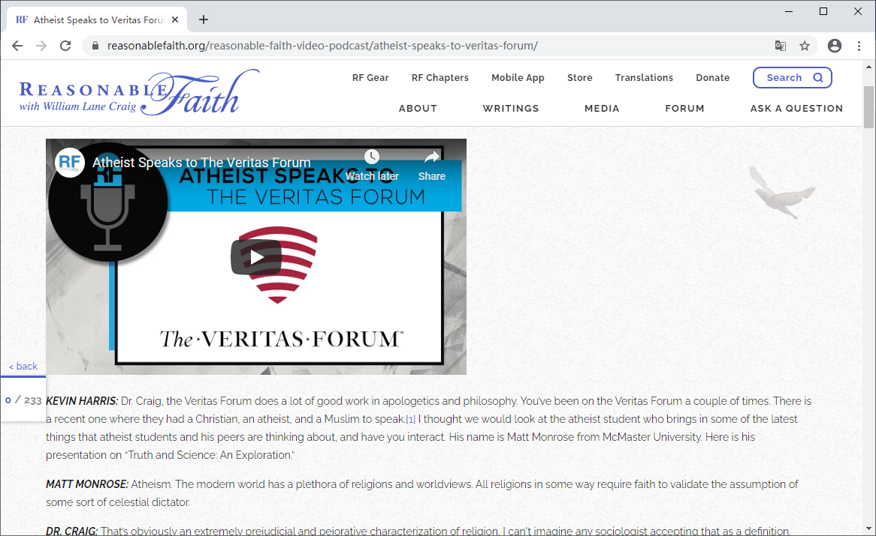

*Picture about item 3.*

1. It is not easy to download videos and audios from this site, it does have a download time indicator (but I think it is calculated by the browser itself), but downloading a text file is not hard. I tested some audios, and the download speed is slow because of the distance between my laptop and web server (I have broadband connection).
2. There are links for downloading, but not convenient. The videos are embedded on YouTube so someone who has little knowledge about YouTube may have trouble downloading videos. As for audios, it's easier for audience to download, but still have space to improve, for example, download audio by just click a button instead of making a right click on link, select "Save as" in the menu.

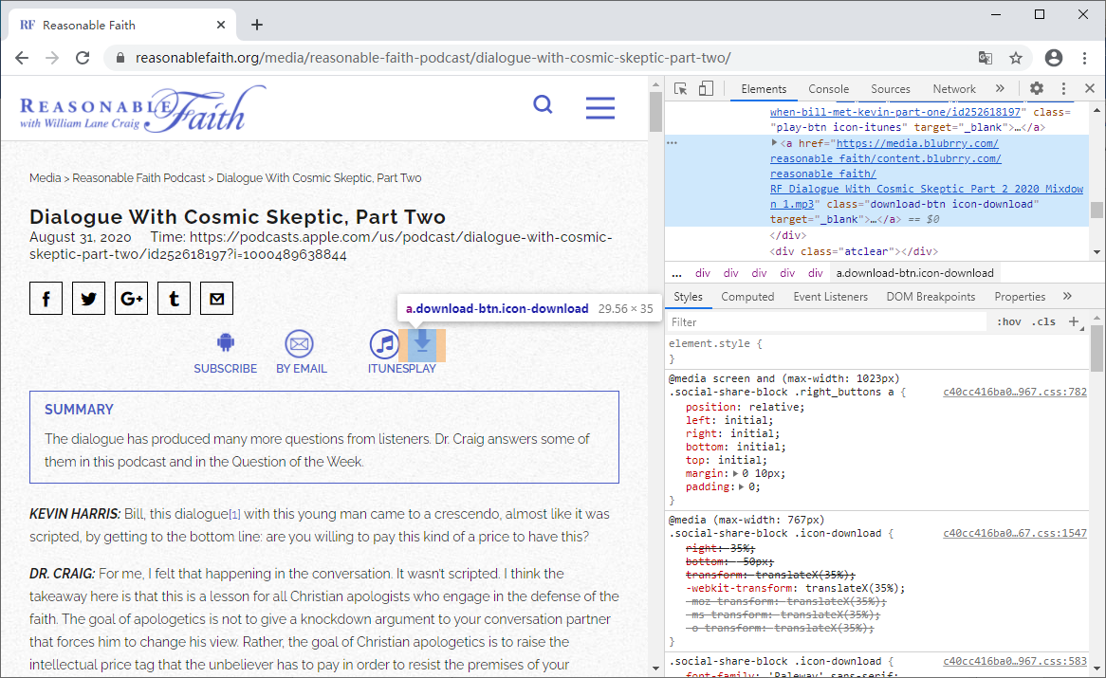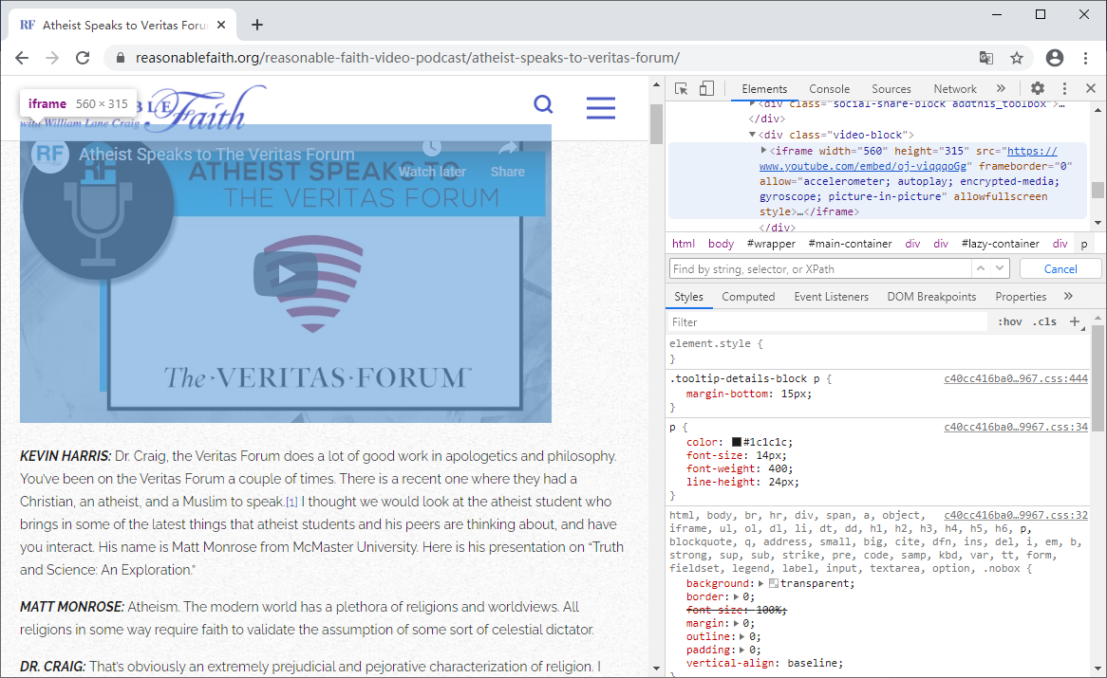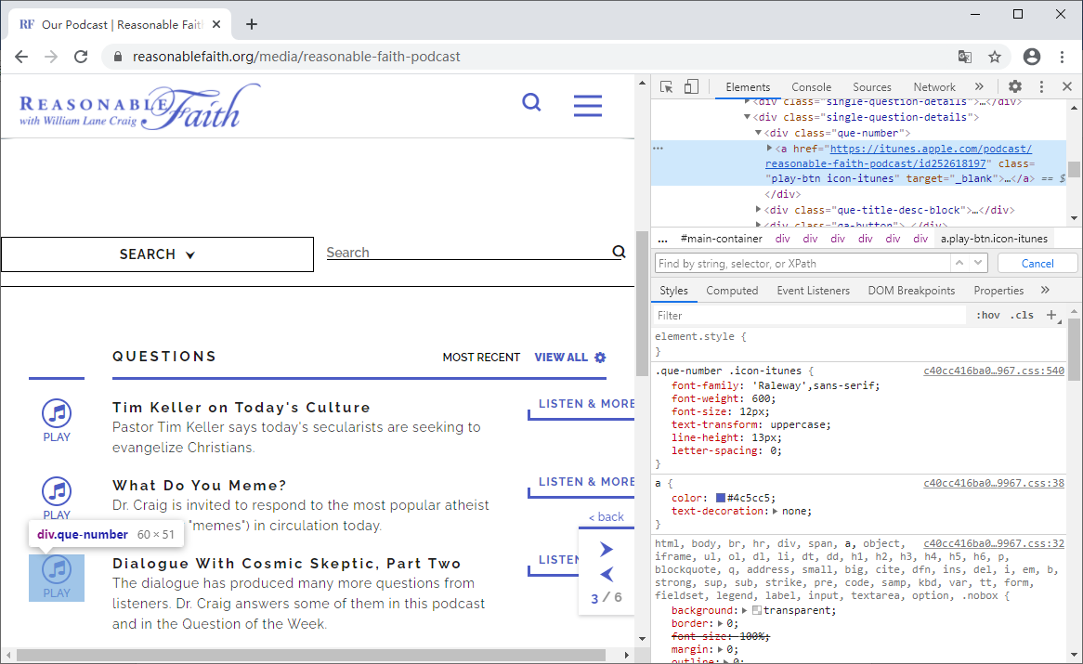

Picture about item 5.