6.navigation

This section is the navigation of the web page，

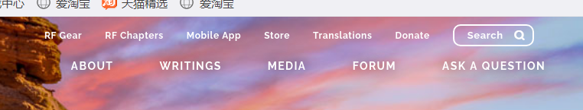

These three are dynamic navigation, you can open the rest of the navigation with the mouse, save a lot of space, give a sense of simplicity

First of all, as a tag, should be very clear, the site's tag navigation, indeed, very clear, simple, without excessive decoration.And the use of dynamic navigation, the mouse will be placed on the navigation, using the label to expand, in this way, first to avoid the audience, when looking for the content they want, because too many content labels are overwhelmed, leading to give up looking, leave the site, navigation as an auxiliary tool, all the connections are effective

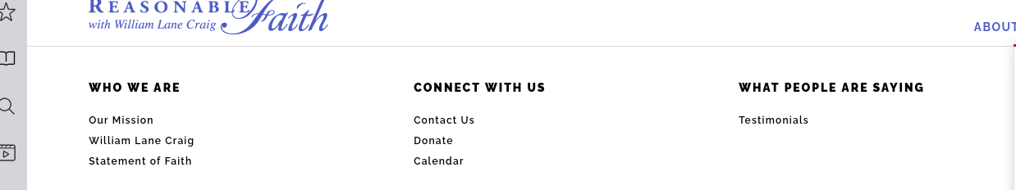

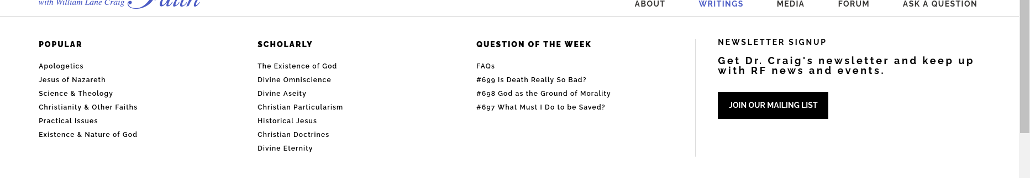

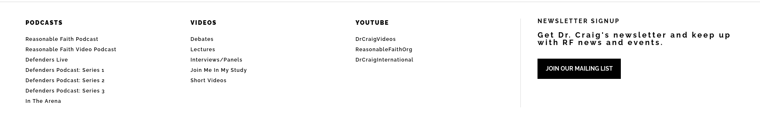

剩下的部分，是静态的导航

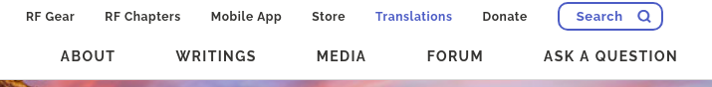

First of all, as a navigation, to give people obvious to see, so put it in the beginning, let people see navigation more directly, which is now absolutely most sites, the use of navigation on top, and the use of dynamic, mouse point can be expanded, such a design more understand convenient

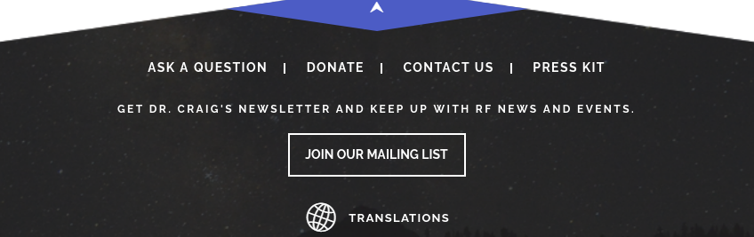

Here's the navigation below, here's a question about the site, not conspicuous, not to be complained about, nice design.

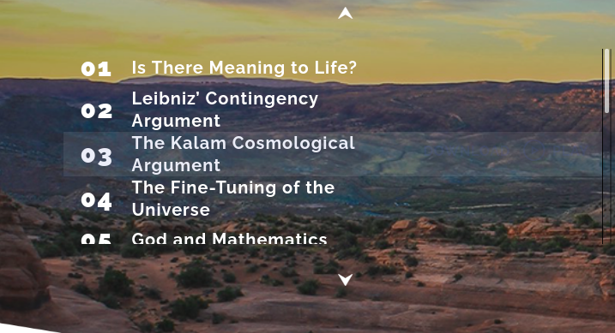

This is the navigation of the content, through which you can jump directly to the desired part

2.Color and graphics

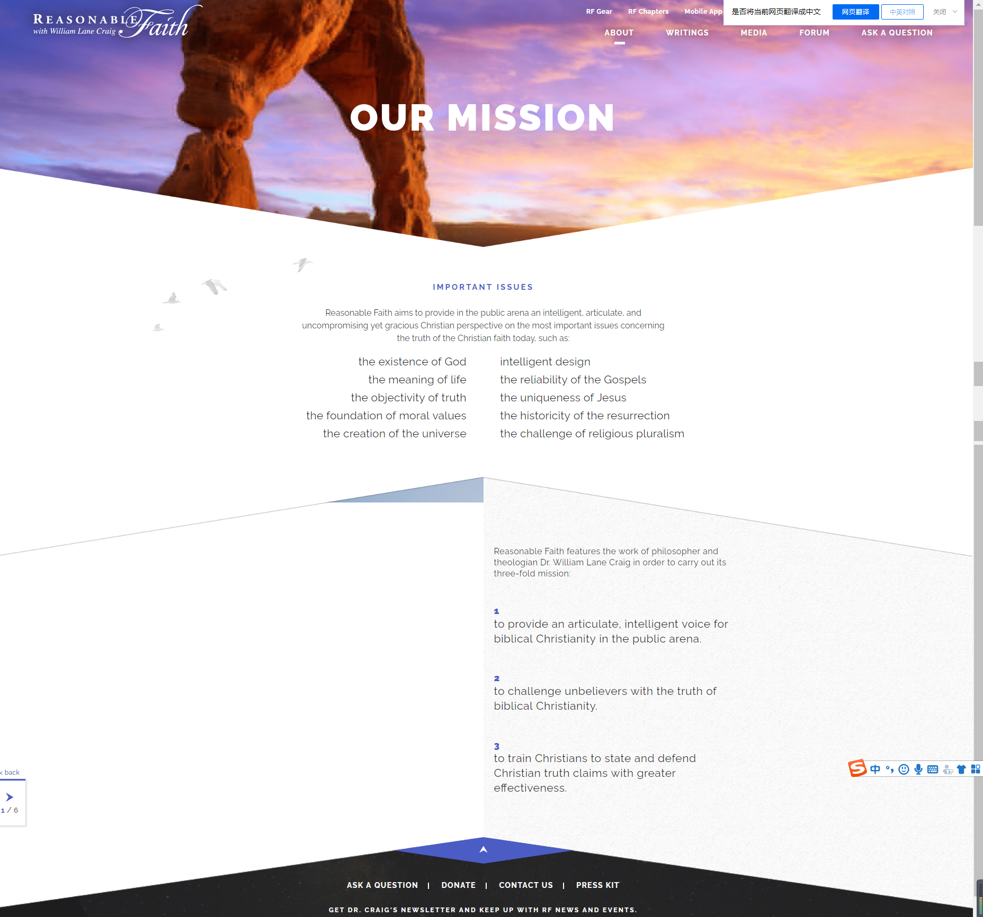

The whole web page is white, which gives people a simple and profound feeling, which can be more associated with religion, sanctity and belong to the noble feeling，

First of all, the main body is white, generally in foreign countries, white belongs to, noble and sacred，First of all, the body is white, generally in a foreign country, belongs to white, noble and pure divine, suitable for the characteristics of religious sites, most images using the rock landscape, make the audience to convey, deep, doubting, give a person with mysterious feeling only, it should be said that the site as a whole is tonal, is white, and will not have larger color wave, tonal change suddenly, regardless of the point in the tag, is simple and clear website, the theme of the site, should be already contracted style, it should be considering this is a religious sites, so there won't be the waves of ups and downs,