SPICT-4ALL is for care staff, individuals, their family and friends.
You might notice changes in your health and wellbeing and the things you can do. You may be having more problems managing your health problems or treatments. Your family and friends or staff who look after you might see that your health is not as good as it was.
It can be difficult to know when to ask for more help and support or how to talk about this.
SPICT-4ALL helps people start talking about their health and care. It can be used to ask for a review from a doctor, nurse, social worker or other care staff by describing what’s changing.
Staff looking after you want to hear about what matters to you if your life, health or care are changing. That helps you get more support now. Staff who know you can make or update a future care plan with you and your family or a friend. These plans can have information about you and your health and care. This is important if you ever need urgent or emergency care.
Using SPICT-4ALL to look for signs of changing health and plan care
■ Emergency admission or visit to hospital. A warning sign even if a person gets better again. We think about what we can do to keep the person as well as possible.
■ Symptoms that are there most of the time or getting worse. We look for medicines and treatments that can help. We talk about stopping those that are not working or helping.
■ Needing more help with personal care. The person is less able to manage things they could do before. Getting extra help and support in good time is important. We try to look after people who care for the person as well. This can help avoid a crisis if things get worse.
■ Problems that are difficult to manage. These could be physical, emotional, social or spiritual problems. Asking a specialist or another service to give advice can help.
■ Care at home: Plan care and support from the primary care team, social care teams, other community staff or services; find out about the person’s own support network or community.
Future care planning
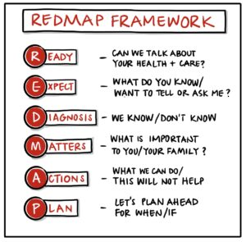 | Future care planning conversations can be about:  - What matters for this person if their health changes.  - Plans for hospital care - admission, outpatient visits, tests and treatments. Depends on the person’s health problems, situation, and what matters to them.  - Treatments/medicines that help, could stop, will not work or have a poor outcome.  - Cardiopulmonary resuscitation (if relevant for them)  - Choosing trusted people to help make decisions about your care, housing or money (Power of Attorney)  - Care or support they’d like, or do not want to happen.
Talking about changes in health
Find out what matters to this person. What could help them with the things they enjoy and want to carry on doing? Are there things they worry about? What do family/friends know?
“You are well at the moment, but I can see that…” “I think we should ask the doctor/ nurse for advice?” “They might need to see you to talk about…” “We could make a care plan with you.”
“What would (name) say about this if we could ask them? Why is that?”
www.spict.org.uk 2025




