**VERIFICATION** **OF** **LAWS OF PHOTOELECTRIC**

**EFFECT USING V-LAB SIMULATIONS**

Submitted in partial fulfillment of the requirement for the degree of

Bachelor of Science

in

PHYSICS

by

**RITHIK VINAYARAJ**

PR18CPHR17

Under the guidance of

**Dr.Deepa K**

HOD

PAZHASSI RAJA NSS COLLEGE, MATTANUR

KANNUR UNIVERSITY



**DECLARATION**

I hereby declare that the project report entitled “ **VERIFICATION OF PHOTOELECTRIC EFFECT USING V-LAB SIMULATIONS”** submitted for the award of the degree of *Bachelor of Science in Physics*  to Kannur University is a record of original and bonafide work done by our project group carried out by the members under the guidance and supervision of **Dr.Deepa K**

I further declare that the Information and Data given in this project is authentic and true to the best of my knowledge. The work report in this project has not been submitted and will not be submitted, either in part or in full, for the award of any other degree or diploma or any other fellowship in this institute or any other institute or university.

**Aswathi P** (PR18CPHR24)

**Rithik Vinayaraj**(PR18CPHR17)

**Amalendu Raghunath**(PR18CPHR21)

**DEPARTMENT OF PHYSICS**

**PAZHASSI RAJA N.S.S COLLEGE, MATTANUR**



(AFFILIATED TO KANNUR UNIVERISTY)

**CERTIFICATE**

This is to certify that the Project report entitled “ ***VERIFICATION OF PHOTOELECTRIC EFFECT USING V-LAB SIMULATOR***” is a bonafide work submitted by ***ASWATHI.P, RITHIK VINAYARAJ*** and ***AMALENDU RAGHUNATH***

of VIth semester in partial fulfillment of the requirement for the awarding of the degree of Bachelor of Science in Physics, Kannur University.

The project (Core XVIII- 6B18PHY) is a record of original work done by

them under my supervision, as per the K.U code of academic & research ethics.

The project is not submitted to any other institute for the award of any other degree in any university.

The project fulfills the requirement and regulation of the university and in my opinion meets the necessary standard for submission.

Place: Signature of Guide

Date : Dr.Deepa K

HOD-PHYSICS

Internal Examiner External Examiner

**ACKNOWLEDGEMENT**

I’m very glad to express my deep sense of gratitude to all the staff of Dept.Of.Physics - PRNSS College, Mattanur for their encouragement and support in presenting the project. I’m highly indebted to Dr.Deepa.K – Assistant Professor of Physics (my guide) for her guidance and constant supervision as well as for providing necessary information regarding the project and also for her support in completing the project.

I can’t forget to offer my sincere thanks to my astoundingly supportive fellow colleague for their kind co-operation & encouragement which helped me in completion of this project. My thanks & appreciation also for my colleague in developing the project and people who have willingly helped me out with their abilities.

**CONTENT**

* Abstract
* Introduction
  + - * Objective
      * Motivation
      * Background
* Theory
* Project Descriptions & Goals (Methodology)
* Results and Discussion
* Conclusions
* Reference
* Appendix1: Github repository

**ABSTRACT**

This project report is on the experimental verifications of **Laws of Photoelectric Effect** using Amritha Virtual lab simulations. The laws of Photoelectric Effect have been verified for various metals like Copper, Zinc and Platinum. The experimental curves could be reproduced for these metals for various intensities and frequencies of the incident radiation. The curves are plotted using Visualization with Python module namely **Matplotlib** in **Jupyter notebook** – open source Computational notebook ,using **Anaconda Navigator-3 Distribution Package** of the python for scientific computing as well as plotting manually in a graph. **The Work Function (Φ)** of the metals has also been calculated.

**INTRODUCTION**

**OBJECTIVE :**

1. To understand the phenomenon- Photoelectric Effect as a whole.
2. To draw the Kinetic Energy (KEmax ) of photoelectrons as a functions of frequency of incident radiation.
3. To plot a graph connecting photocurrent and applied potential
4. To determine the stopping potential from the photocurrent Vs applied potential graph.

**MOTIVATIONS :**

Physicists at the end of the nineteenth century believed that most of the fundamental physical law had been worked out. They expected only minor refinement to get “an extra decimal place” of accuracy. As it turns out , the field of physics was transformed profoundly in the early twentieth century by Einstein’s discovery of relativity and by the development of Quantum Mechanics. While relativity has had daily little impact on chemistry, all of theoretical chemistry is founded upon Quantum Mechanics.

The Development of Quantum Mechanics was initially motivated by two observations which demonstrated the inadequacy of classical physics. These are the “Ultraviolet Catastrophe” and “**The Photoelectric Effect”**.

**Background :**

The photoelectric effect was discovered in 1887 by the German physicist Heinrich Rudolf Hertz. In connection with work on radio waves, Hertz observed that, when ultraviolet light shines on two metal electrodes with a voltage applied across them, the light changes the voltage at which sparking takes place. This relation between light and electricity (hence photoelectric) was clarified in 1902 by another German physicist, Philipp Lenard. He demonstrated that electrically charged particles are liberated from a metal surface when it is illuminated and that these particles are identical to electrons, which had been discovered by the British physicist Joseph John Thomson in 1897.

The experimental observations with respect to variation in intensity and frequency of incident radiation were compiled by Lenard and are often referred to as ‘*Law of Photoelectric Effect’.* As the first experiment demonstrated the Quantum Theory of Energy levels, photoelectric experiment is of great historical importance.

In this work, attempts have been made to verify the laws of photoelectric effect using Amritha V-lab simulations. Virtual lab provides remote-access to labs in various disciplines of Science and Engineering, and helps in learning basic and advanced concepts through remote experimentation. This also helps to share costly equipments and resources, which are otherwise available to limited number of users due to constraints on time and geographical distance.

**THEORY**

When Electromagnetic radiation (EMwave ) of high frequency get incident on clean metal surface, electron is emitted from the surface of the metal. This phenomenon is called **Photoelectric Effect** and the emitted electrons are called **Photoelectrons .**The UV-light, X-ray, γ-ray, Visible-light and InfraRed produces this effect.

The phenomenon is studied in condensed matter physics, and solid state and quantum chemistry to draw inferences about the properties of atoms, molecules and solids. The effect has found use in electronic devices specialized for light detection and precisely timed electron emission.

Experimental arrangement of Photoelectric Effect

**fig1.**

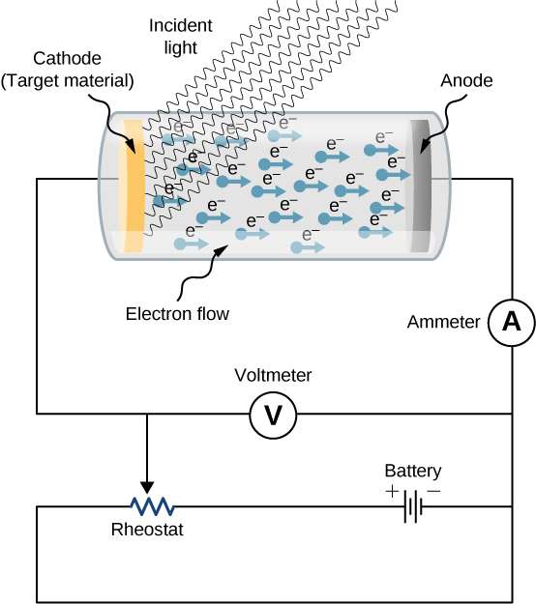

**Evacuated Glass tube**

**Stopping Potential**

**Collector Plate**

**Emitter Plate**

**Laws of Photoelectric Effect.**

The experimental observations were compiled by Philip Lenard and are known as “*Laws of Photoelectric Effect*” for which he won Nobel Prize in Physics-1905.

1. For given sensitive surface there is a minimum frequency of the incident radiation below which there is no emission of photoelectrons (photons). This is known as **Threshold frequency ( υo ).**
2. For a given frequency –υ, the photoelectric current under a constant accelerating potential is directly proportional to the intensity of the incident radiation. The variation is shown in the **fig2.**

**Current-Intensity Graph @ constant potential**

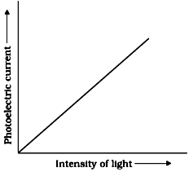

**Fig 2. Variation of Photocurrent with intensity of radiation**

1. The stopping potential V0 and hence the maximum kinetic energy KEmax of the emitted electrons is independent of the intensity of the incident light. **Fig3.** Shows the plot for various intensities of incident radiaton.

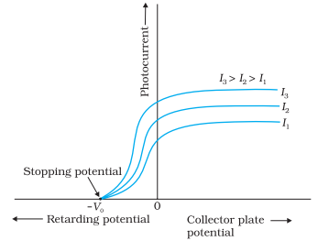

**Fig3. Variation of photocurrent with retarding potential for various intensity**

**Voltage-Current @Different Intensity**

1. The maximum kinetic energy (KEmax ) of the electron emitted from a given surface increases linearly with the frequency radiation as shown in **fig4.**

**Anode potential**

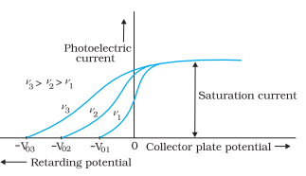

**Variation of Photoelectric Current with potential for various frequency of incident radiation**

**Voltage-Current @Different Frequency**

1. The emission of photo electrons from the photo sensitive surface is an instantaneous process.

**Overview of Graph of Photoelectric Effect -various condition.**

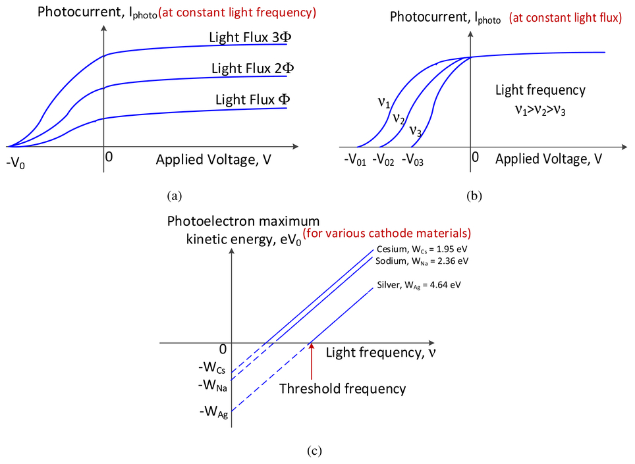

**Einstein’s Theory of Photoelectric Effect**

In 1905, Einstein proposed a theory of the photoelectric effect using a concept first put forward by Max Planck that light consist of tiny packets of energy known as **photons** or light quanta. Each packet carries energy **hυ** that is proportional to the frequency **υ** of the corresponding electromagnetic waves. The proportionality constant **h** has become known as the ***Planck’s constant*** .

When an electromagnetic radiation of energy ‘**hυ’** is incident on a metal surface. It transfers it’s entire energy to the metal in a single step. The metal consumes this energy to increase the **Work Function φ0** and the remaining energy remains with **e-** as **KEmax**

**hυ**

e-‘s

Φ0

**KEmax**

By the Laws of Conservation of Energy:-

**\*hυ = ϕ0 +KEmax** ----------(1) ; **ϕ0** – Work Function

to get the value of **ϕ0** we assume incident frequency equal to threshold frequency

when the incident frequency **υ** decreases ,then **KEmax** also decreases.

* **υ=υ0** ; **KEmax =0**

∴ **hυ0** = **ϕ0 ---------------(2)**

substituting in eq(1) =>

**hυ=** **hυ0 + KEmax**

**KEmax =** **hυ+** **hυ0**

Formula for maximum Kinetic energy of the ejected electron;

**KEmax = h(υ- υ0)**

;**υ>>> υ0** to emit electrons **υ** must be always greater than

**υ0.** If not **υ- υ0** becomes negative & KE becomes –ve.

Energy cannot be –ve.

**KE** is +ve ,when **υ>>> υ0** and is required for the photoelectric effect to occur. The frequency **υ0** is the threshold frequency for the given material, Above that frequency the maximum KE of the photoelectrons as well as the stopping

Voltage in the experiment **V0=­**rise linearly with the frequency and have no dependence on the number of photons and the intensity of the impinging monochromatic light. Einstein’s formula, however explain the phenomenon of the photoelectric effect , and had far reaching consequences in the development of **quantum mechanics.**

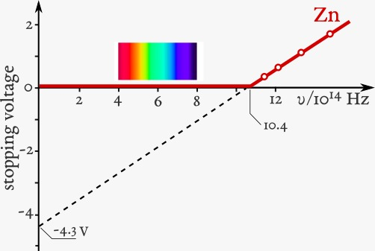

**Diagram of the maximum kinetic energy as a function of the frequency of light on zinc**.

**Work Function**

It is the minimum amount of energy required by an electron to liberate from a metal surface

**ϕ0= hυ0**

but, υ = ∴ **ϕ0 = h**

* If work function is more ,then the material is said to be photosensitive. Of all alkali metal poses high photosensitivity.

**METHODOLOGY**

**Project Description & Goal .**

The measurements of photoelectric current and accelerating potential was done using Amritha V-lab simulations . The experimental set up is used is shown below

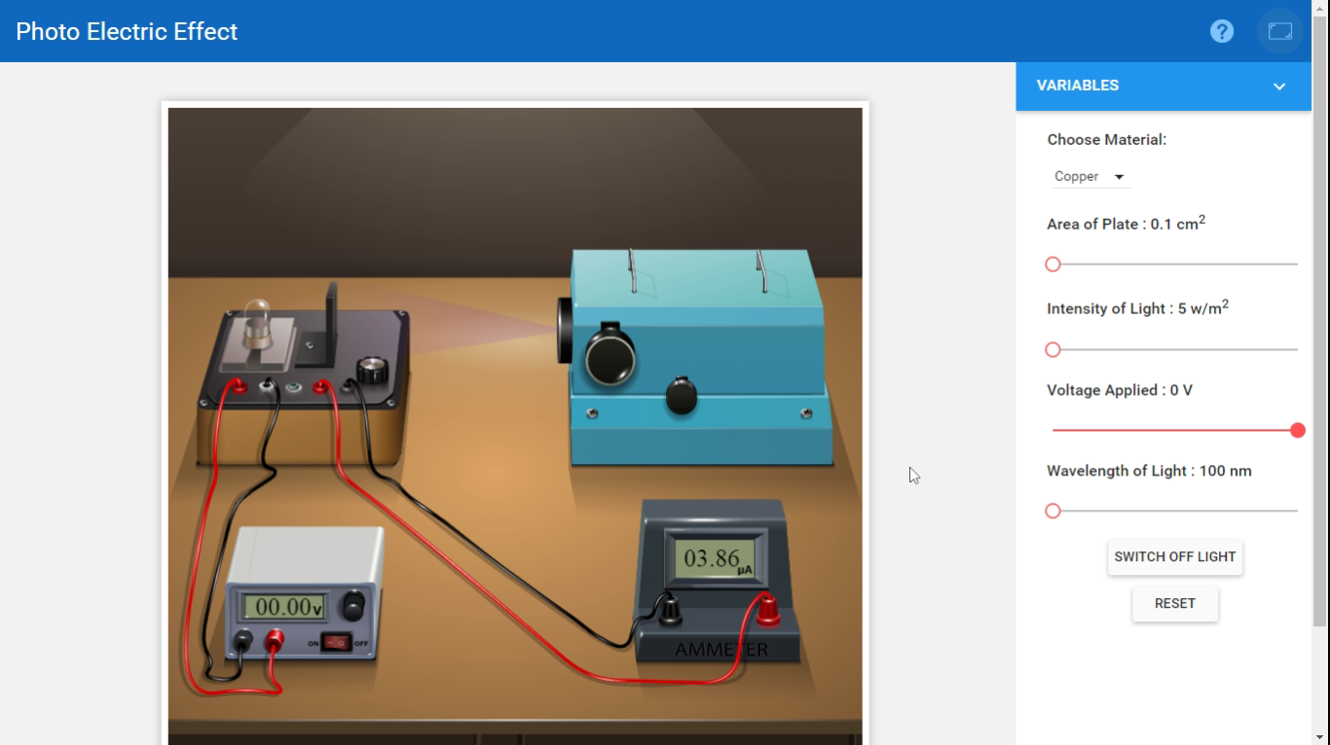

**V-lab experimental arrangement for photoelectric effect**

* **To study the Effect of Intensity of the incident light on the current:**

By keeping the potential difference between the plates and the frequency of the incident light constant, the photo electric current for various intensities of the incident light.

* **To study the Effect of Potential difference on current:**

Keeping the frequency and intensity of the incident light constant the potential difference between the electrodes is varied.

* **To study the Effect of frequency on the stopping potential :**

Adjusting the positive potential (accelerating potential) of the electrode for the saturation current for the given intensity and frequency of the incident radiation. Repeating the experiment for different frequencies for

the same saturation current and in all the cases stopping potentials are determined.

* **To determine the Work Function of given metals experimentally.**

The work function **ϕ0** of the Copper, Zinc and Platinum is determined experimentally – from the plotted graph ,calculated using python program (user input) as well by determining the **ϕ0** via direct mathematical calculation.

**RESULTS AND DISCUSSION**

The observed values of photoelectric potential and accelerating potential for different metals are tabulated below.

**Metal : COPPER**

**1). Effect of Frequency.**

**\*Intensity:- 5w/m2 ; *Area of plate:- 0.1cm2**

**Table.1 Values of photoelectric current and potential for *Different Frequencies.***

|  |  |  |  |  |  |
| --- | --- | --- | --- | --- | --- |
| Freq **υ= 3x106 Hz** | | Freq **υ= 2.5x106 Hz** | | Freq **υ= 2.14x106 Hz** | |
| Wav **λ=100nm** | | Wav **λ=120nm** | | Wav **λ=140nm** | |
| **Potential (V)** | **Current(A)** | **Potential (V)** | **Current(A)** | **Potential (V)** | **Current(A)** |
| 3.8 | 1.96x10-6 | 1.7 | 1.97x10-6 | 0.2 | 1.98x10-6 |
| 4.3 | 1.71x10-6 | 2.3 | 1.67x10-6 | 0.5 | 1.83x10-6 |
| 4.8 | 1.46x10-6 | 2.7 | 1.47x10-6 | 1.2 | 1.48x10-6 |
| 5.3 | 1.21x10-6 | 3.3 | 1.17x10-6 | 1.7 | 1.23x10-6 |
| 5.8 | 0.96x10-6 | 3.7 | 0.97x10-6 | 2.2 | 0.98x10-6 |
| 6.3 | 0.71x10-6 | 4.3 | 0.67x10-6 | 2.7 | 0.73x10-6 |
| 6.8 | 0.46x10-6 | 4.7 | 0.47x10-6 | 3.2 | 0.48x10-6 |
| 7.3 | 0.21x10-6 | 5.3 | 0.17x10-6 | 3.7 | 0.23x10-6 |
| 7.8 | 0 | 5.7 | 0 | 4.2 | 0 |

**2).Effect of Intensity**

**\*Wavelength λ= 100nm ; *Area of plate :- 0.1cm2**

**Table.2 Values of photoelectric current and potential for *Different Intensities***

|  |  |  |  |  |  |
| --- | --- | --- | --- | --- | --- |
| Intensity : **10w/m2** | | Intensity : **15w/m2** | | Intensity : **20w/m2** | |
| **Potential (V)** | **Current(A)** | **Potential (V)** | **Current(A)** | **Potential (V)** | **Current(A)** |
| 0 | 7.72x10-6 | 0 | 11.57x10-6 | 0 | 15.43x10-6 |
| 1 | 6.72x10-6 | 1 | 10.07x10-6 | 1 | 13.43x10-6 |
| 2 | 5.72x10-6 | 2 | 8.57x10-6 | 2 | 11.43x10-6 |
| 3 | 4.72x10-6 | 3 | 7.07x10-6 | 3 | 9.43x10-6 |
| 4 | 3.72x10-6 | 4 | 5.57x10-6 | 4 | 7.43x10-6 |
| 5 | 2.72 x10-6 | 5 | 4.07x10-6 | 5 | 5.43x10-6 |
| 6 | 1.72x10-6 | 6 | 2.57x10-6 | 6 | 3.43x10-6 |
| 7 | 0.72x10-6 | 7 | 1.07x10-6 | 7 | 1.43x10-6 |
| 8 | 0 | 8 | 0 | 8 | 0 |

**3).Effect of intensity on current**

**\*Potential V:- 1V ; *Frequency υ** =**3x106 ; *Area:- 0.1cm2 ; *Wavelength λ=100nm**

**Table.3 Values of intensity of incident radiation and photocurrent**

|  |  |
| --- | --- |
| Intensity **w/m2** | Current **(μA)** |
| 5 | 3.36 |
| 10 | 6.72 |
| 15 | 10.07 |
| 20 | 13.43 |
| 25 | 16.79 |
| 30 | 20.15 |

**Plotting the Graph – Computational representation using Python**

The graphs are plotted with above data computationally by using Python. Using the **matplotlib** in python the visualization of above data is achieved. For that, **Anaconda3** package which consist of comprehensive library for creating static visualization in python-coded in **Jupyter notebook** used for data analysis.

**Metal : COPPER**

**1). Effect of Frequency.**

**Type-1(without extending towards the +ve abscissa)**

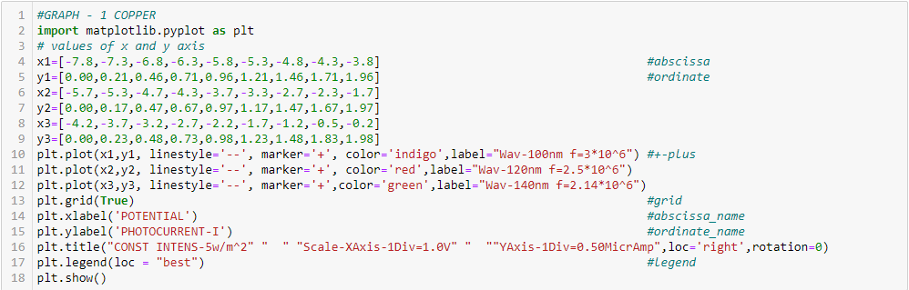

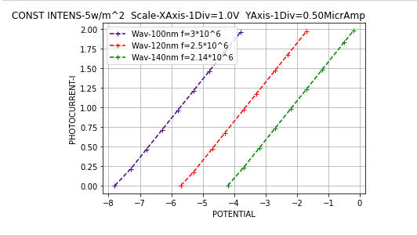

**Type-2(extending towards +ve abscissa-replicating the last value)**

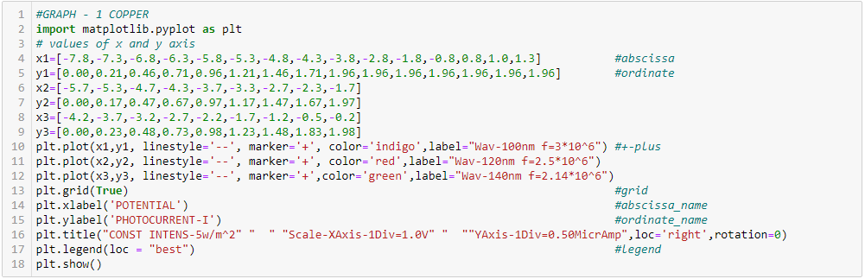

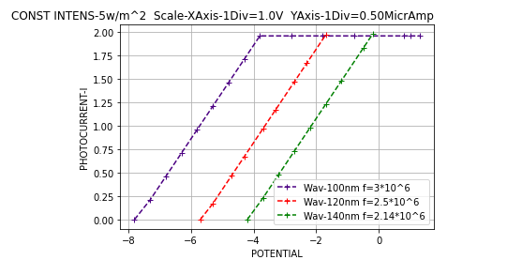

**2).Effect of Intensity**

**Type-1(without extending towards the +ve abscissa)**

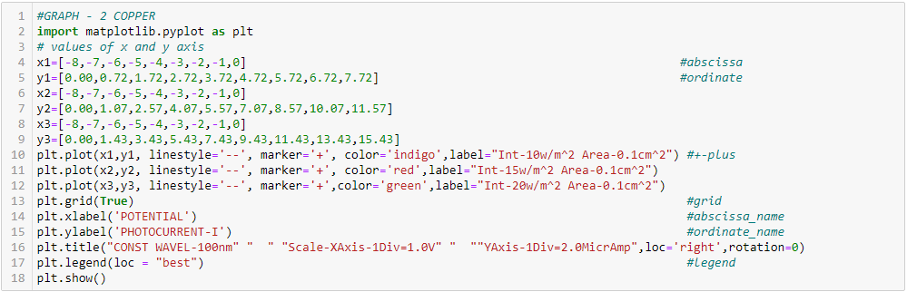

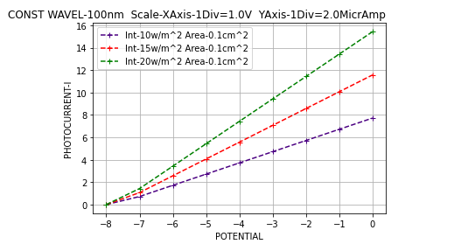

**Type-2(extending towards +ve abscissa-replicating the last value)**

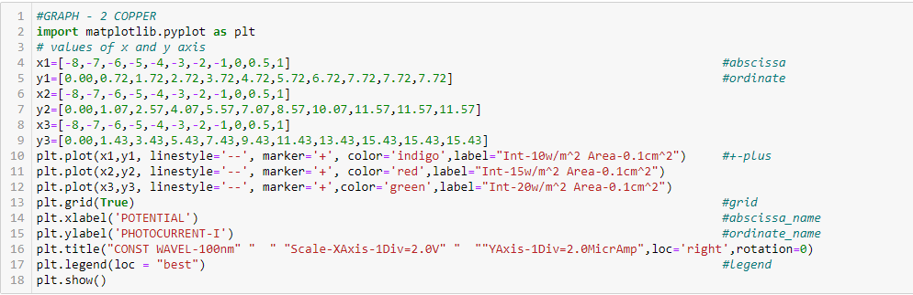

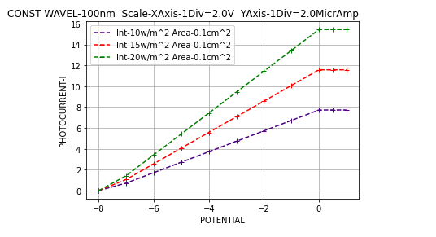

**3).Effect of intensity on current**

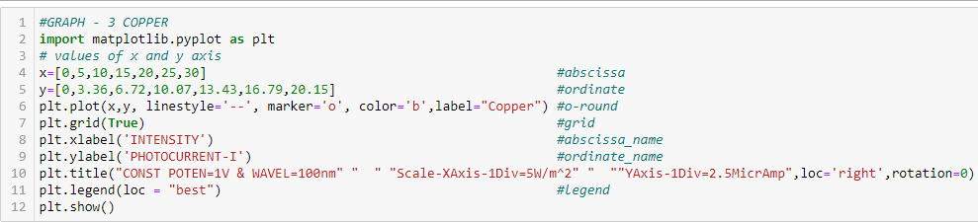

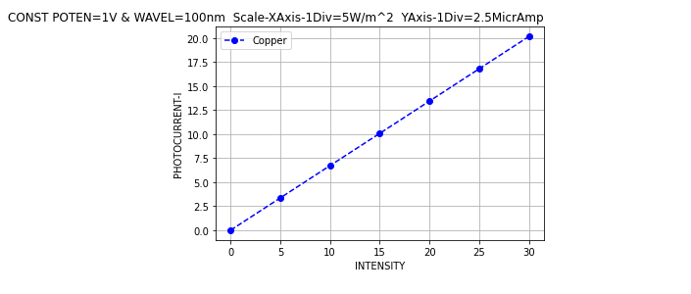

**Metal : PLATINUM**

**1). Effect of Frequency.**

**\*Intensity:- 5w/m2 ; *Area of plate:- 0.1cm2**

**Table.1 Values of photoelectric current and potential for *Different Frequencies.***

|  |  |  |  |  |  |
| --- | --- | --- | --- | --- | --- |
| Freq **υ= 3x106 Hz** | | Freq **υ= 2.5x106 Hz** | | Freq **υ= 2.14x106 Hz** | |
| Wav **λ=100nm** | | Wav **λ=120nm** | | Wav **λ=140nm** | |
| **Potential (V)** | **Current(A)** | **Potential (V)** | **Current(A)** | **Potential (V)** | **Current(A)** |
| 3.6 | 1.23x10-6 | 1.5 | 1.25x10-6 | 0 | 1.26x10-6 |
| 4.1 | 0.98x10-6 | 2 | 1x10-6 | 0.6 | 0.96x10-6 |
| 4.6 | 0.73x10-6 | 2.5 | 0.75x10-6 | 1.3 | 0.61x10-6 |
| 5.1 | 0.48x10-6 | 3 | 0.5x10-6 | 1.6 | 0.46x10-6 |
| 5.6 | 0.23x10-6 | 3.5 | 0.25x10-6 | 1.9 | 0.31x10-6 |
| 6.1 | 0 | 4 | 0 | 2.6 | 0 |

**2).Effect of Intensity**

**\*Wavelength λ=100nm ; *Area of plate :- 0.1cm2**

**Table.2 Values of photoelectric current and potential for *Different Intensities***

|  |  |  |  |  |  |
| --- | --- | --- | --- | --- | --- |
| Intensity : **10w/m2** | | Intensity : **15w/m2** | | Intensity : **20w/m2** | |
| **Potential (V)** | **Current(A)** | **Potential (V)** | **Current(A)** | **Potential (V)** | **Current(A)** |
| 0 | 9.10 x10-6 | 0 | 12.13x10-6 | 0 | 6.07x10-6 |
| 0.1 | 8.95 x10-6 | 0.1 | 11.93x10-6 | 0.1 | 5.97x10-6 |
| 1.1 | 7.45x10-6 | 1.1 | 9.93x10-6 | 1.1 | 4.97x10-6 |
| 2.1 | 5.95x10-6 | 2.1 | 7.93x10-6 | 2.1 | 3.97x10-6 |
| 3.1 | 4.45x10-6 | 3.1 | 5.93x10-6 | 3.1 | 2.97x10-6 |
| 4.1 | 2.95 x10-6 | 4.1 | 3.93x10-6 | 4.1 | 1.97x10-6 |
| 5.1 | 1.45x10-6 | 5.1 | 1.93x10-6 | 5.1 | 0.97x10-6 |
| 6.1 | 0 | 6.1 | 0 | 6.1 | 0 |

**3).Effect of intensity on current**

**\*Potential V:- 1V ; *Frequency υ** =**3x106 ; *Area:- 0.1cm2 ; *Wavelength λ=100nm**

**Table.3 Values of intensity of incident radiation and photocurrent**

|  |  |
| --- | --- |
| Intensity **w/m2** | Current **(μA)** |
| 5 | 2.53 |
| 10 | 5.07 |
| 15 | 7.60 |
| 20 | 10.13 |
| 25 | 12.66 |
| 30 | 15.20 |

**Metal : PLATINUM**

**1). Effect of Frequency.**

**Type-1(without extending towards the +ve abscissa)**

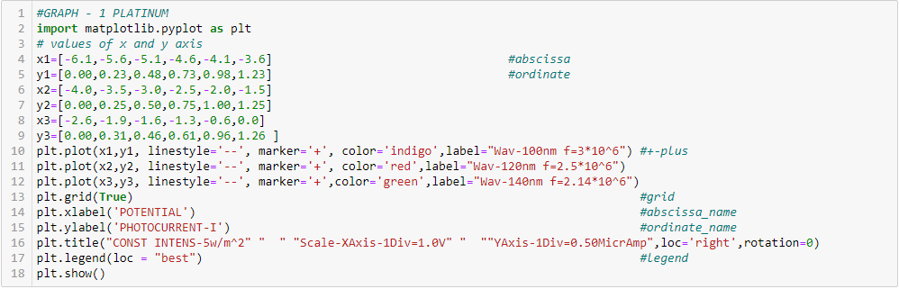

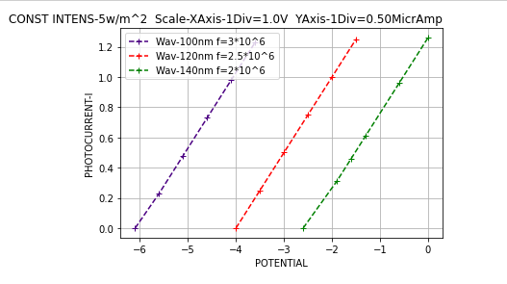

**Type-2(extending towards +ve abscissa-replicating the last value).**

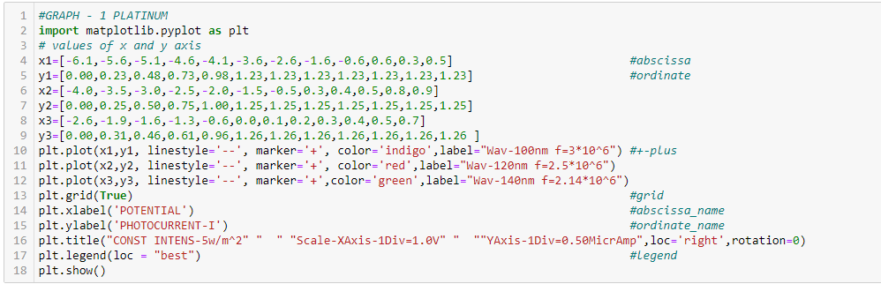

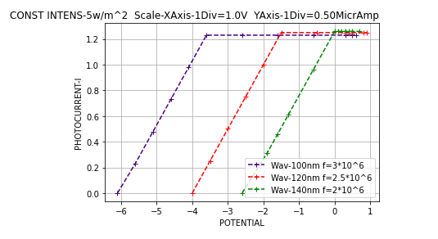

**2).Effect of Intensity**

**Type-1(without extending towards the +ve abscissa)**

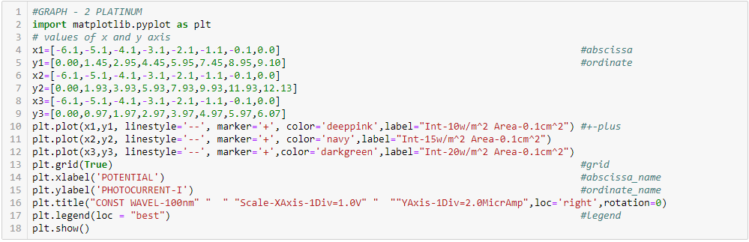

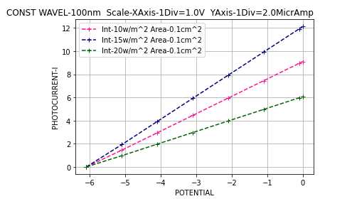

**Type-2(extending towards +ve abscissa-replicating the last value)**

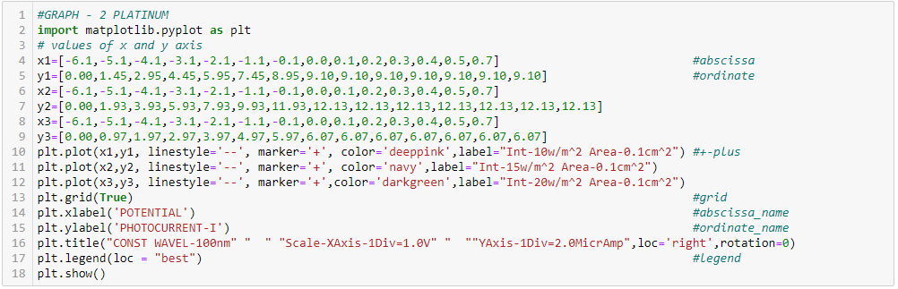

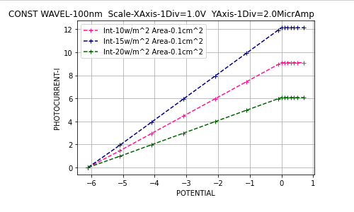

**3).Effect of intensity on current**

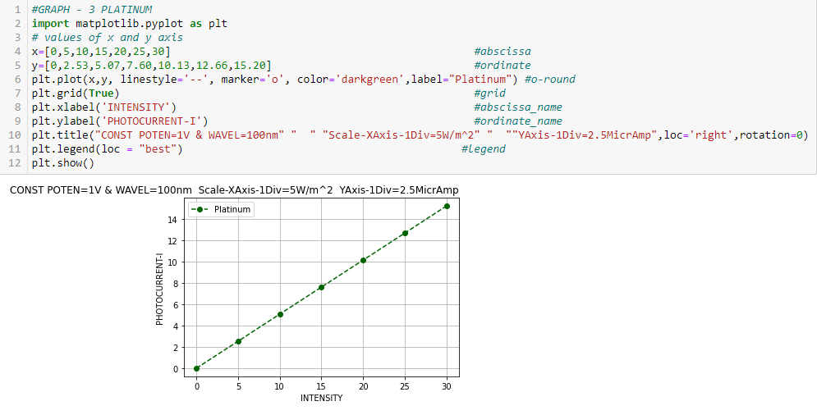

**Metal : ZINC**

**1). Effect of Frequency.**

**\*Intensity:- 5w/m2 ; *Area of plate:- 0.1cm2**

**Table.1 Values of photoelectric current and potential for *Different Frequencies***

|  |  |  |  |  |  |
| --- | --- | --- | --- | --- | --- |
| Freq **υ= 3x106 Hz** | | Freq **υ= 2.5x106 Hz** | | Freq **υ= 2.14x106 Hz** | |
| Wav **λ=100nm** | | Wav **λ=120nm** | | Wav **λ=140nm** | |
| **Potential (V)** | **Current(A)** | **Potential (V)** | **Current(A)** | **Potential (V)** | **Current(A)** |
| 3.7 | 2.21x10-6 | 1.6 | 2.22x10-6 | 0 | 2.26x10-6 |
| 4.2 | 1.96x10-6 | 2.1 | 1.97x10-6 | 0.6 | 1.98x10-6 |
| 4.7 | 1.71x10-6 | 2.6 | 1.72x10-6 | 1 | 1.78x10-6 |
| 5.2 | 1.46x10-6 | 3.1 | 1.47x10-6 | 1.6 | 1.48x10-6 |
| 5.7 | 1.21x10-6 | 3.6 | 1.22x10-6 | 2 | 1.28x10-6 |
| 6.2 | 0.96x10-6 | 4.1 | 0.97x10-6 | 2.6 | 0.98x10-6 |
| 6.7 | 0.71x10-6 | 4.6 | 0.72x10-6 | 3 | 0.78x10-6 |
| 7.2 | 0.46x10-6 | 5.1 | 0.47x10-6 | 3.6 | 0.48x10-6 |
| 7.7 | 0.21x10-6 | 5.6 | 0.22x10-6 | 4 | 0.28x10-6 |
| 8.2 | 0 | 6.1 | 0 | 4.6 | 0 |

**2).Effect of Intensity**

**\*Wavelength λ=100nm ; *Area of plate :- 0.1cm2**

**Table.2 Values of photoelectric current and potential for *Different Intensities***

|  |  |  |  |  |  |
| --- | --- | --- | --- | --- | --- |
| Intensity : **10w/m2** | | Intensity : **15w/m2** | | Intensity : **20w/m2** | |
| **Potential (V)** | **Current(A)** | **Potential (V)** | **Current(A)** | **Potential (V)** | **Current(A)** |
| 1.2 | 6.92x10-6 | 1.2 | 10.37x10-6 | 1.2 | 13.83x10-6 |
| 2.2 | 5.92x10-6 | 2.2 | 8.87x10-6 | 2.2 | 11.83x10-6 |
| 3.2 | 4.92x10-6 | 3.2 | 7.37x10-6 | 3.2 | 9.83x10-6 |
| 4.2 | 3.92x10-6 | 4.2 | 5.87x10-6 | 4.2 | 7.83x10-6 |
| 5.2 | 2.92x10-6 | 5.2 | 4.37x10-6 | 5.2 | 5.83x10-6 |
| 6.2 | 1.92x10-6 | 6.2 | 2.87x10-6 | 6.2 | 3.83x10-6 |
| 7.2 | 0.92x10-6 | 7.2 | 1.37x10-6 | 7.2 | 1.83x10-6 |
| 8.2 | 0 | 8.2 | 0 | 8.2 | 0 |

**3).Effect of intensity on current**

**\*Potential V:- 1V ; *Frequency υ** =**3x106 ; *Area:- 0.1cm2 ; *Wavelength λ=100nm**

**Table.3 Values of intensity of incident radiation and photocurrent**

|  |  |
| --- | --- |
| Intensity **w/m2** | Current **(μA)** |
| 5 | 3.56 |
| 10 | 7.12 |
| 15 | 10.67 |
| 20 | 14.23 |
| 25 | 17.79 |
| 30 | 21.35 |

**Metal : ZINC**

**1). Effect of Frequency.**

**Type-1(without extending towards the +ve abscissa)**

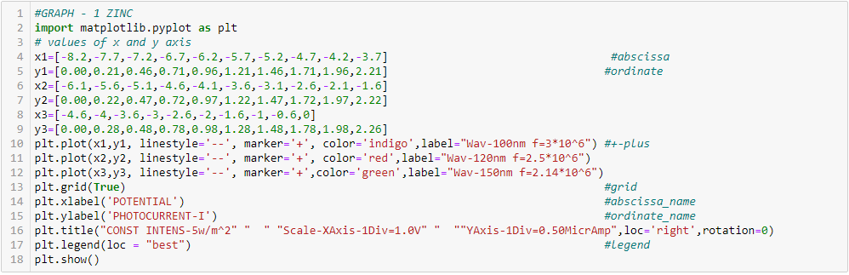

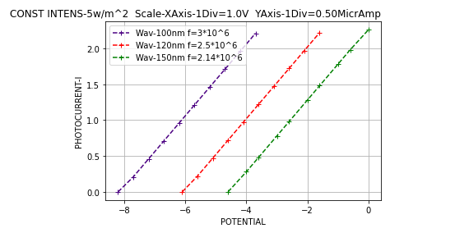

**Type-2(extending towards +ve abscissa-replicating the last value).**

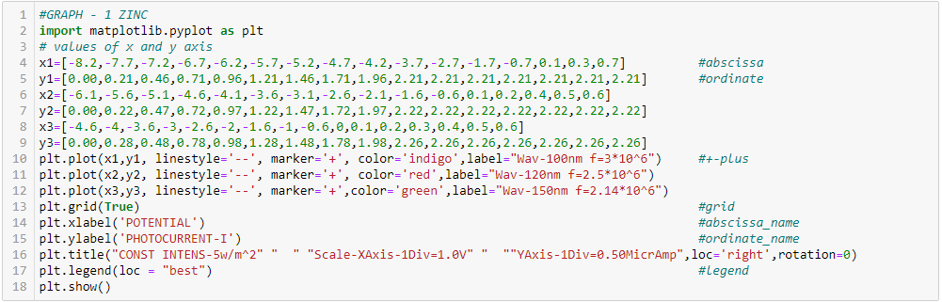

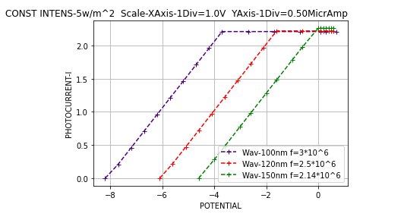

**2).Effect of Intensity**

**Type-1(without extending towards the +ve abscissa)**

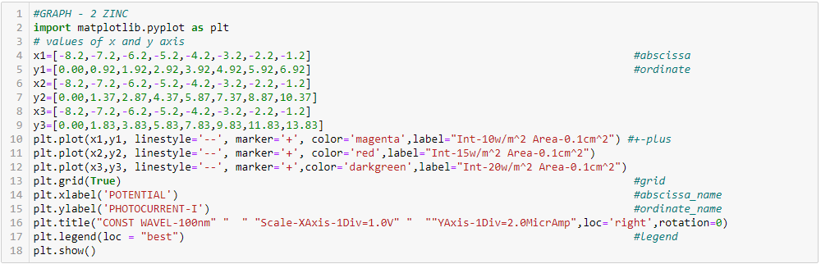

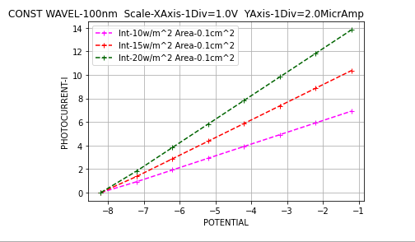

**Type-2(extending towards +ve abscissa-replicating the last value)**

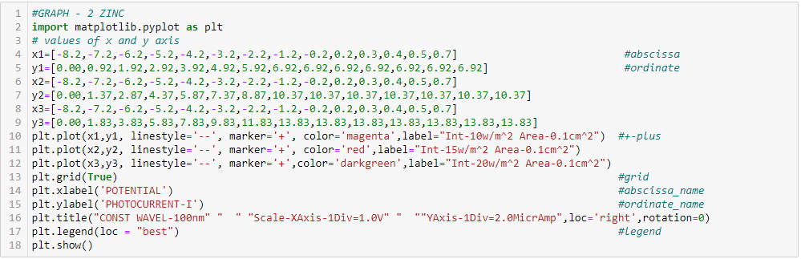

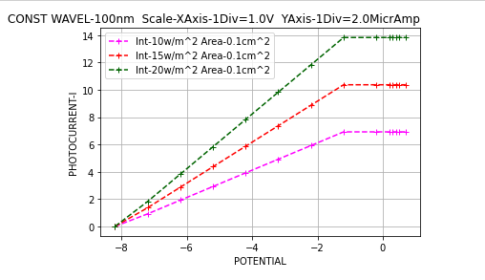

**3).Effect of intensity on current**

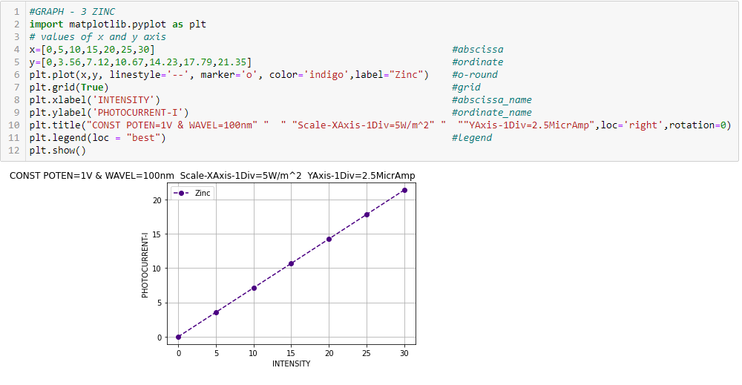

COPPER

**WORK FUNCTION- ϕo  - Using PYTHON**

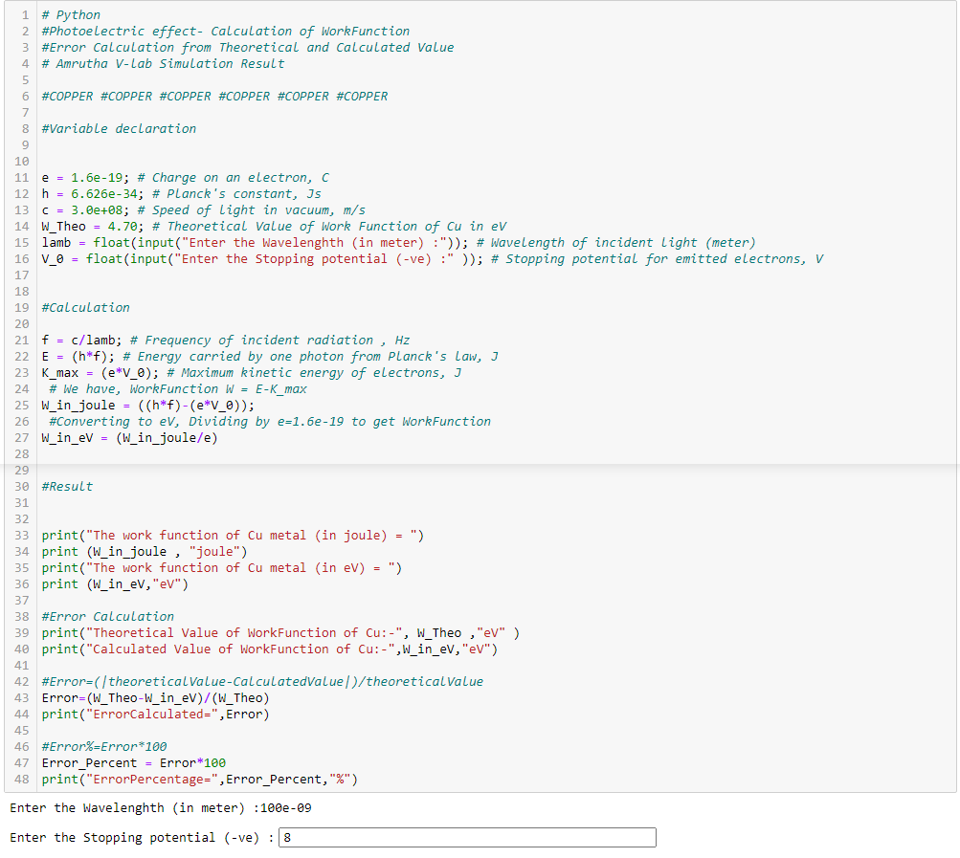

Output

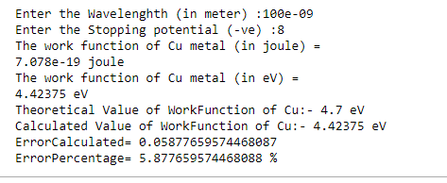

**WORK FUNCTION - ϕo - Using Einstein’s photoelectric eqn.**

**E= Kmax + ϕ0**

G.E :- \***V0**(from graph2)= **8eV**

**\*C= 3x108m/s**

**eV0**

**hυ**

\***λ**= **100nm** = **100x10-9m**

**\*h** = **6.626x10-34Joule-Sec**

\***e** = **1.6x10-19coulomb**

**ϕo** = **hυ - eV0** but **υ =**

= **h - eV0**

= – 1.6x10-19x8.0

Converting to eV ,dividing by **e**

=7.078x10-19 Joule

= eV

= 4.42375 eV Calculated Value of Copper -Work Function.

* Theoretical Work Function of Cu= **4.7eV**
* Calculated Work Function of Cu = **4.42375 eV**
* Error =

=

= = 0.05877

* Error% = Errorx100 = **5.87%**

PLATINUM

**WORK FUNCTION- ϕo  - Using PYTHON**

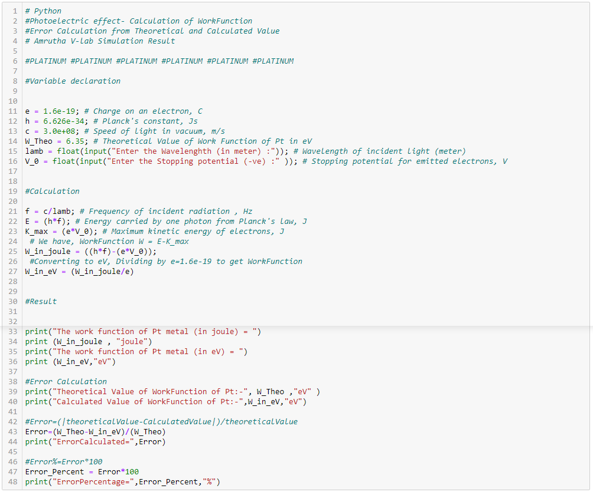

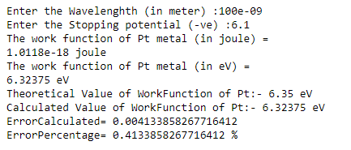

**WORK FUNCTION - ϕo - Using Einstein’s photoelectric eqn.**

**E= Kmax + ϕ0**

G.E :- \***V0**(from graph2)= **6.1eV**

**\*C= 3x108m/s**

**eV0**

**hυ**

\***λ**= **100nm** = **100x10-9m**

**\*h** = **6.626x10-34Joule-Sec**

\***e** = **1.6x10-19coulomb**

**ϕo** = **hυ - eV0** but **υ =**

= **h - eV0**

= – 1.6x10-19x6.1

Converting to eV ,dividing by **e**

=1.0118x10-18 Joule

= eV

= 6.32375 eV Calculated Value of Platinum -Work Function.

* Theoretical Work Function of Pt= **6.35eV**
* Calculated Work Function of Pt = **6.32375 eV**
* Error =

=

= = 0.004133858268

* Error% = Errorx100 = **0.41%**

ZINC

**WORK FUNCTION- ϕo  - Using PYTHON**

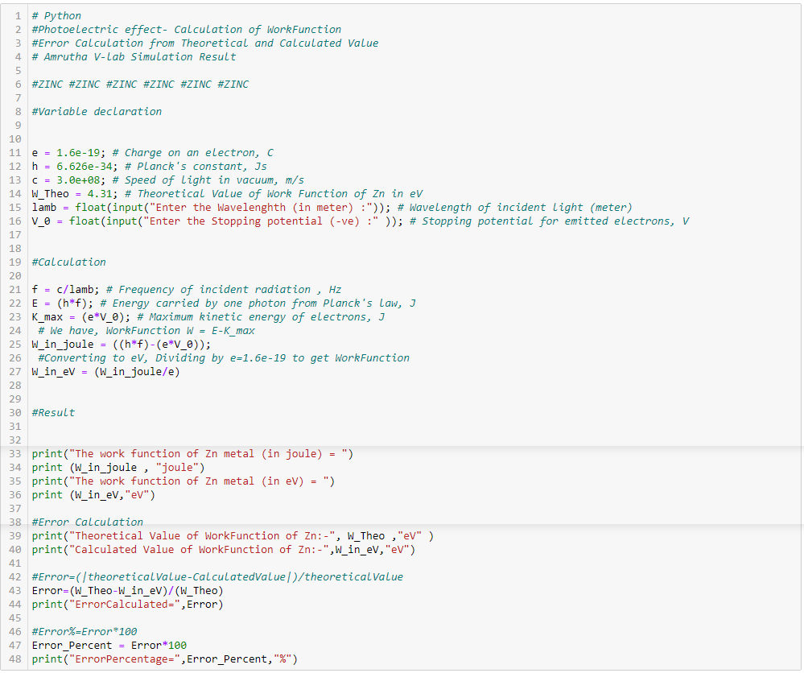

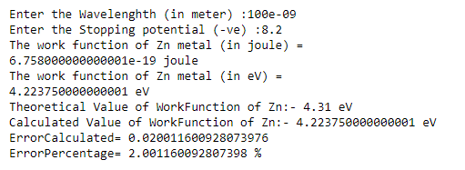

**WORK FUNCTION - ϕo - Using Einstein’s photoelectric eqn.**

**E= Kmax + ϕ0**

G.E :- \***V0**(from graph2)= **8.2eV**

**\*C= 3x108m/s**

**eV0**

**hυ**

\***λ**= **100nm** = **100x10-9m**

**\*h** = **6.626x10-34Joule-Sec**

\***e** = **1.6x10-19coulomb**

**ϕo** = **hυ - eV0** but **υ =**

= **h - eV0**

= – 1.6x10-19x8.2

Converting to eV ,dividing by **e**

=6.758x10-19 Joule

= eV

= 4.22375 eV Calculated Value of Zinc -Work Function.

* Theoretical Work Function of Zn= **4.31eV**
* Calculated Work Function of Zn = **4.22375 eV**
* Error =

=

= = 0.02001160093

* Error% = Errorx100 = **2.0011%**

**Overview of Work Function**

The Work Function of the 3 metals viz, **Cu , Pt ,Zn** are calculated by knowing the **V0**stopping potential. The results are determined by both scientific computations – using **Python** program as well as by mathematical formulation- using **Einstein’s Photoelectric Equation.**

1. **C*OPPER*** 
   * + - * Theoretical Work Function = **4.7eV**
         * Calculated Work Function = **4.42375eV**
         * Error% = **5.87%**
2. **PLATINUM**
   * + - Theoretical Work Function = **6.35eV**
       - Calculated Work Function = **6.32375eV**
       - Error% = **0.41%**
3. **ZINC**
   * + Theoretical Work Function = **4.31eV**
     + Calculated Work Function = **4.22375eV**
     + Error% = **2.0011%**

**CONCLUSION**

The values of Work Function were calculated using Einstein’s Photoelectric Equation. The values obtained using data from Virtual- lab simulation is in slight disagreement with the typical values in literature. Its accuracy is calculated by means of Error percentage.

*******************

**REFERENCES**

**Bibliography:**

1. Concepts of Modern physics by Sir Arthur Beiser.
2. Basics of Quantum mechanics by Ajoy Ghatak and S.Lokanathan.
3. Willett, Edward. The basics of quantum physics : understanding the photoelectric effect and line spectra. New York: Rosen Pub. Group, 2005.
4. Vandome, John. Photoelectric effect. S.l: Vdm Publishing House, 2009.
5. Serway, Raymond. College physics. Belmont, CA: Brooks/Cole, Cengage Learning, 2009.

**Webliography:**

1. [www.citycollegiate.com/physicsXII_17a.htm](http://www.citycollegiate.com/physicsXII_17a.htm)
2. [en.wikipedia.org/wiki/Photoelectric_effect](http://en.wikipedia.org/wiki/Photoelectric_effect)
3. <http://www.youtube.com/watch?v=UWT-bgYRh7g>
4. <http://www.youtube.com/watch?v=lTxs1usXSmk&feature=related>
5. https://phys.libretexts.org/Bookshelves/University_Physics/Book%3A_University_Physics_(OpenStax)/Book%3A_University_Physics_III_-_Optics_and_Modern_Physics_(OpenStax)/06%3A_Photons_and_Matter_Waves/6.03%3A_Photoelectric_Effect

**APPENDIX-1**

**Github- repository**

The python code included in the report, for all the metal’s different graph and its Work Functions are hosted in **Github** – coding platform.

Pull request is allowed to discuss changes in repositories with the owner for collaborator.

* Repository :-**Photoelectric-Effect--Graph-and-Work-Function--PYTHON-CODE**
* Web URL(HTTPS):- <https://github.com/FoxTrot-dev/Photoelectric-Effect--Graph-and-Work-Function--PYTHON-CODE.git>
* Github CLI :- **gh repo clone FoxTrot-dev/Photoelectric-Effect--Graph-and-Work-Function--PYTHON-CODE**
* Language :- **Python**
* Owner :- **Rithik Vinayaraj**

Id: - **FoxTrot-dev©**

Nb: - The new code owner and collaborator-individuals are responsible for the section

Of new code, if you make a pull request on that code.

The Owner of the Github retain all the Copyright © of the code