[go vscode undeclared name-掘金 (juejin.cn)](https://juejin.cn/s/go%20vscode%20undeclared%20name)//适合vscode开发的六个插件

[上传本地文件（夹）到GitHub和更新仓库文件 - 知乎 (zhihu.com)](https://zhuanlan.zhihu.com/p/136355306)

其实已经上传成功了，要在左上角的文件分支那里改成（master,main）,才看得见上传的代码

[(10条消息) 在Ubuntu中下载github上的文件_Silence-Lee的博客-CSDN博客_ubuntu下载github文件](https://blog.csdn.net/chenxi_li/article/details/93913210)

从github上下载文件失败原因：

[(10条消息) 解决fatal: unable to connect to github.com问题_青青木屋的博客-CSDN博客](https://blog.csdn.net/greenqingqingws/article/details/11808745)

然后再git clone +网址信息

[(10条消息) Git分支之master合并到main_亚林瓜子的博客-CSDN博客_git master 合并到main](https://blog.csdn.net/fxtxz2/article/details/115526965)

[(10条消息) Git 报错 Updates were rejected because the remote contains work that you do_很萌の萌新的博客-CSDN博客](https://blog.csdn.net/liulei952413829/article/details/117553977)

解决远程仓库一部分在main分支下，一部分在master分支下：

1. [解决Git中fatal: refusing to merge unrelated histories-阿里云开发者社区 (aliyun.com)](https://developer.aliyun.com/article/614459)
2. [git push报错：Updates were rejected because the tip of your current branch is behind - 知乎 (zhihu.com)](https://zhuanlan.zhihu.com/p/422024766)

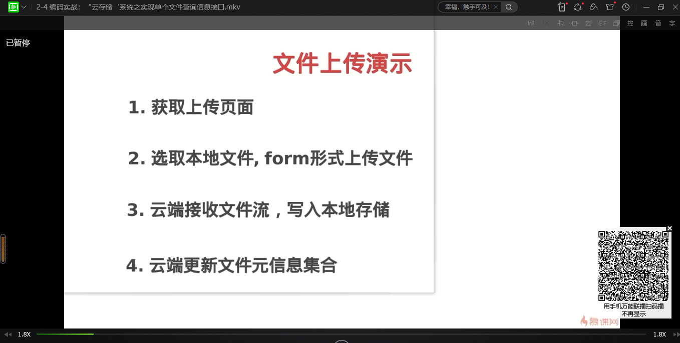

[本地更新代码同步至github仓库 & 拉取更新后的github仓库代码到本地仓库 - 杂货屋 (sword.studio)](https://sword.studio/143.html#:~:text=%E4%B8%80%E3%80%81%E6%9C%AC%E5%9C%B0%E6%9B%B4%E6%96%B0%E4%BB%A3%E7%A0%81%E5%90%8C%E6%AD%A5%E8%87%B3github%E4%BB%93%E5%BA%93%201%E3%80%81%E6%B7%BB%E5%8A%A0%E6%9B%B4%E6%96%B0%E6%96%87%E4%BB%B6%20%23%E6%B7%BB%E5%8A%A0%E6%9B%B4%E6%96%B0%E7%9A%84%E6%96%87%E4%BB%B6%20git%20add%20%3Cfilename%3E,%2F%2F%E5%8D%95%E4%B8%AA%E6%96%87%E4%BB%B6%20%E6%88%96%20git%20add%20-A%20%2F%2F-A%E8%A1%A8%E7%A4%BA%E5%85%A8%E9%83%A8%E6%96%87%E4%BB%B6%202%E3%80%81%E6%9A%82%E5%AD%98%E5%8C%BA%E6%96%87%E4%BB%B6%E6%8F%90%E4%BA%A4%E5%88%B0%E6%9C%AC%E5%9C%B0%E7%89%88%E6%9C%AC%E5%BA%93%EF%BC%8C%E5%B9%B6%E6%B7%BB%E5%8A%A0%E6%B3%A8%E9%87%8A%E4%BF%A1%E6%81%AF)

Github拉取远程指定库的代码以及更新后的代码到本地指定的分支

[ubuntu18.04 git clone:Failed to connect to github.com port 443: Connection refused_das白的博客-CSDN博客](https://blog.csdn.net/qq_38204686/article/details/123444765)