



**Membership Form 2021/22 (New members ONLY)  
please ‘edit’ this doc to add your information and READ *everything*.  
*Ensure your “NAME” and “MSHIP FEE” is put on the EFT transaction. Change file name of this edited doc you are returning to include your name please. Also add the screenshot of payment.  
Then email to*** [***admin@melbournechelsea.com.au***](mailto:admin@melbournechelsea.com.au) ***AND CC*** [***treasurer@melbournechelsea.com.au***](mailto:treasurer@melbournechelsea.com.au) ***Please put “Membership 2021/22” in the subject heading when emailing everything back to us.*  
If you are a member with CFC in London, please put your 8 digit membership number next to your name(s)**

|  |  |
| --- | --- |
| **NAME** |  |
| **ADDRESS** |  |
| **POST CODE** |  |
| **MOBILE** |  |
| **EMAIL** |  |

|  |  |
| --- | --- |
| **2nd person** |  |
| **3rd person** |  |
| **4th person** |  |
| **Additional email addresses *(if they want to be on our list too)*** |  |

**$60 for 1st membership (if in Melbourne) and $40 for any additional member.  
All fees include the membership items being posted to your supplied address.  
Country Victoria/Tasmania/International* members pay $40.   
(*International postage fee will be added)  
*Our Preferred* payment is via EFT to our club account  
Club account name “MCSC”  
Bendigo Bank - BSB 633000   
Account number 167877786  
*Alternatively, PayPal to*** [***admin@melbournechelsea.com.au***](mailto:admin@melbournechelsea.com.au) ***“Friends” option please.****For 2021/22 MCSC merchandise is a ceramic mug*, fridge magnet*, season badge, membership card, $20 food voucher to use at The Crafty Squire and bumper sticker.  
You can also get 20% off food and drink at TCS if you use their Australian Venue Co. App*

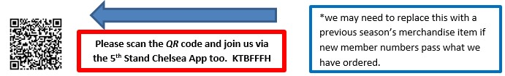



***Additional members below (family or household)***