Step Into Your Style
How to Design Custom Patterns for Women's Shoes
Your shoes say something before you ever speak a word. They're the finishing touch on every outfit, so why not make yours one of a kind? Custom shoe design used to live in fashion houses. Now anyone can try it. Personalize canvas sneakers with your own patterns and turn a basic pair into something that looks made for you.
This guide covers designing custom patterns for women's shoes, from picking a style direction to the final details.

Why Customize Your Shoes?
Custom shoes are a clear form of self-expression. Here's why more people are painting their own pairs:
- Creativity: Designing is hands-on and absorbing in a way shopping isn't.
- Gifts: A hand-designed pair is a personal gift people actually remember.

Pattern Inspiration: 10 Ideas for Custom Shoe Design
The hardest part is usually deciding where to start. Here are ten pattern directions with specific ideas for each:

1. Botanical & Floral Patterns
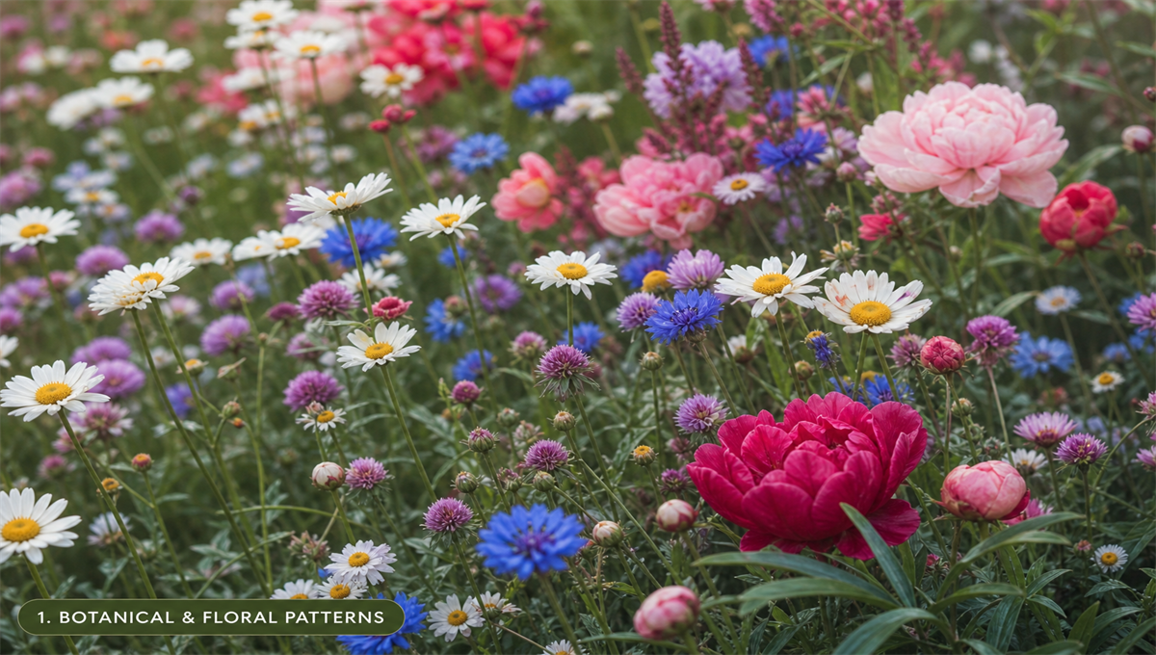
Florals work on almost every shoe style. The key is finding a floral look that fits you:
- Wildflower meadows: Scatter tiny daisies, clover, and cornflowers across the entire shoe in an allover print style.
- Single statement bloom: Paint one oversized peony or hibiscus in saturated color on the toe cap against a clean background.
- Trailing vines: Wind illustrated ivy or wisteria up the heel and around the ankle of a boot or high-top.
- Pressed flower effect: Use soft watercolor-style painting to mimic the look of botanically pressed flowers, adding gentle shadows and translucency.
- Art Nouveau florals: Borrow from Alphonse Mucha: curved lines, stylized petals, and jewel tones.
Color direction: Try an unexpected palette: deep burgundy flowers on a forest green background, or pale blush blooms on a charcoal base.

2. Geometric & Abstract Patterns
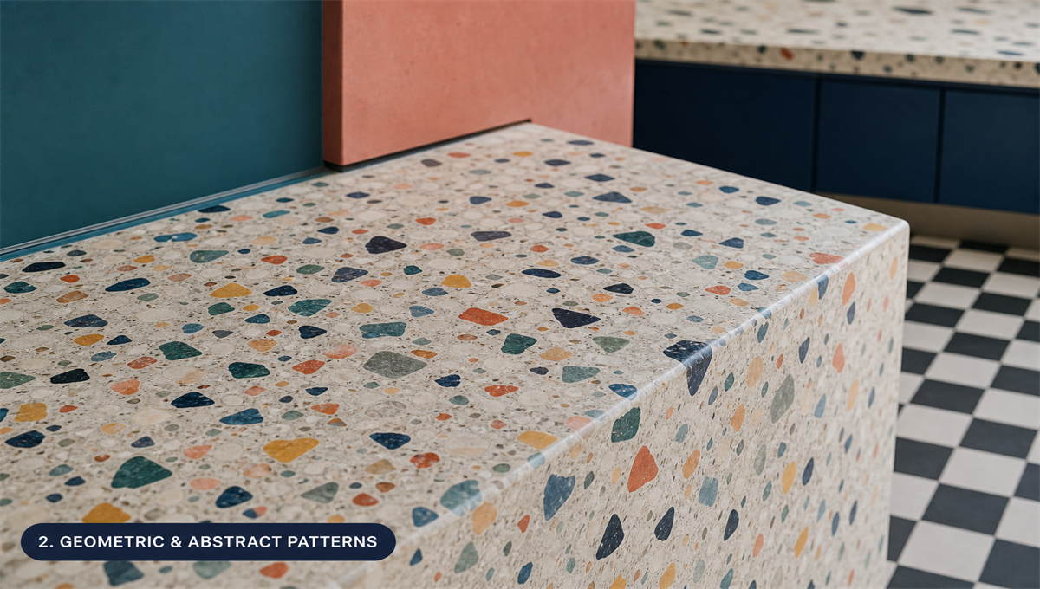
Clean lines and shapes look modern on structured shoes like loafers, oxfords, and block-heeled sandals.
- Color blocking: Divide the shoe into sections (toe, vamp, heel) and paint each a different saturated color for a bold, graphic look.
- Terrazzo: Mimic a terrazzo stone surface with scattered irregular shapes in multiple colors on a white or cream ground.
- Checkerboard: A two-tone check that works in classic black-and-white or unexpected color combinations.
- Abstract brushwork: Use gestural brushstrokes, color fields, and loose mark-making.
- Sacred geometry: Mandalas, hexagonal grids, or radial symmetry patterns create focused, repeating designs.

3. Animal & Nature Prints
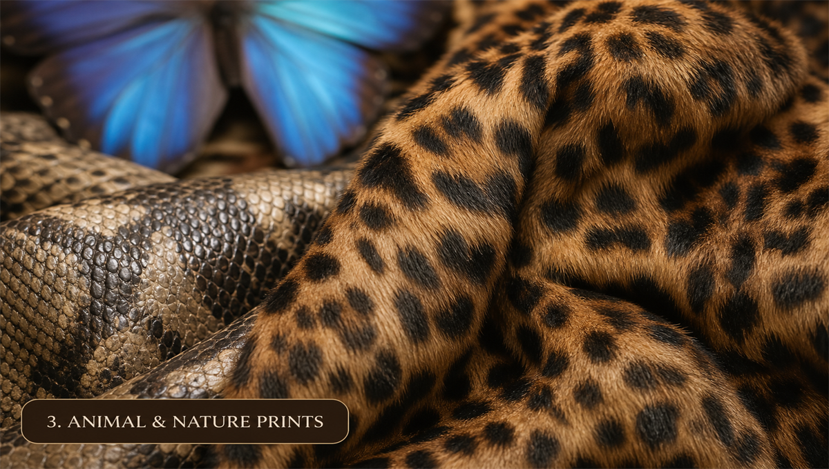
Nature's patterns are varied and still look current:
- Leopard spots: Classic and versatile. Try the traditional amber-and-black version, or reinvent it in teal, coral, or lilac.
- Snake skin textures: Fine-scaled patterns in earth tones or metallics add a polished, reptilian feel.
- Butterfly wings: Paint detailed Monarch, Blue Morpho, or Swallowtail wings across the upper for a dramatic effect.
- Watercolor animals: A loose, painterly fox, deer, or hummingbird in soft washes creates a soft, storybook feel.
- Coral reef: Bright tropical fish, sea anemones, and coral branches on a gradient blue background.

4. Cultural & Folk Art Patterns
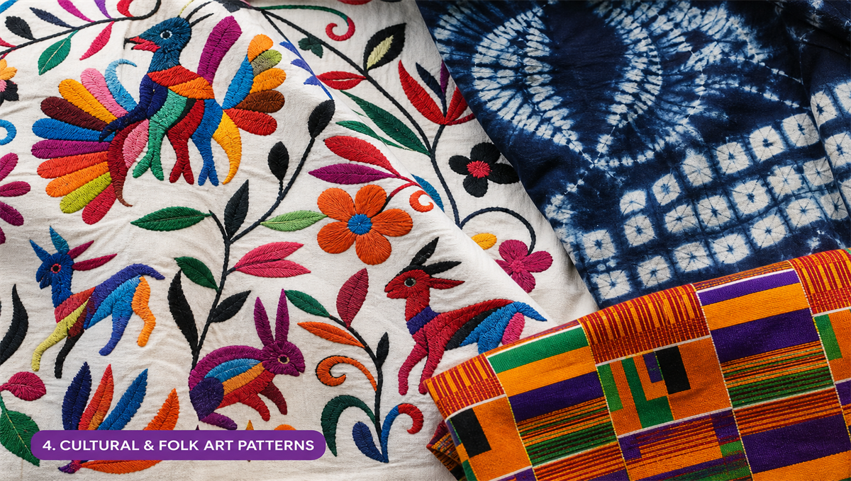
Textile traditions around the world are full of pattern ideas:
- Mexican Otomi embroidery: Stylized animals and plants outlined in black, filled with primary colors.
- Hungarian folk art: Tulips, heart motifs, and paired birds in rich red, black, and green.
- Japanese Shibori/Indigo patterns: Wave, circle, and fan repeating patterns in deep indigo and white.
- Scandinavian rosemaling: Swirling acanthus leaves and stylized flowers in traditional Norse palette.
- African kente-inspired geometry: Bold interlocking bands of color in gold, red, green, and black.

5. Celestial & Cosmic Patterns

Stars, moons, and galaxies look especially good on dark-based shoes:
- Galaxy wash: Layer deep blues, purples, and blacks, then spatter white and gold to create a starfield.
- Constellation maps: Draw specific constellations connected by delicate gold lines on a midnight blue ground.
- Sun and moon: Crescent moons, radiating suns, and planet motifs.
- Zodiac illustrations: Each shoe can feature a different zodiac sign's symbolic imagery.
- Aurora Borealis: Flowing ribbons of aqua, violet, and green on a dark background.

6. Food & Whimsical Illustrations
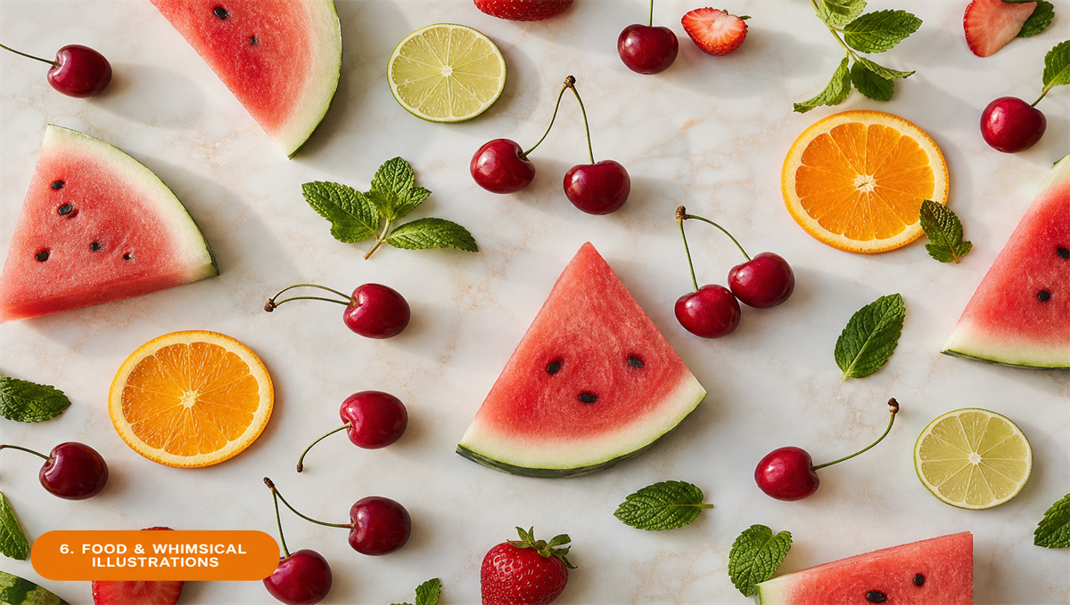
Illustrated shoes are playful and usually get a reaction. They work especially well on casual canvas styles:
- Fruit salad: Watermelon slices, strawberries, citrus, and cherries scattered across the shoe.
- Mushroom fairy circles: Illustrated toadstools, ferns, and forest floor elements in an earthy palette.
- Vintage botanical illustrations: Scientific-style drawings of herbs, vegetables, or flowers with handwritten labels.
- Sweets and pastry: Macarons, croissants, and soft-serve ice cream in pastel tones.
- Tea and coffee ritual: Illustrated teacups, coffee beans, and steam wisps on a warm cream background.

7. Tie-Dye & Dye Techniques
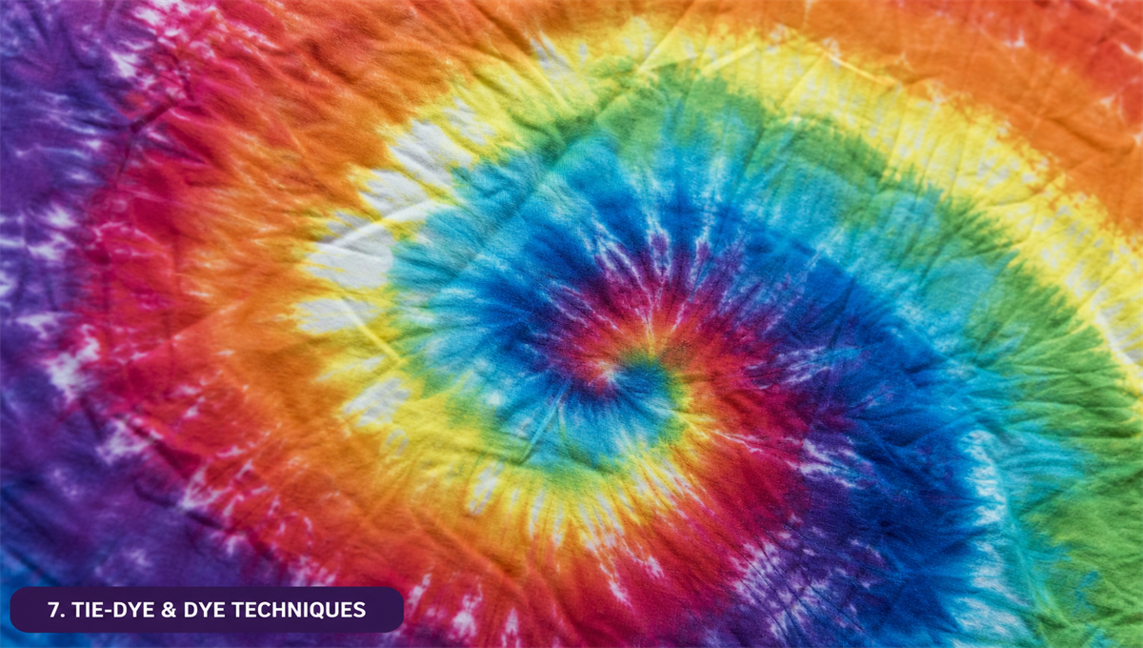
For fabric and canvas shoes, dyeing (rather than painting) produces unique, organic patterns:
- Classic spiral tie-dye: The classic pinched-and-twisted technique in rainbow or monochromatic colorways.
- Shibori indigo: Fold, clamp, or bind canvas before dipping in indigo dye for elegant Japanese-style resist patterns.
- Ombre dip-dye: Submerge shoes progressively in dye bath for a gradient fade from toe to ankle.
- Crumple tie-dye: Randomly scrunch fabric and bind with rubber bands for an abstract, all-over cloud pattern.
- Bleach reverse tie-dye: Apply bleach to dark canvas in controlled patterns for a graphic, faded effect.

8. Typography & Text Patterns
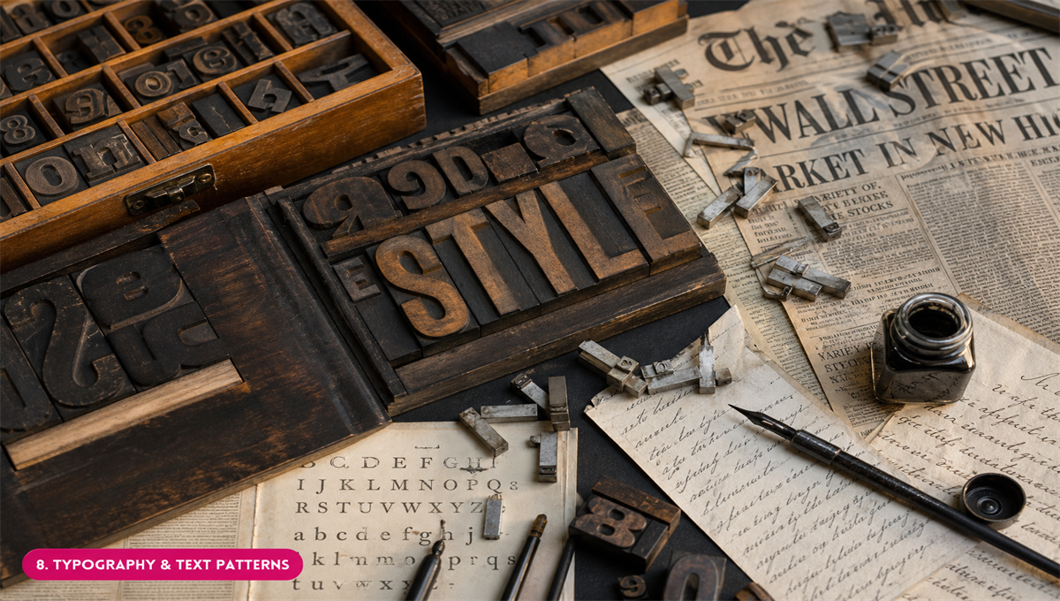
Words and letters as pattern can feel personal and bold:
- All-over text: Fill the entire shoe with a repeated word or phrase in varying sizes and orientations.
- Poetry: Write a favorite poem or song lyric in tiny, careful script across the vamp.
- Alphabet soup: Scatter random letters across the shoe in a playful, graphic pattern.
- Vintage newspaper: Photocopy a favorite headline onto transfer paper and apply to canvas.
- Monogram pattern: Interlock your initials in a repeating tile that covers the shoe like a luxury brand logo.

9. Patchwork & Collage Patterns
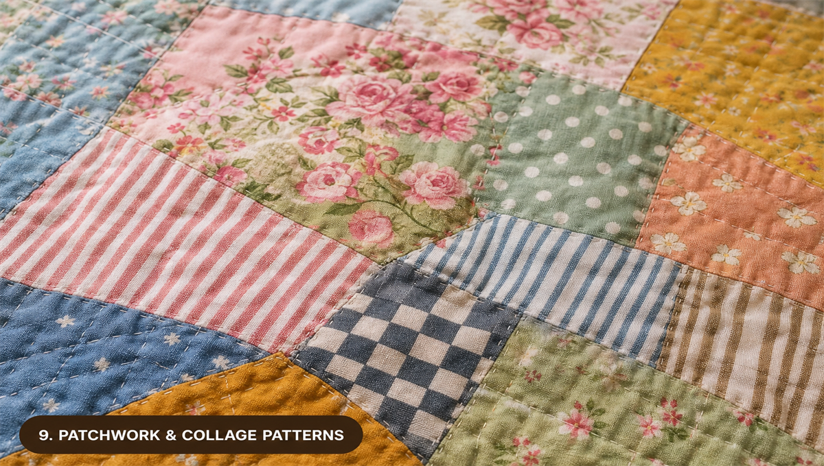
Combining multiple design elements creates eclectic, layered shoes:
- Scrap quilt: Divide the shoe into irregular patches and fill each with a different color or small pattern.
- Mixed motifs: Combine florals, geometrics, animals, and text in a controlled chaos style.
- Decoupage: Apply cut images or patterned paper to canvas shoes with Mod Podge for a collaged effect.
- Vintage ephemera: Use old postage stamps, playing card suits, or tarot imagery in a layered collage.
Design tip: Use a consistent color palette (3 to 5 colors) to unify a complex multi-motif design and keep it from feeling chaotic.

10. Seasonal & Holiday Themes
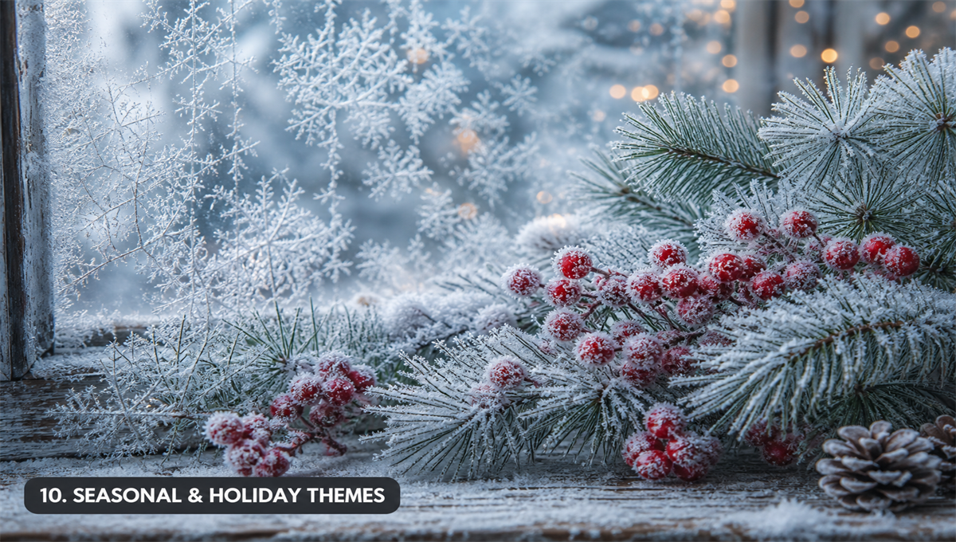
Shoes designed around a specific season or occasion have a festive feel:
- Autumn harvest: Falling leaves in amber, rust, and sienna with acorn and mushroom accents.
- Winter wonderland: Snowflakes, pine branches, and frosted berries on a pale icy blue ground.
- Spring garden: Soft pastels, budding branches, and baby animals for an Eastertime feel.
- Summer festival: Bold tropical prints, sunflower fields, or ocean waves in saturated brights.
- Halloween: Spiderwebs, black cats, and crescent moons for a Halloween statement shoe.

Final Thoughts
Custom shoes mix fashion, craft, and personal taste.
The best custom shoe pattern is the one that feels like you. Start with a style that excites you. Wear every experiment with confidence, learn from each project, and keep going.
Have fun with it.

