Step Into Your Style
A Complete Guide to Designing Custom Patterns for Women's Shoes
Your shoes say something before you ever speak a word. They're the exclamation point at the end of every outfit — so why not make yours completely one-of-a-kind? Custom shoe design has moved from high-end fashion houses to the hands of everyday creatives, and the results are stunning. You can personalize canvas sneakers by adding your own patterns; this transforms footwear into wearable art.
In this guide, we'll explore everything you need to know about designing custom patterns for women's shoes — from finding your style inspiration to the finishing touches that make your creation truly shine.

Why Customize Your Shoes?
Custom shoes aren't just a fashion statement — they're a form of self-expression. Here's why more women are reaching for a paintbrush instead of a price tag:
- Creativity: The design process itself is deeply satisfying and meditative.
- Gift potential: A hand-designed pair makes an unforgettable, personal gift.

Pattern Inspiration: 10 Ideas for Custom Shoe Design
The hardest part is often just deciding where to start. Here are ten rich pattern directions, each with specific ideas to spark your creativity:

1. Botanical & Floral Patterns
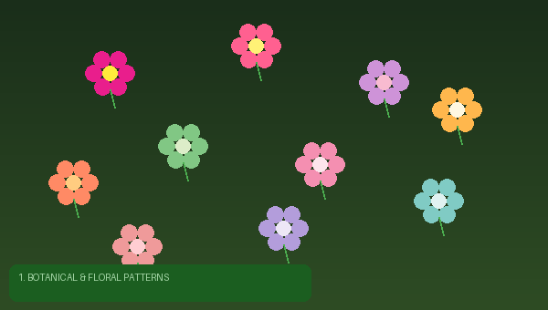
Florals are enduring classics that work on virtually every shoe style. The key is finding your specific floral personality:
- Wildflower meadows: Scatter tiny daisies, clover, and cornflowers across the entire shoe in an allover print style.
- Single statement bloom: Paint one oversized peony or hibiscus in saturated color on the toe cap, letting it breathe against a clean background.
- Trailing vines: Wind illustrated ivy or wisteria up the heel and around the ankle of a boot or high-top.
- Pressed flower effect: Use soft watercolor-style painting to mimic the look of botanically pressed flowers, adding gentle shadows and translucency.
- Art Nouveau florals: Draw inspiration from Alphonse Mucha — sinuous lines, stylized petals, and rich jewel tones.
✨ Color Direction: Try an unexpected palette: deep burgundy flowers on a forest green background, or pale blush blooms on a charcoal base for modern drama.

2. Geometric & Abstract Patterns
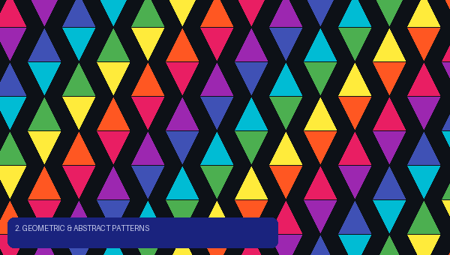
Clean lines and shapes create a striking, modern look that's especially beautiful on structured shoes like loafers, oxfords, and block-heeled sandals.
- Color blocking: Divide the shoe into sections — toe, vamp, heel — and paint each a different saturated color for a bold, graphic look.
- Terrazzo: Mimic the beloved stone surface with scattered irregular shapes in multiple colors on a white or cream ground.
- Checkerboard: A timeless two-tone check that works in classic black-and-white or unexpected color combinations.
- Abstract brushwork: Channel Abstract Expressionism with gestural brushstrokes, color fields, and expressive mark-making.
- Sacred geometry: Mandalas, hexagonal grids, or radial symmetry patterns create hypnotic, meditative designs.

3. Animal & Nature Prints
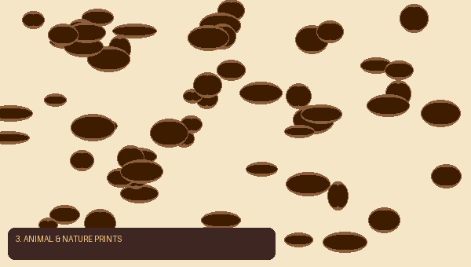
Nature's own patterns are infinitely varied and endlessly fashionable:
- Leopard spots: Classic and versatile — try the traditional amber-and-black version, or reinvent it in teal, coral, or lilac.
- Snake skin textures: Fine-scaled patterns in earth tones or metallics add a luxe, reptilian feel.
- Butterfly wings: Paint detailed Monarch, Blue Morpho, or Swallowtail wings across the upper for an otherworldly effect.
- Watercolor animals: A loose, painterly fox, deer, or hummingbird rendered in soft washes creates a fairytale quality.
- Coral reef: Bright tropical fish, sea anemones, and coral branches on a gradient blue background.

4. Cultural & Folk Art Patterns
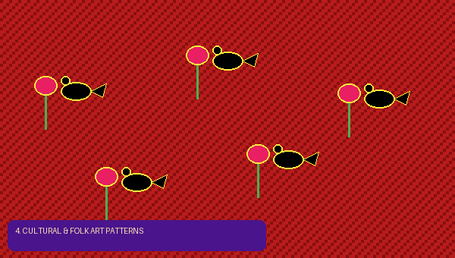
The world's textile traditions offer inexhaustible pattern inspiration:
- Mexican Otomi embroidery: Stylized animals and plants outlined in black, filled with primary colors.
- Hungarian folk art: Tulips, heart motifs, and paired birds in rich red, black, and green.
- Japanese Shibori/Indigo patterns: Wave, circle, and fan repeating patterns in deep indigo and white.
- Scandinavian rosemaling: Swirling acanthus leaves and stylized flowers in traditional Norse palette.
- African kente-inspired geometry: Bold interlocking bands of color in gold, red, green, and black.

5. Celestial & Cosmic Patterns

Stars, moons, and galaxies have a timeless romantic appeal — and look spectacular on dark-based shoes:
- Galaxy wash: Layer deep blues, purples, and blacks, then spatter white and gold to create a starfield.
- Constellation maps: Draw specific constellations connected by delicate gold lines on a midnight blue ground.
- Sun and moon: Classic celestial iconography — crescent moons, radiating suns, and planet motifs in a mystical style.
- Zodiac illustrations: Each shoe can feature a different zodiac sign's symbolic imagery.
- Aurora Borealis: Flowing ribbons of aqua, violet, and green on a dark background.

6. Food & Whimsical Illustrations
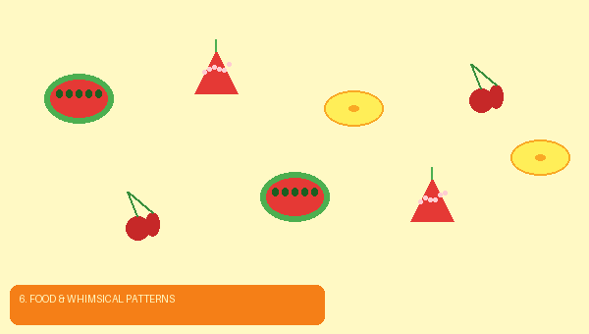
Playful and personality-packed, illustrated shoes make people smile. These work especially well on casual canvas styles:
- Fruit salad: Watermelon slices, strawberries, citrus, and cherries scattered across the shoe.
- Mushroom fairy circles: Illustrated toadstools, ferns, and forest floor elements in an earthy palette.
- Vintage botanical illustrations: Scientific-style drawings of herbs, vegetables, or flowers with handwritten labels.
- Sweets and pastry: Macarons, croissants, and soft-serve ice cream in pastel tones.
- Tea and coffee ritual: Illustrated teacups, coffee beans, and steam wisps on a warm cream background.

7. Tie-Dye & Dye Techniques
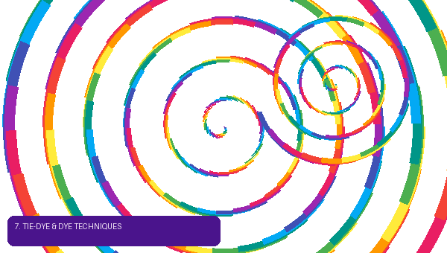
For fabric and canvas shoes, actual dyeing techniques — rather than painting — produce unique, organic patterns:
- Classic spiral tie-dye: The iconic pinched-and-twisted technique in rainbow or monochromatic colorways.
- Shibori indigo: Fold, clamp, or bind canvas before dipping in indigo dye for elegant Japanese-style resist patterns.
- Ombre dip-dye: Submerge shoes progressively in dye bath for a gradient fade from toe to ankle.
- Crumple tie-dye: Randomly scrunch fabric and bind with rubber bands for an abstract, all-over cloud pattern.
- Bleach reverse tie-dye: Apply bleach to dark canvas in controlled patterns for a graphic, faded effect.

8. Typography & Text Patterns
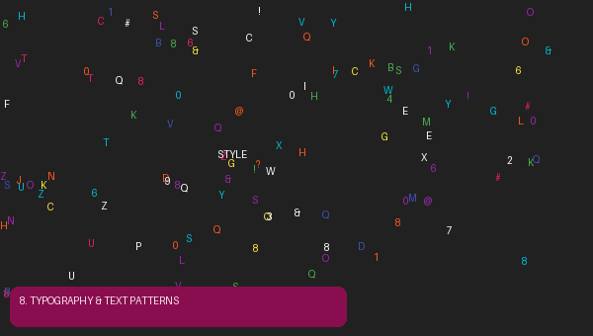
Words and letters as pattern elements can be deeply personal and incredibly striking:
- All-over text: Fill the entire shoe with a repeated word or phrase in varying sizes and orientations.
- Poetry: Write a meaningful poem or song lyric in tiny, careful script across the vamp.
- Alphabet soup: Scatter random letters across the shoe in a playful, graphic pattern.
- Vintage newspaper: Photocopy a meaningful headline onto transfer paper and apply to canvas.
- Monogram pattern: Interlock your initials in a repeating tile that covers the shoe like a luxury brand logo.

9. Patchwork & Collage Patterns
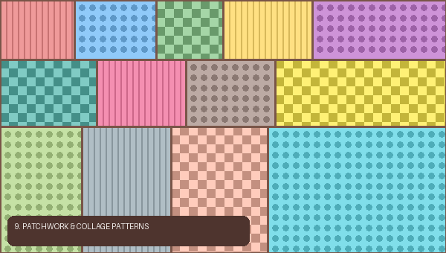
Combining multiple design elements creates richly layered, eclectic shoes:
- Scrap quilt: Divide the shoe into irregular patches and fill each with a different color or small pattern.
- Mixed motifs: Combine florals, geometrics, animals, and text in a curated-chaos style.
- Decoupage: Apply cut images or patterned paper to canvas shoes with Mod Podge for a collaged effect.
- Vintage ephemera: Use old postage stamps, playing card suits, or tarot imagery in a sophisticated collage.
✨ Design Tip: Use a consistent color palette (3–5 colors) to unify a complex multi-motif design and keep it from feeling chaotic.

10. Seasonal & Holiday Themes

Shoes designed around a specific season or occasion have a festive, joyful energy:
- Autumn harvest: Falling leaves in amber, rust, and sienna with acorn and mushroom accents.
- Winter wonderland: Snowflakes, pine branches, and frosted berries on a pale icy blue ground.
- Spring garden: Soft pastels, budding branches, and baby animals for an Eastertime feel.
- Summer festival: Bold tropical prints, sunflower fields, or ocean waves in saturated brights.
- Halloween: Spiderwebs, black cats, and crescent moons for a spooky-chic statement shoe.

Final Thoughts: Walk in Your Own Masterpiece
Custom shoes sit at the beautiful intersection of fashion, fine art, and personal storytelling.
The best custom shoe pattern is the one that makes you feel most like yourself. Start with a style that excites youWear every experiment with confidence, learn from each project, and let your feet do the talking.
Happy creating. 🌸

