**Project 6. Moran’s I: Spatial Autocorrelation**

**Abstract**

This project will detail the use of the Moran’s I test statistic on county census data for Indiana. Moran’s I details the overall spatial autocorrelation of a dataset and is available in the ‘spdep’ package in R.

1. **Spatial Connectivity Evaluation**

To begin this analysis of spatial autocorrelation, it was necessary to generate a set of links for contiguous counties. Fortunately, this is quite easy with the aid of the poly2nb function. This function establishes neighbors from polygons under two different boundary conditions, queen and rook. The queen neighborhood is defined as at least one shared boundary while the rook neighborhood is defined as having more than one shared boundary. This indicates that the queen boundaries will always have more connections. These neighborhoods can be seen in **Figure 1** with queen connections in red and rook in blue.

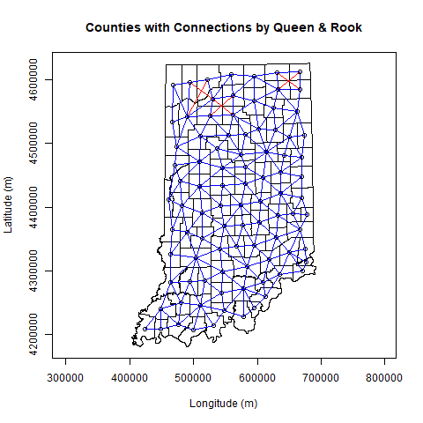

**Figure 1:** Neighborhood connections for queen (red) and rook (blue) for Indiana counties.

1. **Weight Matrix Evaluation**

Texts..

1. **Moran’s I Evaluation**

Text

1. **Conclusions**

Text

**Acknowledgement**

**References**