Project Proposal: SmartAP – Intelligent Invoice & AP Hub
V2026-02-26
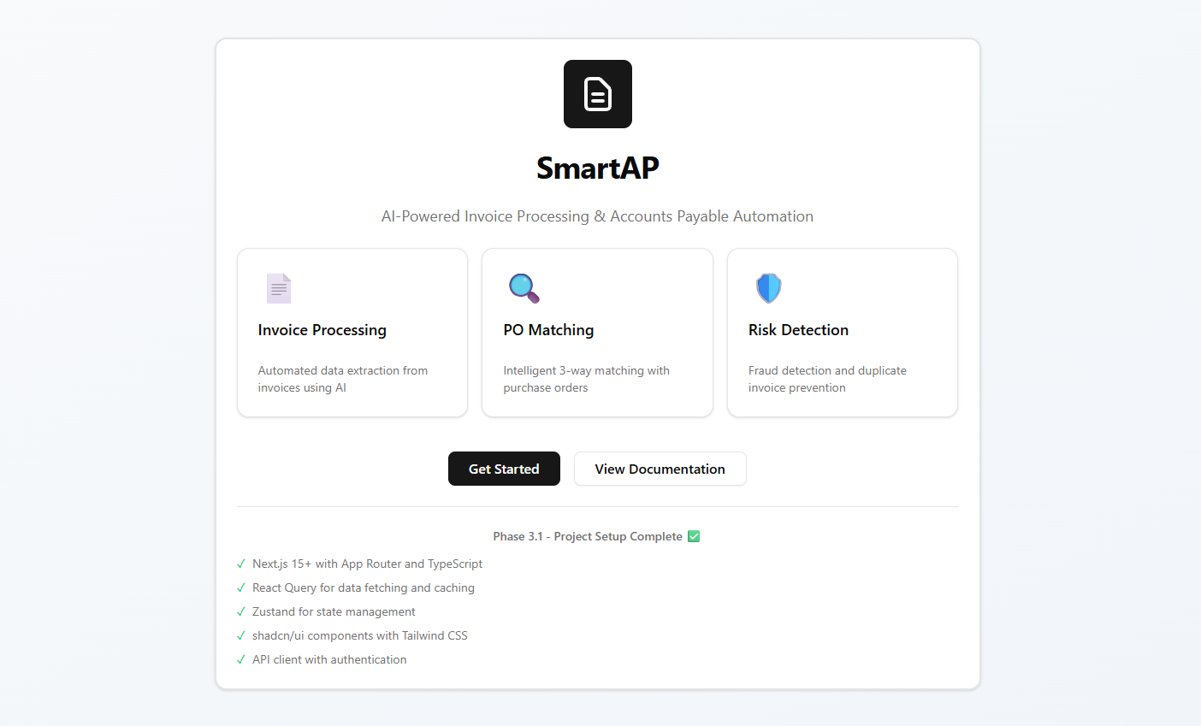
Contents
1. Executive Summary & Introduction 4
A. Executive Summary 4
Value Proposition of SmartAP 4
B. Value Proposition of Foxit Open-Source SmartAP 5
a. Demonstrating "Real-World" Technology Impact 5
b. Accelerating Business Innovation and Adoption 5
c. Building a Trustworthy and Agile Ecosystem 5
d. Empowering the Developer Community 6
C. Technical Core: The Foxit Advantage 6
D. Key Product Features 7
a. Intelligent Dashboard 7
b. Automated Invoice Matching & Reconciliation 7
c. Advanced Extraction & Logging 7
E. Operational Workflow 8
F. Security & Risk Management 8
2. Dashboard (Executive Overview) 9
3. Invoice Management & Detailed View 10
Invoice Details 12
Purchase Order Details 19
Approval – Needs Review 23
6. Vendor Risk Profiles 24
7. Analytics & Performance Tracking 25
8. Technical Processing Logs 30
9. Matching Settings (Configuration) 31

Executive Summary & Introduction
SmartAP is an AI-powered accounts payable (AP) automation platform designed for SMEs and mid-market firms. It leverages Foxit APIs to transform the manual, error-prone process of invoice handling into a streamlined, high-ROI digital workflow.

Executive Summary
Manual invoice processing is a significant bottleneck for finance departments, leading to delayed payments and increased risk of fraud. SmartAP automates the lifecycle of an invoice—from ingestion and data extraction to reconciliation and final approval. By integrating Foxit's OCR and PDF technology with modern AI, SmartAP achieves high Straight-Through Processing (STP) rates, allowing teams to focus on strategic financial planning rather than data entry.

Value Proposition of SmartAP
The SmartAP platform is designed to solve the critical challenges of modern accounts payable departments. By implementing this solution, organizations can expect:
- High ROI for Finance Departments: Automates labor-intensive tasks like manual entry and reconciliation, leading to significant cost savings.
- High Straight-Through Processing (STP): Achieves a high rate of automated processing (95.5% in prototype), minimizing the need for human intervention.
- Reduced Financial Risk: AI-powered detection flags potential fraud, duplicate billing, and discrepancies between invoices and purchase orders.
- Enhanced Data Accuracy: Utilizes zero-shot extraction to pull line items and complex data automatically, reducing human error.
- Scalability for Growth: Specifically tailored to meet the needs of SMEs and mid-market firms looking to professionalize their finance workflows.

Value Proposition of Foxit Open-Source SmartAP
Open-sourcing a project like SmartAP serves as a powerful bridge between Foxit’s high-performance technology and the real-world operational needs of modern businesses. This strategic approach offers value by providing a tangible, functional framework that demonstrates how to solve complex business problems using Foxit’s AI and PDF capabilities.

Demonstrating "Real-World" Technology Impact
- From Sample Code to Solutions: Unlike isolated sample code, an open-source business application provides a complete blueprint for end-to-end workflows like invoice matching and automated approvals.
- Showcasing Performance: It allows businesses to see Foxit’s high-fidelity rendering and fast parsing engines in action within a demanding enterprise environment.
- AI Integration Evidence: It highlights how Foxit AI can move beyond simple chat to perform complex tasks like zero-shot data extraction and risk mitigation in financial workflows.

Accelerating Business Innovation and Adoption
- Lowering Barriers to Entry: Businesses can "start small" with the open-source community version to test feasibility before migrating to a fully supported enterprise-grade implementation.
- Speed to Market: Developers can adapt the SmartAP codebase to their specific needs, significantly reducing the time required to build custom AP automation from scratch.
- Cost Efficiency: Utilizing open-source frameworks for critical platforms can save firms up to 3.5 times the cost of building from proprietary scratch.

Building a Trustworthy and Agile Ecosystem
- Transparency and Security: Publicly available code invites community monitoring, which helps identify and close security gaps faster than closed proprietary systems.
- Flexibility and Choice: Open-sourcing ensures that businesses are not "locked in" to a single vendor's roadmap; they have the freedom to modify and extend the application as their requirements evolve.
- Shaping the Future: It encourages contributions from users across industries (Finance, Healthcare, Legal), allowing the technology to evolve based on actual user needs rather than theoretical features.

Empowering the Developer Community
- Skill Development: Providing complete applications helps developers master Foxit’s multi-platform SDKs (supporting Windows, Mac, Linux, Web, Android, and iOS) in a practical context.
- Developer-Friendly Integration: It demonstrates how easily Foxit’s REST APIs can be chained together for low-code or no-code environments.
- Access to Talent: Active participation in open source connects Foxit with a global pool of skilled developers who are passionate about advancing document technology.

C. Technical Core: The Foxit Advantage
The application's intelligence is built on a foundation of high-performance document services:
- Foxit OCR API: Converts scanned receipts and image-based PDFs into machine-readable text with high precision.
- Zero-Shot Data Extraction: Utilizing AI to automatically identify and extract line items, vendor details, and tax amounts without requiring pre-defined templates for every vendor.
- PDF Flattening: Ensures document integrity and security by merging form fields and annotations before final archiving or payment.

D. Key Product Features

a. Intelligent Dashboard
The command center provides real-time visibility into the AP pipeline.
- Key Metrics: Tracks Total Invoices, Pending Approvals, and Risk Flags.
- STP Rate: Monitors the percentage of invoices processed without human intervention
- Quick Actions: Enables one-click access to Upload Invoices, View POs, and Analytics.

b. Automated Invoice Matching & Reconciliation
SmartAP replaces manual verification with an automated three-way matching logic.
- PO Matching: Automatically links invoices to existing Purchase Orders (e.g., matching Invoice INV-2024-2284 to PO-TECH-001).
- Discrepancy Detection: AI flags mismatches in pricing, quantity, or vendor information.
- Confidence Scoring: Provides an Overall Score for matches (e.g., 99% match) based on vendor, amount, and line item accuracy.

c. Advanced Extraction & Logging
Users can dive deep into individual documents to verify AI performance.
- Line Item Detail: Granular extraction of descriptions, SKUs, quantities, and unit prices (e.g., Cloud Storage, Laptops).
- Processing Logs: Transparent "Step-by-step" logs that show the exact time and status of upload, extraction, and matching stages.

E. Operational Workflow
Stage | Description | AI/API Role
Ingestion | Invoices are uploaded via the "Quick Actions" portal. | Foxit OCR
Extraction | System identifies 10+ fields including Net Amount, Tax, and Due Date. | Zero-shot AI
Verification | Invoice is cross-referenced with POs in the database. | Logic Engine
Approval | High-confidence matches are auto-approved; others enter the "Approval Queue". | Decision AI

F. Security & Risk Management
SmartAP prioritizes financial integrity through:
- Risk Flags: Detecting potential duplicates or fraudulent billing patterns.
- Vendor Profiles: Managing risk scores and payment rates for every supplier (e.g., "Acme Office Supplies" vs "Unknown").
- Audit Trails: Every action is logged, providing a clear path for compliance and internal audits.

Dashboard (Executive Overview)
The primary landing page that displays high-level metrics. It tracks total invoices, pending approvals, risk flags, and the STP rate while providing "Quick Actions" for common tasks.
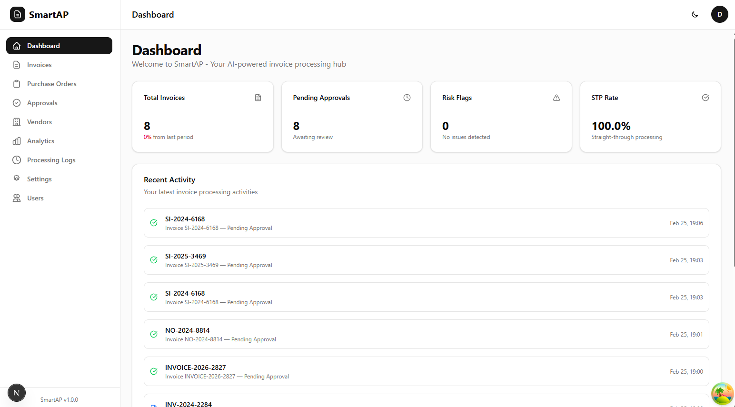

Invoice Management & Detailed View
This section details the invoice repository where users can filter and manage all documents.
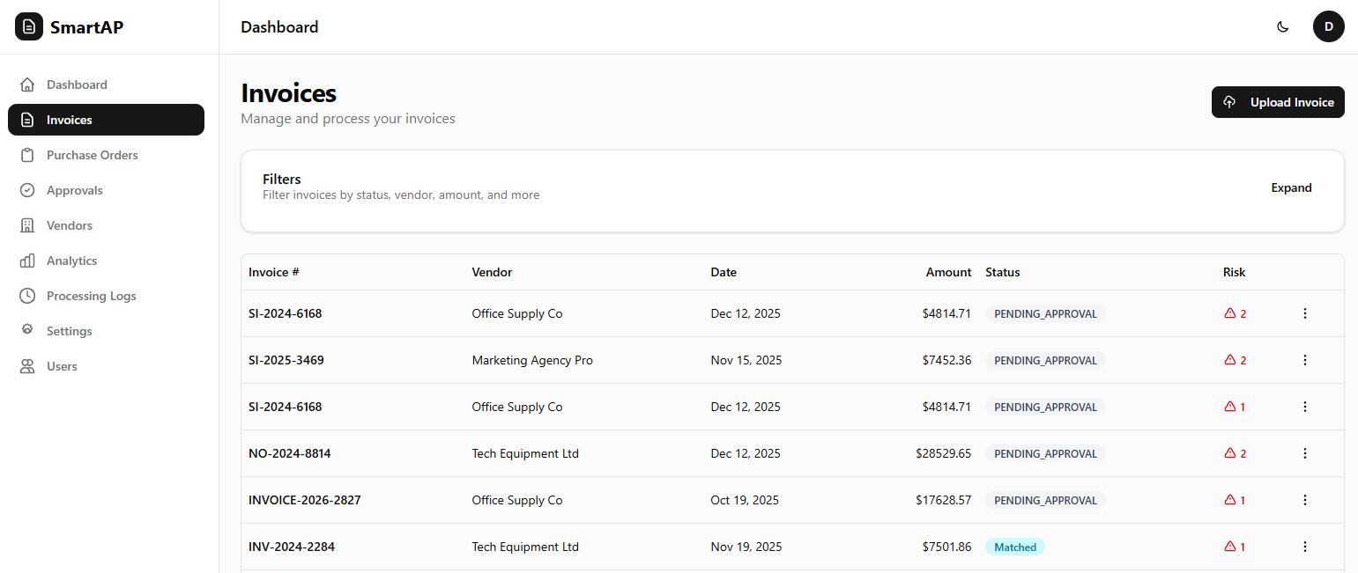
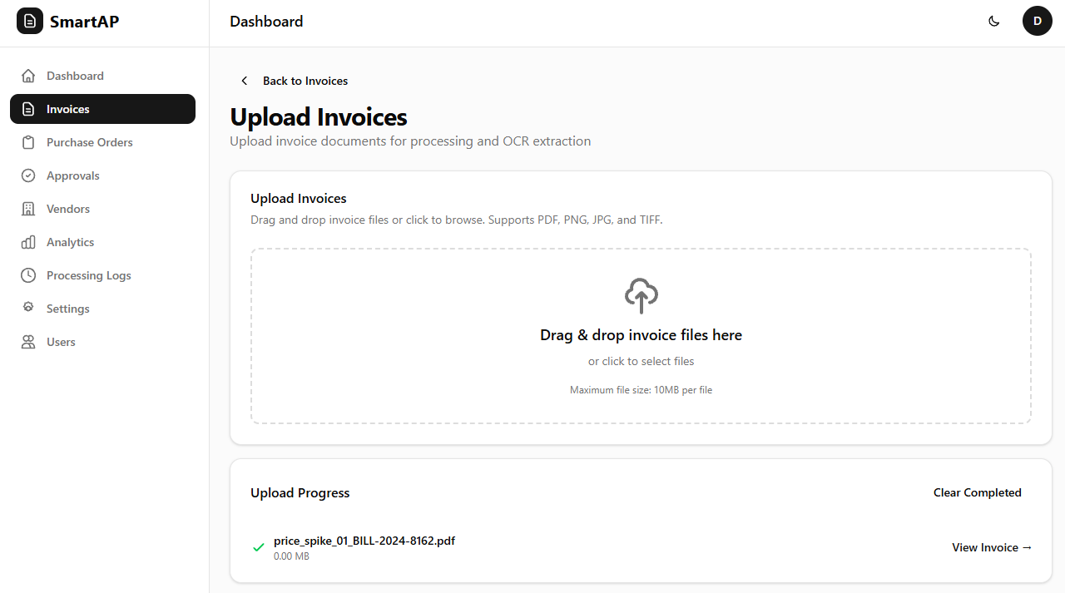

Invoice Details
The Invoice Details view provides a deep dive into specific extractions, showing the original PDF alongside AI-extracted fields like tax ID, subtotal, and currency.
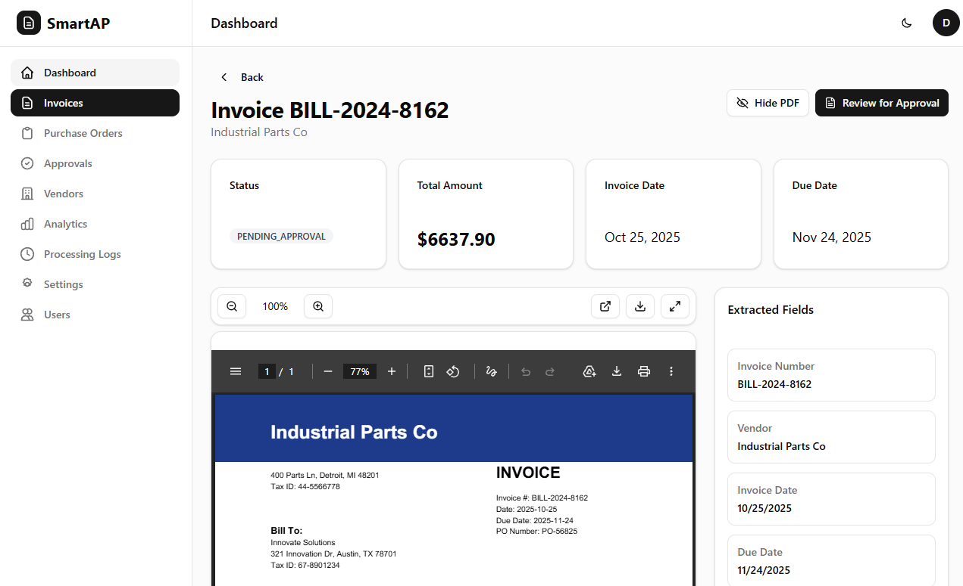

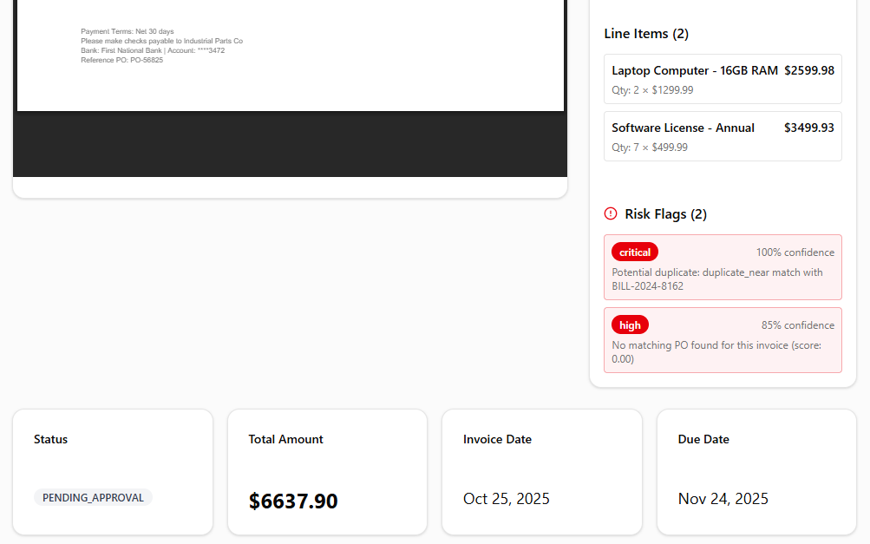
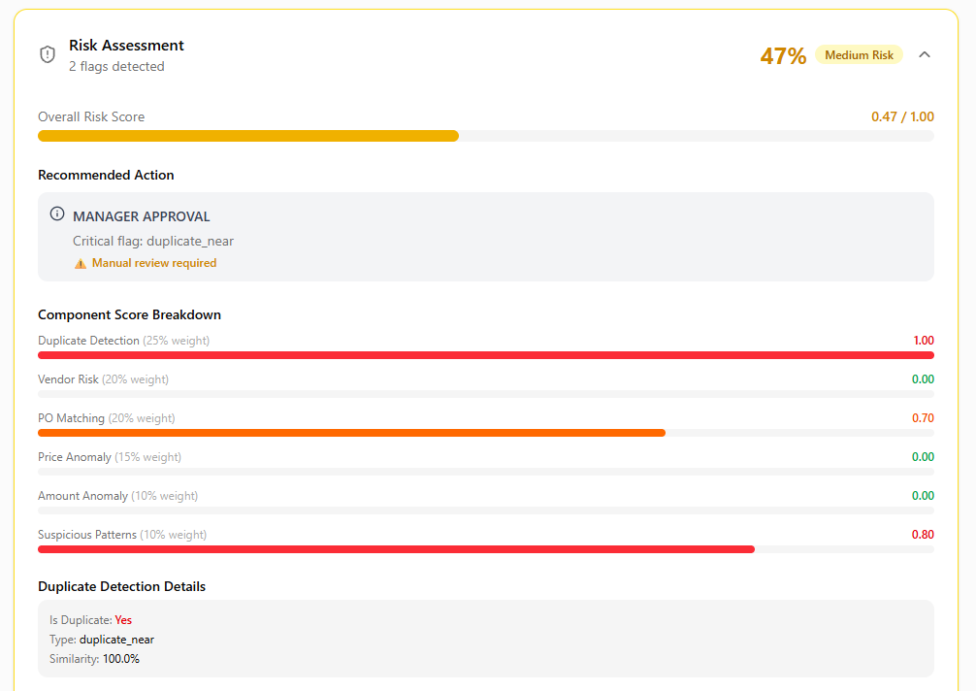
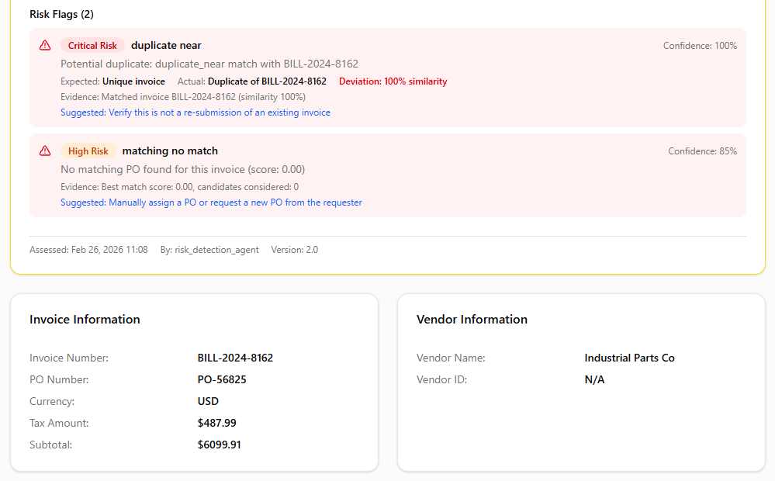
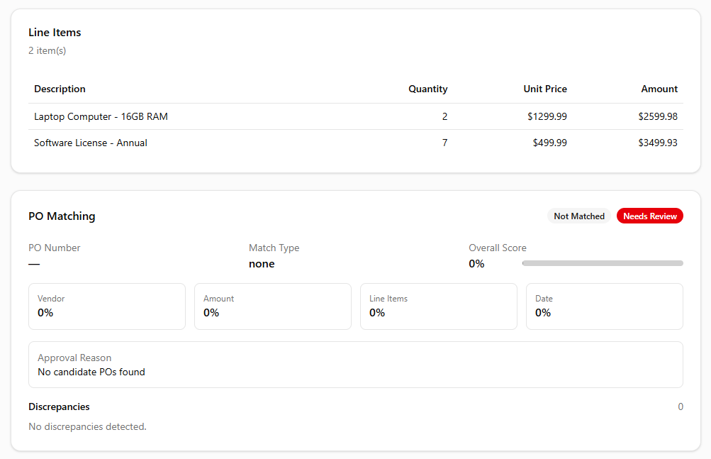
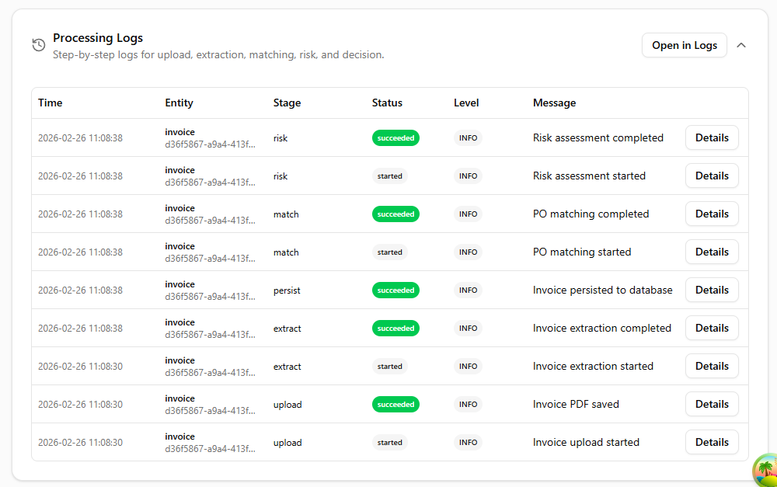
- Purchase Order (PO) Management
A dedicated space for managing POs and tracking their matching status. It includes a searchable list of POs with details on matched amounts and expected delivery dates.
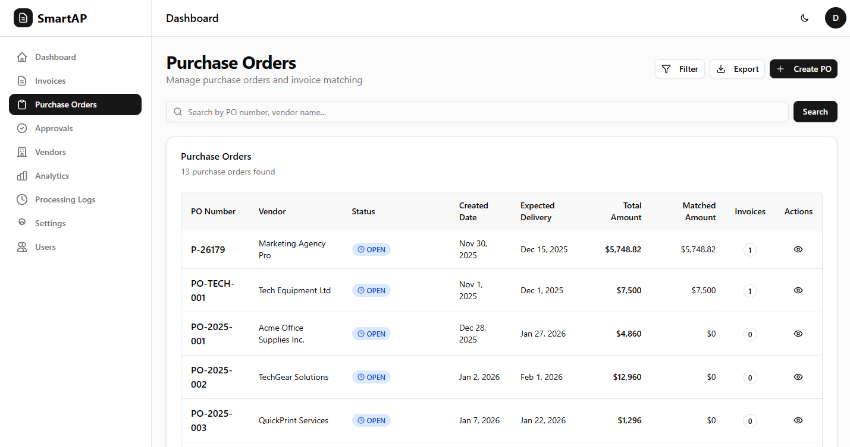

Purchase Order Details
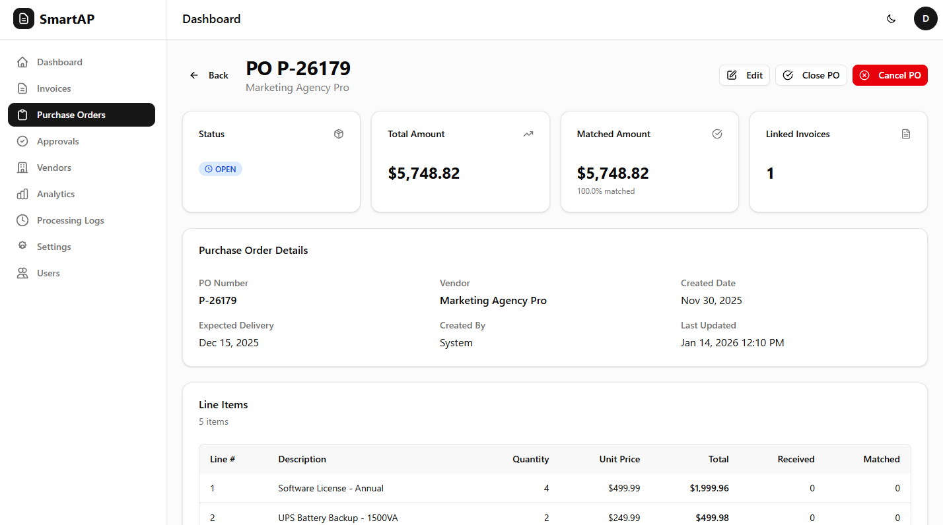
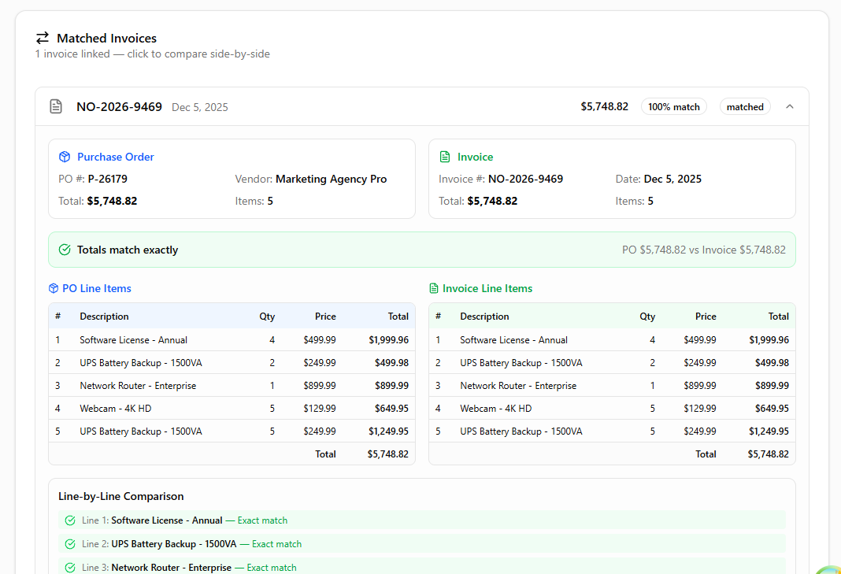
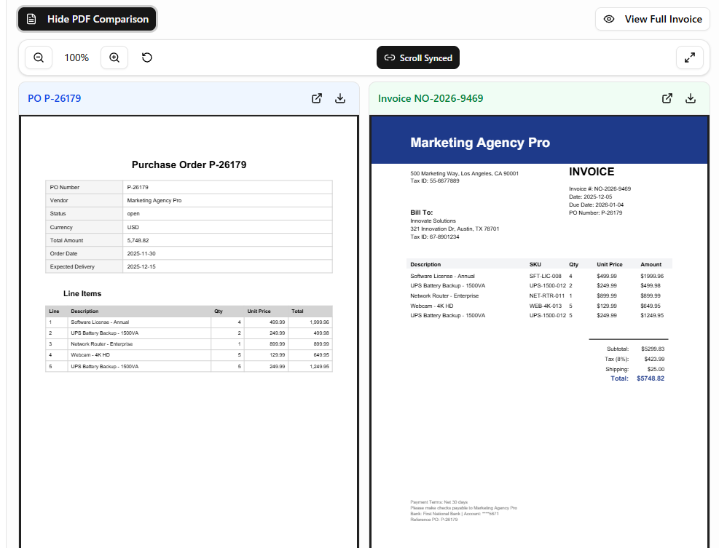
- AI Matching & Approval Queue
Documents the "Three-Way Match" logic. This section describes the Approval Queue where discrepancies are flagged and the Approval Review interface, which compares the Invoice PDF directly against the PO PDF to highlight matches or missing data.
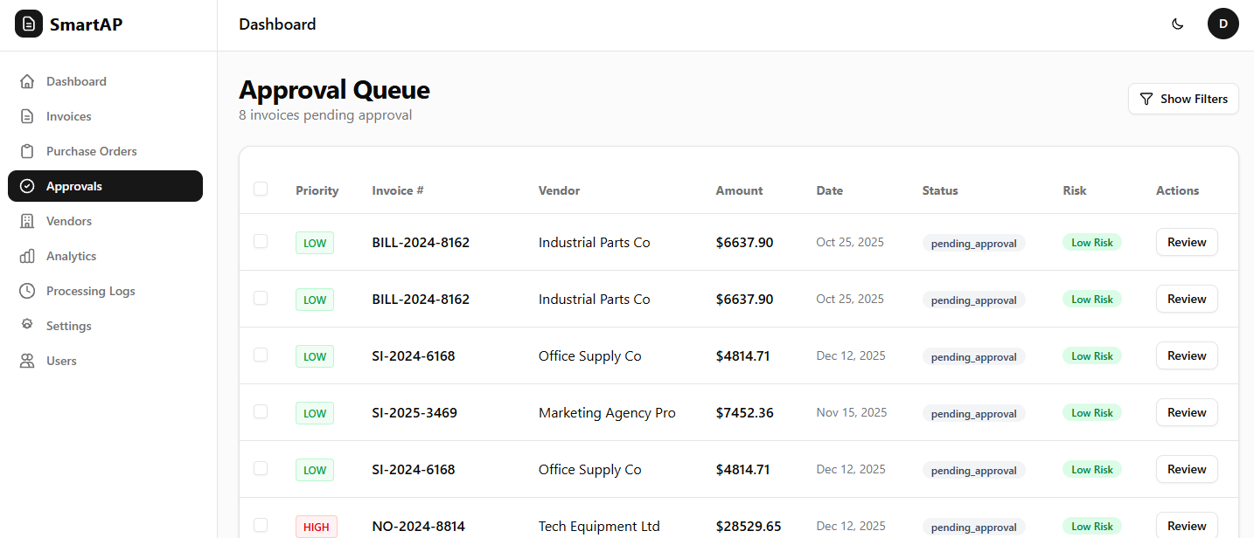

Approval – Needs Review
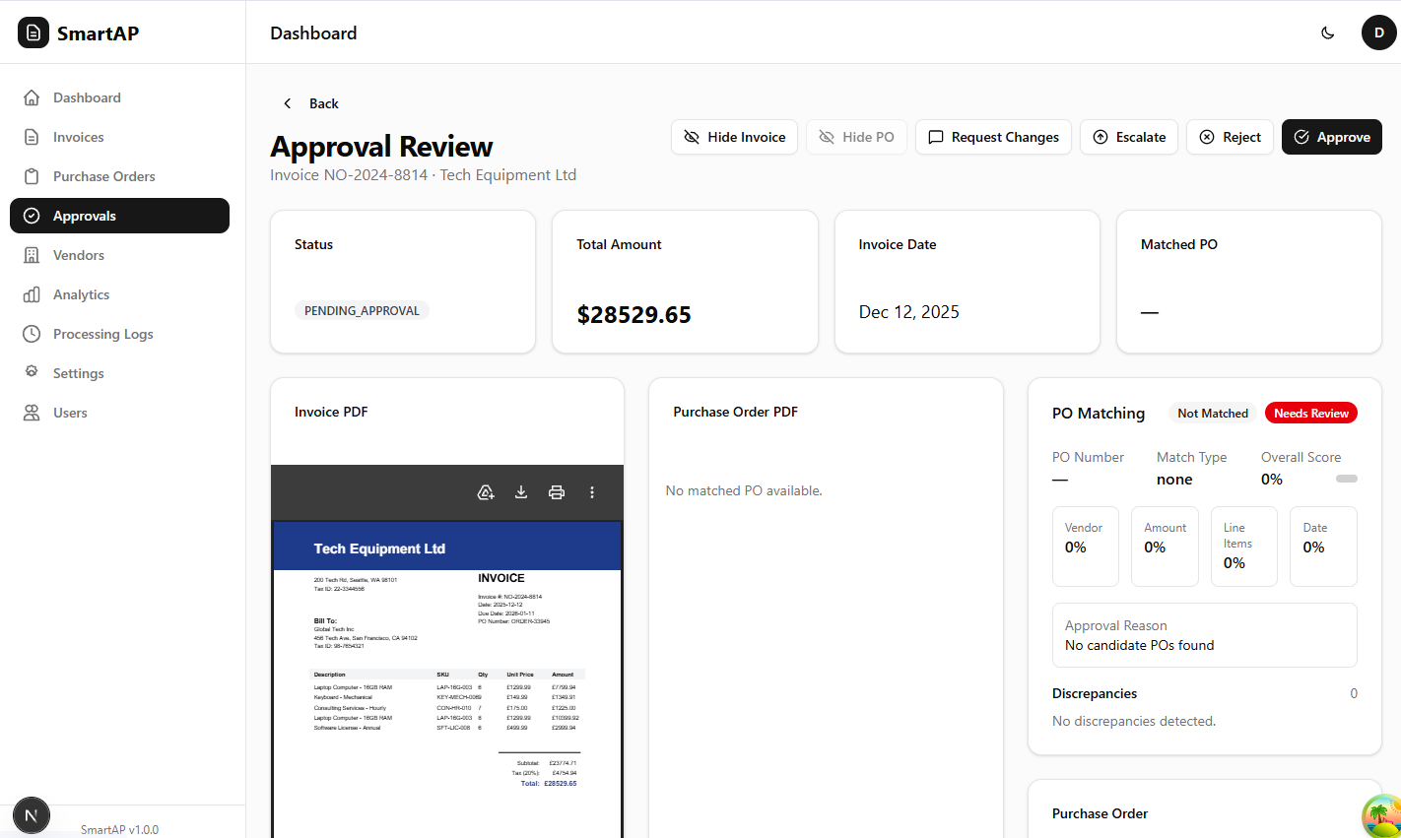

Vendor Risk Profiles
A directory of all suppliers that tracks risk levels, risk scores, and payment rates. It allows finance teams to monitor vendor health and historical performance
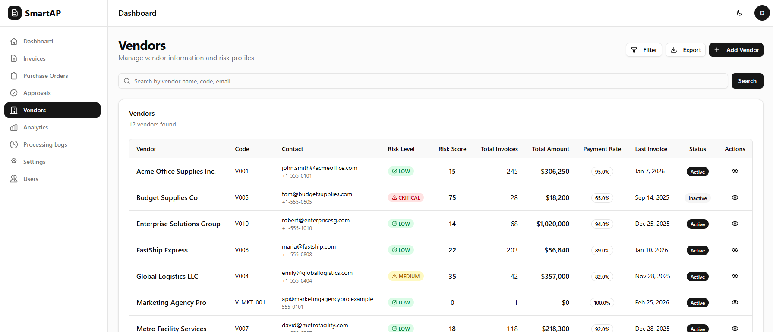

Analytics & Performance Tracking
The Analytics Dashboard provides real-time insights into average processing times and total value processed, helping departments measure efficiency gains over time.
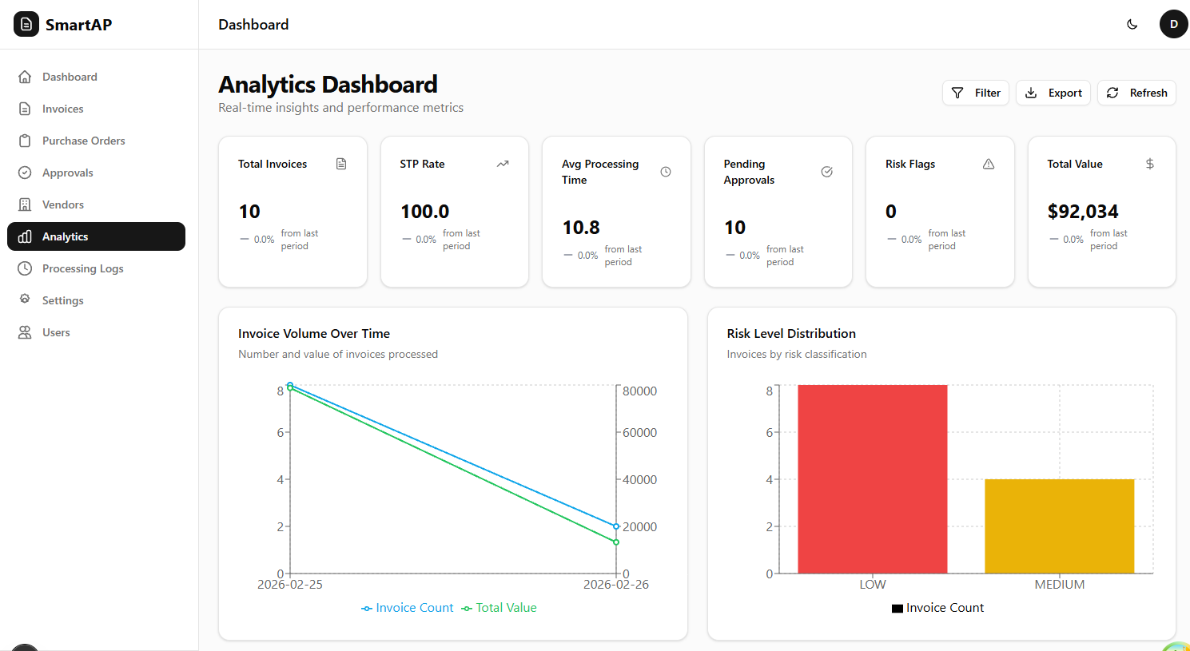
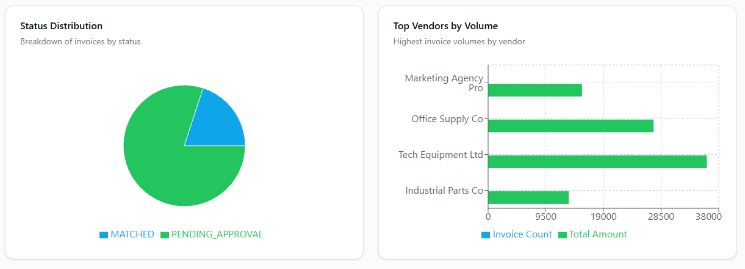
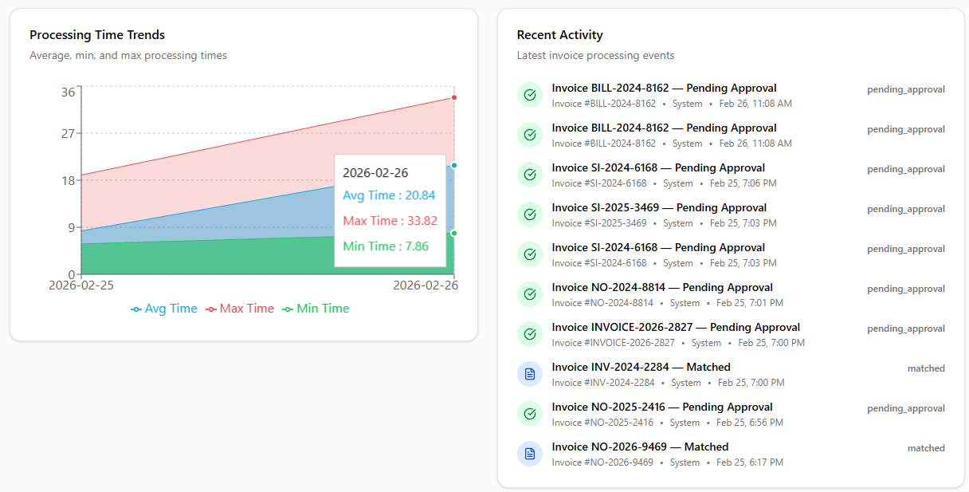
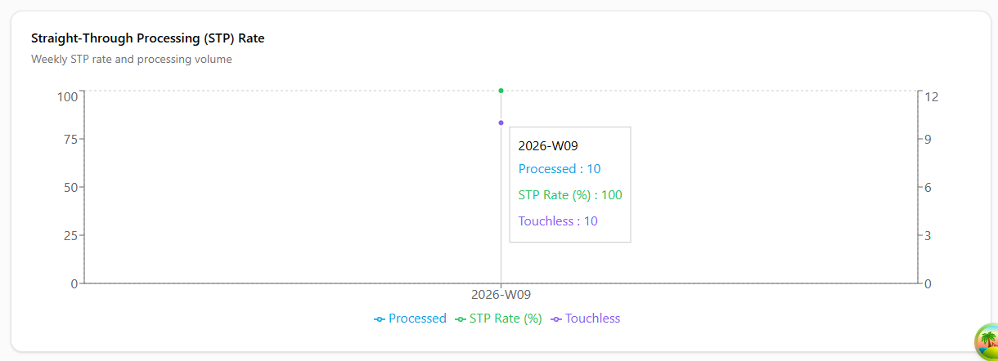

Technical Processing Logs
A transparent audit trail that shows "under-the-hood" events. It provides step-by-step logs for every document stage: upload, extraction, matching, and decision.
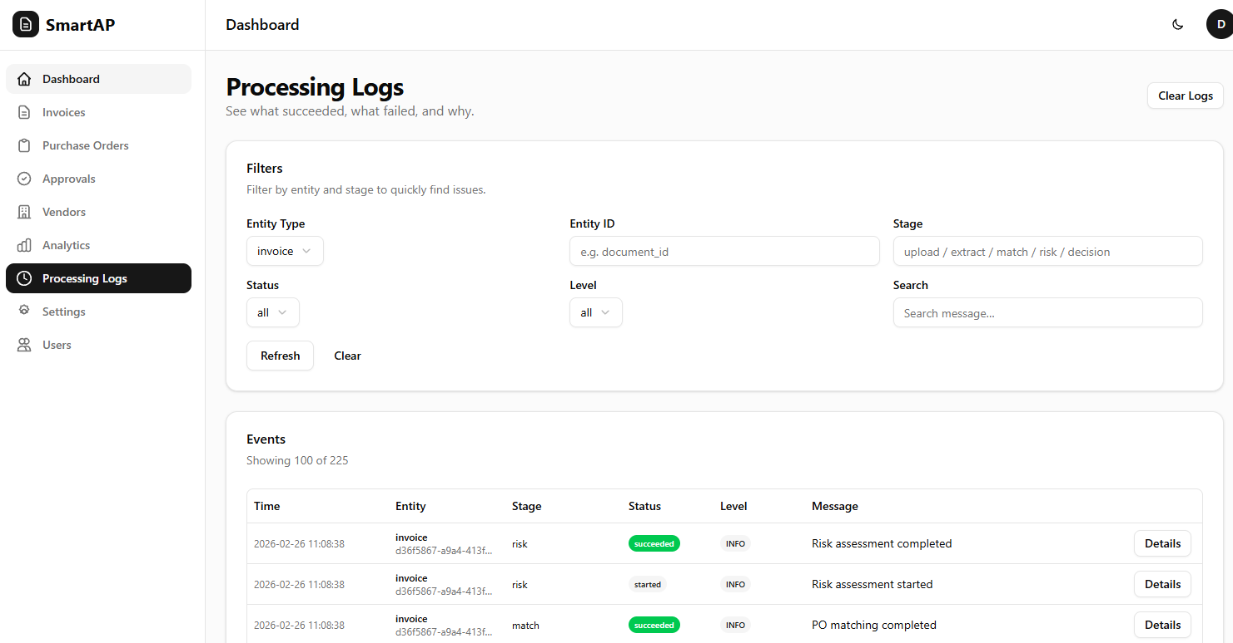

Matching Settings (Configuration)
Dictates the "Business Rules" of the AI. This section allows users to tune scoring weights for vendors, amounts, and dates, and set thresholds for what the AI can auto-approve versus what requires human review.
