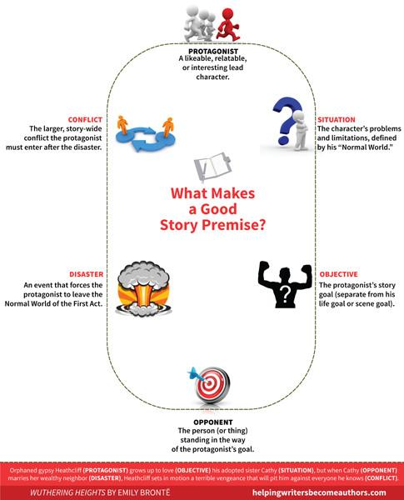

An imaginative boy, stayed in social situation was shoved into a fantasy adventure by a friend, discovers that his fantasy isn’t real, and must face the fact that he need to have real connections.

A Lonely, Imaginative boy, must dive into himself and meet the personifications of his personalities, and battles his personification of his loneliness, an Ice Dragon.

A Boy found a portal to a fantasy realm and discovers that its inhabitants has been suffering through long winter because of the Ice Dragon’s fury. He and his party must find a way to defeat the dragon and end the long winter.

