Dimitri Etienne, Rayan Biharie, Chakir Bouchrouch

INF1C

Public library System

Documentation

Inhoud

Group info 2

Requirements Specification 3

Class Diagram 4

Use Case Diagram 5

User Manual 6

Required programs 6

Database Maintenance 6

Running the program 6

First Setup 6

Changing account types 7

Using the Public Library System 7

Loaning a book 8

# Group info

Dimitri Etienne – 1007284 – Leader

Rayan Biharie - 0970671

Chakir Bouchrouch - 1008730

# Requirements Specification

# Class Diagram

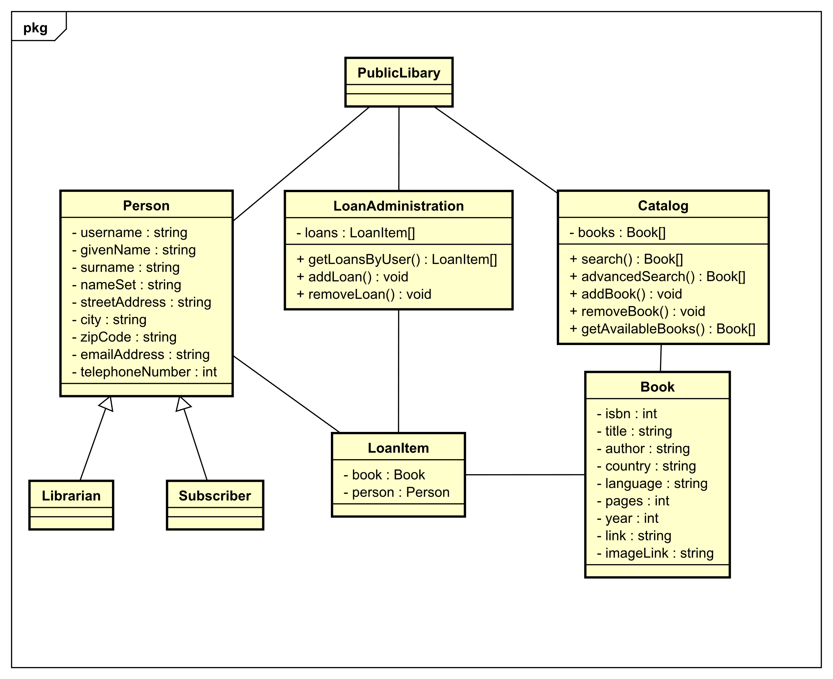

# Use Case Diagram

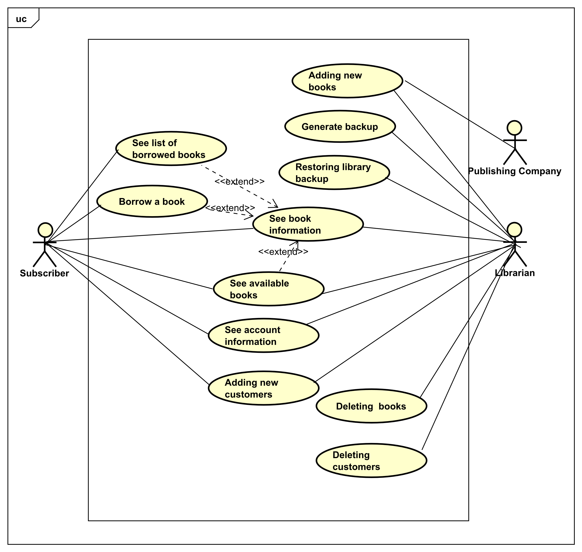

# User Manual

## Required programs

### Database Maintenance

For maintaining the database, the use of the free program <https://sqlitebrowser.org/> is recommended. This program is available on Windows, Mac OS, and most Linux distributions.

### Running the program

At least python 3.8 has to be installed on the system with the standard library.

## First Setup

The included database contains 1 librarian account, 20 user accounts and 100 books.

It is recommended to change the information of the librarian account in the database with the tool recommended for database maintenance.

It is also recommended to change the password of the librarian account before running the system. To do so, follow the following steps:

1. Open the “database.db” file
2. Navigate to the Data Browser (number 1) near the top left corner of the application.
3. In the table dropdown, select the Users table (number 2).
4. Select the password field of the first record, this should be the librarian account (number 3).
5. Change the password from “1234” to anything you like, using the text field near the top right (number 4).
6. When you have entered a new password, click on the apply button (number 5)
7. Make sure to save the database. The program will **NOT** run if you don’t do this. To save the database, press CTRL+S on Windows or Linux and CMD+S on Mac OS.

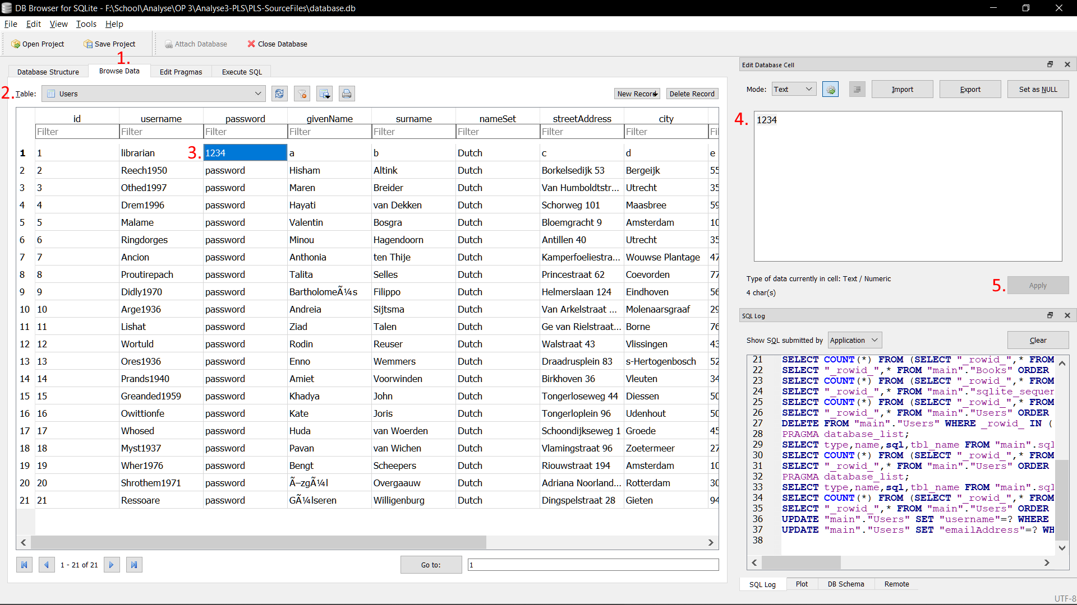

## Changing account types

To change the account type. Open the “database.db” file with the tool recommended for database maintenance and go to the users table. (For basic instructions on how to use the recommend tool, see First Setup).

To change a **Subscriber** account to a **Librarian** account or the other way round, change the permType field in the users record accordingly.

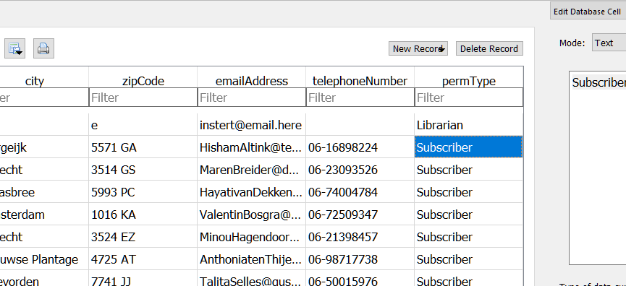

## Using the Public Library System

1. Navigate your terminal to the location of the PLS.py file
2. Type “python PLS.py” in your terminal. You will be met with this screen.  
   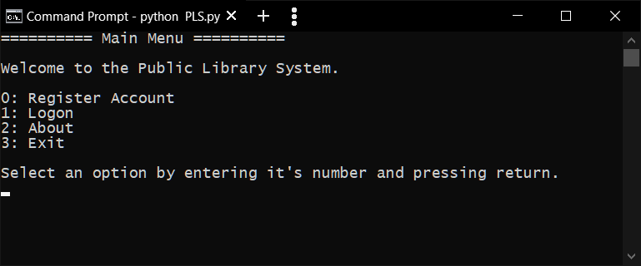
3. In this screen you can create a new account, logon with an existing account, view the about page or exit the app. Make your choice by typing the number of the option and press return.
4. Once logged in, follow the instructions on the screen.

### Loaning a book

**This part of the manual assumes you are logged in as a Subscriber.**

1. Select option 0 in the main menu  
   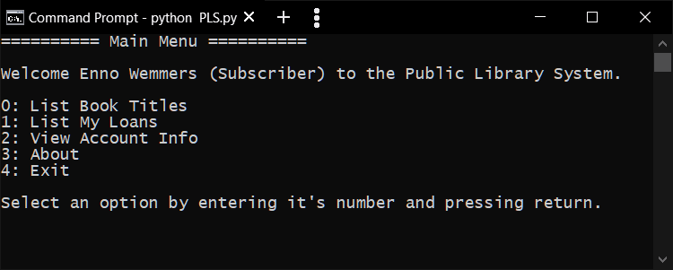
2. Select a book from the list  
   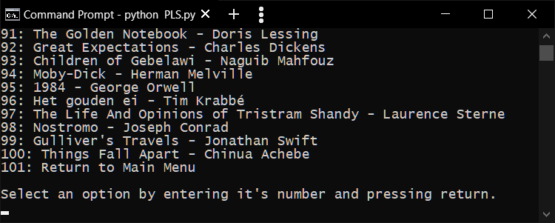
3. To loan the book, enter 0 and press return  
   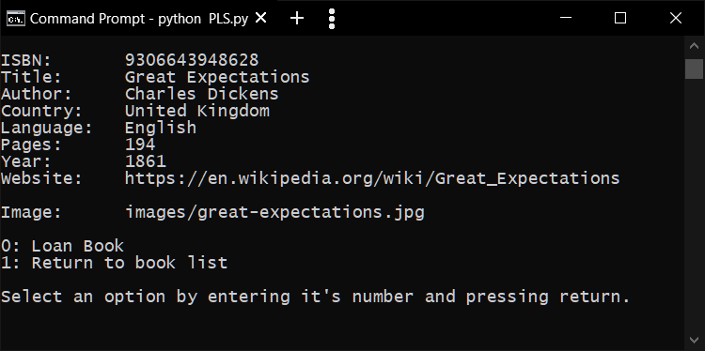
4. To view your loans, select 1 in the main menu  
   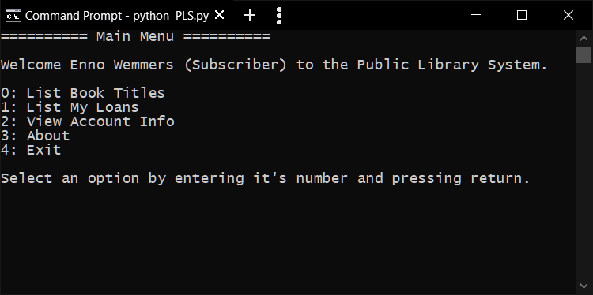  
   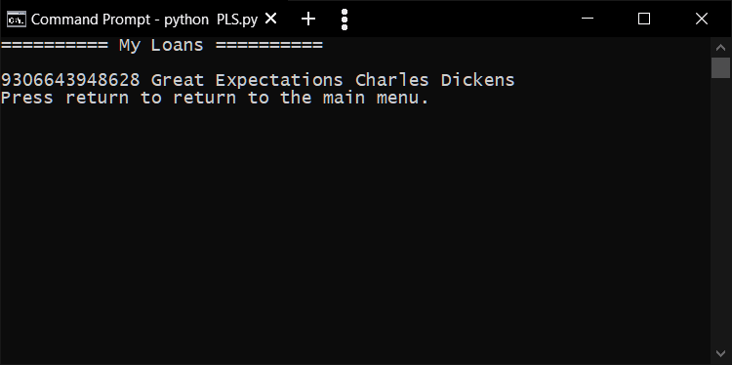

### Librarian Options

**This part of the manual assumes you are logged in as a Librarian.**

The librarian has too many options to cover, all options contain in program instructions. In there figure below you can see an overview of all the options librarians have.

