Software Requirements Specification for PLS

***Version 1.0***

***Prepared by Dimitri Etienne, Rayan Biharie and Chakir Bouchrouch***

***Hogeschool Rotterdam***

***April 2021***

Inhoud

1. Introduction 3

1.1 Purpose 3

1.2 PRoject Scope 3

2. Overall Description 3

2.1 Product Perspective 3

2.2 Operating Environment 4

2.3 Product Features 4

3. Requirements specification 4

3.1 DESCRIPTION and PRIORITY 4

4. EXTERNAL INTERFACE REQUIREMENTS 4

4.1 User Interfaces 4

4.2 Hardware Interfaces 5

4.3 Communication Interfaces 5

5. Non-functional requirement 5

5.1 Performance requirement 5

5.2 Safety requirement 5

5.3 Security requirement 5

5.4 Software Quility Attributes 5

# Introduction

## 1.1 Purpose

The purpose of this document is to build a Public Library System (PLS) with which the information can be managed that is needed to run a public library, lending out paper books to customers.

## 1.2 PRoject Scope

The purpose of the Public Library System (PLS) is to manage the information that is needed to run a public library. The system will consist of a backend (data processing and storage) and a frontend. The frontend can consist of a console based (textual) interface that gives access to all the functions of the system. The whole issue of security and access rights is left out of scope of this assignment.

The library has paper books, a catalog of books, a loan administration, customers, and a librarian (bibliothecaris). New customers can be added to the administration. New books (that means: the identification details of paper book items) can be added to the catalog. Customers can search for books and loan books. The library can be filled with books and customers from data files. All the data in the PLS can be backed up on file, and restored from file.

# Overall Description

## Product Perspective

The Public Library System (PLS) was developed to store the following information:

* **Librarian details:**

It includes adding a customer to the system, adding book(s), deleting book(s), filling the system with customers from a file of people (.csv files and .json files), add loan(s), remove loan(s)

* **Subscriber details:**

It includes loaning a book and editing his account information

* **Publishing company details:**

It includes adding books to the catalog

## Operating Environment

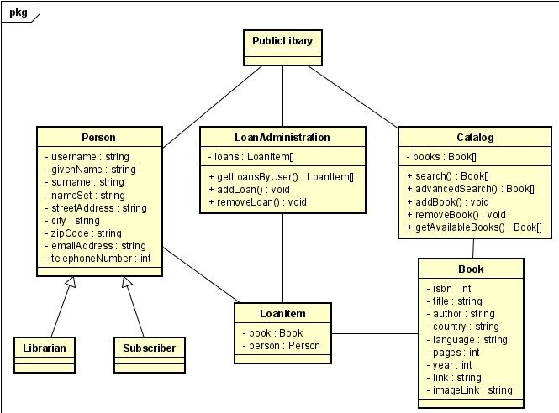The major features of the Public Library System (PLS) is shown below in a Class Diagram:

## Product Features

Operating environment for the Public Library System (PLS) is as listed below.

* Client/server system
* Operating system: Windows/Linux
* Database: SQLite 3
* Platform: Python

# Requirements specification

## DESCRIPTION and PRIORITY

The Public Library System (PLS) maintains information on the catalog, users information and loans. This project has high priority, because with the PLS we cannot lend books, add books to the catalog, et cetera.

# EXTERNAL INTERFACE REQUIREMENTS

## User Interfaces

* Front-end software: Python(Console based)
* Back-end software: SQLite 3

## Hardware Interfaces

* Windows or Linux with Python installed

## Communication Interfaces

This project support computers with Python installed. For this project we are using a simple command interface and the user needs to enter the corresponding key for the action that he or she wants.

# Non-functional requirement

## Performance requirement

The Public Library System (PLS) can be used with any modern computers and even old computers, because it is basically a console interface program.

## Safety requirement

To ensure that no one of the Public Library System (PLS) users will lose any data while using the system the librarian can manually make a backup of the system. There is also a debug menu that is only visible to the librarian.

## Security requirement

At the moment the Public Library System (PLS) does not have any security requirements.

## Software Quility Attributes

The Public Library System (PLS) provides the users with both a simple and advanced features. It’s well designed and easy to use interface that it can be used by both experts and typical users.