# **32 Работа с SqlDataAdapter и DataSet**

Задание 1. Свяжите данные с помощью DataSet, предварительно создайте DataTable для каждой из таблиц БД. Листинг программы:

using (SqlConnection sqlConnection = new SqlConnection(ConfigurationManager.ConnectionStrings["Test"].ConnectionString))

{

sqlConnection.Open();

if (sqlConnection.State == System.Data.ConnectionState.Open)

{

SqlCommand getAllTouristsInfo = sqlConnection.CreateCommand();

getAllTouristsInfo.CommandText = "SELECT * FROM Tourists JOIN TouristsInfo ON Tourists.ID = TouristsInfo.TouristID";

DataTable touristsInfo = GetData(getAllTouristsInfo);

touristsInfo.Columns.Remove("TouristID");

TouristsView.AutoGenerateColumns = true;

TouristsView.DataSource = touristsInfo;

TouristsView.Columns[0].Width = 25;

SqlCommand getTours = sqlConnection.CreateCommand();

getTours.CommandText = "SELECT * FROM Tours";

DataTable tours = GetData(getTours);

ToursView.AutoGenerateColumns = true;

ToursView.DataSource = tours;

ToursView.Columns[0].Width = 50;

ToursView.Columns[3].Width = 500;

SqlCommand getSeasons = sqlConnection.CreateCommand();

getSeasons.CommandText = "SELECT Seasons.SeasonID, Seasons.StartDate, Seasons.EndDate, Seasons.SeatsCount, Seasons.IsSeasonClosed, Tours.Name, Tours.Price, Tours.Info FROM Tours JOIN Seasons ON Tours.TourID = Seasons.TourID";

DataTable seasons = GetData(getSeasons);

SeasonsView.AutoGenerateColumns = true;

SeasonsView.DataSource = seasons;

SeasonsView.Columns[0].Width = 75;

SqlCommand getTravels = sqlConnection.CreateCommand();

getTravels.CommandText = "SELECT Tourists.Surname, Tourists.Name, Seasons.SeasonID FROM Travels JOIN Tourists ON Travels.TouristID = Tourists.ID JOIN Seasons ON Travels.SeasonID = Seasons.SeasonID";

DataTable travels = GetData(getTravels);

travels.Columns[0].ColumnName = "Surname";

travels.Columns[1].ColumnName = "Tourist Name";

SqlCommand getSeasonsTravels = sqlConnection.CreateCommand();

getSeasonsTravels.CommandText = "SELECT Seasons.SeasonID, Tours.Name, Tours.Price, Tours.Info FROM Seasons JOIN Tours ON Seasons.TourID = Tours.TourID";

travels = FullOuterJoinDataTables(travels, GetData(getSeasonsTravels));

travels.Columns[3].ColumnName = "Tour Name";

TravelsView.AutoGenerateColumns = true;

TravelsView.DataSource = travels;

SqlCommand getPayments = sqlConnection.CreateCommand();

getPayments.CommandText = "SELECT Payments.Cost, Travels.ID FROM Payments JOIN Travels ON Payments.TravelID = Travels.ID" ;

DataTable payments = GetData(getPayments);

SqlCommand getTouristPayment = sqlConnection.CreateCommand();

getTouristPayment.CommandText = "SELECT Travels.ID, Tourists.Name, Tourists.Surname FROM Travels JOIN Tourists ON Travels.TouristID = Tourists.ID";

payments = FullOuterJoinDataTables(GetData(getTouristPayment), payments);

payments.Columns["ID"].ColumnName = "TravelID";

PaymentsView.AutoGenerateColumns = true;

PaymentsView.DataSource = payments;

}

}

Анализ результатов:

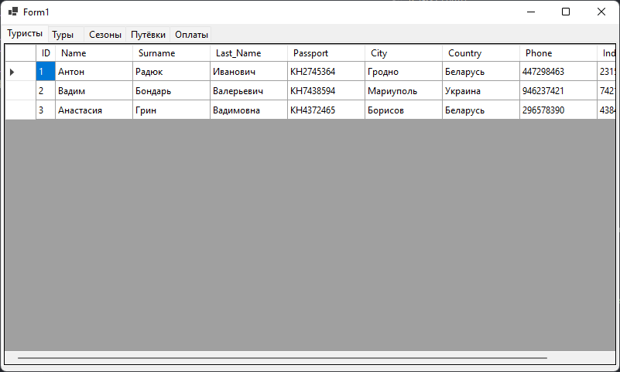

Рисунок 32.1 – Результат работы программы