**25 Язык разметки XAML**

Задание 1. Изучить теоретический материал. Выполнить на практике все примеры создания WPF приложения.

Листинг приложения:

namespace Day27Prac26 {

/// <summary>

/// Логика взаимодействия для MainWindow.xaml

/// </summary>

public partial class MainWindow : Window {

private readonly IXmlSweets _worker;

public bool IsFileOpened = false;

private string _xmlFilePath;

public MainWindow() {

InitializeComponent();

}

private void Button_Click(object sender, RoutedEventArgs e) {

var path = "D:\\кпияп\\практика по с#\\Practica\\Day27Prac26\\Day27Prac26\\File\\sweets.xml\\";

SweetsSet sweets = new SweetsSet();

XmlDocumentSweets xml = new XmlDocumentSweets();

xml.Add(sweets);

}

private void TextBox_TextChanged(object sender, TextChangedEventArgs e) {

}

private void Button_Click_1(object sender, RoutedEventArgs e) {

var dialog = new OpenFileDialog();

dialog.InitialDirectory = Directory.GetParent(AppContext.BaseDirectory)

.Parent

.Parent

.FullName;

dialog.DefaultExt = ".xml";

dialog.Filter = "Xml document (.xml)|*.xml";

var result = dialog.ShowDialog();

if (result.HasValue && result.Value) {

_xmlFilePath = dialog.FileName;

TextBlock3.Text = _xmlFilePath;

_worker.Load(_xmlFilePath);

}

}

private void Button_Click_2(object sender, RoutedEventArgs e) {

var sweets = _worker.FindBy(TextBox1.Text);

PrintBooks(sweets);}

private void PrintBooks(SweetsSet sweets) {

TextBlock1.Text = "========Sweet========" + Environment.NewLine;

TextBlock2.Text += sweets?.ToString() ?? "Sweet not found";}

private void TextBox_TextChanged_1(object sender, TextChangedEventArgs e) {}

private void RadioButton_Checked_2(object sender, RoutedEventArgs e) {

if (RadioButton1.Checked){

TextBlock2.Text += sweets?.ToString() ?? "Sweet not found";

}

}

}

}

Анализ результатов:

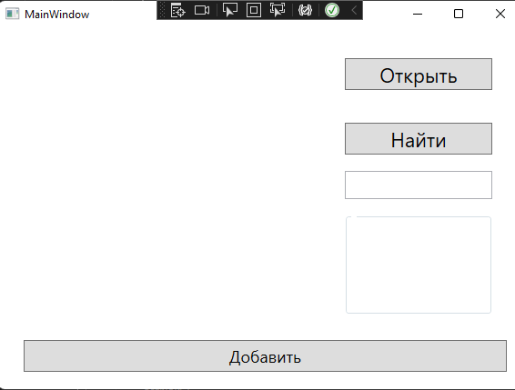

Рисунок 1.1 – Результат работы программы