

|  |  |
| --- | --- |
| **Title:** **Study of Digital to Analog Conversion using MATLAB.** | |
| **Name: Toufiq Ahmed Tanna** | **ID:16-32358-2** |
| **Lab No: 5** | **Date of Submission: 30/11/2020** |
| **Course Title:** **Data Communication** | **Section: J** |
| **Semester: Fall 2020-21** | |
| **Course Teacher:MD MEHEDI HASAN** | |

Here, my ID;16-32358-2

D=0 0 1 1 0 0 1 0

E=0 0 1 1 0 0 1 1

F=0 0 1 1 0 1 0 1

a)

|  |
| --- |
| close all;  clc;  %16-32358-2  f=5;  f2=10;  D=[0 0 1 1 0 0 1 0]; %2  E=[0 0 1 1 0 0 1 1]; %3  F=[0 0 1 1 0 1 0 1]; %5  T = [D E F]  nt=size(T,2);  i=1;  while i<nt+1  t = i:0.001:i+1;  if T(i)==1  ask=sin(2*pi*f*t);  fsk=sin(2*pi*f*t);  psk=sin(2*pi*f*t);  else  ask=0;  fsk=sin(2*pi*f2*t);  psk=sin(2*pi*f*t+pi);  end  subplot(3,1,1);  plot(t,ask);  hold on;  grid on;  axis([1 20 -1 1]);  title('Amplitude Shift Key')  subplot(3,1,2);  plot(t,fsk);  hold on;  grid on;  axis([1 20 -1 1]);  title('Frequency Shift Key')  subplot(3,1,3);  plot(t,psk);  hold on;  grid on;  axis([1 20 -1 1]);  title('Phase Shift Key')  i=i+1;  end |

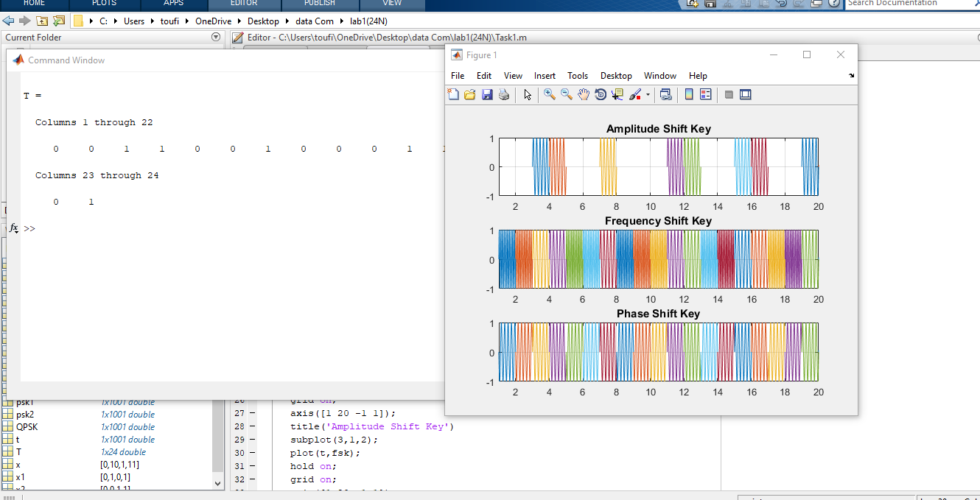

b)

|  |
| --- |
| close all;  clc;  f=10;  x=[00 11 00 10 00 11 00 11 00 11 01 01]  x1=[0 1 0 1 0 1 0 1 0 1 0 0];  x2=[0 1 0 0 0 1 0 1 0 1 1 1];  nx=size(x1,2)  i=1;  while i<nx+1  t = i:0.01:i+1;  if x1(i)==1  psk1=sin(2*pi*f*t);  else  psk1=sin(2*pi*f*t+pi);  end    if x2(i)==1  psk2=sin(2*pi*f*t+pi/2);  else  psk2=sin(2*pi*f*t+pi+pi/2);  end    QPSK = psk1+psk2;    subplot(3,1,1);  plot(t,psk1);  hold on;  grid on;  axis([1 5 -1 1]);  title('PSK1')    subplot(3,1,2);  plot(t,psk2);  hold on;  grid on;  axis([1 5 -1 1]);  title('PSK2')  subplot(3,1,3);  plot(t,QPSK);  hold on;  grid on;  axis([1 5 -2 2]);  title('QPSK')  i=i+1;  end |

