CITIZENS BANK PLC (CZB)
CloudNet Corporate Dynamic Internet Banking Platform
CORPORATE USER OPERATIONS MANUAL
Standard Operating Procedures, Field Specifications & Procedural Guide for Corporate Operators

Parameter | Operational Details
Financial Institution | Citizens Bank PLC (CZB)
Platform Engine | CloudNet Corporate Dynamic Internet Banking (Angular 15 SPA)
Portal UAT / Staging URL | https://ibanktest.citizensbankbd.com/CorporateCBPLCUAT/login
Production Access URL | https://corporate.citizensbankbd.com/ (or /corporate/)
Client Reference Account | ttml2023 (Corporate Institutional Client Profile)
Initial Access Credential | User ID: ttml2023 | Password: 1 (Requires Mandatory Change)
Document Scope | Complete End-to-End User Operations Manual with Screen Walkthroughs
Document Version | Version 2.0 (Enterprise Release with UI Screenshots)
Corporate Banking Helpline | 16222 (24/7 Dedicated Corporate Helpdesk)
Corporate Support Email | corporate.support@citizensbankbd.com

[SECURITY NOTICE] ENTERPRISE SECURITY & GOVERNANCE ADVISORY
This User Operations Manual is the property of Citizens Bank PLC. It details standard operating procedures for corporate cash management, bulk payroll, maker-checker authorization, and account administration. Corporate operators must strictly adhere to internal financial controls and never share login credentials, OTP codes, or security tokens.

Chapter 1: Platform Overview, Security Architecture & Governance
Welcome to the Citizens Bank PLC CloudNet Corporate Dynamic Internet Banking Platform. Engineered specifically for corporate institutions, commercial enterprises, manufacturing conglomerates, government agencies, and educational institutions, the portal provides high-speed treasury operations, high-volume bulk disbursements, trade finance requisitions, and multi-level authorization governance.

1.1 The Maker-Checker Dual-Control Principle
In strict compliance with Bangladesh Bank Guidelines on ICT Security for Scheduled Banks, all financial movements and administrative changes enforce the Maker-Checker Dual Approval Framework:
• Corporate Maker (Operator): The initiator responsible for drafting single fund transfers, uploading bulk payroll spreadsheets, creating beneficiaries, and initiating service requests. A Maker cannot debit funds or finalize transactions.
• Corporate Checker (Authorizer): The authorized signatory responsible for inspecting transaction details, recipient account titles, routing codes, and total amounts in both figures and words before providing cryptographic 2FA OTP sign-off. A Checker cannot authorize transactions they initiated.
• Corporate Viewer (Auditor): Internal auditors and finance viewers granted read-only visibility over account balances, transaction histories, receipts, and audit logs without financial movement capabilities.
• Corporate Administrator: The corporate domain master managing child operator accounts, setting account-level transaction caps, and mapping ERP spreadsheet formats.

1.2 Tiered Monetary Approval Slabs
Transactions are automatically routed through dynamic approval workflows based on amount thresholds:
Monetary Slab Threshold | Required Approval Flow | Authorizer Designations | Enforcement Rule
BDT 0.01 – BDT 500,000 | Single Level Approval (1-of-1) | Level 1 Authorizer | Approved by any Level 1 Checker
BDT 500,000.01 – BDT 5,000,000 | Dual Level Approval (2-of-2) | Level 1 + Level 2 Authorizers | Sequential: Level 1 signs first, then Level 2 signs off
BDT 5,000,000.01 – BDT 50,000,000 | Triple Level Approval (3-of-3) | Level 1 + Level 2 + Level 3 Authorizers | Sequential or Parallel approval requiring all 3 levels
Above BDT 50,000,000 | Executive Board Slab | Level 3 + Managing Director / Signatory | Mandatory dual Level 3 signing with executive OTP

Chapter 2: Accessing the Portal, Login & Authentication
To access the Citizens Bank Corporate Portal, open a modern web browser (Google Chrome, Microsoft Edge, Mozilla Firefox, or Apple Safari) and navigate to the portal login page:
Portal URL: https://ibanktest.citizensbankbd.com/CorporateCBPLCUAT/login

2.1 Step-by-Step Login Procedure
• Step 1 - User ID: Enter your assigned Corporate User ID in the 'User ID' field (e.g., ttml2023).
• Step 2 - Password: Enter your password in the 'Password' field (e.g., initial assigned password 1).
• Step 3 - Captcha: Solve the displayed cryptographic Captcha challenge to confirm human interaction.
• Step 4 - Submit: Click the prominent 'LOGIN' button. The system validates credentials against the Core Banking API.
• Step 5 - 2FA Verification: The system prompts an OTP challenge. Retrieve the 6-digit OTP sent to your registered mobile and corporate email, input the digits, and confirm within the 120-second timer.
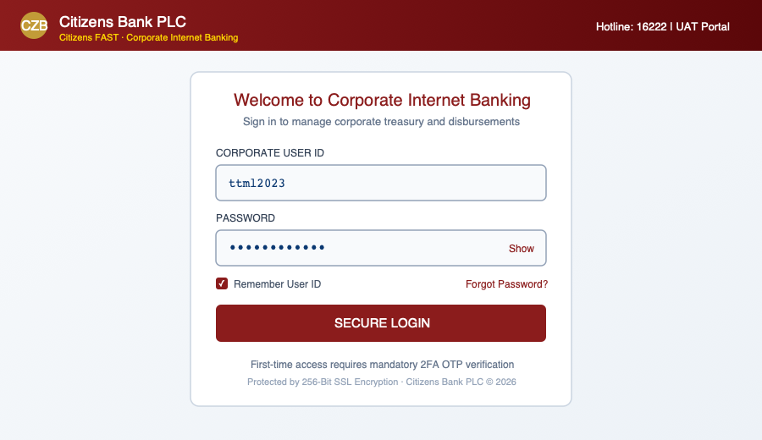
Figure 1: Citizens Bank Corporate Login Portal (User ID: ttml2023, Captcha Challenge, and 2FA Verification)

2.2 First-Time Login & Mandatory Password Change
Upon first login with a temporary password (e.g., password '1'), the portal immediately redirects to the Mandatory Password Change screen (/account/changepassword). You must set a permanent high-entropy password satisfying the bank's security policy:
• Rule 1: Minimum Length: At least 12 characters.
• Rule 2: Complexity: Must include at least 3 of 4 character classes: Uppercase (A-Z), Lowercase (a-z), Numeric (0-9), and Special Characters (@&.-_!#^*()+).
• Rule 3: History Lock: Cannot be identical to any of your previous 4 passwords.
• Rule 4: Validity Period: Passwords remain valid for 90 days before a scheduled change is enforced.

Chapter 3: Corporate Dashboard Navigation & Liquidity Overview
Upon successful authentication, operators land on the Corporate Dashboard (/). The interface provides an executive summary of the company's financial status and pending action items:
• Liquidity Balance Widgets: Displays total available funds, ledger balances, and currency across all operating accounts, time deposits, and loan facilities.
• Pending Authorization Center: Prominently alerts Checkers to the exact count and cumulative monetary value of pending transfers waiting for their sign-off.
• Quick Action Shortcuts: One-click access to Single Fund Transfer, Bulk Payroll, Beneficiary Directory, Statement Inquiry, and Cheque Services.
• Notification Center: Bell icon in top bar showing unread bank operational notices, clearing cutoff updates, and scheduled maintenance alerts.
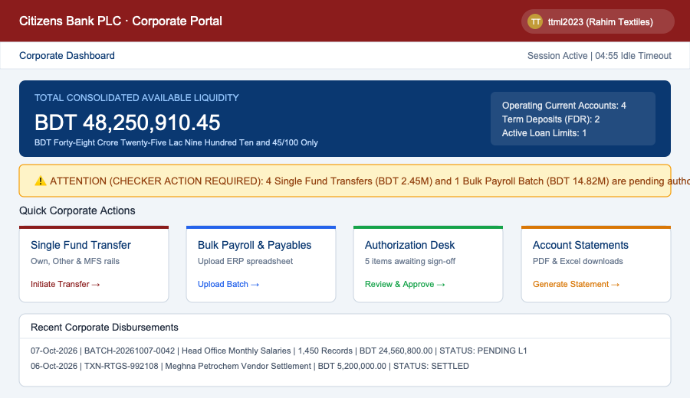
Figure 2: Corporate Dashboard — Real-time Account Liquidity, Pending Approvals Badge, and Quick Action Center

Chapter 4: Single Fund Transfers & Interbank Clearing Rails
Navigate to Transactions -> Fund Transfer (/transactions/fundtransfer) to initiate individual disbursements:

4.1 Own Account Transfers (Intra-Company Rebalancing)
Move funds instantly between corporate operating, collection, and payroll accounts within Citizens Bank PLC. Select Source Account, select Destination Account, input the Amount and Narration, and click Submit. Real-time balance validation ensures sufficient funds are maintained.

4.2 Third-Party Citizens Bank Account Transfers
Transfer funds to vendor or supplier accounts maintained at any branch of Citizens Bank PLC. When the Maker selects or inputs the 13-digit destination account number, the portal automatically triggers an asynchronous CBS title lookup. The official registered Account Holder Name is displayed in a highlighted green badge. The Maker must visually verify the recipient title before submitting.
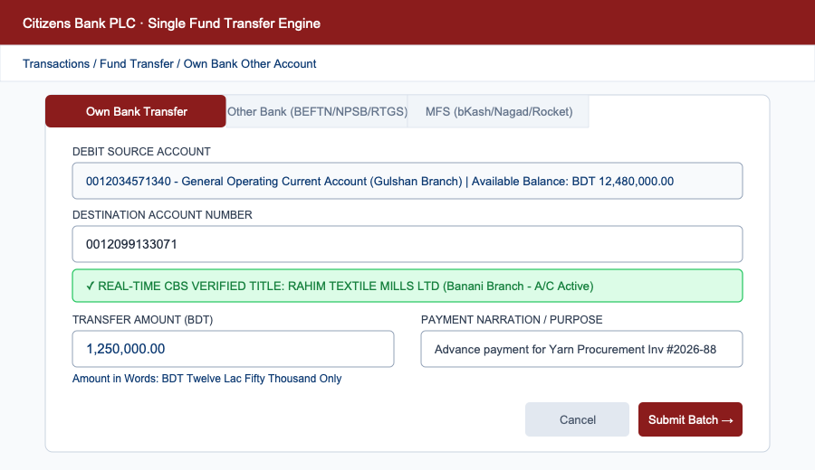
Figure 3: Single Fund Transfer Console with Real-time CBS Account Title Lookup & Validation Badge

4.3 National Interbank Clearing Rails (Other Bank)
Clearing Rail | Processing Speed | Amount Floor & Caps | Operational Window | Recommended Use Case
BEFTN | Batch Settlement (Same/Next Day) | No minimum amount floor | 2 Central Bank Sessions / Day | Routine vendor payments, dividend payouts
NPSB | Instant Real-Time (Seconds) | Up to BDT 300,000 per txn | 24/7/365 Continuous | Urgent contractor fees, emergency vendor settlements
RTGS | Instant Gross Settlement | Minimum floor: >= BDT 100,000 | 10:00 AM – 03:00 PM (Sun–Thu) | High-value corporate treasury & supplier settlements

4.4 Mobile Financial Services (MFS) Corporate Disbursements
Disburse funds directly to mobile wallets: bKash, Nagad, Rocket, Upay, and TAP. The system enforces wallet syntax rules (11 digits for bKash/Nagad/Upay/TAP, and strictly 12 digits for Rocket wallets). To eliminate typographical errors, direct manual typing of wallet numbers is restricted; users must select an enrolled, pre-authorized MFS payee.

Chapter 5: Enterprise Bulk Fund Transfer & Corporate Payroll Engine
The Bulk Fund Transfer console (/transactions/bulk-transfer) is engineered for high-volume salary disbursements, contractor fees, and shareholder dividends, supporting up to 10,000 transactions per file.

5.1 Dynamic File Mapping Engine (/settings/dynamic-file-mapping)
Corporate clients can upload spreadsheets directly from SAP, Oracle, Tally, or custom HRMS without manual reformatting:
• File Support: ed Formats: Microsoft Excel (.xlsx, .xls) and Comma-Separated Values (.csv).
• Column Mapping: Visual Column Mapping: Map spreadsheet headers to Core Banking target fields: Account Number, Account Title, Bank Name, Branch Name, Routing Number, Payment Amount, and Narration.
• Substring Rules: Substring Extraction Rules: Define character range rules (e.g., extract 13 digits starting from index 5 in composite ERP strings like 'EMP-0012345678901-SAL').
• Named Profiles: Saved Profiles: Save named profiles (e.g., 'SAP Factory Payroll', 'Head Office Monthly Salary') for one-click reuse.

5.2 Pre-Execution Validation & Error Handling
Upon file upload, the engine pre-validates every row: syntax checks, routing number resolution, and real-time core banking status verification for internal Citizens Bank accounts (verifying accounts are Active and not dormant or frozen). If errors exist, an interactive Error Grid highlights specific row numbers and error descriptions with an option to download the error report for correction.
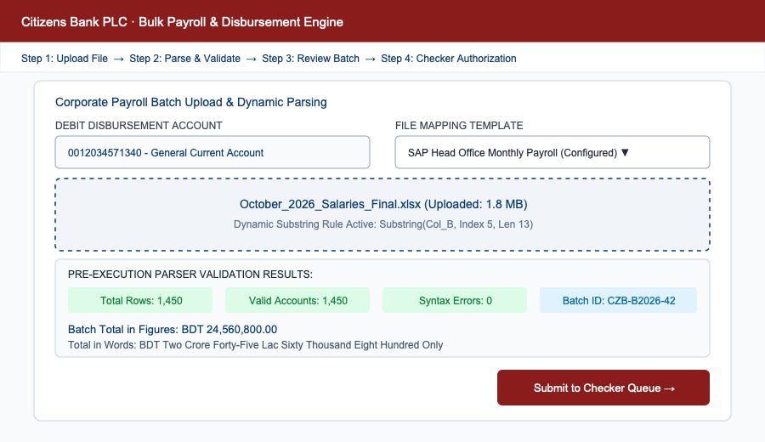
Figure 4: Bulk Payroll Transfer Engine with Dynamic Column Mapping, Substring Parsing & Pre-Execution Validation

5.3 Batch Total in Figures & Words and Maker Submission
Upon validation, the portal displays a Batch Summary Card showing Total Records, Total Amount in Figures, and the total converted into words (e.g., 'BDT Two Crore Forty Lac Fifty Thousand Only'). The Maker reviews the summary and clicks 'Submit Batch', generating a Batch Reference Number (e.g., BATCH-CZB-20261007-0042) and routing it to the authorization queue.

Chapter 6: Dual-Control & Multi-Level Authorization (Checker Guide)
Checkers log in to /transactions/ftauthorization to inspect and sign off on pending single transfers, bulk payroll batches, and service requests.

6.1 Step-by-Step Approval Workflow
• Step 1 - Inspect Queue: Locate the pending transaction or batch in the queue. Inspect Value Date, Batch Reference, Debit Account, Channel, and Total Amount.
• Step 2 - Verification: Click 'Details' to inspect row-level recipient names, account numbers, routing codes, and total amounts in figures and words.
• Step 3 - OTP Challenge: Click 'Authorize / Approve'. The system triggers a dual-channel 2FA OTP to your mobile phone and email.
• Step 4 - Execution: Enter the 6-digit OTP within 120 seconds and click 'Confirm'. The Core Banking API executes real-time disbursements and generates a downloadable voucher.
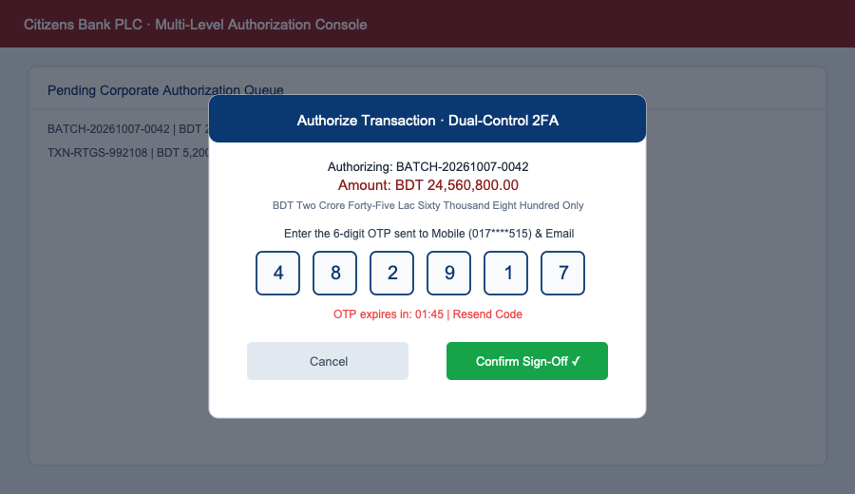
Figure 5: Checker Authorization Queue, Transaction Detail Inspector & 2FA OTP Cryptographic Sign-Off Modal

6.2 Rejection Workflow
If discrepancies exist, click 'Reject'. A mandatory remarks dialog appears requiring a specific rejection explanation (minimum 10 characters, e.g., 'Incorrect payment amount for invoice #402'). The Maker is notified, and the item is logged as REJECTED in the audit trail.

Chapter 7: Corporate Account Management & Statement Reconciliation

7.1 Account Details & Cheque History (/account/account-details)
Provides an in-depth view of individual corporate accounts: Ledger Balance, Available Balance, Lien/Hold Amount (funds held for LC margins or guarantees), and Cheque Leaf Status Inquiry (Issued, In-Clearing, Honored, Stopped, or Bounced).

7.2 Statement Inquiry & High-Resolution Export (/account/statement)
Generate detailed transaction statements using flexible filters: Account Selector, Preset Period Filters (Today, 7 Days, 1 Month, 3 Months, Financial Year), or Custom Date ranges, rendering up to 500 rows per page with search-within-results.
• PDF Statement: Download Official PDF: Download high-resolution signed statements generated via CloudNetReportAPI complete with bank logo, branch details, CIF, and balances.
• Excel Statement: Download Excel Spreadsheet: Export editable .xlsx spreadsheets for ERP general ledger reconciliation.
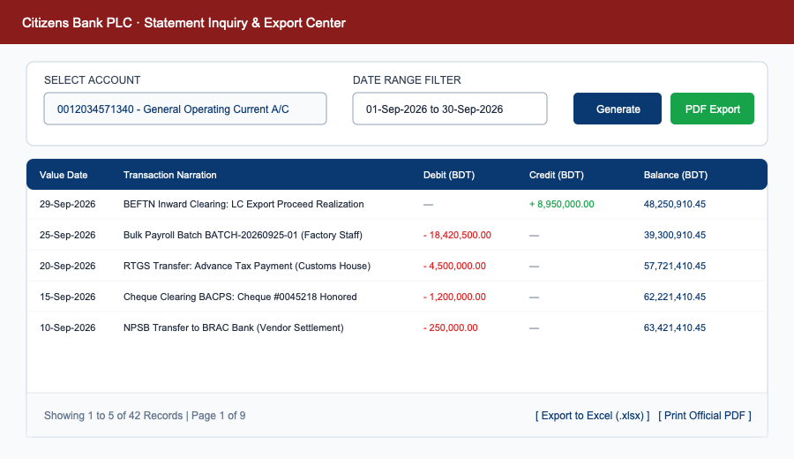
Figure 6: Corporate Account Statement Inquiry Console with Multi-criteria Filtering & Signed PDF/Excel Export

7.3 Transaction Receipts (/account/transaction-receipt)
Download official branded transaction vouchers containing CBS Transaction ID, Clearing Batch Reference, Value Date, Sender Account, Recipient Title, Channel, and Amount in Figures and Words.

Chapter 8: Beneficiary Directory Management Hub
The Beneficiary Directory (/beneficiary/beneficiary) centralizes payee management across Own Bank (Citizens Bank), Other Bank, and MFS categories.
• Enrolling Own Bank: Own Bank Payee: Input 13-digit account number. System auto-verifies and displays Account Title via CBS. Assign Nickname and verify via 2FA OTP.
• Enrolling Other Bank: Other Bank Payee: Select Account or Card. Enter Account Title, Account Number, select Bank -> District -> Branch. System auto-populates the 9-digit routing number. Verify via OTP.
• Enrolling MFS: Payee: Select provider (bKash, Nagad, Rocket, Upay, TAP), input valid wallet number, assign Nickname, and verify via OTP.
• Field Locking Rule: Field Locking Policy: Once authorized and saved, core financial routing fields (Account Number, Bank, Branch, Routing Number, Wallet Number) are permanently locked. Users can only edit the Nickname.

Chapter 9: Corporate Service Requests ('Requests Desk')

9.1 Bank Solvency Certificate Requisition (/myservices/banksolvencyrequest)
Request official Bank Solvency Certificates online for tender bids, visa applications, or audit reviews. Select Account Number, Purpose, Currency conversion preferences, and Delivery Branch or digital issuance.

9.2 Tax Return Proof (PSR) Document Upload (/myservices/tax-document-upload)
In accordance with NBR regulations, upload annual Proof of Submission of Return (PSR) acknowledgment slips. Attaching valid slips ensures corporate accounts retain the standard 10% withholding tax rate instead of the 20% non-compliance penalty rate.

9.3 Centralized Service Request Log (/myservices/request-log)
Track the real-time lifecycle of all submitted service tickets with status badges: Pending (Amber), In-Review (Blue), Approved / Dispatched (Green), and Rejected (Red).

Chapter 10: Corporate Administration & User Management

10.1 Provisioning Child Operators (/usermanagement/usercreation-request)
Corporate Master Administrators provision child user accounts under the corporate domain. Fields include Full Name, Official Employee ID, Department, Corporate Email, Mobile Number, Designation, and Assigned Role (Maker, Checker, Viewer).

10.2 User Account Permission Matrix (/usermanagement/useraccountpermission)
Configure account-level access controls and monetary limits on a per-user, per-account basis: associate specific corporate bank accounts with individual users, set Single Transaction Caps, Daily Cumulative Volume Caps, and Daily Transaction Count limits.

Chapter 11: Audit Trails & Enterprise Cybersecurity Governance

11.1 Immutable User Activity Log (/activity/useractivity)
An immutable audit trail recording all user interactions: Logins, Logouts, Beneficiary Additions, File Mappings, and Transaction Authorizations. Each log entry captures Timestamp (ISO 8601), User ID, Client Network IP Address (resolved dynamically via UserIPUrl), Action Category, and Status (SUCCESS, FAILED, REVOKED).

11.2 Best Practices for Corporate Cyber Hygiene
• Zero Credential Sharing: Never share login credentials or OTPs with colleagues or external callers.
• Account Title Verification: Always visually verify the Account Title retrieved from CBS before confirming single transfers.
• Figures vs Words Check: Confirm that bulk payroll amounts in words match your company's approved payroll register.
• Phishing Awareness: Citizens Bank staff will never ask for your password or OTP. Report suspicious activity immediately to 16222.

Chapter 12: Complete Application Routing & Role Permissions Map
Master matrix detailing all 29 functional screen routes across the Citizens Bank Corporate Portal:
Application URL Route | Feature Screen & Operational Purpose | Route Guard | Required Role Permission Code
/login | Corporate User Login | Public | None
/selfregistration | Corporate Client Self-Registration | Public | None
/passwordrecovery | Self-Service Password Reset | Public | None
/useridrecovery | User ID Recovery | Public | None
/instruction | Sign-Up Guidelines & Terms | Public | None
/aboutus | About Citizens Bank PLC | Public | None
/privacypolicy | Privacy Policy & Data Protection | Public | None
/ | Corporate Dashboard Overview | AuthGuard | Authenticated Session
/account/account-details | Account Details & Cheque History | AuthGuard | Authenticated Session
/account/statement | Statement Inquiry & PDF/Excel Export | AuthGuard | Authenticated Session
/account/financial-transactions | Fund Transfer Transaction History | AuthGuard | Authenticated Session
/account/transaction-receipt | Official Transaction Receipt Slip | AuthGuard | Authenticated Session
/account/changepassword | Change User Password | AuthGuard | Authenticated Session
/transactions/fundtransfer | Single Fund Transfer (EFT/NPSB/RTGS/MFS) | RoleGuard | CORP_FUND_TRANSFER
/transactions/bulk-transfer | Bulk Payroll & Vendor Batch Transfer | RoleGuard | CORP_BULK_FUND_TRANSFER
/transactions/ftauthorization | Multi-Level Transaction Authorization | RoleGuard | CORP_FUND_TRANSFER_AUTHORIZATION
/beneficiary/beneficiary | Beneficiary Directory Management | AuthGuard | Authenticated Session
/myservices/banksolvencyrequest | Solvency Certificate Request | AuthGuard | Authenticated Session
/myservices/tax-document-upload | Tax Return Proof (PSR) Slip Upload | AuthGuard | Authenticated Session
/myservices/request-log | Service Request Tracking Console | AuthGuard | Authenticated Session
/usermanagement/usercreation-request | Create Corporate Child Operators | RoleGuard | CORP_ADD_NEW_USER
/usermanagement/useraccountpermission | User Account Permission & Limits | RoleGuard | CORP_ADD_EDT_USER_ACC_SETTINGS
/settings/authorizationlevel | Corporate Approval Hierarchy Setup | RoleGuard | CORP_ADD_EDT_ACC_LVL
/settings/orgauthlevelname | Org Designation Customization | AuthGuard | Authenticated Session
/settings/dynamic-file-mapping | Custom Spreadsheet Column Parser | RoleGuard | CORP_ADD_EDT_DYNAMIC_FILE_MAPPING
/activity/useractivity | Immutable User Activity Audit Trail | AuthGuard | Authenticated Session
/profile/detailprofile | Corporate Detailed KYC & Contacts | AuthGuard | Authenticated Session
/otherservices/notifications | Notifications & Announcements | AuthGuard | Authenticated Session
/securityadvice | Information Security Guidelines | AuthGuard | Authenticated Session

Chapter 13: Operational Checklists, Troubleshooting & FAQs

13.1 Daily Operational Checklist
• Maker Checklist 1: Verify available account balances prior to initiating transfers.
• Maker Checklist 2: Ensure payroll spreadsheets conform to your saved Dynamic File Mapping profile.
• Maker Checklist 3: Check row-level syntax errors and verify total amounts in words.
• Maker Checklist 4: Submit batches and note the generated Batch Reference Number for tracking.
• Checker Checklist 1: Inspect the Pending Authorization Queue (/transactions/ftauthorization) each morning.
• Checker Checklist 2: Verify recipient titles, routing codes, and amounts in words against internal payment vouchers.
• Checker Checklist 3: Submit 2FA OTP promptly within the 120-second validity timer.

13.2 Frequently Asked Questions (FAQ)
• Q1: Why is RTGS disabled? RTGS clearing is only open Sunday to Thursday between 10:00 AM and 03:00 PM BST for amounts >= BDT 100,000. For lower amounts or after hours, use NPSB (instant up to BDT 300,000) or BEFTN.
• Q2: Can a Maker authorize their own transfer? No. The system strictly enforces dual-control segregation of duties. Transactions must be signed off by an independent Checker.
• Q3: What if I enter the wrong password 5 times? Your account will be locked for security. Use the 'Forgot Password' link on the login page or contact your Corporate Master Administrator to reset your profile.
• Q4: How do I change an existing beneficiary's account number? Due to field locking rules, core routing fields are permanently immutable once authorized. Delete the existing payee and re-enroll with the corrected details.

13.3 Support Contacts & Emergency Escalation
• 24/7 Corporate Helpline: Dial 16222 from any mobile or landline within Bangladesh.
• Corporate Helpdesk Email: Email corporate.support@citizensbankbd.com or ibank.support@citizensbankbd.com.
• Head Office: Citizens Bank PLC, Corporate Banking Division, Head Office, Motijheel, Dhaka, Bangladesh.

