**Online Blood Bank Management System**

Tabassum Aroni(220101015)*, Nusrin Toma(2201010116)*,

Moumita Sarkar mou (2201010117)* and Fahim Foysal(210101026)

Course Code: CSE 2206 Course Title: Database Management systems Sessional

Semester: Summer 2023

*Department of Computer Science and Engineering, Bangladesh Army University of Science and Technology (BAUST)

1. **Introduction**

A Blood Bank Management System is a software application or system designed to efficiently manage the various aspects of blood donation and blood supply within a healthcare organization or a dedicated blood bank facility. This system helps streamline the process of collecting, testing, storing, and distributing blood and blood products. Here is an introduction to the Blood Bank Management System

It serves as the bridge between voluntary blood donors and individuals requiring blood transfusions, making it an essential and life-saving part of the medical ecosystem.

1. **Problem Definition**

* **Blood Shortages**
* **Blood Wastage**
* **Lack of Standardization**
* **Inadequate Donor Management**
* **Manual and Paper-Based Systems**
* **Reporting and Compliance**

We solve those problems by the authorities of clinic and know the solution of a nurse in the clinic .

1. **Available Applications**

* [https://bbms.dghs.gov.bd](https://bbms.dghs.gov.bd/)
* [https://bdrcs.org](https://bdrcs.org/)
* https://blood.quantummethod.org.bd

1. **Stakeholders**

**Blood Donors:** Individuals who voluntarily donate blood to the blood bank. They are a vital part of the system as they provide the blood supply.

**Blood Recipients:** Patients in need of blood transfusions who receive blood from the blood bank.

**Blood Bank Staff:** The employees of the blood bank, including administrators, doctors, nurses, and laboratory technicians. They are responsible for collecting, testing, storing, and distributing blood.

**Blood Bank Management:** The management team overseeing the operation of the blood bank, including setting policies and ensuring compliance with regulations.

1. **Issues Encountered**

* Blood Shortages
* Inventory Management
* Blood Wastage
* Donor Recruitment and Retention
* Emergency Response
* Technology Adoption
* Staff Training
* Public Awareness

1. **System Architecture**

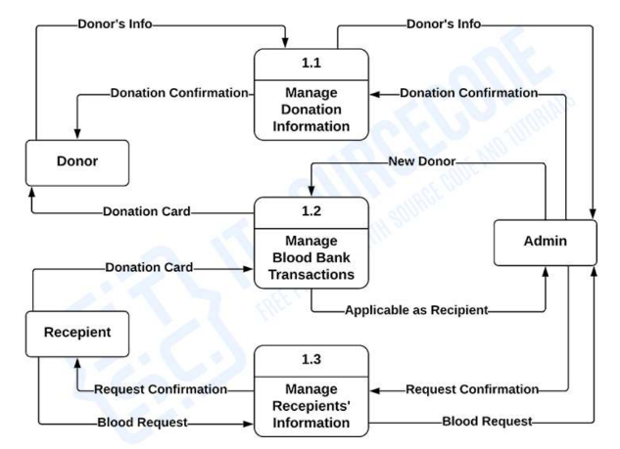

1. **Database Design**

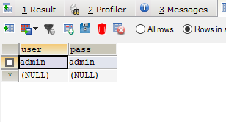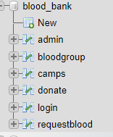

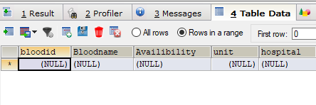

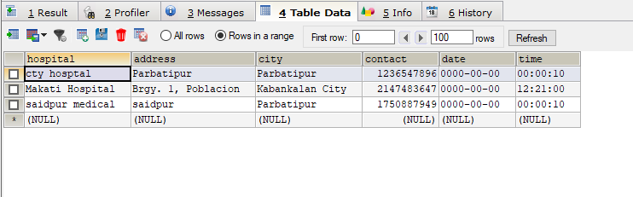

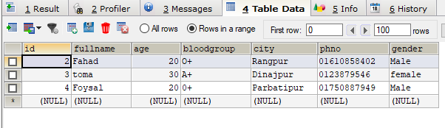

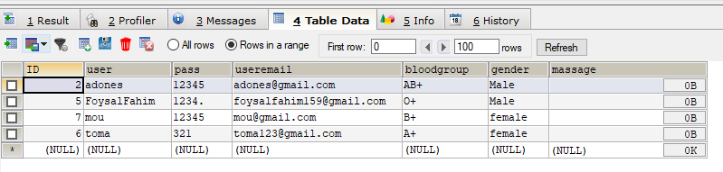

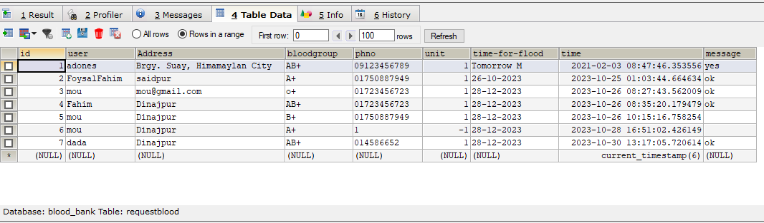

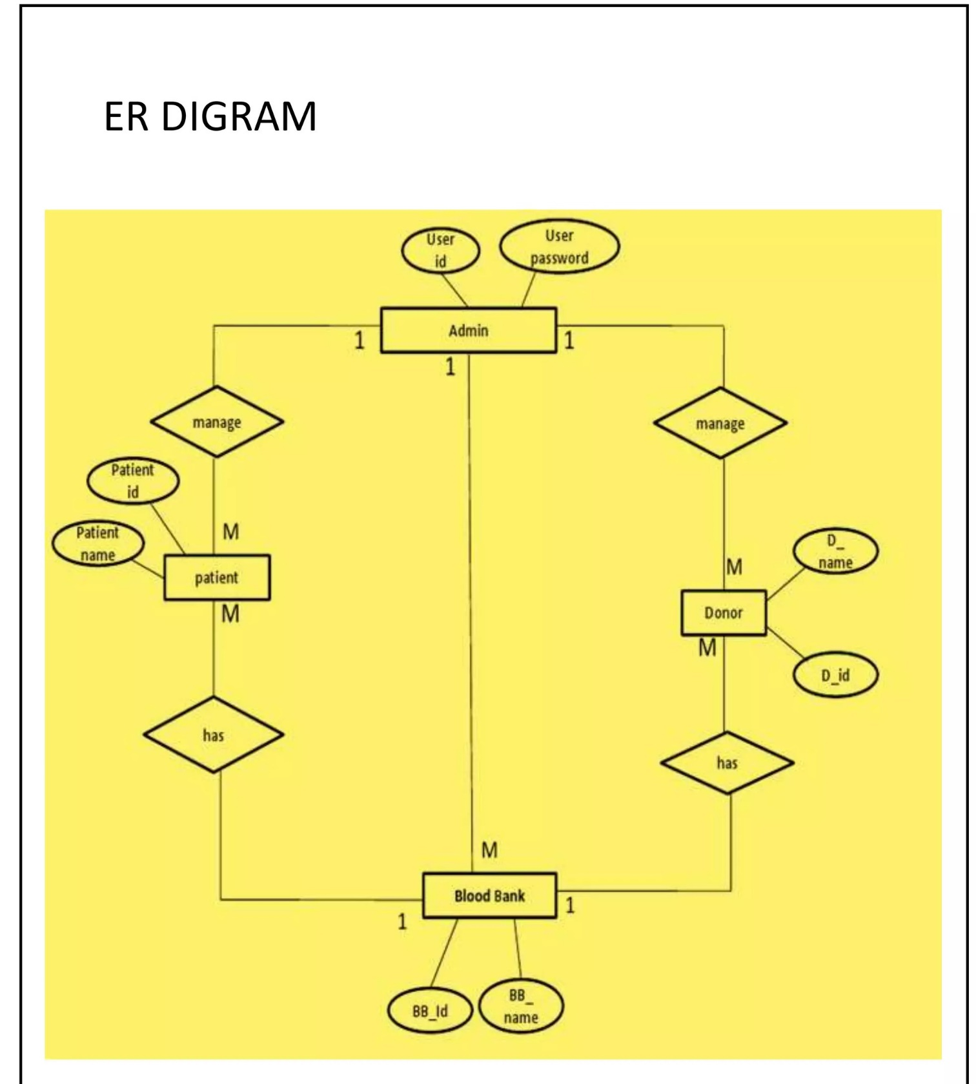

1. **Tools and Technologies**

**HTML**- A markup language used for creating and structuring web content

**CSS**- A styling language used for enhancing the look and feel of web content

**PHP**- A server-side scripting language used for developing dynamic web pages and applications

**MySQL**-An open-source relational database management system used for storing and retrieving data.

1. 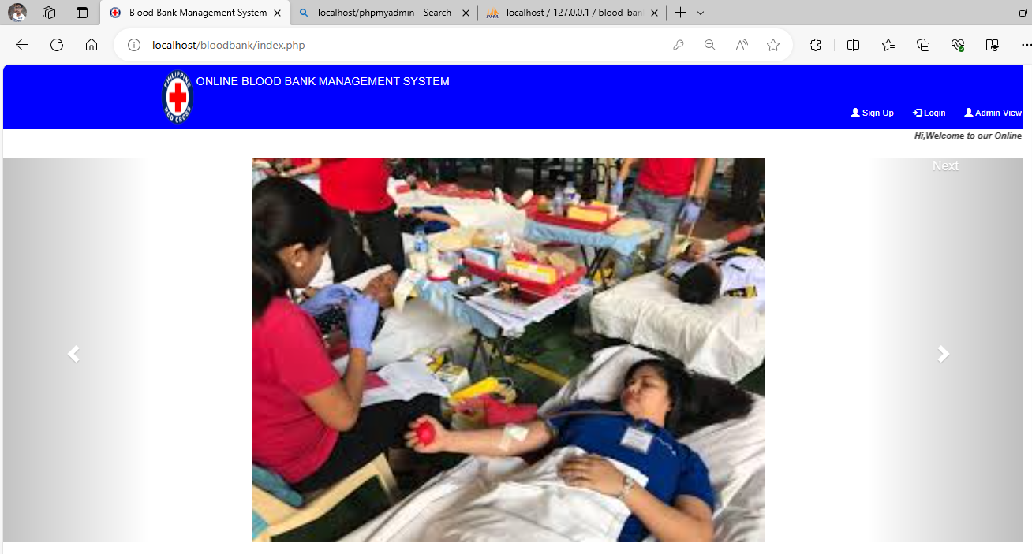**Implementation**

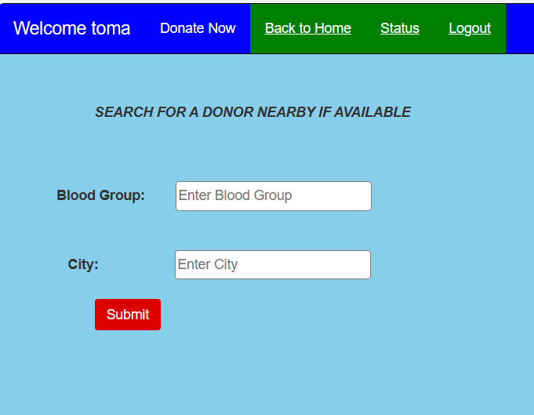

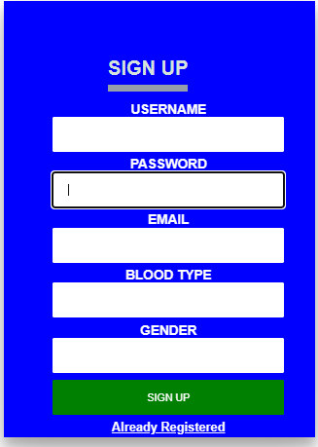

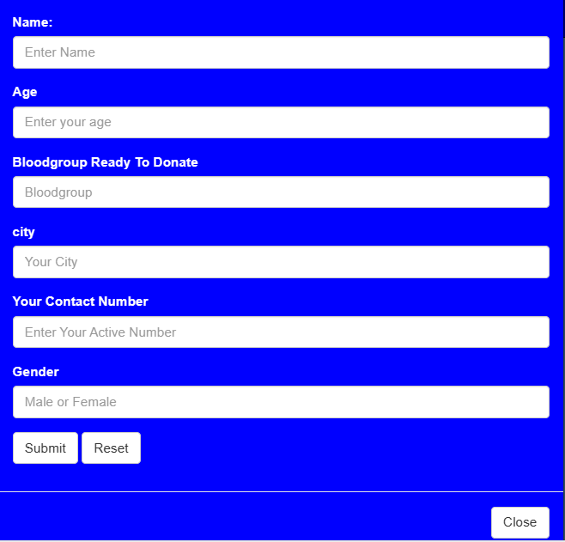

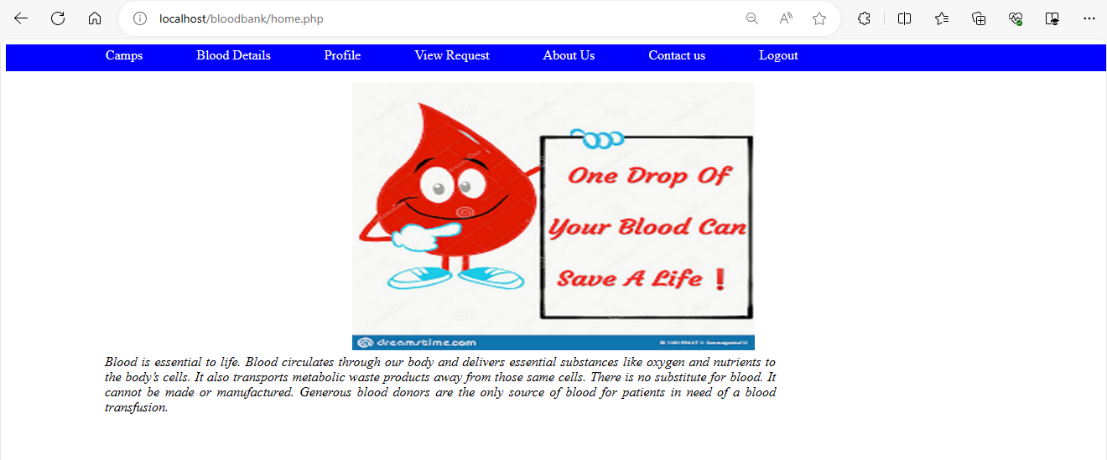

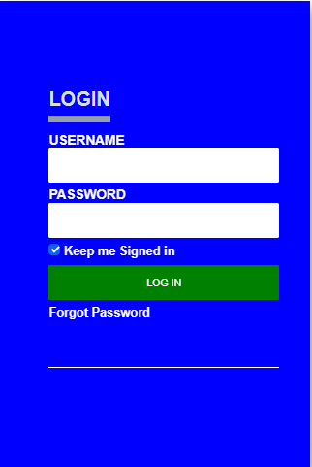

1. **Conclusion and Limitations**

In conclusion, an Online Blood Bank Management System is a vital and efficient solution for the organization, coordination, and automation of blood donation and distribution processes. It streamlines donor recruitment, ensures the safety and quality of blood products, and facilitates quick responses during emergencies. By leveraging technology, such a system can enhance the availability of life-saving blood and strengthen healthcare systems, ultimately improving the quality of patient care and public health.

* Donor Verification
* Limited Access
* Data Security
* Technical Issues
* Dependence on Connectivity

**Appendix**

Attainment of Complex Engineering Problem (CP)

|  |  |  |  |
| --- | --- | --- | --- |
| S.L. | CP No. | Attainment | Remarks |
| 1. | P1: Depth of Knowledge Required | Yes | K3 (Engineering Fundamentals): Database Design |
| K4 (Engineering Specialization): Bootstrap |
| K5 (Design): ER diagram Article no:7 |
| K6 (Technology): Article no 8: PHP, MySQL, HTML, CSS |
| K8 (Research): Article no 3. Available Applications |
| 2. | P2: Range of Conflicting Requirements | yes | Online blood bank management System, Database management system |
| 3. | P3: Depth of Analysis Required | No |  |
| 4. | P4: Familiarity of Issues | Yes | Online Blood bank management system |
| 5. | P5: Extent of Applicable Codes | Yes | Article no 6. System Architecture |
| 6. | P6: Extent of Stakeholder Involvement and Conflicting Requirements | Yes | Blood Donors,  Blood Bank Staff  Blood Recipients  Blood Bank Management |
| 7. | P7: Interdependence | Yes | Article No 9. Implementation |

Mapping of Complex Engineering Activities (CA)

|  |  |  |  |
| --- | --- | --- | --- |
| S.L. | CA No. | Attainment | Remarks |
| 1. | A1: Range of resources | Yes | Stakeholder:Blood Donors, Blood Bank Staff,Blood Recipients, Blood Bank Management |
| 2. | A2: Level of interaction | Yes | We have learned PHP, MySQL, CSS, HTML |
| 3. | A3: Innovation | No |  |
| 4. | A4: Consequences for Society and the Environment | No |  |
| 5. | A5: Familiarity | No |  |