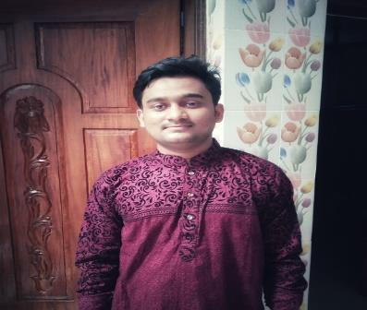

**Curriculum Vitae**

Of

Abdullah Al Foysal

**Mailing Address:**

House#30/A, Sokrabad Masjid Road,

Sokrabad, Dhaka.

**Cell:** +8801639070766

**Email:** [faysalakhan743@gmail.com](mailto:faysalakhan743@gmail.com)

**Objective:**

Seeking a position with a challenging role in a reputable organization to expand and utilize my learnings, knowledge and skills.

**Technical Skills:**

**Language:** Java, C, JavaScript, PHP.

**Others:** React.js library,Swing, HTML, CSS, Bootstrap.

**Database:** MySQL, SQLite.

**Operating System:** Windows, Linux.

**Projects:**

**.**

**.**

**.**

**.**

**.**

**.**

Global Custody (Java and MySQL Database).

Money Exchange (Java Swing).

Facebook Log-in Page (HTML, CSS).

Website for a Software Company (Xebec-ware Software Solution): (HTML, CSS, Bootstrap, JavaScript).

Simple E-commerce Website (HTML, CSS, Bootstrap, JavaScript). React Phone E-Commerce Website: (React.js).

**.** Car Zone Corner webpage. (Bootstrap).

.YouTube Clone: (React.js)

**Extra Curriculum Activities:**

 **Member at Daffodil International University Robotics Club (DIURC):**

I am a member of Daffodil International University Robotics Club**.** From the interesting on robotics I contribute with this club and with this club I am trying to learn new things.

 **Learned React.js with Daffodil International University CPC Club:**

I took a three month course to study JavaScript Library React.js that is run by Daffodil International University CPC club. I also attended many event and workshop

of DIU CPC club.

**Interested In Research:**

**.**

**.**

**.**

Machine Learning.

Data Mining

Bioinformatics

**Education**

B.Sc. in Computer Science and Engineering (11th Semester)

CGPA 3.37 out of 4.00, **Daffodil International University**