OPERATING SYSTEM
FINAL PROJECT
SPRING (2021)

MUHAMMAD FOZAN
19I-0507
CS-D

MUHAMMAD BILAL
19I-0636
CS-D

Phase 1 Pseudo code:

Main() function

MasterThread();
GameDisplay();

MasterThread() function
for i=0 to 4
create PlayerThread

PlayerThread() function
//Nothing related to phase one

GameDisplay()
call Display_board()
call Display_Dice()
call Display_tokens()

Phase 2 Pseudo code:

Main() function

MasterThread();
GameDisplay();

MasterThread() function
for i=0 to 4
create PlayerThread
create CollisionAndWinningThread
for i=0 to 4
if(stopmasterthread)
pthread_exit(NULL)

PlayerThread( int playerno) function

Diceinthread[3]
Sem_wait(SemDice)
while(turnagain)
Dicevalue=rand() % 6+1
Diceinthread[counter] = Dicevalue //getting the value of dice
if(dicevalue == 6 and its not a third 6)
turnagain = 1
else
turnagain = 0
Sem_post(SemDice)

Sem_wait(Board)
MoveIndex = rand() % totaltokens
//Move the token if possible else if any other token can move then call the random //function again and move the token if possible and so on
//If No move possible then pass the turn
Sem_post(Board)

CollisionAndWinningThread( int CurrPlayer) function
//For all players and their tokens
if(position of one player ‘s token = position of other player’s token)
if(position of the one player token != anysafepoint)
Send the token to home yard for the player which is not Curr Player
allpassed[CurrPlayer] = 0
For i=0 to totaltokens
if ( token location = winning triangle )
allpassed[CurrPlayer]++

GameDisplay() Function
call Display_board()
call Display_Dice()
call Display_tokens()

Concepts used in pseudo Code

The major concepts used in the pseudo are multi-threading and semaphores.
Multi-threading is used for faster computation where 4 player moves independently of one another in each iteration.

Semaphore of Dice is used so that more than one player does not try to get the value of the Dice at the same instant.

Semaphore of Board is used so that more than one player does not try to change the position of tokens on the board at the same instant which may lead to synchronization error.

Semaphore for Board is also used in collision detection to check the values of tokens on the board so that players don’t change the positions of tokens while detection of collision.

System specifications:

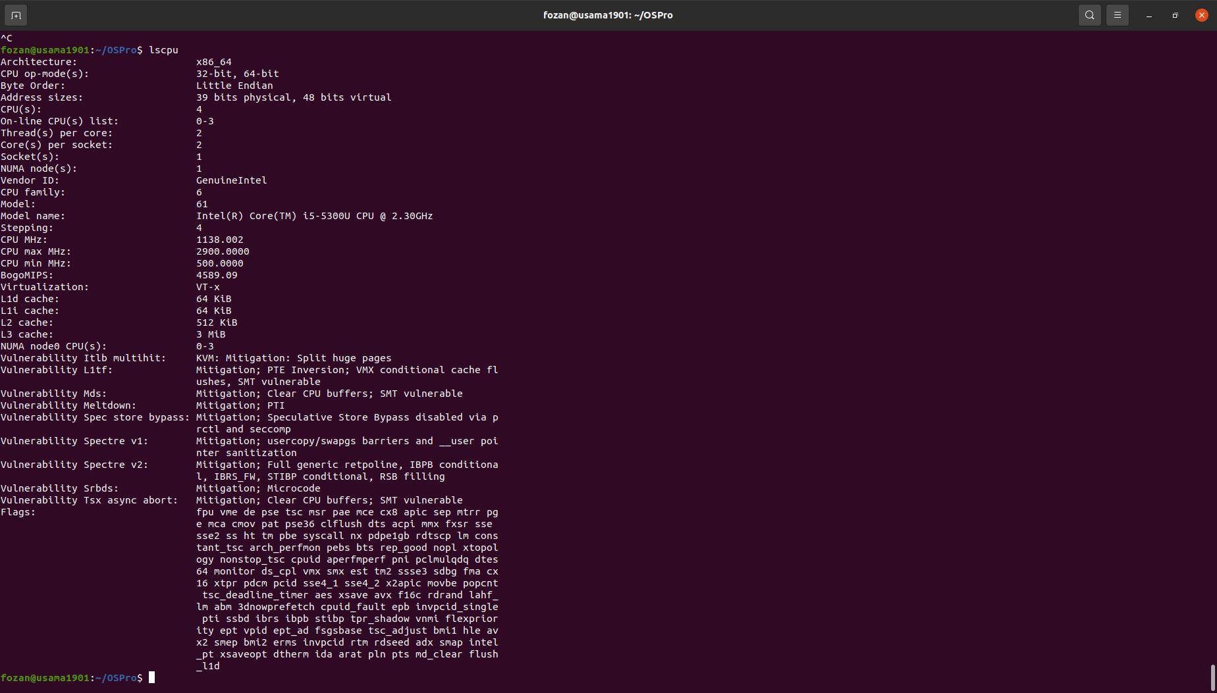

How to implement these concepts in some other scenario:

Consider a database, where multiple processes are attempting to write and read data. Multiple processes may read content from the database, but when one process is writing to the database, no other process, whether reader or writer, should be allowed to enter the database. This solution is possible using the techniques of semaphores where different threads are trying to access the database and the semaphore allows only one thread to access the critical section stopping all other threads.

Contribution:

We have implemented the whole project collectively but we focused more on these points individually.

Muhammad Bilal 19I-0636: 50%

Threads
Collision Detection
Winning portion
Half Display portion

Muhammad Fozan 19I-0507: 50%

Token implementation using Semaphores
Movement and Dice Rolling
Half Display portion

