Home work 2

Aaron fosmire

Ajf434

Collaborators None

Part 1

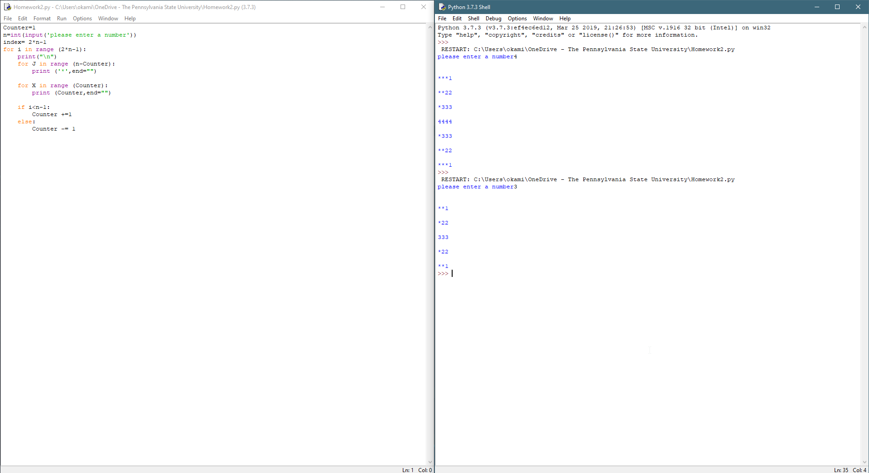

#Homework2

#Aaron fosmire

#ajf434

#Collaborators: None

Counter=1

n=int(input('please enter a number'))

index= 2*n-1

for i in range (2*n-1):

print("\n")

for J in range (n-Counter):

print ('*',end="")

for X in range (Counter):

print (Counter,end="")

if i<n-1:

Counter +=1

else:

Counter -= 1

Part 2

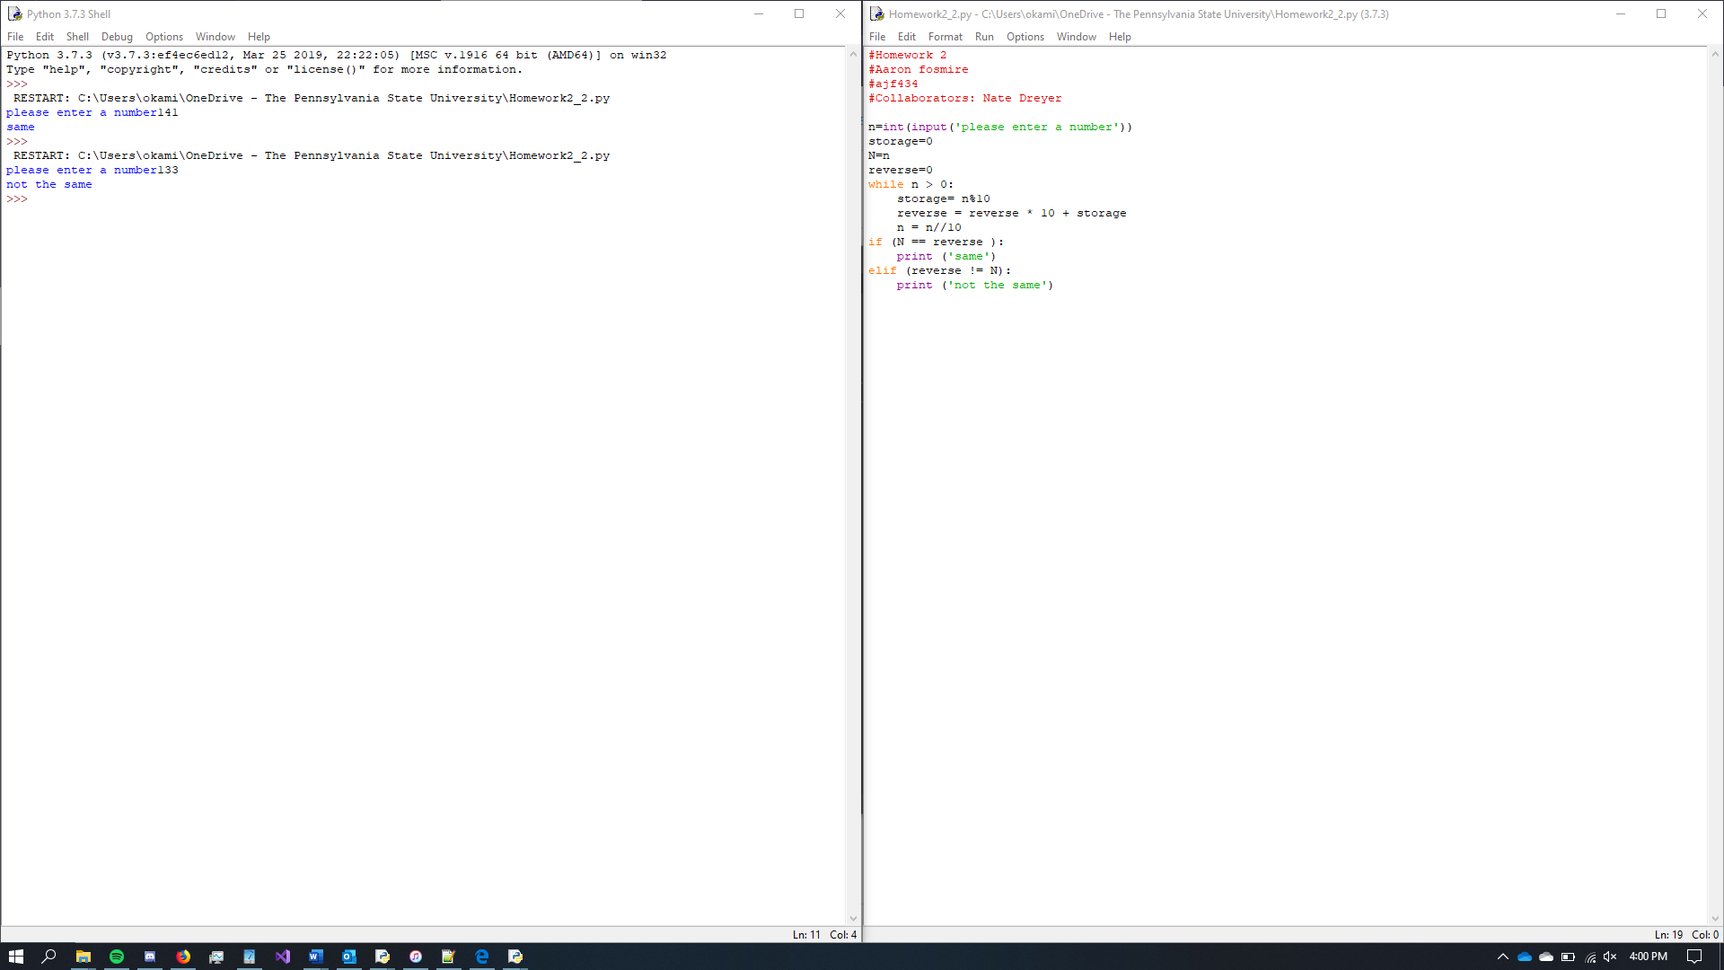

#Homework 2

#Aaron fosmire

#ajf434

#Collaborators: Nate Dreyer

n=int(input('please enter a number'))

storage=0

N=n

reverse=0

while n > 0:

storage= n%10

reverse = reverse * 10 + storage

n = n//10

if (N == reverse ):

print ('same')

elif (reverse != N):

print ('not the same')

Part 3

Aaron fosmire

Ajf434

Collaborators None

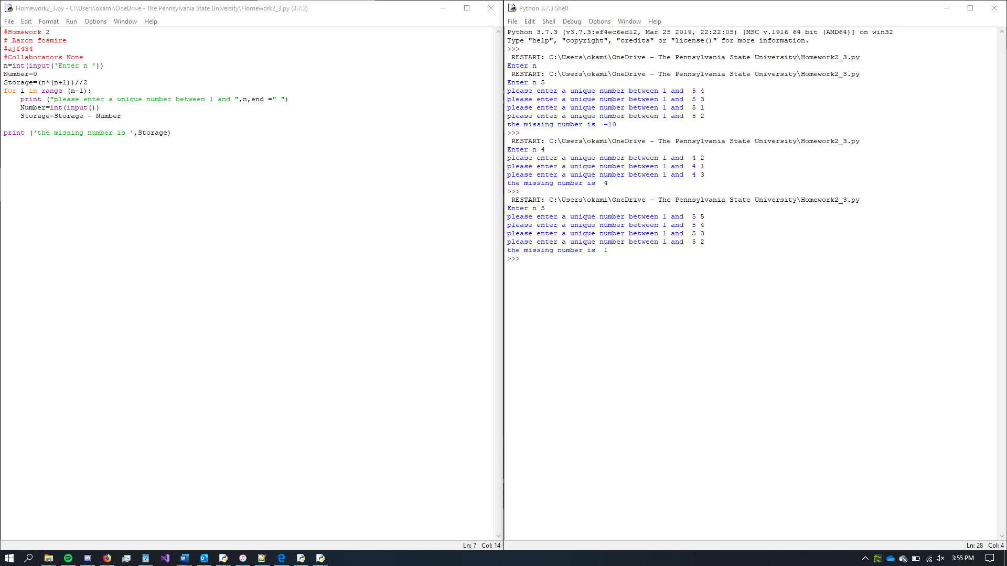

#Homework 2

# Aaron fosmire

#ajf434

#Collaborators None

n=int(input('Enter n '))

Number=0

Storage=(n*(n+1))//2

for i in range (n-1):

print ("please enter a unique number between 1 and ",n,end =" ")

Number=int(input())

Storage=Storage - Number

print ('the missing number is ',Storage)