Homework 4

Aaron Fosmire

Ajf434

Collaborators Nate Malay

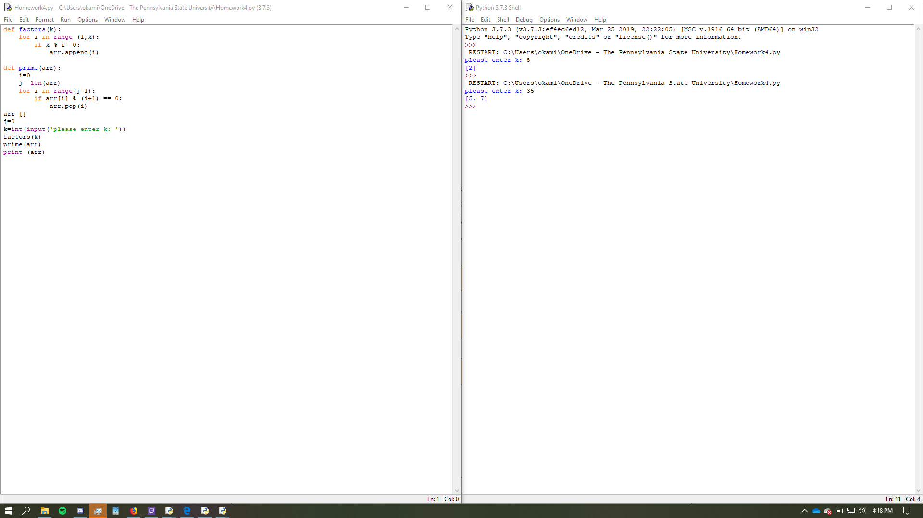

#aaron fosmire

#ajf434

#homework 4

#collaborators Malay Nate

def factors(k):

for i in range (1,k):

if k % i==0:

arr.append(i)

def prime(arr):

i=0

j= len(arr)

for i in range(j-1):

if arr[i] % (i+1) == 0:

arr.pop(i)

arr=[]

j=0

k=int(input('please enter k: '))

factors(k)

prime(arr)

print (arr)

Aaron fosmire

Ajf434

Homework 4pt2

Collabs Nate Malay

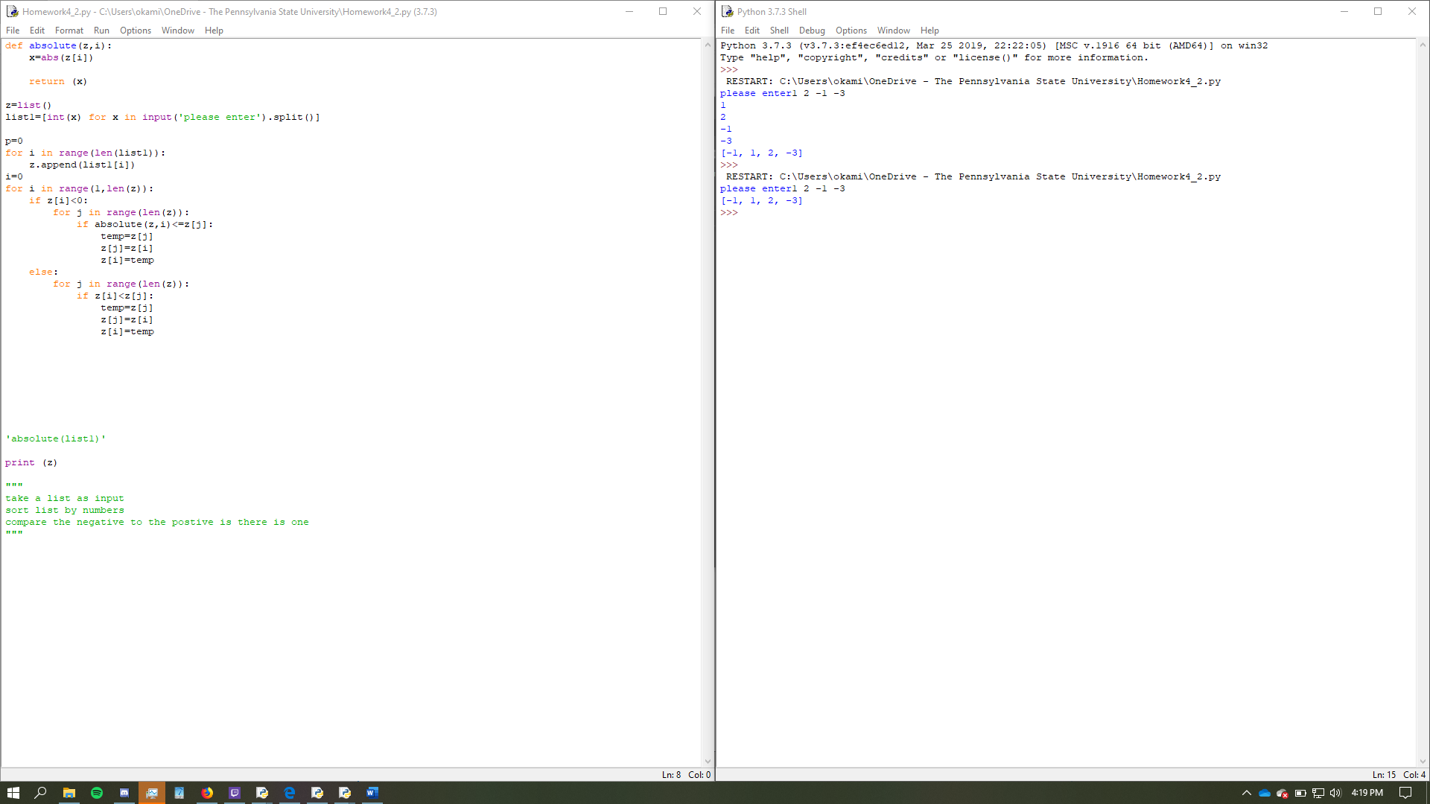

#aaron fosmire

#homework 4 pt 2

#Collabs Nate malay

#ajf434

def absolute(z,i):

x=abs(z[i])

return (x)

z=list()

list1=[int(x) for x in input('please enter').split()]

p=0

for i in range(len(list1)):

z.append(list1[i])

i=0

for i in range(1,len(z)):

if z[i]<0:

for j in range(len(z)):

if absolute(z,i)<=z[j]:

temp=z[j]

z[j]=z[i]

z[i]=temp

else:

for j in range(len(z)):

if z[i]<z[j]:

temp=z[j]

z[j]=z[i]

z[i]=temp

'absolute(list1)'

print (z)

"""

take a list as input

sort list by numbers

compare the negative to the postive is there is one

"""