LAB Logbook

Lab 1

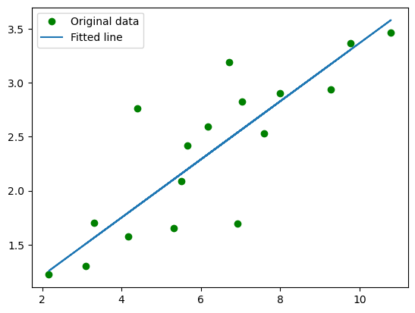

Lab 2

Test Accuracy: 0.879

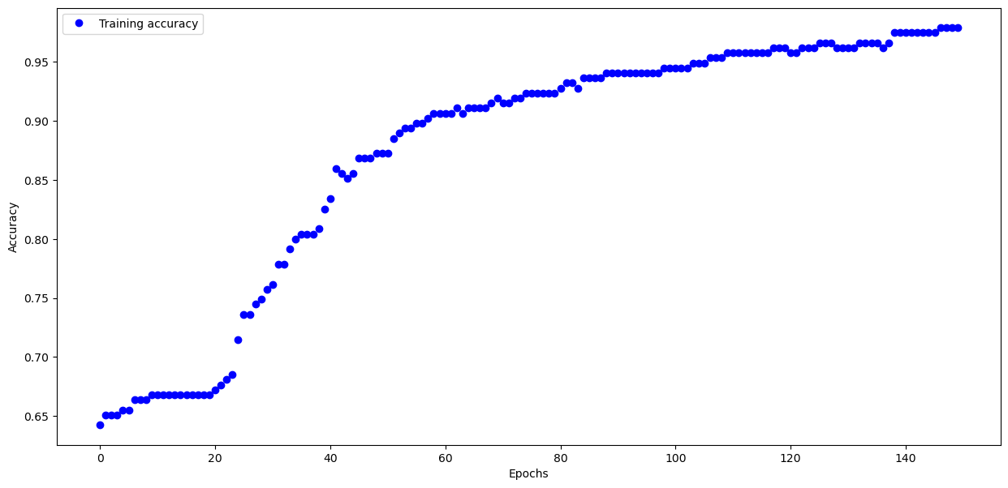

Lab 3

Test accuracy: 0.7394000291824341

**Model: "sequential_2"**

━━━━━━━━━━━━━━━━━━━━━━━━━━━━━━━━━┳━━━━━━━━━━━━━━━━━━━━━━━━┳━━━━━━━━━━━━━━━┓

┃ **Layer (type)** ┃ **Output Shape** ┃ **Param #** ┃

┡━━━━━━━━━━━━━━━━━━━━━━━━━━━━━━━━━╇━━━━━━━━━━━━━━━━━━━━━━━━╇━━━━━━━━━━━━━━━┩

│ flatten_2 (Flatten) │ (None, 784) │ 0 │

├─────────────────────────────────┼────────────────────────┼───────────────┤

│ dense_6 (Dense) │ (None, 68) │ 53,380 │

├─────────────────────────────────┼────────────────────────┼───────────────┤

│ dense_7 (Dense) │ (None, 55) │ 3,795 │

├─────────────────────────────────┼────────────────────────┼───────────────┤

│ dense_8 (Dense) │ (None, 10) │ 560 │

└─────────────────────────────────┴────────────────────────┴───────────────┘

**Total params:** 57,735 (225.53 KB)

**Trainable params:** 57,735 (225.53 KB)

**Non-trainable params:** 0 (0.00 B)

None

Lab 4

Model: "sequential_1"

┏━━━━━━━━━━━━━━━━━━━━━━━━━━━━━━━━━┳━━━━━━━━━━━━━━━━━━━━━━━━┳━━━━━━━━━━━━━━━┓

┃ Layer (type) ┃ Output Shape ┃ Param # ┃

┡━━━━━━━━━━━━━━━━━━━━━━━━━━━━━━━━━╇━━━━━━━━━━━━━━━━━━━━━━━━╇━━━━━━━━━━━━━━━┩

│ dense_5 (Dense) │ (None, 100) │ 2,000 │

├─────────────────────────────────┼────────────────────────┼───────────────┤

│ dense_6 (Dense) │ (None, 73) │ 7,373 │

├─────────────────────────────────┼────────────────────────┼───────────────┤

│ dense_7 (Dense) │ (None, 22) │ 1,628 │

├─────────────────────────────────┼────────────────────────┼───────────────┤

│ dense_8 (Dense) │ (None, 10) │ 230 │

├─────────────────────────────────┼────────────────────────┼───────────────┤

│ dense_9 (Dense) │ (None, 1) │ 11

Total params: 33,728 (131.75 KB)

Trainable params: 11,242 (43.91 KB)

Non-trainable params: 0 (0.00 B)

Optimizer params: 22,486 (87.84 KB)

None

Lab 5

**Model: "sequential"**

┏━━━━━━━━━━━━━━━━━━━━━━━━━━━━━━━━━┳━━━━━━━━━━━━━━━━━━━━━━━━┳━━━━━━━━━━━━━━━┓

┃ **Layer (type)** ┃ **Output Shape** ┃ **Param #** ┃

┡━━━━━━━━━━━━━━━━━━━━━━━━━━━━━━━━━╇━━━━━━━━━━━━━━━━━━━━━━━━╇━━━━━━━━━━━━━━━┩

│ conv2d (Conv2D) │ (None, 29, 29, 32) │ 1,568 │

├─────────────────────────────────┼────────────────────────┼───────────────┤

│ max_pooling2d (MaxPooling2D) │ (None, 14, 14, 32) │ 0 │

├─────────────────────────────────┼────────────────────────┼───────────────┤

│ conv2d_1 (Conv2D) │ (None, 12, 12, 28) │ 8,092 │

├─────────────────────────────────┼────────────────────────┼───────────────┤

│ max_pooling2d_1 (MaxPooling2D) │ (None, 12, 12, 28) │ 0 │

├─────────────────────────────────┼────────────────────────┼───────────────┤

│ conv2d_2 (Conv2D) │ (None, 11, 10, 22) │ 3,718 │

├─────────────────────────────────┼────────────────────────┼───────────────┤

│ max_pooling2d_2 (MaxPooling2D) │ (None, 3, 3, 22) │ 0 │

├─────────────────────────────────┼────────────────────────┼───────────────┤

│ flatten (Flatten) │ (None, 198) │ 0 │

├─────────────────────────────────┼────────────────────────┼───────────────┤

│ dense (Dense) │ (None, 228) │ 45,372 │

├─────────────────────────────────┼────────────────────────┼───────────────┤

│ dense_1 (Dense) │ (None, 128) │ 29,312 │

├─────────────────────────────────┼────────────────────────┼───────────────┤

│ dense_2 (Dense) │ (None, 10) │ 1,290 │

└─────────────────────────────────┴────────────────────────┴───────────────┘

**Total params:** 89,352 (349.03 KB)

**Trainable params:** 89,352 (349.03 KB)

**Non-trainable params:** 0 (0.00 B)

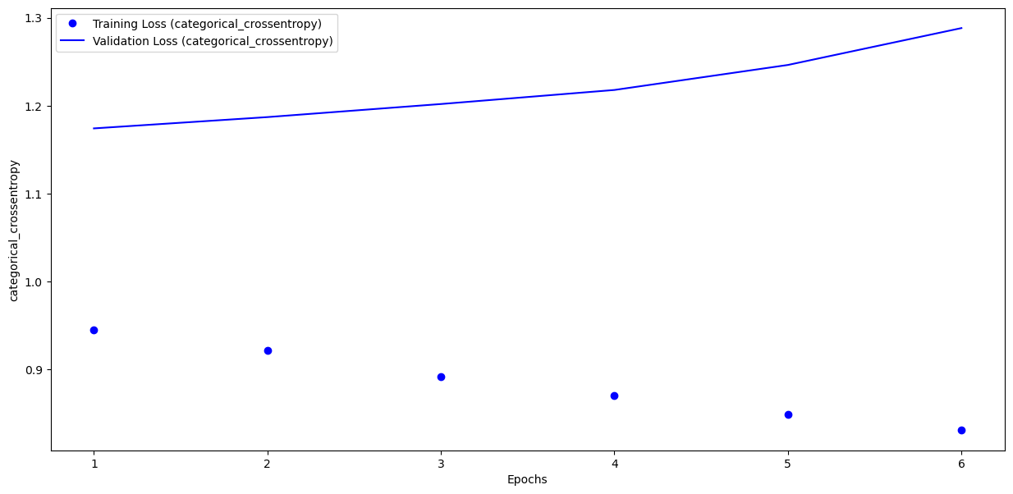

Epoch 1/10 **1563/1563** ━━━━━━━━━━━━━━━━━━━━ **7s** 5ms/step - accuracy: 0.6733 - loss: 0.9203 - val_accuracy: 0.6023 - val_loss: 1.1742

Epoch 2/10 **1563/1563** ━━━━━━━━━━━━━━━━━━━━ **7s** 4ms/step - accuracy: 0.6766 - loss: 0.9076 - val_accuracy: 0.6043 - val_loss: 1.1870

Epoch 3/10 **1563/1563** ━━━━━━━━━━━━━━━━━━━━ **7s** 5ms/step - accuracy: 0.6947 - loss: 0.8556 - val_accuracy: 0.5996 - val_loss: 1.2019

Epoch 4/10 **1563/1563** ━━━━━━━━━━━━━━━━━━━━ **7s** 4ms/step - accuracy: 0.7007 - loss: 0.8444 - val_accuracy: 0.6034 - val_loss: 1.2179

Epoch 5/10 **1563/1563** ━━━━━━━━━━━━━━━━━━━━ **8s** 5ms/step - accuracy: 0.7069 - loss: 0.8189 - val_accuracy: 0.6047 - val_loss: 1.2464

Epoch 6/10 **1563/1563** ━━━━━━━━━━━━━━━━━━━━ **7s** 4ms/step - accuracy: 0.7140 - loss: 0.8035 - val_accuracy: 0.5926 - val_loss: 1.2883

Lab 6

**Model: "sequential_2"**

┏━━━━━━━━━━━━━━━━━━━┳━━━━━━━━━━━━━━━━┳━━━━━━━━┓

┃ **Layer (type)** ┃ **Output Shape** ┃**Param #** ┃

┡━━━━━━━━━━━━━━━━━━━╇━━━━━━━━━━━━━━━━╇━━━━━━━━┩

│ gru (GRU) │ (None, 73) │ 16,644 │

├───────────────────┼────────────────┼────────┤

│ dense_2 (Dense) │ (None, 1) │ 74 │

└───────────────────┴────────────────┴────────┘

**Total params:** 16,718 (65.30 KB)

**Trainable params:** 16,718 (65.30 KB)

**Non-trainable params:** 0 (0.00 B)

early_stop = EarlyStopping(monitor='val_loss',patience=2)

**366/366** ━━━━━━━━━━━━━━━━━━━━ **2s** 3ms/step - loss: 0.0260 - val_loss: 0.0293

Epoch 2/30**366/366** ━━━━━━━━━━━━━━━━━━━━ **1s** 2ms/step - loss: 0.0159 - val_loss: 0.0536

Epoch 3/30**366/366** ━━━━━━━━━━━━━━━━━━━━ **1s** 2ms/step - loss: 0.0186 - val_loss: 0.0375

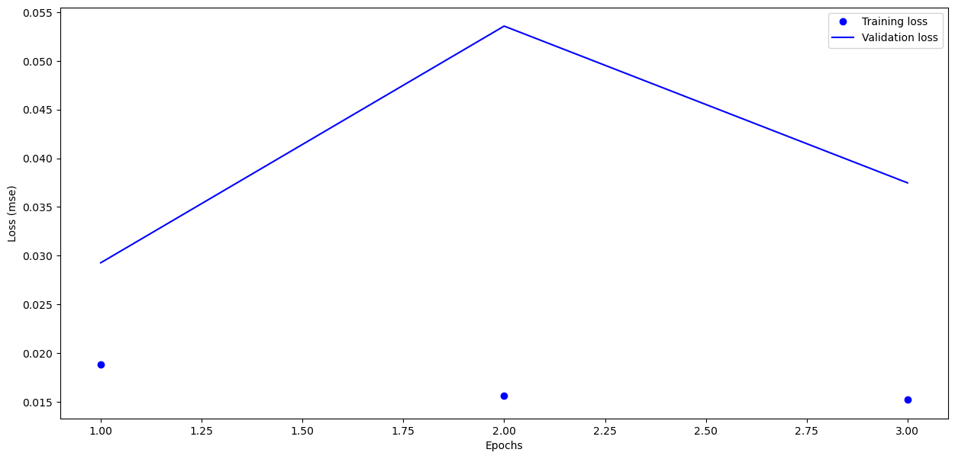

Lab 7

Epoch 1/40

1328/1328 ━━━━━━━━━━━━━━━━━━━━ 36s 24ms/step - accuracy: 0.2126 - loss: 2.1780 - val_accuracy: 0.3295 - val_loss: 1.8580

Epoch 2/40

1328/1328 ━━━━━━━━━━━━━━━━━━━━ 4s 3ms/step - accuracy: 0.2812 - loss: 2.0580 - val_accuracy: 0.3301 - val_loss: 1.8573

Epoch 3/40

1328/1328 ━━━━━━━━━━━━━━━━━━━━ 33s 22ms/step - accuracy: 0.3093 - loss: 1.8816 - val_accuracy: 0.3662 - val_loss: 1.7502

Epoch 4/40

1328/1328 ━━━━━━━━━━━━━━━━━━━━ 5s 4ms/step - accuracy: 0.3750 - loss: 1.8530 - val_accuracy: 0.3667 - val_loss: 1.7504

Epoch 5/40

1328/1328 ━━━━━━━━━━━━━━━━━━━━ 41s 31ms/step - accuracy: 0.3386 - loss: 1.7916 - val_accuracy: 0.3818 - val_loss: 1.6992

Epoch 6/40

1328/1328 ━━━━━━━━━━━━━━━━━━━━ 5s 4ms/step - accuracy: 0.5312 - loss: 1.6565 - val_accuracy: 0.3817 - val_loss: 1.6988

Epoch 7/40

1328/1328 ━━━━━━━━━━━━━━━━━━━━ 82s 35ms/step - accuracy: 0.3653 - loss: 1.7516 - val_accuracy: 0.3994 - val_loss: 1.6557

Epoch 8/40

1328/1328 ━━━━━━━━━━━━━━━━━━━━ 5s 4ms/step - accuracy: 0.3750 - loss: 1.7194 - val_accuracy: 0.3985 - val_loss: 1.6565

Epoch 9/40

1328/1328 ━━━━━━━━━━━━━━━━━━━━ 62s 23ms/step - accuracy: 0.3772 - loss: 1.7049 - val_accuracy: 0.4097 - val_loss: 1.6263

Epoch 10/40

1328/1328 ━━━━━━━━━━━━━━━━━━━━ 5s 4ms/step - accuracy: 0.3438 - loss: 1.7962 - val_accuracy: 0.4096 - val_loss: 1.6263

Epoch 11/40

1328/1328 ━━━━━━━━━━━━━━━━━━━━ 41s 31ms/step - accuracy: 0.3856 - loss: 1.6924 - val_accuracy: 0.4205 - val_loss: 1.5945

Epoch 12/40

1328/1328 ━━━━━━━━━━━━━━━━━━━━ 5s 4ms/step - accuracy: 0.4375 - loss: 1.8502 - val_accuracy: 0.4203 - val_loss: 1.5944

Epoch 13/40

1328/1328 ━━━━━━━━━━━━━━━━━━━━ 67s 23ms/step - accuracy: 0.4011 - loss: 1.6571 - val_accuracy: 0.4303 - val_loss: 1.5735

Epoch 14/40

1328/1328 ━━━━━━━━━━━━━━━━━━━━ 4s 3ms/step - accuracy: 0.4688 - loss: 1.7099 - val_accuracy: 0.4307 - val_loss: 1.5725

Epoch 15/40

1328/1328 ━━━━━━━━━━━━━━━━━━━━ 36s 22ms/step - accuracy: 0.4053 - loss: 1.6333 - val_accuracy: 0.4410 - val_loss: 1.5550

Epoch 16/40

1328/1328 ━━━━━━━━━━━━━━━━━━━━ 5s 4ms/step - accuracy: 0.5312 - loss: 1.3139 - val_accuracy: 0.4414 - val_loss: 1.5548

Epoch 17/40

1328/1328 ━━━━━━━━━━━━━━━━━━━━ 41s 26ms/step - accuracy: 0.4183 - loss: 1.6206 - val_accuracy: 0.4472 - val_loss: 1.5343

Epoch 18/40

1328/1328 ━━━━━━━━━━━━━━━━━━━━ 5s 4ms/step - accuracy: 0.4688 - loss: 1.5680 - val_accuracy: 0.4466 - val_loss: 1.5338

Epoch 19/40

1328/1328 ━━━━━━━━━━━━━━━━━━━━ 41s 31ms/step - accuracy: 0.4241 - loss: 1.5977 - val_accuracy: 0.4571 - val_loss: 1.5137

Epoch 20/40

1328/1328 ━━━━━━━━━━━━━━━━━━━━ 5s 4ms/step - accuracy: 0.3750 - loss: 1.6213 - val_accuracy: 0.4567 - val_loss: 1.5146

Epoch 21/40

1328/1328 ━━━━━━━━━━━━━━━━━━━━ 67s 23ms/step - accuracy: 0.4309 - loss: 1.5757 - val_accuracy: 0.4617 - val_loss: 1.4988

Epoch 22/40

1328/1328 ━━━━━━━━━━━━━━━━━━━━ 5s 4ms/step - accuracy: 0.4688 - loss: 1.4201 - val_accuracy: 0.4611 - val_loss: 1.4994

Epoch 23/40

1328/1328 ━━━━━━━━━━━━━━━━━━━━ 41s 31ms/step - accuracy: 0.4379 - loss: 1.5676 - val_accuracy: 0.4671 - val_loss: 1.4835

Epoch 24/40

1328/1328 ━━━━━━━━━━━━━━━━━━━━ 4s 3ms/step - accuracy: 0.4375 - loss: 1.4519 - val_accuracy: 0.4677 - val_loss: 1.4836

Epoch 25/40

1328/1328 ━━━━━━━━━━━━━━━━━━━━ 68s 23ms/step - accuracy: 0.4466 - loss: 1.5374 - val_accuracy: 0.4732 - val_loss: 1.4689

Epoch 26/40

1328/1328 ━━━━━━━━━━━━━━━━━━━━ 4s 3ms/step - accuracy: 0.5000 - loss: 1.6416 - val_accuracy: 0.4728 - val_loss: 1.4694

Epoch 27/40

1328/1328 ━━━━━━━━━━━━━━━━━━━━ 36s 23ms/step - accuracy: 0.4509 - loss: 1.5387 - val_accuracy: 0.4770 - val_loss: 1.4577

Epoch 28/40

1328/1328 ━━━━━━━━━━━━━━━━━━━━ 5s 4ms/step - accuracy: 0.4062 - loss: 1.4612 - val_accuracy: 0.4765 - val_loss: 1.4577

Epoch 29/40

1328/1328 ━━━━━━━━━━━━━━━━━━━━ 41s 31ms/step - accuracy: 0.4553 - loss: 1.5211 - val_accuracy: 0.4812 - val_loss: 1.4491

Epoch 30/40

1328/1328 ━━━━━━━━━━━━━━━━━━━━ 5s 4ms/step - accuracy: 0.4375 - loss: 1.5371 - val_accuracy: 0.4809 - val_loss: 1.4493

Epoch 31/40

1328/1328 ━━━━━━━━━━━━━━━━━━━━ 82s 35ms/step - accuracy: 0.4623 - loss: 1.5162 - val_accuracy: 0.4796 - val_loss: 1.4516

Epoch 32/40

1328/1328 ━━━━━━━━━━━━━━━━━━━━ 4s 3ms/step - accuracy: 0.5312 - loss: 1.5323 - val_accuracy: 0.4781 - val_loss: 1.4500

Epoch 33/40

1328/1328 ━━━━━━━━━━━━━━━━━━━━ 41s 31ms/step - accuracy: 0.4630 - loss: 1.5040 - val_accuracy: 0.4897 - val_loss: 1.4262

Epoch 34/40

1328/1328 ━━━━━━━━━━━━━━━━━━━━ 4s 3ms/step - accuracy: 0.4688 - loss: 1.4638 - val_accuracy: 0.4896 - val_loss: 1.4255

Epoch 35/40

1328/1328 ━━━━━━━━━━━━━━━━━━━━ 41s 31ms/step - accuracy: 0.4667 - loss: 1.4974 - val_accuracy: 0.4945 - val_loss: 1.4136

Epoch 36/40

1328/1328 ━━━━━━━━━━━━━━━━━━━━ 4s 3ms/step - accuracy: 0.5000 - loss: 1.4790 - val_accuracy: 0.4953 - val_loss: 1.4130

Epoch 37/40

1328/1328 ━━━━━━━━━━━━━━━━━━━━ 31s 23ms/step - accuracy: 0.4704 - loss: 1.4886 - val_accuracy: 0.4973 - val_loss: 1.4089

Epoch 38/40

1328/1328 ━━━━━━━━━━━━━━━━━━━━ 5s 4ms/step - accuracy: 0.6250 - loss: 1.2994 - val_accuracy: 0.4985 - val_loss: 1.4090

Epoch 39/40

1328/1328 ━━━━━━━━━━━━━━━━━━━━ 41s 27ms/step - accuracy: 0.4719 - loss: 1.4814 - val_accuracy: 0.4976 - val_loss: 1.4021

Epoch 40/40

1328/1328 ━━━━━━━━━━━━━━━━━━━━ 4s 3ms/step - accuracy: 0.4688 - loss: 1.4763 - val_accuracy: 0.4981 - val_loss: 1.4017

precision recall f1-score support

0 0.54 0.56 0.55 1000

1 0.53 0.67 0.59 1000

2 0.39 0.35 0.37 1000

3 0.36 0.31 0.33 1000

4 0.43 0.41 0.42 1000

5 0.46 0.36 0.40 1000

6 0.50 0.56 0.53 1000

7 0.53 0.57 0.55 1000

8 0.66 0.66 0.66 1000

9 0.55 0.55 0.55 1000

accuracy 0.50 10000

macro avg 0.49 0.50 0.49 10000

weighted avg 0.49 0.50 0.49 10000

|  | **Accuracy** | **Precision** | **Recall** | **F1_Score** |
| --- | --- | --- | --- | --- |
| **VGG-16** | 0.6521 | 0.650271 | 0.6521 | 0.650654 |
| **VGG_19** | 0.4993 | 0.494120 | 0.4993 | 0.494805 |

Lab 8

**Model: "sequential_2"**

┏━━━━━━━━━━┳━━━━━━━━━┳━━━━━━┓

┃ **Layer (type)** ┃ **Output Shape** ┃ **Param #** ┃

┡━━━━━━━━━━╇━━━━━━━━━━╇━━ ━━━━┩

│ lstm_2 (LSTM) │ (None, 62) │ 20,088 │

├───────────────────┼──────────────────┼─────────────┤

│ dense_2 (Dense) │ (None, 2) │ 126 │

└───────────────────┴────────────────────┴─────────────┘

**Total params:** 20,214 (78.96 KB)

**Trainable params:** 20,214 (78.96 KB)

**Non-trainable params:** 0 (0.00 B)

None

history = model.fit(X_train, y_train, batch_size=20, epochs=10,

                    validation_split=0.1,

                    verbose=1, callbacks=[es, mc])

Epoch 1/10

**1419/1425** ━━━━━━━━━━━━━━━━━━━━ **0s** 6ms/step - loss: 0.1636 - mae: 0.0933

Epoch 1: val_loss improved from inf to 0.00011, saving model to best_model_LSTM_Silver_3D_Tensor.keras

**1425/1425** ━━━━━━━━━━━━━━━━━━━━ **10s** 6ms/step - loss: 0.1629 - mae: 0.0930 - val_loss: 1.1051e-04 - val_mae: 0.0089

Epoch 2/10

**1423/1425** ━━━━━━━━━━━━━━━━━━━━ **0s** 6ms/step - loss: 7.2315e-05 - mae: 0.0062

Epoch 2: val_loss improved from 0.00011 to 0.00004, saving model to best_model_LSTM_Silver_3D_Tensor.keras

**1425/1425** ━━━━━━━━━━━━━━━━━━━━ **8s** 6ms/step - loss: 7.2323e-05 - mae: 0.0062 - val_loss: 4.2700e-05 - val_mae: 0.0050

Epoch 3/10

**1424/1425** ━━━━━━━━━━━━━━━━━━━━ **0s** 5ms/step - loss: 7.4497e-05 - mae: 0.0064

Epoch 3: val_loss did not improve from 0.00004

**1425/1425** ━━━━━━━━━━━━━━━━━━━━ **8s** 6ms/step - loss: 7.4507e-05 - mae: 0.0064 - val_loss: 3.3703e-04 - val_mae: 0.0166

Epoch 4/10

**1418/1425** ━━━━━━━━━━━━━━━━━━━━ **0s** 5ms/step - loss: 9.7377e-05 - mae: 0.0074

Epoch 4: val_loss did not improve from 0.00004

**1425/1425** ━━━━━━━━━━━━━━━━━━━━ **8s** 6ms/step - loss: 9.7364e-05 - mae: 0.0074 - val_loss: 1.9855e-04 - val_mae: 0.0124

Epoch 5/10

**1420/1425** ━━━━━━━━━━━━━━━━━━━━ **0s** 5ms/step - loss: 8.3108e-05 - mae: 0.0070

Epoch 5: val_loss did not improve from 0.00004

**1425/1425** ━━━━━━━━━━━━━━━━━━━━ **8s** 6ms/step - loss: 8.3106e-05 - mae: 0.0070 - val_loss: 7.0140e-04 - val_mae: 0.0256

Epoch 6/10

**1418/1425** ━━━━━━━━━━━━━━━━━━━━ **0s** 5ms/step - loss: 9.2733e-05 - mae: 0.0072

Epoch 6: val_loss did not improve from 0.00004

**1425/1425** ━━━━━━━━━━━━━━━━━━━━ **8s** 6ms/step - loss: 9.2646e-05 - mae: 0.0072 - val_loss: 4.9412e-05 - val_mae: 0.0056

Epoch 7/10

**1422/1425** ━━━━━━━━━━━━━━━━━━━━ **0s** 5ms/step - loss: 6.4840e-05 - mae: 0.0061

Epoch 7: val_loss improved from 0.00004 to 0.00003, saving model to best_model_LSTM_Silver_3D_Tensor.keras

**1425/1425** ━━━━━━━━━━━━━━━━━━━━ **8s** 6ms/step - loss: 6.4843e-05 - mae: 0.0061 - val_loss: 3.2470e-05 - val_mae: 0.0044

Epoch 8/10

**1417/1425** ━━━━━━━━━━━━━━━━━━━━ **0s** 5ms/step - loss: 6.0650e-05 - mae: 0.0060

Epoch 8: val_loss improved from 0.00003 to 0.00003, saving model to best_model_LSTM_Silver_3D_Tensor.keras

**1425/1425** ━━━━━━━━━━━━━━━━━━━━ **8s** 6ms/step - loss: 6.0635e-05 - mae: 0.0060 - val_loss: 2.9329e-05 - val_mae: 0.0043

Epoch 9/10

**1417/1425** ━━━━━━━━━━━━━━━━━━━━ **0s** 5ms/step - loss: 5.8880e-05 - mae: 0.0059

Epoch 9: val_loss did not improve from 0.00003

**1425/1425** ━━━━━━━━━━━━━━━━━━━━ **8s** 6ms/step - loss: 5.8872e-05 - mae: 0.0059 - val_loss: 3.3335e-05 - val_mae: 0.0046

Epoch 10/10

**1421/1425** ━━━━━━━━━━━━━━━━━━━━ **0s** 5ms/step - loss: 4.7338e-05 - mae: 0.0052

Epoch 10: val_loss improved from 0.00003 to 0.00003, saving model to best_model_LSTM_Silver_3D_Tensor.keras

**1425/1425** ━━━━━━━━━━━━━━━━━━━━ **8s** 6ms/step - loss: 4.7346e-05 - mae: 0.0052 - val_loss: 2.7086e-05 - val_mae: 0.0038

Lab 9

es = EarlyStopping(monitor='val_loss', mode='min', patience=10, verbose=1)

mc = ModelCheckpoint('best_Trand-Flat_model_LSTM_GOLD.keras', monitor='val_loss', mode='min', verbose=1, save_best_only=True)

history = model.fit(X_train, y_train, batch_size=12, epochs=32,

                    validation_split=0.2, shuffle=True,

                    verbose=1, callbacks=[es, mc],

                    class_weight=class_weight_dict)

Epoch 1/32

**717/717** ━━━━━━━━━━━━━━━━━━━━ **0s** 35ms/step - accuracy: 0.4546 - loss: 0.7110

Epoch 1: val_loss improved from inf to 0.79430, saving model to best_Trand-Flat_model_LSTM_GOLD.keras

**717/717** ━━━━━━━━━━━━━━━━━━━━ **32s** 40ms/step - accuracy: 0.4545 - loss: 0.7110 - val_accuracy: 0.0711 - val_loss: 0.7943

Epoch 2/32

**716/717** ━━━━━━━━━━━━━━━━━━━━ **0s** 21ms/step - accuracy: 0.3053 - loss: 0.8390

Epoch 2: val_loss did not improve from 0.79430

**717/717** ━━━━━━━━━━━━━━━━━━━━ **17s** 23ms/step - accuracy: 0.3054 - loss: 0.8388 - val_accuracy: 0.0874 - val_loss: 0.8450

Epoch 3/32

**716/717** ━━━━━━━━━━━━━━━━━━━━ **0s** 17ms/step - accuracy: 0.3925 - loss: 0.7008

Epoch 3: val_loss improved from 0.79430 to 0.73899, saving model to best_Trand-Flat_model_LSTM_GOLD.keras

**717/717** ━━━━━━━━━━━━━━━━━━━━ **17s** 18ms/step - accuracy: 0.3926 - loss: 0.7008 - val_accuracy: 0.2139 - val_loss: 0.7390

Epoch 4/32

**714/717** ━━━━━━━━━━━━━━━━━━━━ **0s** 17ms/step - accuracy: 0.3963 - loss: 0.8466

Epoch 4: val_loss improved from 0.73899 to 0.67909, saving model to best_Trand-Flat_model_LSTM_GOLD.keras

**717/717** ━━━━━━━━━━━━━━━━━━━━ **21s** 19ms/step - accuracy: 0.3962 - loss: 0.8474 - val_accuracy: 0.5937 - val_loss: 0.6791

Epoch 5/32

**714/717** ━━━━━━━━━━━━━━━━━━━━ **0s** 17ms/step - accuracy: 0.3449 - loss: 14139.7939

Epoch 5: val_loss did not improve from 0.67909

**717/717** ━━━━━━━━━━━━━━━━━━━━ **13s** 18ms/step - accuracy: 0.3453 - loss: 14155.7930 - val_accuracy: 0.8940 - val_loss: 1.1885

Epoch 6/32

**716/717** ━━━━━━━━━━━━━━━━━━━━ **0s** 17ms/step - accuracy: 0.4789 - loss: 1.8995

Epoch 6: val_loss improved from 0.67909 to 0.57935, saving model to best_Trand-Flat_model_LSTM_GOLD.keras

**717/717** ━━━━━━━━━━━━━━━━━━━━ **22s** 20ms/step - accuracy: 0.4789 - loss: 1.9002 - val_accuracy: 0.8689 - val_loss: 0.5794

Epoch 7/32

**716/717** ━━━━━━━━━━━━━━━━━━━━ **0s** 17ms/step - accuracy: 0.4821 - loss: 3.1034

Epoch 7: val_loss did not improve from 0.57935

**717/717** ━━━━━━━━━━━━━━━━━━━━ **15s** 21ms/step - accuracy: 0.4821 - loss: 3.1019 - val_accuracy: 0.8312 - val_loss: 0.6175

Epoch 8/32

**715/717** ━━━━━━━━━━━━━━━━━━━━ **0s** 17ms/step - accuracy: 0.5006 - loss: 2.2015

Epoch 8: val_loss did not improve from 0.57935

**717/717** ━━━━━━━━━━━━━━━━━━━━ **15s** 20ms/step - accuracy: 0.5006 - loss: 2.2007 - val_accuracy: 0.8949 - val_loss: 0.8261

Epoch 9/32

**714/717** ━━━━━━━━━━━━━━━━━━━━ **0s** 17ms/step - accuracy: 0.5016 - loss: 2.0803

Epoch 9: val_loss did not improve from 0.57935

**717/717** ━━━━━━━━━━━━━━━━━━━━ **19s** 19ms/step - accuracy: 0.5015 - loss: 2.0827 - val_accuracy: 0.1241 - val_loss: 1.6664

Epoch 10/32

**715/717** ━━━━━━━━━━━━━━━━━━━━ **0s** 17ms/step - accuracy: 0.4548 - loss: 10.3357

Epoch 10: val_loss did not improve from 0.57935

**717/717** ━━━━━━━━━━━━━━━━━━━━ **14s** 19ms/step - accuracy: 0.4549 - loss: 10.3146 - val_accuracy: 0.2734 - val_loss: 0.9193

Epoch 11/32

**714/717** ━━━━━━━━━━━━━━━━━━━━ **0s** 17ms/step - accuracy: 0.5153 - loss: 0.9263

Epoch 11: val_loss improved from 0.57935 to 0.49829, saving model to best_Trand-Flat_model_LSTM_GOLD.keras

**717/717** ━━━━━━━━━━━━━━━━━━━━ **20s** 19ms/step - accuracy: 0.5152 - loss: 0.9263 - val_accuracy: 0.8866 - val_loss: 0.4983

Epoch 12/32

**716/717** ━━━━━━━━━━━━━━━━━━━━ **0s** 16ms/step - accuracy: 0.4998 - loss: 0.9449

Epoch 12: val_loss improved from 0.49829 to 0.35054, saving model to best_Trand-Flat_model_LSTM_GOLD.keras

**717/717** ━━━━━━━━━━━━━━━━━━━━ **20s** 19ms/step - accuracy: 0.4998 - loss: 0.9449 - val_accuracy: 0.9233 - val_loss: 0.3505

Epoch 13/32

**715/717** ━━━━━━━━━━━━━━━━━━━━ **0s** 17ms/step - accuracy: 0.4995 - loss: 1.0386

Epoch 13: val_loss did not improve from 0.35054

**717/717** ━━━━━━━━━━━━━━━━━━━━ **21s** 19ms/step - accuracy: 0.4995 - loss: 1.0385 - val_accuracy: 0.8963 - val_loss: 0.4822

Epoch 14/32

**715/717** ━━━━━━━━━━━━━━━━━━━━ **0s** 17ms/step - accuracy: 0.4829 - loss: 0.8972

Epoch 14: val_loss did not improve from 0.35054

**717/717** ━━━━━━━━━━━━━━━━━━━━ **21s** 19ms/step - accuracy: 0.4828 - loss: 0.8973 - val_accuracy: 0.0958 - val_loss: 1.9997

Epoch 15/32

**715/717** ━━━━━━━━━━━━━━━━━━━━ **0s** 17ms/step - accuracy: 0.4750 - loss: 0.9518

Epoch 15: val_loss did not improve from 0.35054

**717/717** ━━━━━━━━━━━━━━━━━━━━ **20s** 19ms/step - accuracy: 0.4750 - loss: 0.9516 - val_accuracy: 0.2957 - val_loss: 0.8226

Epoch 16/32

**716/717** ━━━━━━━━━━━━━━━━━━━━ **0s** 17ms/step - accuracy: 0.4972 - loss: 0.9810

Epoch 16: val_loss did not improve from 0.35054

**717/717** ━━━━━━━━━━━━━━━━━━━━ **20s** 19ms/step - accuracy: 0.4971 - loss: 0.9812 - val_accuracy: 0.8945 - val_loss: 0.4048

Epoch 17/32

**715/717** ━━━━━━━━━━━━━━━━━━━━ **0s** 17ms/step - accuracy: 0.4979 - loss: 1.0001

Epoch 17: val_loss did not improve from 0.35054

**717/717** ━━━━━━━━━━━━━━━━━━━━ **21s** 19ms/step - accuracy: 0.4978 - loss: 1.0001 - val_accuracy: 0.8443 - val_loss: 0.4580

Epoch 18/32

**716/717** ━━━━━━━━━━━━━━━━━━━━ **0s** 17ms/step - accuracy: 0.5053 - loss: 1.0955

Epoch 18: val_loss improved from 0.35054 to 0.27675, saving model to best_Trand-Flat_model_LSTM_GOLD.keras

**717/717** ━━━━━━━━━━━━━━━━━━━━ **14s** 19ms/step - accuracy: 0.5053 - loss: 1.0955 - val_accuracy: 0.9252 - val_loss: 0.2767

Epoch 19/32

**715/717** ━━━━━━━━━━━━━━━━━━━━ **0s** 17ms/step - accuracy: 0.4799 - loss: 0.9219

Epoch 19: val_loss did not improve from 0.27675

**717/717** ━━━━━━━━━━━━━━━━━━━━ **21s** 19ms/step - accuracy: 0.4800 - loss: 0.9218 - val_accuracy: 0.9326 - val_loss: 0.3445

Epoch 20/32

**715/717** ━━━━━━━━━━━━━━━━━━━━ **0s** 17ms/step - accuracy: 0.4341 - loss: 0.8722

Epoch 20: val_loss did not improve from 0.27675

**717/717** ━━━━━━━━━━━━━━━━━━━━ **20s** 19ms/step - accuracy: 0.4343 - loss: 0.8723 - val_accuracy: 0.1358 - val_loss: 1.0263

Epoch 21/32

**717/717** ━━━━━━━━━━━━━━━━━━━━ **0s** 17ms/step - accuracy: 0.4440 - loss: 0.8080

Epoch 21: val_loss did not improve from 0.27675

**717/717** ━━━━━━━━━━━━━━━━━━━━ **14s** 19ms/step - accuracy: 0.4440 - loss: 0.8080 - val_accuracy: 0.9326 - val_loss: 0.3461

Epoch 22/32

**714/717** ━━━━━━━━━━━━━━━━━━━━ **0s** 17ms/step - accuracy: 0.4905 - loss: 45818888192.0000

Epoch 22: val_loss did not improve from 0.27675

**717/717** ━━━━━━━━━━━━━━━━━━━━ **13s** 19ms/step - accuracy: 0.4905 - loss: 45830639616.0000 - val_accuracy: 0.0674 - val_loss: 1.4287

Epoch 23/32

**717/717** ━━━━━━━━━━━━━━━━━━━━ **0s** 17ms/step - accuracy: 0.4540 - loss: 0.8148

Epoch 23: val_loss did not improve from 0.27675

**717/717** ━━━━━━━━━━━━━━━━━━━━ **13s** 19ms/step - accuracy: 0.4540 - loss: 0.8148 - val_accuracy: 0.8377 - val_loss: 0.6045

Epoch 24/32

**717/717** ━━━━━━━━━━━━━━━━━━━━ **0s** 17ms/step - accuracy: 0.4296 - loss: 0.7892

Epoch 24: val_loss did not improve from 0.27675

**717/717** ━━━━━━━━━━━━━━━━━━━━ **21s** 19ms/step - accuracy: 0.4296 - loss: 0.7892 - val_accuracy: 0.8773 - val_loss: 0.5898

Epoch 25/32

**714/717** ━━━━━━━━━━━━━━━━━━━━ **0s** 21ms/step - accuracy: 0.4433 - loss: 0.7732

Epoch 25: val_loss did not improve from 0.27675

**717/717** ━━━━━━━━━━━━━━━━━━━━ **23s** 23ms/step - accuracy: 0.4433 - loss: 0.7732 - val_accuracy: 0.1199 - val_loss: 0.9640

Epoch 26/32

**716/717** ━━━━━━━━━━━━━━━━━━━━ **0s** 17ms/step - accuracy: 0.4551 - loss: 0.7629

Epoch 26: val_loss did not improve from 0.27675

**717/717** ━━━━━━━━━━━━━━━━━━━━ **14s** 19ms/step - accuracy: 0.4551 - loss: 0.7629 - val_accuracy: 0.6713 - val_loss: 0.6620

Epoch 27/32

**716/717** ━━━━━━━━━━━━━━━━━━━━ **0s** 18ms/step - accuracy: 0.4825 - loss: 0.7970

Epoch 27: val_loss did not improve from 0.27675

**717/717** ━━━━━━━━━━━━━━━━━━━━ **14s** 20ms/step - accuracy: 0.4825 - loss: 0.7970 - val_accuracy: 0.0939 - val_loss: 0.8680

Epoch 28/32

**717/717** ━━━━━━━━━━━━━━━━━━━━ **0s** 17ms/step - accuracy: 0.4482 - loss: 0.7451

Epoch 28: val_loss did not improve from 0.27675

**717/717** ━━━━━━━━━━━━━━━━━━━━ **15s** 21ms/step - accuracy: 0.4482 - loss: 0.7451 - val_accuracy: 0.0855 - val_loss: 1.1025

Epoch 28: early stopping

precision recall f1-score support

0.0 0.88 0.99 0.94 1058

1.0 0.00 0.00 0.00 137

accuracy 0.88 1195

macro avg 0.44 0.50 0.47 1195

weighted avg 0.78 0.88 0.83 1195

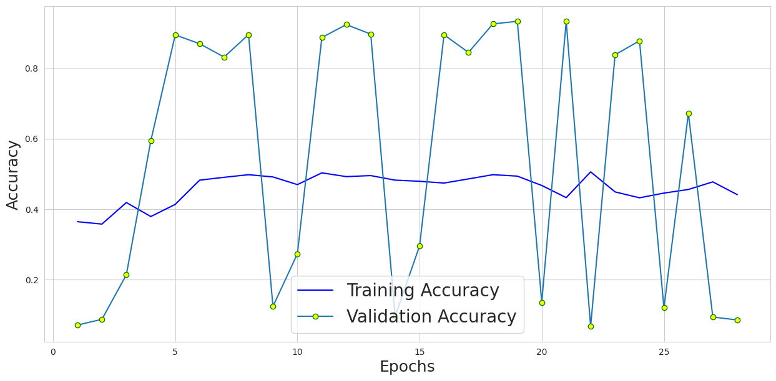

Lab 10

Lab 10_1

**Model: "sequential"**

┏━━━━━━━━━━━┳━━━━━━━━━━┳━━━━━┓

┃ **Layer (type)** ┃ **Output Shape** ┃ **Param #** ┃

┡━━━━━━━━━━━━╇━━━━━━━━━━╇━━━━━**-**┩

│ flatten (Flatten) │ (None, 784) │ 0 │

├──────────────────────┼───────────────────┼───────────┤

│ dense (Dense) │ (None, 600) │ 471,000 │

├─────────────────────┼────────────────────┼───────────┤

│ dense_1 (Dense) │ (None, 300) │ 180,300 │

├─────────────────────┼────────────────────┼───────────┤

│ dense_2 (Dense) │ (None, 150) │ 45,150 │

├─────────────────────┼─────────────── ────┼────────────┤

│ dense_3 (Dense) │ (None, 75) │ 11,325 │

├─────────────────────┼───────────────────┼────────────┤

│ dense_4 (Dense) │ (None, 50) │ 3,800 │ └──────────────────────┴───────────────────┴────────────┘

**Total params:** 711,575 (2.71 MB)

**Trainable params:** 711,575 (2.71 MB)

**Non-trainable params:** 0 (0.00 B)

None

**Model: "sequential_1"**

┏━━━━━━━━━━━┳━━━━━━━━━┳━━━━━━ ┓

┃ **Layer (type)** ┃ **Output Shape** ┃ **Param #** ┃

┡━━━━━━━━━━━━╇━━━━━━━━━╇━━━━━━━┩

│ dense_5 (Dense) │ (None, 75) │ 3,825 │

├───────────────────────┼─────────────────┼─────────────┤

│ dense_6 (Dense) │ (None, 150) │ 11,400 │

├───────────────────────┼─────────────────┼─────────────┤

│ dense_7 (Dense) │ (None, 300) │ 45,300 │

├──────────────────────┼─────────────────┼───────────── ┤

│ dense_8 (Dense) │ (None, 600) │ 180,600 │

├──────────────────────┼─────────────────┼──────────────┤

│ dense_9 (Dense) │ (None, 784) │ 471,184 │

├──────────────────────┼─────────────────┼──────────────┤

│ reshape (Reshape) │ (None, 28, 28) │ 0 │

└───────────────────────┴─────────────────┴──────────────┘

**Total params:** 712,309 (2.72 MB)

**Trainable params:** 712,309 (2.72 MB)

**Non-trainable params:** 0 (0.00 B)

None

**Model: "sequential_2"**

┏━━━━━━━━━━━┳━━━━━━━━━━┳━━━━━┓

┃ **Layer (type)** ┃ **Output Shape** ┃ **Param #** ┃

┡━━━━━━━━━━━━╇━━━━━━━━━━╇━━━━━━┩

│ sequential (Sequential) │ (None, 50) │ 711,575 │

├──────────────────────┼───────────────────┼───────────┤

│ sequential_1 (Sequential) │ (None, 28, 28) │ 712,309 │

└───────────────────────┴───────────────────┴───────────┘

**Total params:** 1,423,884 (5.43 MB)

**Trainable params:** 1,423,884 (5.43 MB)

**Non-trainable params:** 0 (0.00 B)

None

Lab 10_2

**Model: "sequential_2"**

┏ ━━━━━━━━━━┳━━━━━━━━━━┳━━ ━━━┓

┃ **Layer (type)** ┃ **Output Shape** ┃ **Param #** ┃

┡━ ━━━━━━━━━━╇━━━━━━━━━━╇━━━━━━ ┩

│ sequential (Sequential) │ (None, 30) │ 167,166 │

├─────────────────────┼─────────────────── ┼────────────┤

│ sequential_1 (Sequential) │ (None, 28, 28, 1) │ 14,049 │

└───────────────────────┴──────────────────┴─────────────┘

**Total params:** 543,647 (2.07 MB)

**Trainable params:** 181,215 (707.87 KB)

**Non-trainable params:** 0 (0.00 B)

**Optimizer params:** 362,432 (1.38 MB)

history_2 = autoencoder.fit(x_train, x_train,  epochs=42, batch_size=128, shuffle=True, verbose=1, validation_data=[x_test, x_test])

Epoch 1/42

**469/469** ━━━━━━━━━━━━━━━━━━━━ **3s** 6ms/step - accuracy: 0.8088 - loss: 2.6872e-05 - val_accuracy: 0.8072 - val_loss: 0.0065

Epoch 2/42

**469/469** ━━━━━━━━━━━━━━━━━━━━ **4s** 5ms/step - accuracy: 0.8091 - loss: 2.6805e-05 - val_accuracy: 0.8072 - val_loss: 0.0065

Epoch 3/42

**469/469** ━━━━━━━━━━━━━━━━━━━━ **2s** 4ms/step - accuracy: 0.8090 - loss: 2.6803e-05 - val_accuracy: 0.8072 - val_loss: 0.0065

Epoch 4/42

**469/469** ━━━━━━━━━━━━━━━━━━━━ **2s** 4ms/step - accuracy: 0.8088 - loss: 2.6790e-05 - val_accuracy: 0.8072 - val_loss: 0.0065

Epoch 5/42

**469/469** ━━━━━━━━━━━━━━━━━━━━ **3s** 5ms/step - accuracy: 0.8088 - loss: 2.6787e-05 - val_accuracy: 0.8072 - val_loss: 0.0065

Epoch 6/42

**469/469** ━━━━━━━━━━━━━━━━━━━━ **2s** 4ms/step - accuracy: 0.8088 - loss: 2.6792e-05 - val_accuracy: 0.8072 - val_loss: 0.0065

Epoch 7/42

**469/469** ━━━━━━━━━━━━━━━━━━━━ **2s** 4ms/step - accuracy: 0.8087 - loss: 2.6797e-05 - val_accuracy: 0.8072 - val_loss: 0.0065

Epoch 8/42

**469/469** ━━━━━━━━━━━━━━━━━━━━ **3s** 4ms/step - accuracy: 0.8092 - loss: 2.6715e-05 - val_accuracy: 0.8072 - val_loss: 0.0064

Epoch 9/42

**469/469** ━━━━━━━━━━━━━━━━━━━━ **2s** 4ms/step - accuracy: 0.8083 - loss: 2.6845e-05 - val_accuracy: 0.8072 - val_loss: 0.0064

Epoch 10/42

**469/469** ━━━━━━━━━━━━━━━━━━━━ **3s** 5ms/step - accuracy: 0.8091 - loss: 2.6705e-05 - val_accuracy: 0.8072 - val_loss: 0.0064

Epoch 11/42

**469/469** ━━━━━━━━━━━━━━━━━━━━ **2s** 4ms/step - accuracy: 0.8084 - loss: 2.6814e-05 - val_accuracy: 0.8072 - val_loss: 0.0065

Epoch 12/42

**469/469** ━━━━━━━━━━━━━━━━━━━━ **2s** 4ms/step - accuracy: 0.8086 - loss: 2.6779e-05 - val_accuracy: 0.8072 - val_loss: 0.0064

Epoch 13/42

**469/469** ━━━━━━━━━━━━━━━━━━━━ **2s** 4ms/step - accuracy: 0.8087 - loss: 2.6767e-05 - val_accuracy: 0.8072 - val_loss: 0.0065

Epoch 14/42

**469/469** ━━━━━━━━━━━━━━━━━━━━ **2s** 4ms/step - accuracy: 0.8084 - loss: 2.6809e-05 - val_accuracy: 0.8072 - val_loss: 0.0065

Epoch 15/42

**469/469** ━━━━━━━━━━━━━━━━━━━━ **3s** 5ms/step - accuracy: 0.8093 - loss: 2.6669e-05 - val_accuracy: 0.8072 - val_loss: 0.0065

Epoch 16/42

**469/469** ━━━━━━━━━━━━━━━━━━━━ **2s** 4ms/step - accuracy: 0.8088 - loss: 2.6734e-05 - val_accuracy: 0.8072 - val_loss: 0.0064

Epoch 17/42

**469/469** ━━━━━━━━━━━━━━━━━━━━ **2s** 4ms/step - accuracy: 0.8085 - loss: 2.6779e-05 - val_accuracy: 0.8072 - val_loss: 0.0065

Epoch 18/42

**469/469** ━━━━━━━━━━━━━━━━━━━━ **3s** 4ms/step - accuracy: 0.8086 - loss: 2.6769e-05 - val_accuracy: 0.8072 - val_loss: 0.0064

Epoch 19/42

**469/469** ━━━━━━━━━━━━━━━━━━━━ **2s** 4ms/step - accuracy: 0.8087 - loss: 2.6717e-05 - val_accuracy: 0.8072 - val_loss: 0.0065

Epoch 20/42

**469/469** ━━━━━━━━━━━━━━━━━━━━ **3s** 5ms/step - accuracy: 0.8087 - loss: 2.6756e-05 - val_accuracy: 0.8072 - val_loss: 0.0064

Epoch 21/42

**469/469** ━━━━━━━━━━━━━━━━━━━━ **2s** 5ms/step - accuracy: 0.8091 - loss: 2.6691e-05 - val_accuracy: 0.8072 - val_loss: 0.0064

Epoch 22/42

**469/469** ━━━━━━━━━━━━━━━━━━━━ **2s** 4ms/step - accuracy: 0.8088 - loss: 2.6710e-05 - val_accuracy: 0.8072 - val_loss: 0.0065

Epoch 23/42

**469/469** ━━━━━━━━━━━━━━━━━━━━ **3s** 4ms/step - accuracy: 0.8090 - loss: 2.6710e-05 - val_accuracy: 0.8072 - val_loss: 0.0065

Epoch 24/42

**469/469** ━━━━━━━━━━━━━━━━━━━━ **3s** 4ms/step - accuracy: 0.8090 - loss: 2.6699e-05 - val_accuracy: 0.8072 - val_loss: 0.0064

Epoch 25/42

**469/469** ━━━━━━━━━━━━━━━━━━━━ **3s** 5ms/step - accuracy: 0.8085 - loss: 2.6768e-05 - val_accuracy: 0.8072 - val_loss: 0.0065

Epoch 26/42

**469/469** ━━━━━━━━━━━━━━━━━━━━ **2s** 5ms/step - accuracy: 0.8091 - loss: 2.6686e-05 - val_accuracy: 0.8072 - val_loss: 0.0064

Epoch 27/42

**469/469** ━━━━━━━━━━━━━━━━━━━━ **2s** 4ms/step - accuracy: 0.8087 - loss: 2.6751e-05 - val_accuracy: 0.8072 - val_loss: 0.0064

Epoch 28/42

**469/469** ━━━━━━━━━━━━━━━━━━━━ **2s** 4ms/step - accuracy: 0.8088 - loss: 2.6722e-05 - val_accuracy: 0.8072 - val_loss: 0.0065

Epoch 29/42

**469/469** ━━━━━━━━━━━━━━━━━━━━ **2s** 4ms/step - accuracy: 0.8091 - loss: 2.6663e-05 - val_accuracy: 0.8072 - val_loss: 0.0065

Epoch 30/42

**469/469** ━━━━━━━━━━━━━━━━━━━━ **2s** 5ms/step - accuracy: 0.8088 - loss: 2.6723e-05 - val_accuracy: 0.8072 - val_loss: 0.0064

Epoch 31/42

**469/469** ━━━━━━━━━━━━━━━━━━━━ **2s** 5ms/step - accuracy: 0.8084 - loss: 2.6789e-05 - val_accuracy: 0.8072 - val_loss: 0.0064

Epoch 32/42

**469/469** ━━━━━━━━━━━━━━━━━━━━ **2s** 4ms/step - accuracy: 0.8087 - loss: 2.6728e-05 - val_accuracy: 0.8072 - val_loss: 0.0064

Epoch 33/42

**469/469** ━━━━━━━━━━━━━━━━━━━━ **2s** 4ms/step - accuracy: 0.8087 - loss: 2.6752e-05 - val_accuracy: 0.8072 - val_loss: 0.0064

Epoch 34/42

**469/469** ━━━━━━━━━━━━━━━━━━━━ **3s** 4ms/step - accuracy: 0.8086 - loss: 2.6746e-05 - val_accuracy: 0.8072 - val_loss: 0.0065

Epoch 35/42

**469/469** ━━━━━━━━━━━━━━━━━━━━ **2s** 4ms/step - accuracy: 0.8089 - loss: 2.6707e-05 - val_accuracy: 0.8072 - val_loss: 0.0065

Epoch 36/42

**469/469** ━━━━━━━━━━━━━━━━━━━━ **3s** 5ms/step - accuracy: 0.8087 - loss: 2.6741e-05 - val_accuracy: 0.8072 - val_loss: 0.0065

Epoch 37/42

**469/469** ━━━━━━━━━━━━━━━━━━━━ **2s** 4ms/step - accuracy: 0.8090 - loss: 2.6678e-05 - val_accuracy: 0.8072 - val_loss: 0.0064

Epoch 38/42

**469/469** ━━━━━━━━━━━━━━━━━━━━ **2s** 4ms/step - accuracy: 0.8090 - loss: 2.6706e-05 - val_accuracy: 0.8072 - val_loss: 0.0065

Epoch 39/42

**469/469** ━━━━━━━━━━━━━━━━━━━━ **2s** 4ms/step - accuracy: 0.8089 - loss: 2.6700e-05 - val_accuracy: 0.8072 - val_loss: 0.0065

Epoch 40/42

**469/469** ━━━━━━━━━━━━━━━━━━━━ **3s** 4ms/step - accuracy: 0.8086 - loss: 2.6768e-05 - val_accuracy: 0.8072 - val_loss: 0.0064

Epoch 41/42

**469/469** ━━━━━━━━━━━━━━━━━━━━ **3s** 5ms/step - accuracy: 0.8087 - loss: 2.6740e-05 - val_accuracy: 0.8072 - val_loss: 0.0064

Epoch 42/42

**469/469** ━━━━━━━━━━━━━━━━━━━━ **2s** 4ms/step - accuracy: 0.8090 - loss: 2.6702e-05 - val_accuracy: 0.8072 - val_loss: 0.0065

# display reconstruction

    ax = plt.subplot(2, n, i+1+n)

    plt.imshow(decoded_imgs[i].reshape(14, 56))

    plt.set_cmap('viridis')

    ax.get_xaxis().set_visible(False)

    ax.get_yaxis().set_visible(False)

    ax.set_title("Decoded", fontsize=10, color='red')

**Changed:**

Colour:

 plt.set_cmap('viridis')

Appearance:

ax.set_title("Decoded", fontsize=10, color='red')

Shape:

Reshape(14, 56)

Lab 11

Lab 12