LAB Logbook

Lab 1

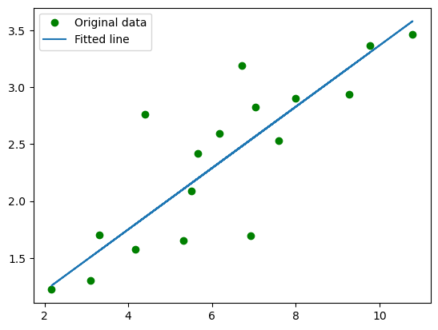

Lab 2

Test Accuracy: 0.879

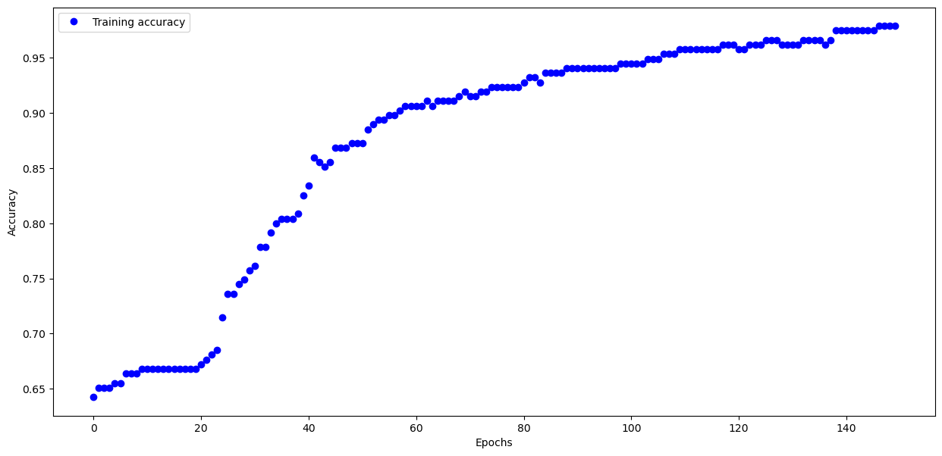

Lab 3

Test accuracy: 0.7394000291824341

**Model: "sequential_2"**

━━━━━━━━━━━━━━━━━━━━━━━━━━━━━━━━━┳━━━━━━━━━━━━━━━━━━━━━━━━┳━━━━━━━━━━━━━━━┓

┃ **Layer (type)** ┃ **Output Shape** ┃ **Param #** ┃

┡━━━━━━━━━━━━━━━━━━━━━━━━━━━━━━━━━╇━━━━━━━━━━━━━━━━━━━━━━━━╇━━━━━━━━━━━━━━━┩

│ flatten_2 (Flatten) │ (None, 784) │ 0 │

├─────────────────────────────────┼────────────────────────┼───────────────┤

│ dense_6 (Dense) │ (None, 68) │ 53,380 │

├─────────────────────────────────┼────────────────────────┼───────────────┤

│ dense_7 (Dense) │ (None, 55) │ 3,795 │

├─────────────────────────────────┼────────────────────────┼───────────────┤

│ dense_8 (Dense) │ (None, 10) │ 560 │

└─────────────────────────────────┴────────────────────────┴───────────────┘

**Total params:** 57,735 (225.53 KB)

**Trainable params:** 57,735 (225.53 KB)

**Non-trainable params:** 0 (0.00 B)

None

Lab 4

Model: "sequential_1"

┏━━━━━━━━━━━━━━━━━━━━━━━━━━━━━━━━━┳━━━━━━━━━━━━━━━━━━━━━━━━┳━━━━━━━━━━━━━━━┓

┃ Layer (type) ┃ Output Shape ┃ Param # ┃

┡━━━━━━━━━━━━━━━━━━━━━━━━━━━━━━━━━╇━━━━━━━━━━━━━━━━━━━━━━━━╇━━━━━━━━━━━━━━━┩

│ dense_5 (Dense) │ (None, 100) │ 2,000 │

├─────────────────────────────────┼────────────────────────┼───────────────┤

│ dense_6 (Dense) │ (None, 73) │ 7,373 │

├─────────────────────────────────┼────────────────────────┼───────────────┤

│ dense_7 (Dense) │ (None, 22) │ 1,628 │

├─────────────────────────────────┼────────────────────────┼───────────────┤

│ dense_8 (Dense) │ (None, 10) │ 230 │

├─────────────────────────────────┼────────────────────────┼───────────────┤

│ dense_9 (Dense) │ (None, 1) │ 11

Total params: 33,728 (131.75 KB)

Trainable params: 11,242 (43.91 KB)

Non-trainable params: 0 (0.00 B)

Optimizer params: 22,486 (87.84 KB)

None

Lab 5

**Model: "sequential"**

┏━━━━━━━━━━━━━━━━━━━━━━━━━━━━━━━━━┳━━━━━━━━━━━━━━━━━━━━━━━━┳━━━━━━━━━━━━━━━┓

┃ **Layer (type)** ┃ **Output Shape** ┃ **Param #** ┃

┡━━━━━━━━━━━━━━━━━━━━━━━━━━━━━━━━━╇━━━━━━━━━━━━━━━━━━━━━━━━╇━━━━━━━━━━━━━━━┩

│ conv2d (Conv2D) │ (None, 29, 29, 32) │ 1,568 │

├─────────────────────────────────┼────────────────────────┼───────────────┤

│ max_pooling2d (MaxPooling2D) │ (None, 14, 14, 32) │ 0 │

├─────────────────────────────────┼────────────────────────┼───────────────┤

│ conv2d_1 (Conv2D) │ (None, 12, 12, 28) │ 8,092 │

├─────────────────────────────────┼────────────────────────┼───────────────┤

│ max_pooling2d_1 (MaxPooling2D) │ (None, 12, 12, 28) │ 0 │

├─────────────────────────────────┼────────────────────────┼───────────────┤

│ conv2d_2 (Conv2D) │ (None, 11, 10, 22) │ 3,718 │

├─────────────────────────────────┼────────────────────────┼───────────────┤

│ max_pooling2d_2 (MaxPooling2D) │ (None, 3, 3, 22) │ 0 │

├─────────────────────────────────┼────────────────────────┼───────────────┤

│ flatten (Flatten) │ (None, 198) │ 0 │

├─────────────────────────────────┼────────────────────────┼───────────────┤

│ dense (Dense) │ (None, 228) │ 45,372 │

├─────────────────────────────────┼────────────────────────┼───────────────┤

│ dense_1 (Dense) │ (None, 128) │ 29,312 │

├─────────────────────────────────┼────────────────────────┼───────────────┤

│ dense_2 (Dense) │ (None, 10) │ 1,290 │

└─────────────────────────────────┴────────────────────────┴───────────────┘

**Total params:** 89,352 (349.03 KB)

**Trainable params:** 89,352 (349.03 KB)

**Non-trainable params:** 0 (0.00 B)

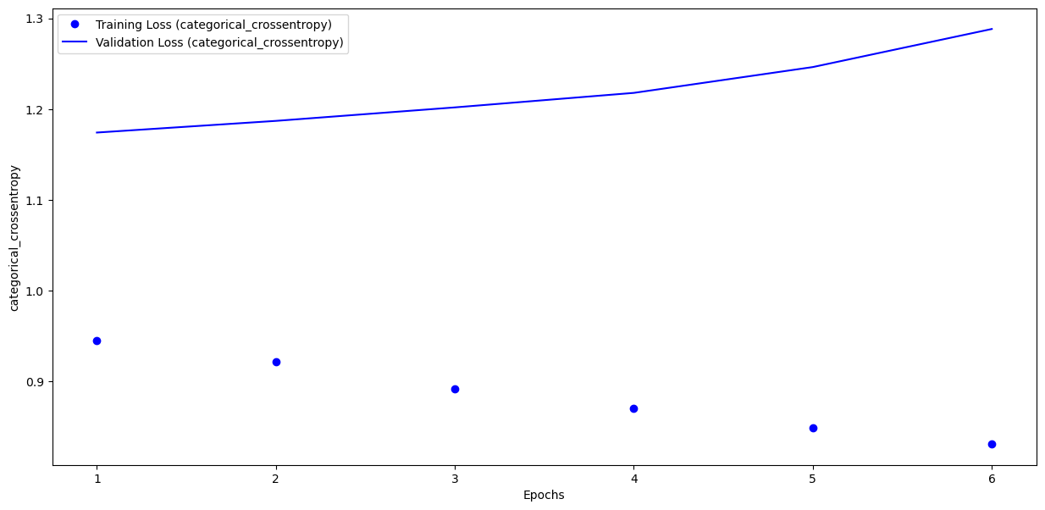

Epoch 1/10 **1563/1563** ━━━━━━━━━━━━━━━━━━━━ **7s** 5ms/step - accuracy: 0.6733 - loss: 0.9203 - val_accuracy: 0.6023 - val_loss: 1.1742

Epoch 2/10 **1563/1563** ━━━━━━━━━━━━━━━━━━━━ **7s** 4ms/step - accuracy: 0.6766 - loss: 0.9076 - val_accuracy: 0.6043 - val_loss: 1.1870

Epoch 3/10 **1563/1563** ━━━━━━━━━━━━━━━━━━━━ **7s** 5ms/step - accuracy: 0.6947 - loss: 0.8556 - val_accuracy: 0.5996 - val_loss: 1.2019

Epoch 4/10 **1563/1563** ━━━━━━━━━━━━━━━━━━━━ **7s** 4ms/step - accuracy: 0.7007 - loss: 0.8444 - val_accuracy: 0.6034 - val_loss: 1.2179

Epoch 5/10 **1563/1563** ━━━━━━━━━━━━━━━━━━━━ **8s** 5ms/step - accuracy: 0.7069 - loss: 0.8189 - val_accuracy: 0.6047 - val_loss: 1.2464

Epoch 6/10 **1563/1563** ━━━━━━━━━━━━━━━━━━━━ **7s** 4ms/step - accuracy: 0.7140 - loss: 0.8035 - val_accuracy: 0.5926 - val_loss: 1.2883

Lab 6

**Model: "sequential_2"**

┏━━━━━━━━━━━━━━━━━━━┳━━━━━━━━━━━━━━━━┳━━━━━━━━┓

┃ **Layer (type)** ┃ **Output Shape** ┃**Param #** ┃

┡━━━━━━━━━━━━━━━━━━━╇━━━━━━━━━━━━━━━━╇━━━━━━━━┩

│ gru (GRU) │ (None, 73) │ 16,644 │

├───────────────────┼────────────────┼────────┤

│ dense_2 (Dense) │ (None, 1) │ 74 │

└───────────────────┴────────────────┴────────┘

**Total params:** 16,718 (65.30 KB)

**Trainable params:** 16,718 (65.30 KB)

**Non-trainable params:** 0 (0.00 B)

early_stop = EarlyStopping(monitor='val_loss',patience=2)

**366/366** ━━━━━━━━━━━━━━━━━━━━ **2s** 3ms/step - loss: 0.0260 - val_loss: 0.0293

Epoch 2/30**366/366** ━━━━━━━━━━━━━━━━━━━━ **1s** 2ms/step - loss: 0.0159 - val_loss: 0.0536

Epoch 3/30**366/366** ━━━━━━━━━━━━━━━━━━━━ **1s** 2ms/step - loss: 0.0186 - val_loss: 0.0375

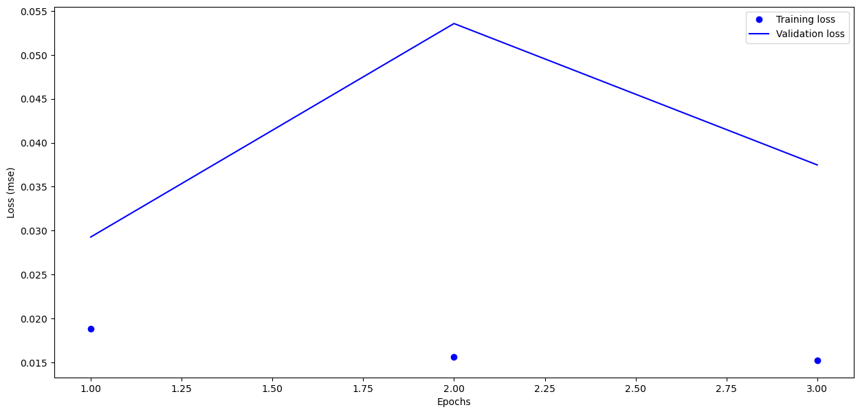

Lab 7

Epoch 1/40

1328/1328 ━━━━━━━━━━━━━━━━━━━━ 36s 24ms/step - accuracy: 0.2126 - loss: 2.1780 - val_accuracy: 0.3295 - val_loss: 1.8580

Epoch 2/40

1328/1328 ━━━━━━━━━━━━━━━━━━━━ 4s 3ms/step - accuracy: 0.2812 - loss: 2.0580 - val_accuracy: 0.3301 - val_loss: 1.8573

Epoch 3/40

1328/1328 ━━━━━━━━━━━━━━━━━━━━ 33s 22ms/step - accuracy: 0.3093 - loss: 1.8816 - val_accuracy: 0.3662 - val_loss: 1.7502

Epoch 4/40

1328/1328 ━━━━━━━━━━━━━━━━━━━━ 5s 4ms/step - accuracy: 0.3750 - loss: 1.8530 - val_accuracy: 0.3667 - val_loss: 1.7504

Epoch 5/40

1328/1328 ━━━━━━━━━━━━━━━━━━━━ 41s 31ms/step - accuracy: 0.3386 - loss: 1.7916 - val_accuracy: 0.3818 - val_loss: 1.6992

Epoch 6/40

1328/1328 ━━━━━━━━━━━━━━━━━━━━ 5s 4ms/step - accuracy: 0.5312 - loss: 1.6565 - val_accuracy: 0.3817 - val_loss: 1.6988

Epoch 7/40

1328/1328 ━━━━━━━━━━━━━━━━━━━━ 82s 35ms/step - accuracy: 0.3653 - loss: 1.7516 - val_accuracy: 0.3994 - val_loss: 1.6557

Epoch 8/40

1328/1328 ━━━━━━━━━━━━━━━━━━━━ 5s 4ms/step - accuracy: 0.3750 - loss: 1.7194 - val_accuracy: 0.3985 - val_loss: 1.6565

Epoch 9/40

1328/1328 ━━━━━━━━━━━━━━━━━━━━ 62s 23ms/step - accuracy: 0.3772 - loss: 1.7049 - val_accuracy: 0.4097 - val_loss: 1.6263

Epoch 10/40

1328/1328 ━━━━━━━━━━━━━━━━━━━━ 5s 4ms/step - accuracy: 0.3438 - loss: 1.7962 - val_accuracy: 0.4096 - val_loss: 1.6263

Epoch 11/40

1328/1328 ━━━━━━━━━━━━━━━━━━━━ 41s 31ms/step - accuracy: 0.3856 - loss: 1.6924 - val_accuracy: 0.4205 - val_loss: 1.5945

Epoch 12/40

1328/1328 ━━━━━━━━━━━━━━━━━━━━ 5s 4ms/step - accuracy: 0.4375 - loss: 1.8502 - val_accuracy: 0.4203 - val_loss: 1.5944

Epoch 13/40

1328/1328 ━━━━━━━━━━━━━━━━━━━━ 67s 23ms/step - accuracy: 0.4011 - loss: 1.6571 - val_accuracy: 0.4303 - val_loss: 1.5735

Epoch 14/40

1328/1328 ━━━━━━━━━━━━━━━━━━━━ 4s 3ms/step - accuracy: 0.4688 - loss: 1.7099 - val_accuracy: 0.4307 - val_loss: 1.5725

Epoch 15/40

1328/1328 ━━━━━━━━━━━━━━━━━━━━ 36s 22ms/step - accuracy: 0.4053 - loss: 1.6333 - val_accuracy: 0.4410 - val_loss: 1.5550

Epoch 16/40

1328/1328 ━━━━━━━━━━━━━━━━━━━━ 5s 4ms/step - accuracy: 0.5312 - loss: 1.3139 - val_accuracy: 0.4414 - val_loss: 1.5548

Epoch 17/40

1328/1328 ━━━━━━━━━━━━━━━━━━━━ 41s 26ms/step - accuracy: 0.4183 - loss: 1.6206 - val_accuracy: 0.4472 - val_loss: 1.5343

Epoch 18/40

1328/1328 ━━━━━━━━━━━━━━━━━━━━ 5s 4ms/step - accuracy: 0.4688 - loss: 1.5680 - val_accuracy: 0.4466 - val_loss: 1.5338

Epoch 19/40

1328/1328 ━━━━━━━━━━━━━━━━━━━━ 41s 31ms/step - accuracy: 0.4241 - loss: 1.5977 - val_accuracy: 0.4571 - val_loss: 1.5137

Epoch 20/40

1328/1328 ━━━━━━━━━━━━━━━━━━━━ 5s 4ms/step - accuracy: 0.3750 - loss: 1.6213 - val_accuracy: 0.4567 - val_loss: 1.5146

Epoch 21/40

1328/1328 ━━━━━━━━━━━━━━━━━━━━ 67s 23ms/step - accuracy: 0.4309 - loss: 1.5757 - val_accuracy: 0.4617 - val_loss: 1.4988

Epoch 22/40

1328/1328 ━━━━━━━━━━━━━━━━━━━━ 5s 4ms/step - accuracy: 0.4688 - loss: 1.4201 - val_accuracy: 0.4611 - val_loss: 1.4994

Epoch 23/40

1328/1328 ━━━━━━━━━━━━━━━━━━━━ 41s 31ms/step - accuracy: 0.4379 - loss: 1.5676 - val_accuracy: 0.4671 - val_loss: 1.4835

Epoch 24/40

1328/1328 ━━━━━━━━━━━━━━━━━━━━ 4s 3ms/step - accuracy: 0.4375 - loss: 1.4519 - val_accuracy: 0.4677 - val_loss: 1.4836

Epoch 25/40

1328/1328 ━━━━━━━━━━━━━━━━━━━━ 68s 23ms/step - accuracy: 0.4466 - loss: 1.5374 - val_accuracy: 0.4732 - val_loss: 1.4689

Epoch 26/40

1328/1328 ━━━━━━━━━━━━━━━━━━━━ 4s 3ms/step - accuracy: 0.5000 - loss: 1.6416 - val_accuracy: 0.4728 - val_loss: 1.4694

Epoch 27/40

1328/1328 ━━━━━━━━━━━━━━━━━━━━ 36s 23ms/step - accuracy: 0.4509 - loss: 1.5387 - val_accuracy: 0.4770 - val_loss: 1.4577

Epoch 28/40

1328/1328 ━━━━━━━━━━━━━━━━━━━━ 5s 4ms/step - accuracy: 0.4062 - loss: 1.4612 - val_accuracy: 0.4765 - val_loss: 1.4577

Epoch 29/40

1328/1328 ━━━━━━━━━━━━━━━━━━━━ 41s 31ms/step - accuracy: 0.4553 - loss: 1.5211 - val_accuracy: 0.4812 - val_loss: 1.4491

Epoch 30/40

1328/1328 ━━━━━━━━━━━━━━━━━━━━ 5s 4ms/step - accuracy: 0.4375 - loss: 1.5371 - val_accuracy: 0.4809 - val_loss: 1.4493

Epoch 31/40

1328/1328 ━━━━━━━━━━━━━━━━━━━━ 82s 35ms/step - accuracy: 0.4623 - loss: 1.5162 - val_accuracy: 0.4796 - val_loss: 1.4516

Epoch 32/40

1328/1328 ━━━━━━━━━━━━━━━━━━━━ 4s 3ms/step - accuracy: 0.5312 - loss: 1.5323 - val_accuracy: 0.4781 - val_loss: 1.4500

Epoch 33/40

1328/1328 ━━━━━━━━━━━━━━━━━━━━ 41s 31ms/step - accuracy: 0.4630 - loss: 1.5040 - val_accuracy: 0.4897 - val_loss: 1.4262

Epoch 34/40

1328/1328 ━━━━━━━━━━━━━━━━━━━━ 4s 3ms/step - accuracy: 0.4688 - loss: 1.4638 - val_accuracy: 0.4896 - val_loss: 1.4255

Epoch 35/40

1328/1328 ━━━━━━━━━━━━━━━━━━━━ 41s 31ms/step - accuracy: 0.4667 - loss: 1.4974 - val_accuracy: 0.4945 - val_loss: 1.4136

Epoch 36/40

1328/1328 ━━━━━━━━━━━━━━━━━━━━ 4s 3ms/step - accuracy: 0.5000 - loss: 1.4790 - val_accuracy: 0.4953 - val_loss: 1.4130

Epoch 37/40

1328/1328 ━━━━━━━━━━━━━━━━━━━━ 31s 23ms/step - accuracy: 0.4704 - loss: 1.4886 - val_accuracy: 0.4973 - val_loss: 1.4089

Epoch 38/40

1328/1328 ━━━━━━━━━━━━━━━━━━━━ 5s 4ms/step - accuracy: 0.6250 - loss: 1.2994 - val_accuracy: 0.4985 - val_loss: 1.4090

Epoch 39/40

1328/1328 ━━━━━━━━━━━━━━━━━━━━ 41s 27ms/step - accuracy: 0.4719 - loss: 1.4814 - val_accuracy: 0.4976 - val_loss: 1.4021

Epoch 40/40

1328/1328 ━━━━━━━━━━━━━━━━━━━━ 4s 3ms/step - accuracy: 0.4688 - loss: 1.4763 - val_accuracy: 0.4981 - val_loss: 1.4017

precision recall f1-score support

0 0.54 0.56 0.55 1000

1 0.53 0.67 0.59 1000

2 0.39 0.35 0.37 1000

3 0.36 0.31 0.33 1000

4 0.43 0.41 0.42 1000

5 0.46 0.36 0.40 1000

6 0.50 0.56 0.53 1000

7 0.53 0.57 0.55 1000

8 0.66 0.66 0.66 1000

9 0.55 0.55 0.55 1000

accuracy 0.50 10000

macro avg 0.49 0.50 0.49 10000

weighted avg 0.49 0.50 0.49 10000

|  | **Accuracy** | **Precision** | **Recall** | **F1_Score** |
| --- | --- | --- | --- | --- |
| **VGG-16** | 0.6521 | 0.650271 | 0.6521 | 0.650654 |
| **VGG_19** | 0.4993 | 0.494120 | 0.4993 | 0.494805 |

Lab 8

Lab 9

Lab 10

Lab 11

Lab 12