VisualR_2

F.J. Padt

Saturday, March 28, 2015

require(graphics)  
  
M <- as.table(cbind(c(18, 28, 14), c(20, 51, 28), c(12, 25, 9)))   
dimnames(M) <- list( Husband = c("Tall", "Medium", "Short"),   
 Wife = c("Tall"," Medium", "Short"))  
  
assocplot(M, col = c("green", "red"))

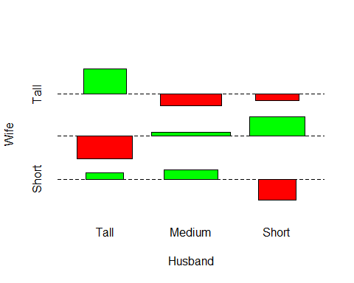

library(vcd)

## Loading required package: grid

assoc(M)

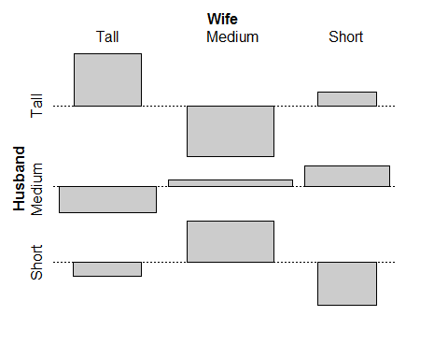

require(graphics)  
# Clean and prepare the data   
r1 <- c(7.9 , 67.6, 28.3, 53.6)   
r2 <- c(4.4 , 54.5, 29.9, 57.6)   
r3 <- c(10.2, 50 , 27.7, 53.4)   
r4 <- c(2.5 , 35.3, 22.2, 47)   
r5 <- c(8.5 , 46.3, 32.2, 50)   
  
data <- as.table(rbind(r1, r2, r3, r4, r5))   
dimnames(data) <- list(   
 Town = c(" Sheffield"," Warrington", "Dewsbury"," Leicester"," Gloucester"),  
 Vaccinated = c(" Yes (< 10)"," No (< 10)", "Yes (> 10)"," No (> 10)"))   
  
#Step 3: Plot the chart   
spineplot(data)

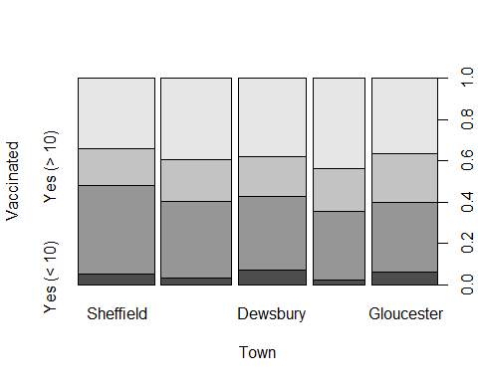

spineplot(data, col = c("darkred", "orange", "darkgreen", "yellow1"))

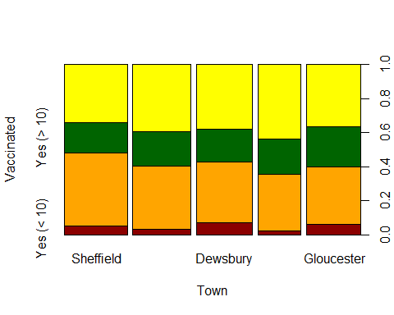

#step4: Mosaic Plot  
mosaicplot(data, color = 1:4)

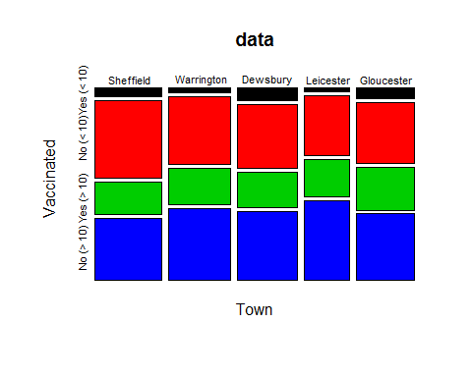

mosaicplot(data, color = 1:4, las = 1)

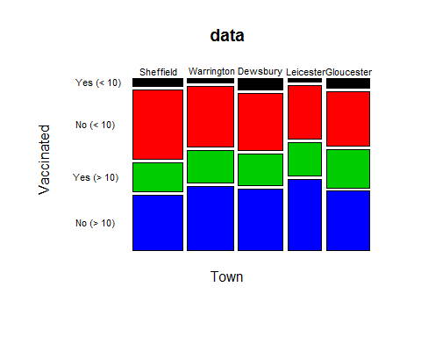

## Quick reference R code

### Figure 5.1 Box plot of the effect of Vitamin C on tooth growth

Lewis, N.D. (2014-02-02). Visualizing Complex Data Using R (p. 25). . Kindle Edition.

data( ToothGrowth)   
boxplot(len ~ dose, data = ToothGrowth,   
 boxwex = 0.25, at = 1: 3 - 0.2,   
 subset = supp == "VC", col = "red",   
 xlab = "Vitamin C dose mg", ylab = "Tooth length",   
 xlim = c(0.5, 3.5), ylim = c(0, 35), yaxs = "i")   
  
boxplot(len ~ dose, data = ToothGrowth,   
 add = TRUE, boxwex = 0.25, at = 1:3 + 0.2,   
 subset = supp == "OJ", col = "cyan")   
  
legend(2, 9,   
 c("Ascorbic acid (VC)", "Orange Juice Group (OJ)"),   
 fill = c("red", "cyan"))

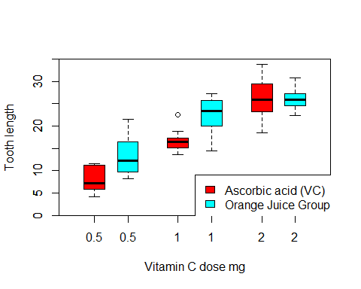

### Figure 5.2 2d contour plot of the effect of Vitamin C on tooth growth

Lewis, N.D. (2014-02-02). Visualizing Complex Data Using R (p. 26). . Kindle Edition.

require(reshape)

## Loading required package: reshape

require(extracat)

## Loading required package: extracat

data(ToothGrowth)   
boxplot2g(ToothGrowth$dose, ToothGrowth$len, ToothGrowth$sup)

## Scale for 'colour' is already present. Adding another scale for 'colour', which will replace the existing scale.

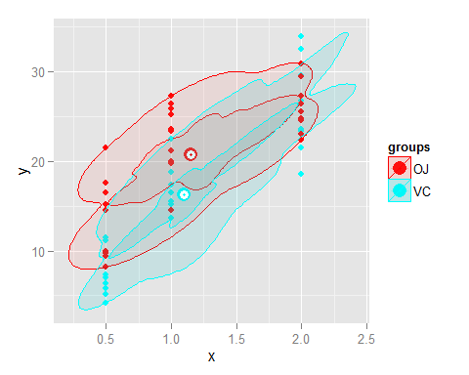

### Figure 5.3 2d contour plot of Iris data

Lewis, N.D. (2014-02-02). Visualizing Complex Data Using R (p. 26). . Kindle Edition.

# install.packages("extracat")   
require(extracat)   
  
boxplot2g(iris$Sepal.Length, iris$Sepal.Width, iris$Species)

## Scale for 'colour' is already present. Adding another scale for 'colour', which will replace the existing scale.  
## Scale for 'colour' is already present. Adding another scale for 'colour', which will replace the existing scale.

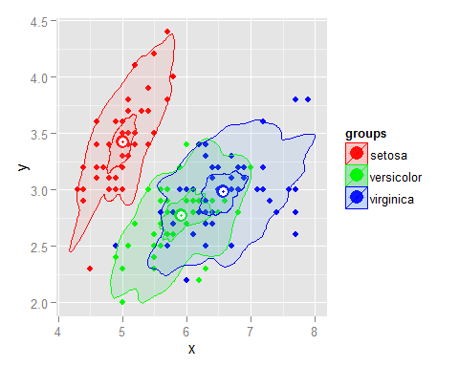

### Figure 5.4 relationship between tips and total bill given group size

Lewis, N.D. (2014-02-02). Visualizing Complex Data Using R (p. 26). . Kindle Edition.

# install.packages("extracat")  
# install.packages("reshape")   
  
require(extracat)   
require(reshape)   
  
data(tips)   
boxplot2g(tips$total_bill, tips$tip, tips$size)

## Scale for 'colour' is already present. Adding another scale for 'colour', which will replace the existing scale.  
## Scale for 'colour' is already present. Adding another scale for 'colour', which will replace the existing scale.  
## Scale for 'colour' is already present. Adding another scale for 'colour', which will replace the existing scale.  
## Scale for 'colour' is already present. Adding another scale for 'colour', which will replace the existing scale.  
## Scale for 'colour' is already present. Adding another scale for 'colour', which will replace the existing scale.

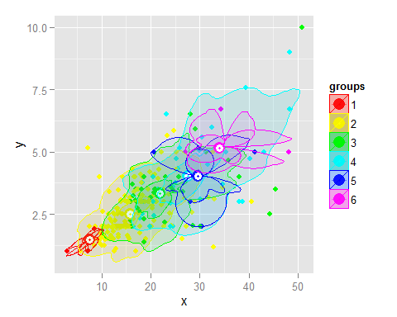

### Figure 5-5 relationship between tips and total bill given day of week

Lewis, N.D. (2014-02-02). Visualizing Complex Data Using R (pp. 26-27). . Kindle Edition.

# install.packages("extracat")  
# install.packages("reshape")   
  
require(extracat)   
require(reshape)   
  
data(tips)   
boxplot2g(tips$total_bill, tips$tip, tips$day)

## Scale for 'colour' is already present. Adding another scale for 'colour', which will replace the existing scale.  
## Scale for 'colour' is already present. Adding another scale for 'colour', which will replace the existing scale.  
## Scale for 'colour' is already present. Adding another scale for 'colour', which will replace the existing scale.

