Journal Club Manager

Version 1.0

Author: Florian Perdreau, Laboratoire Psychologie de la Perception, Paris, France.

Contact: [florian.perdreau@gmail.com](mailto:florian.perdreau@gmail.com)

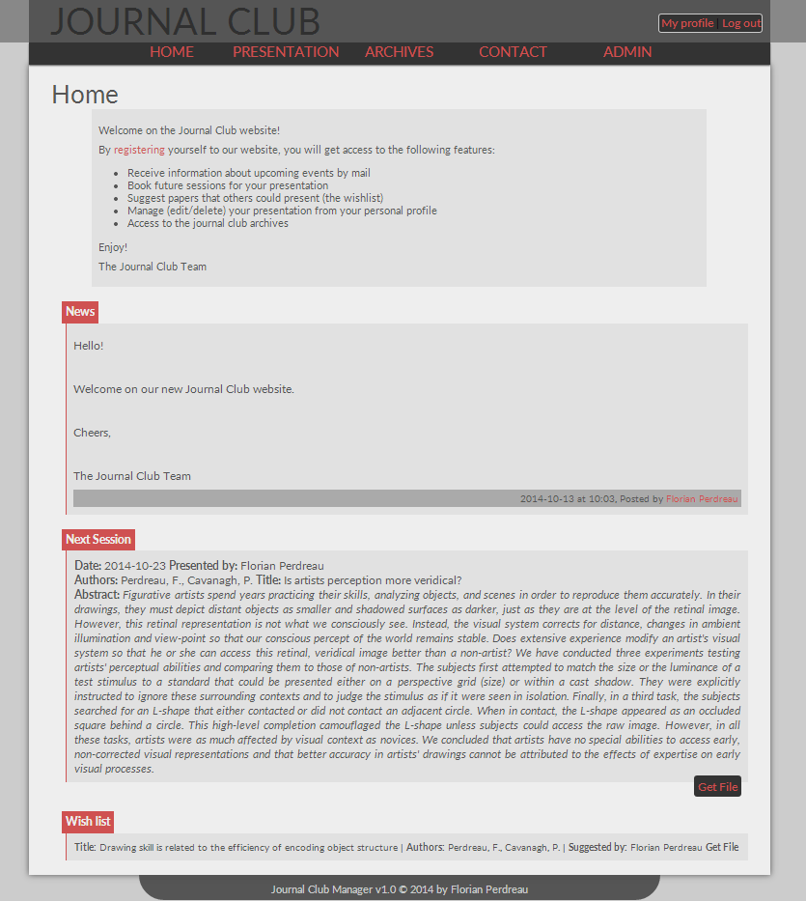

# Introduction

*Journal Club Manager* is a web-application dedicated to the management of labs journal clubs.

# System requirements

To work properly, *JCM* requires:

* A web server
* PHP 5.2 or later
* An SQL database running with mysqli drivers (v.4+)
* PhPMyAdmin

# Installation

## Step 1: Upload files on the server

1. Upload the “Pjc” folder to the root of your web-server using a FTP client (e.g. FileZilla).
2. Make sure that you have the writing authorization for all the folders and files (set folders chmod to 0777 and files chmod to 0666).
3. Go to your PhPMyAdmin interface and create a new database (if you have the authorization, however, ask your admin the name of the database).

## Step 2: Online installer

In your favorite web-browser, go to the URL: <http://www.mydomain.com/Pjc/index.php?page=install> (replacing “yourwebsite” by your domain address; e.g.: [www.domainname.com/mywebsite/](http://www.domainname.com/mywebsite/)).

## Step 3 : MySQL Database access information

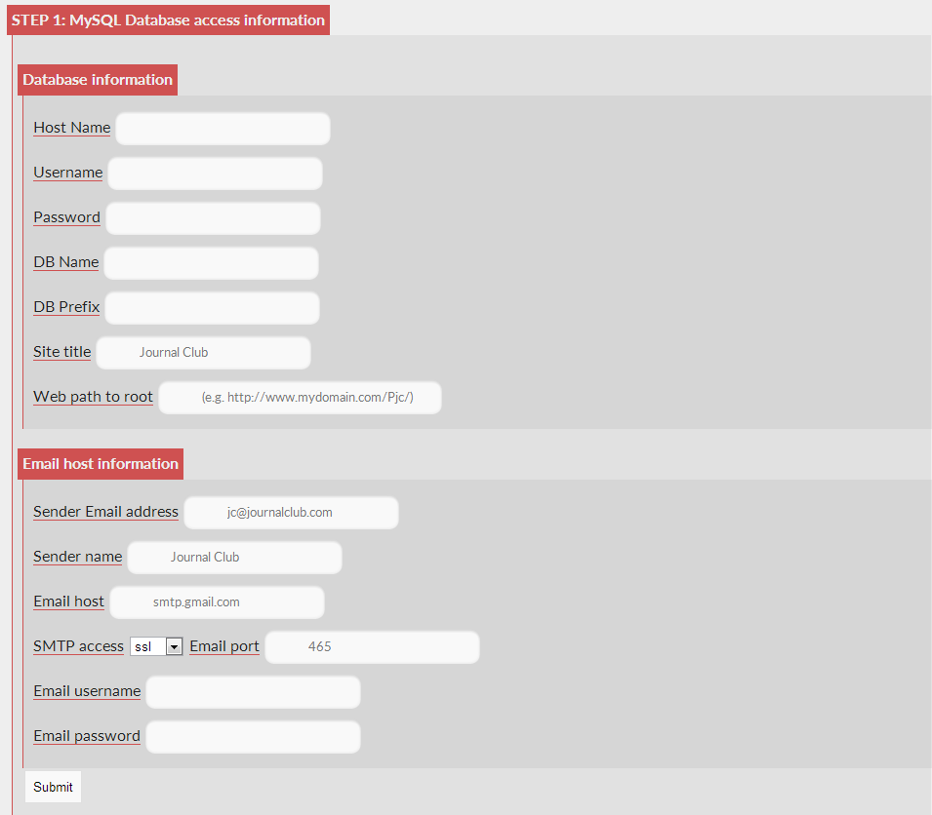

***Hostname***: Your SQL hostname (e.g.: sql.mydomain.com)

***User name***: your SQL username (the one you may use to access PhPMyAdmin).

***Password***: your SQL password (The same you are using to access PhPMyAdmin).

***Database name***: the name of the database you have created at the Step 3 of the preparation phase.

***Database prefix***: Choose a prefix that will be used to create tables in your database (e.g.: pjc). Make sure the prefix you choose if not already used by other applications installed on your server.

**Site title:** title of the website (it will appear in the website’s header: e.g. “My Lab Journal Club”).

Web path to root: Web path to the application root (e.g. <http://www.mydomain.com/Pjc>).

***Email host information (To enable email notifications)***

**Send Email address:** your journal club email

**Sender Name:** Name associated to the email address

**Email host:** SMTP host address (e.g. smtp.gmail.com if you are using a Gmail address).

**SMTP access:** Security protocol (SSL/TLS/none). Note that using SSL/TLS requires that SSL PHP extension is installed on your web-server.

**Email username:** your email username

**Email password:** your email password.

## Step 4 : MySQL Database access information

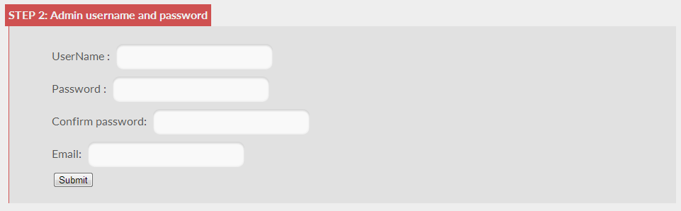

**Username:** choose a username for your admin account

**Password:** choose a password for your admin account

**Confirm password:** re-enter your password

**Email:** provide an email address that will be associated with the admin account.

## Step 5: Delete installation files

For security reasons, you must delete installation files from your web-server. Go to your FTP and:

* Delete the “install.php” file located in the “page” folder.
* Delete the “install” folder located at the root of the “Pjc” folder.

## Step 6 (optional): Set automatic email notification

In order to automatically send email notifications, you must set CRON jobs on your server (if your server is running on Linux) or scheduled tasks (if it’s running on MS Windows).

Whatever the system your server is running on, you must target your scheduled task to the “mailing.php” file present in the “Pjc/cronjobs” folder.

Here is a tutorial to automatically run PHP file:

* on MS Windows: <https://www.drupal.org/node/31506>
* on Linux: <http://www.thegeekstuff.com/2011/07/php-cron-job/>

If you cannot execute scheduled tasks on your system, you still be able to manually send email notifications from the “Send email” page of the admin interface (see Admin interface section below).

# Features

## Publication

### Submit a new publication

**Select a publication type :**

* Paper: a published article
* Research: your own research
* Methodology: a methodology topic
* Invited: an invited speaker.

**Speaker:** Name of the invited speaker (you do not need to fill this field if you are presenting).

**Date:** Choose a date for your presentation (only available dates are selectable).

**Title:** submission title

**Abstract:** submission abstract (2000 characters maximum)

**Authors:** Authors of the article or of the research.

**File:** pdf of the article, or slides, etc.

### Suggest a paper:

**Title:** Article’s title

**Abstract:** Article’s abstract

**Authors:** Name of the authors

**File:** PDF of the article.

### Select a paper from the wish list

**Choose a wish:** select a paper from the wish list (the list may be empty if no papers have been suggested yet).

Check that all the fields are properly filled up and choose a date for your presentation.

## Archives

Here, you can find all the previous presentations and download the associated files. Archives can be filtered by year.

## Contact

Here you can find information relative to the journal club (address, time, map) and contact the organizers by email.

## My profile

Every user can access his/her own profile page and manage his/her account and submissions.

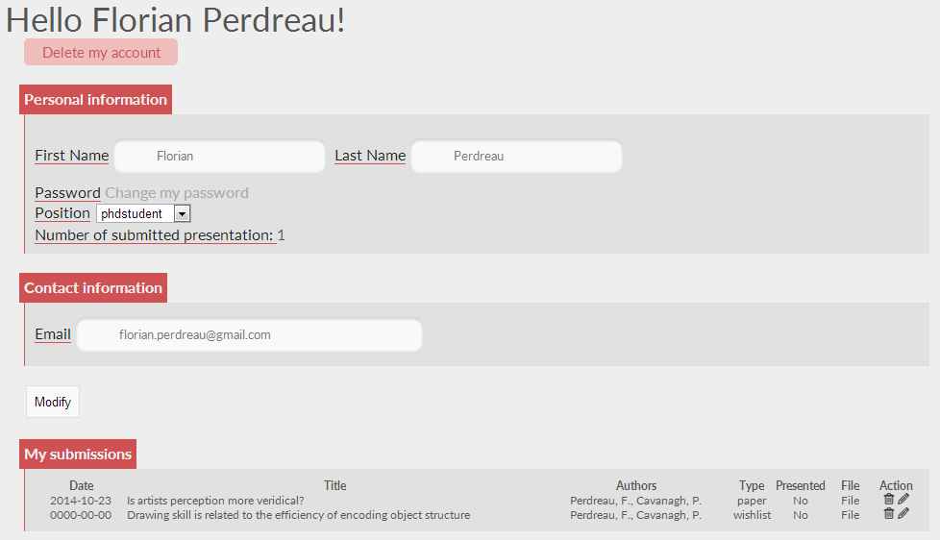

## Admin interface

This interface is only accessible to admins (organizers).

### Configuration

Here are all configurable settings of the website

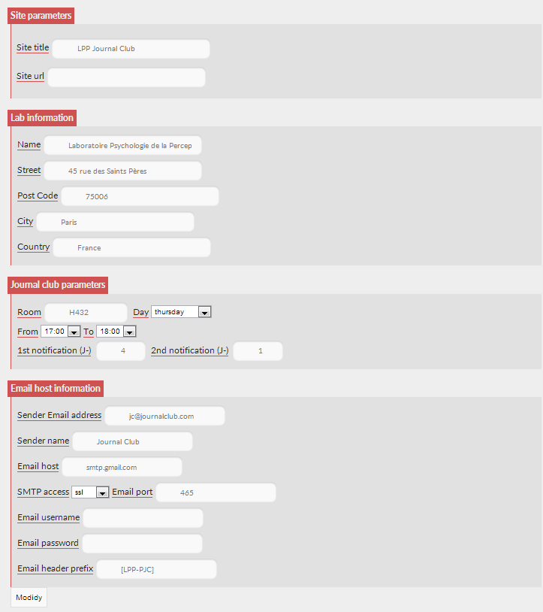

**Site parameters:**

**Site title:** Title of the website

**Site url:** web path to the application folder (e.g. <http://www.mydomain.com/Pjc/>).

**Lab Information**

Here you may precise your lab’s name and address.

**Journal Club Parameters**

**Room:** Room of the journal club

**Day:** Day of the journal club.

**Time (from/to):** set starting and ending time of the JC session.

**1st notification:** First email notification before the JC session (e.g. D-4).

**2nd notification:** Second email notification (reminder) before the JC session (e.g. D-1).

**Email host information**

Please, refer to the 3rd installation step above.

### Manage users

Here you can change users’ status (admin/organizer/member) or delete users’ account.

### Send email

Here you can send an email notification to the mailing list. Your “special header” (email title) and “special message” will be automatically added to the usual notification email.

### Add a post

Here you can add a news that will appear on the website’s homepage.

### Tools

Here you may find several tools:

* Export your database to an XLS format
* Backup your database (a “.sql” copy will be made on the server and sent to the admin’s email address).

# Registration procedure

1. The new user must fill up all the fields (First name, last name, username, password, email, academic position).
2. An email is sent to the admin/organizers for verification (click on authorize or deny accordingly):

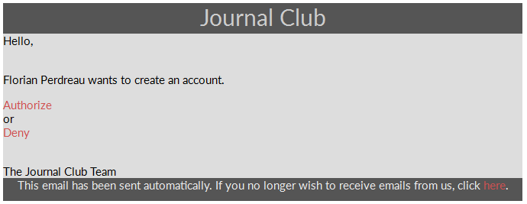

1. Finally, the user receives a confirmation email if his/her registration has been confirmed.