GROUP 9 PRACTICAL 1

EXERCISE 1

04.fa.txt

Bradyrhizobium japonicum strain E109, complete genome
Size: 9224208 bp
Organism: Bradyrhizobium japonicum (bacteria)
Genes: 8743

16.fa.txt

Rhodopirellula baltica SH 1 complete genome
Size: 714763 Mbp
Organism: Rhodopirellula baltica (Bacteria)
Genes: 7405

18.fa.txt

Synechocystis sp. PCC 6714, complete genome
Size: 3485441 bp
Organism: Synechocystis (Bacteria)
Genes: 360

34.fa.txt

TPA: Saccharomyces cerevisiae S288C chromosome XIV, complete sequence
Size: 784333 bp
Organism: Saccharomyces cerevisiae
Genes: 6458

49.fa.txt

Rubrobacter xylanophilus DSM 9941, complete genome
Size: 3225748 bp
Organism: Rubrobacter xylanophilus
Genes: 3257

EXERCISE 2

apoe: Cervus elaphus hippelaphus

2.1.

blastn: it searches a query nucleotide sequence against a nucleotide database.
blastp: it searches a query protein sequence against a protein database.
blastx: it searches a query translated nucleotide sequence against a protein database.
tblastn: it searches a query protein sequence against a translated nucleotide database.
tblastx: it searches a query translated nucleotide sequence against a translated nucleotide database.

2.2. We used blastp to run our protein query sequence against the reference proteins database (refseq_protein).

2.3. A protein family is a set of proteins that have been grouped together based on their evolutionary relationships. A protein superfamily is a group of protein families among which there is some kind of structure similarity.

2.3.1. Yes.

2.3.2. Apolipoprotein superfamily.

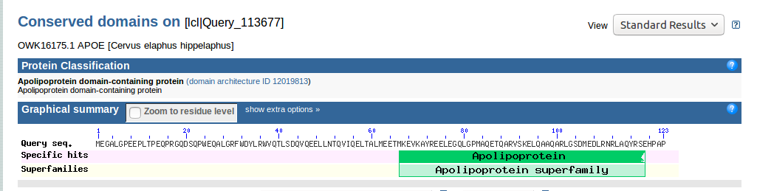

2.3.3. Does not apply.

2.4.1.

The term homology is used in biology to indicate whether two sequences (it can be DNA, RNA or protein sequences) have any kind of evolutionary relationship between them. On the other hand, sequence similarity is used to compare two sequences and have an estimate of how alike they are (this information is usually given as a percentage).

2.4.2.

Based on what has been explained above, homology would be the conclusion that can be drawn from the similarity between two sequences. Depending on the similarity between them, we could say if these sequences share a common ancestor and thus are homologous to each other.

2.4.3.

The apolipoprotein E with highest similarity (97% identity) to the query protein belongs to the organism Odocoileus virginianus texanus. Running a BLAST search is very useful to find, in this case, which other proteins are similar and homologous to the query one and the organism they belong to.

2.5.

The taxonomic spread of this protein family is cellular organisms; Eukaryota; Opisthokonta; Metazoa; Eumetazoa; Bilateria; Deuterostomia; Chordata; Craniata; Vertebrata; Gnathostomata; Teleostomi; Euteleostomi; Sarcopterygii; Dipnotetrapodomorpha; Tetrapoda; Amniota; Mammalia; Theria

Yes, there are homologs to this protein in other kingdoms such as Homo sapiens, Mus musculus, Rattus norvegicus, Bos taurus, etc.

2.6.

Marinik

2.7.

The top three homologous to the query protein are (not taking into account the predicted oens):
- apolipoprotein E [Odocoileus virginianus texanus]
- apolipoprotein E precursor [Bos taurus]
- apolipoprotein E [Delphinapterus leucas]

2.7.1.

Description Identity Matches Gaps
Best hit: apolipoprotein E [Odocoileus virginianus texanus] 97% 96% 0%
Worst hit: apolipoprotein E [Loxodonta africana] 68% 81% 0%

These differences indicate that the main reason for abrupt changes in sequence identity is the amount of matches between the sequences. In this case, both the best and the worst hit have zero gaps when aligned to the query sequence, but it is the amount of mismatches what actually accounts for the similarity between the sequences.

2.7.2.

The max score is the criterion that is used to sort the hits from best to worst hits: the lower the max score value, the worse the hit will be.

2.8.1.

It stands for expectation value.

2.8.2.

The formula for the e value (E) is: E = kmne^{-λS} , where k is a constant, m is the length of the query sequence, n is the length of the database, λ is a scaling factor and S is the raw score.

EXERCISE 3

Marinik.

EXERCISE 4

4.1. and 4.2.

Run.

4.3.

phmmer and jackhmmer took 2,38 and 2,1 seconds respectively, as indicated at the bottom of the webpage. Difference speed to blast? These two tools do not give an alignment of the query to the hits, nor an identity percentage of such alignment. However, they also show the e-value of each hit and can rapidly take the user to the Uniprot database, where it is easy to find the gene, organism, function and cellular localization of each protein hit, among many other data.

4.4.

With phmmer and jackhmmer the taxonomic spread is not as detailed as it is in BLAST. We can see that the spread follows the same main clusters, but phmmer and jackhmmer do not show smaller clusters of the path such as Opisthokonta, Metazoa, Eumetazoa or Amniota, among others.

