PRACTICAL 2

EXERCISE 1 - Glimmer

Parameters:

-n: when used with the long-orfs tool, this parameter is added so that the output file that is generated does not contain data regarding the settings of the program that is used, but the coordinates of the ORFs.
-t: when used with the long-orfs tool, this parameter is added to set a threshold based on the entropy distance score. In this case, those genes with a score less than 1.15 will not be taken into account.
-r: when used with the build-icm tool, the r or reverse parameter is added to specify that the ICM will be built with the reverse strings of those that have been input.
-o50: when used with the glimmer3 tool, this parameter establishes a maximum overlap length. In this case, this length is set equal to 50.
-g110: when used with the glimmer3 tool, this parameter establishes the minimum gene length. In this case, this length is set equal to 110 nucleotides.

Using the 5 genomes:

1.1.

With this code, the ORFs coordinates for each of the 5 genomes are generated.

1.2.

This makes it possible to get the nucleotide sequences of each ORF that has been previously generated.

1.3.

This creates an interpolated context model (ICM) which is basically a probability model of the coding sequences.

1.4.

The glimmer3 tool is run.

1.5.

The sequences can also be obtained from genes that are known in that genome or from genes that have a very high similarity in other strains.

1.6.

No. It is only suitable for prokaryotic genomes. Because eukaryotic genomes are more complex than prokaryotic genomes: they contain introns and this makes it more challenging for the program to find the ORFs, since it is necessary to take into account that some regions will not be coding for genes.

1.7.

Pie de fotos: distribution of predicted gene sizes in genome (A) 04.fa.txt, (B) 16.fa.txt, (C) 18.fa.txt, (D) 34.fa.txt and (E) 49.fa.txt.
Histogram 04.fa.txt.
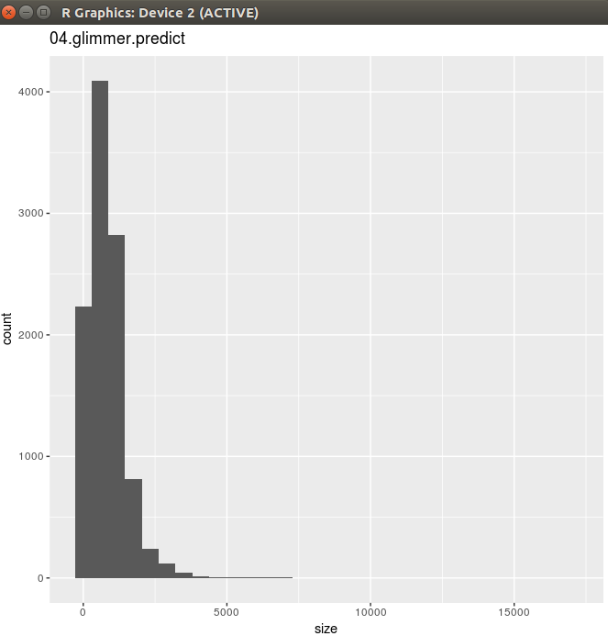

Histogram 16.fa.txt.
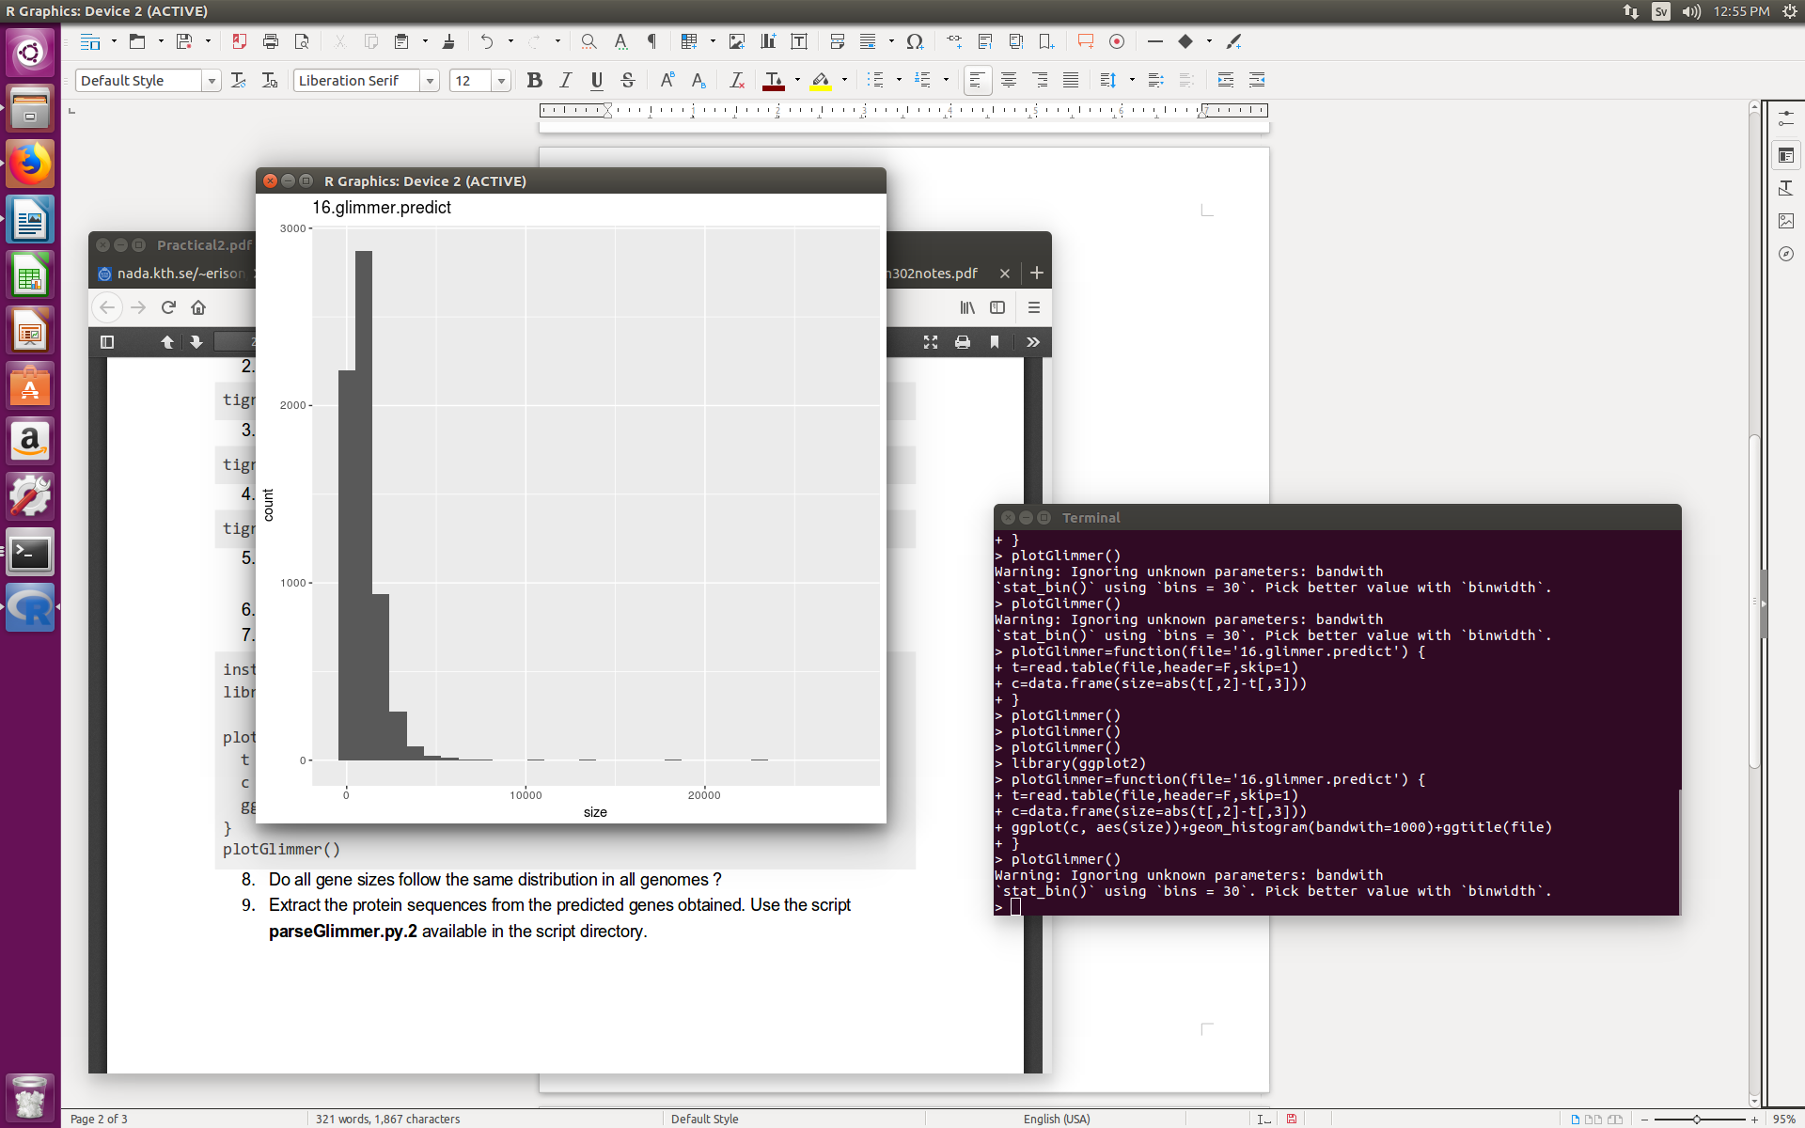

Histogram 18.fa.txt.

Histogram 34.fa.txt.

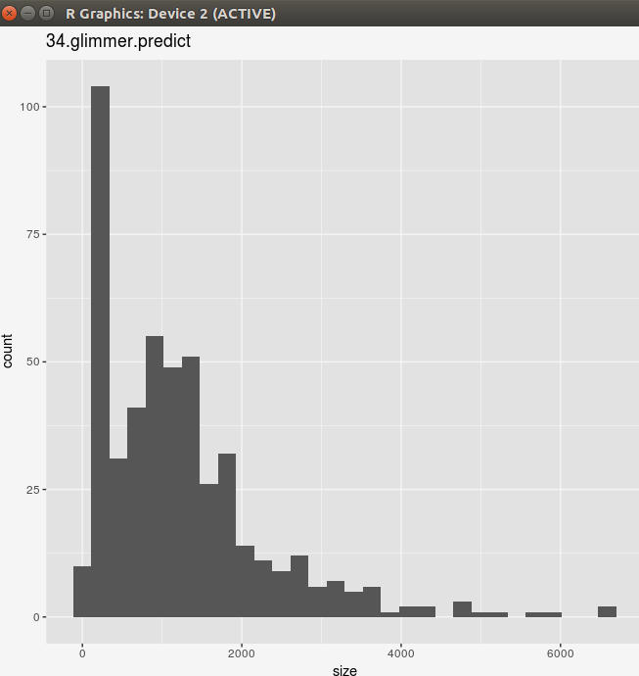

Histogram 49.fa.txt.

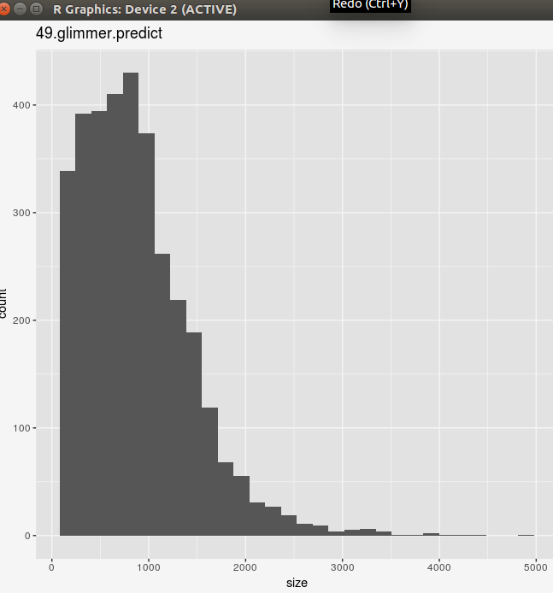

1.8.

No. The histogram of the predicted gene lengths in file 34.fa.txt does not follow the same distribution as the other ones. This is due to the fact that this is an eukaryotic genome and Glimmer is not very suitable to analyze this kind of genomes. Also, it makes sense that the eukaryotic genome histogram represents genes with a larger size than the prokaryotic histograms, since eukaryotic organisms have longer genes than prokaryotic and this can be seen in the figures above.

1.9.

The files containing the protein sequences are attached in the e-mail with the names 04.fa.txt.pfa, 16.fa.txt.pfa, 18.fa.txt.pfa, 34.fa.txt.pfa and 49.fa.txt.pfa.

EXERCISE 2

Using the eukaryote genome (34.fa.txt):

2.1.

Adjuntar files
The files are attached in the e-mail: proteins34.out and proteins34.txt are the files containing the amino acid sequences (same content and different format); nucleotides34.txt is the file containing the nucleotide sequences.

2.2.

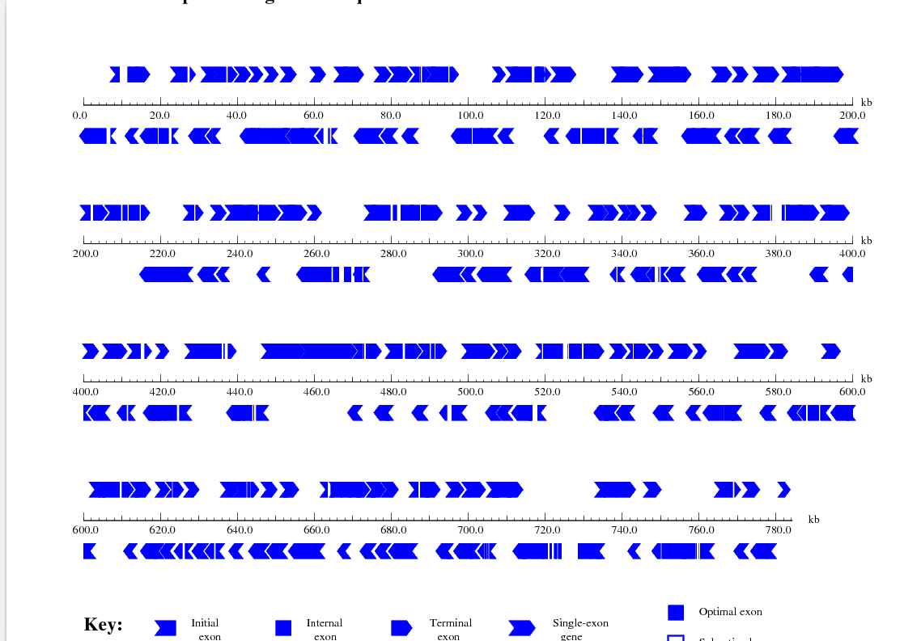

2.3.

Using BLASTx to figure out the protein that the first two nucleotide sequences code for, we got:

- For the first sequence (>./34.fa.txt|GENSCAN_predicted_CDS_1|5589_bp), the corresponding protein name is Y' element ATP-dependent helicase protein 1 copy 6 [Saccharomyces cerevisiae S288C].

- For the second sequence (>./34.fa.txt|GENSCAN_predicted_CDS_2|1812_bp), the corresponding protein name is Cos1p [Saccharomyces cerevisiae S288C].

