PRACTICAL 3

EXERCISE 1

1.1.

-in is the flag used to denote the input file.
-dbtype is the flag used to indicate the if the input is going to be nucleotides (nucl) or proteins (prot).
-outfmt is the flag used to denote the alignment view options. In this case, -outfmt 5 will display an XML BLAST output.
-query is the flag used to indicate the name of the query file.
-db is the flag used to indicated the name of the BLAST database.
-out is the flag that can be used to give a name to the output database that will be created.

1.2.

Done.

2.

Done.

3.1.

Done and saved as hit04, hit16, hit18, hit49.

3.2.

Done and saved as hitMerged.

3.2.1.

The additional parameters -outfmt, -query, -db and -out are explained in exercise 1.1.

3.2.2.

I find my output in the home directory and saved as an XML BLAST output, as I have indicated with the -outfmt flag. Marina responde a what do you expect to see in it.

EXERCISE 2

B.

a.

b.

c.

The BLAST XML outputs is assumed to contain several results and all the attributes that are required by BLAST files so that the program can work correctly. Also, the output is supposed to be ordered from best to lower-scoring hits. This is why the program takes the alignment that appears in position [0] within the hsp argument.

d.

It outputs a FASTA file that contains the best hit for each of the genome files introduced as queries. For example, for the 04 genome file, we get:

>./04.fa.txt
GATTAGCTAGTTGGTGAGGTA-ATGGCTCACCAAGGCGACGATCAGTAGCTGGTCTGAGAGGATGATCAGCCACATTGGGACTGAGACACGGCCCAAACTCCTACGGGAGGCAGCAGTGGGGAATATTGGACAATGGGGGCAACCCTGATCCAGCCATGCCGCGTGAGTGATGAAGGCCCTAGGGTTGTAA-AGC-TCTTTT-GTGCGG-G-AAG—A-TAATG--A---C----G------G---T-ACC-GCAAGAATAAGCCCCGGCTAACTTCGTGCCAGCAGCCGCGGTAATACGAAGGGGGCTAGCGTTGCTCGGAATCACTGGGCGTAAAGGGTGCGTAGGCGGGTCTTTAAGTCAGGGGTGAAATCCTGGAGCTCAACTCCAGAACTGCCTTTGATACTGAGGATCTTGAGT-TCGGGAGAGGTGAGTGGAACTGCGAGTGTAGAGGTGAAATTCGTAGATATTCGCAAGAACACCAGTGGCGAAGGCGGCTCACTGGCCCGATACTGACGCTGAGGCACGAAAGCGTGGGGAGCAAACAGGATTAGATACCCTGGTAGTCCACGCCGTAAACGATGAATGCCA-GCCGTTAGTGGGTTT-ACTCACTAG-TGG-CGCAGCTAACGCTTTAAG-CATTCCGCCTGGGGAGTACGGTCGCAAGATTAAAACTCAAAGGAAT-T-G-ACGGGGGCCCGCACAAGCGGTGGAGCATGTGGTTTAATTCGACGCAACGCGCAGAACCTTACCAGCC-CTTG-ACATGTCCAG-GACCGGTCGCAGAGATGTGACCCTCTCTTCGG-AGCCTGGAACACAGGTGCTGCATGGCTGTCGTCAGCTCGTGTCGTGAGATGTTGGGTTAAGTCCCGCAACGAGCGCAACCCCCGTCCTTAGTTGCTAC-CATTTAGTT-GAGCACTCTAAGGAGACTGCCGGTGATAAGCCGCGAGGAAGGTGGGGATGACGTCAAGTCCTCATGGCCCTTACGGGCTGGGCTACACACGTGCTACAATGGCGGTGACAATGGGATGCTAAGGGGCGACCCTTCGCAAATCTCAAAAAGC-CGTCTCAGTTCGGATTGGGCTCTGCAACTCGAGCCCATGAAGTTGGAATCGCTAGT-AATCGTGGATCAGCACGC-CACGGTGAATACGTTCCCGGGCCTTGTACACACCGCCCGTCACACCATGGGAGTTGGTTTTACCTGAAGACGGTGCGCT-AACCCGCAAGGGAGGCAGCCGGCCACGGTAGGGT-CA-GCGACTGGGGTGAAGTCGTAACAAGGTAGCCGTAGGGGAACCTGCGGCTGGAT

EXERCISE 3

1.

In order to do this, the output files from the previous step were first merged into a single file. Then, this file was input to kalign and this generated a multiple alignment of the homologs that we had previously identified and created a file where this alignment is stored (KALIGNresult).

1.1.

As displayed in the terminal window, the gap penalties applied to the alignment are:

217.00000000 gap open penalty
39.40000153 gap extension
292.60000610 terminal gap penalty

1.2.

Since insertions and deletions are uncommon events in nature, it makes sense that gaps are counted as penalties when scoring the alignment between sequences. When these insertions and deletions do happen, they usually involve several adjacent nucleotides rather than many single ones. Thus, it also makes sense that gap extensions are penalized, although not as harsh as the gap openings. Regarding the terminal gap penalty, it does not make sense to apply them here since we are performing local alignments instead of global ones, where it would make more sense to apply these penalties.

EXERCISE 4

1.1.

Marina.

1.2.

First tree building method: UPGMA

- With Scoredist distance correction (default):
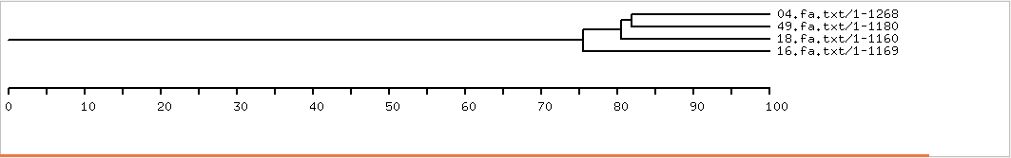
- With Storm and Sonnhammer distance correction:
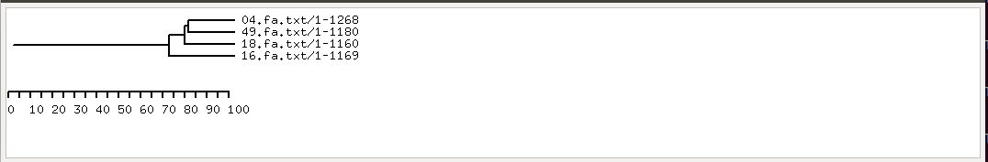
First tree building method: Neighbor-joining

- With Scoredist distance correction (default):
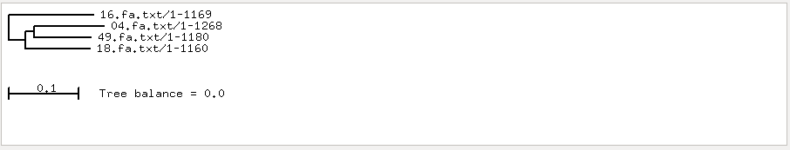

- With Storm and Sonnhammer distance correction:
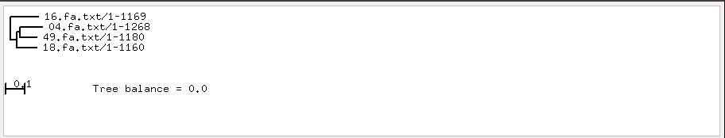

It seems that the distance correction does not change the tree at all. We have also tried other distance corrections apart from the default and the Sonnhammer ones, such as Kimura and Jukes-Cantor distance corrections, but the tree is not affected by these changes.

2.1.

All the gaps in the alignment are already denoted with “-”.

2.2.

Done.

2.3.

-f a: this flag is used to select the algorithm we want to be executed. In this case, -f a indicates that a Bootstrap analysis will be performed by which the maximum likelihood trees with the best scores will be chosen.
-x 54321: this flag is used to indicate the start of a rapid bootstrapping algorithm.
-T 4: this flag is used to indicate the number of threads that the user wants to run.
-p 12345: this flag is basically used to ease the debugging of the program and set a number for parsimony inferences that will be useful for the user to reproduce the results.
-s: this flag is used to indicate the name of our input file; in this case, the name of the file where the alignments are contained.
-n: this flag is used to indicate the name of the file that will be output by the program.

2.4.

Distance-based methods such as UPGMA and Neighbor joining are computationally quick algorithms to generate phylogenetic trees, but they are not as realiable as maximum likelihood methods. Distance-based methods do not perform well when there is a large divergence time between sequences, and this is one of the main reason why they are rarely used for scientific publications. Instead, maximum likelihood methods may take longer than distance based-methods but since they are based on evolution models, the results they provide are reliable and suitable for scientific publications.

EXERCISE 5

The bootstrap value does not change with N, it is zero regardless of the value of N we introduce. This might be due to an non updated version of belvu in our computers.
