PRACTICAL 3 VERSION 2

EXERCISE 4

1.2.

NJ with Scoredist

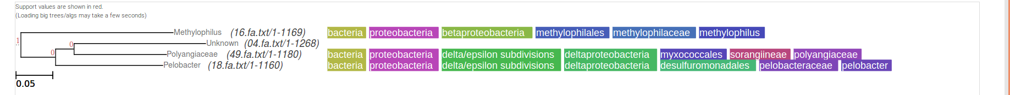
NJ with Sonnhammer

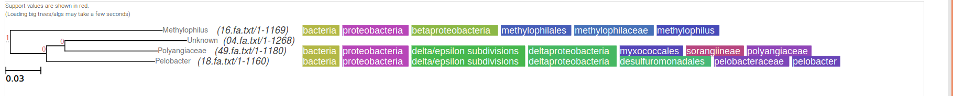
NJ with Kimura

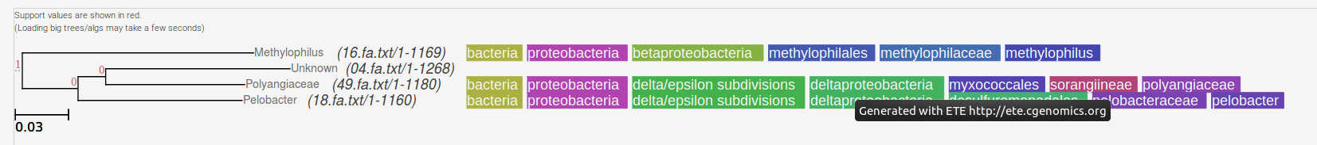

2.2.

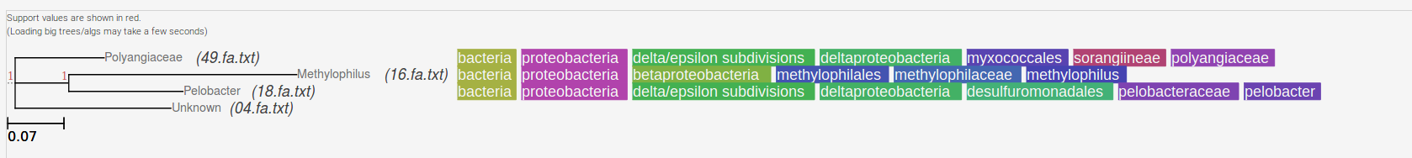

EXERCISE 5

2.

N=10
(
16.fa.txt/1-1169:0.206,
(
(
04.fa.txt/1-1268:0.178,
49.fa.txt/1-1180:0.125)
100:0.024,
18.fa.txt/1-1160:0.145)
90:0.046)
;

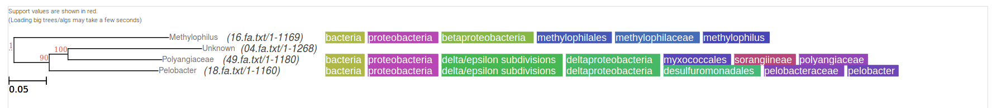

N=1000
(
16.fa.txt/1-1169:0.206,
(
(
04.fa.txt/1-1268:0.178,
49.fa.txt/1-1180:0.125)
87:0.024,
18.fa.txt/1-1160:0.145)
93:0.046)
;

