PRACTICAL 4

SUMMARY

In this practical we selected one of the four prokaryotic genomes as a reference genome and we looked for its ortholog proteins in the other three prokaryotic genomes. First we created proteome databases for each of the genomes and used BLAST to find the best hits of the queries on the reference. After combining the best hits of our reference genome with the other three, we clustered together those proteins that matched the same reference ORF, so that it was possible to find their respective orthologs in the other genomes. Then, we aligned the clustered ortholog proteins and created a metagene out of the alignment. Finally, we also built the phylogenetic tree of some of these alignments and analyzed them.

EXERCISE 1

1.

Reference genome: 04.fa.txt

2.

Done.

3.

The proteome databases were created for each of the 4 prokaryotic proteomes:

makeblastdb -in 49.fa.txt.pfa -dbtype prot -out protDB49

4.1.

Done.

5.

Marina.

6.

Script Marina.

7.
7.1.
7.2.

EXERCISE 2

1.

With the command kalign <inputfile> <outputfile> we are able to obtain the multiple alignment of all the sequences contained in each of the 10 clusters.

1.1.

The metagene is built adding each of the clusters’ sequences one after the other (genome 4 sequence of cluster 1 is followed by genome 4 sequence of cluster 2, etc). This file is saved as metageneclusters.

1.2.

With the command: belvu -T n -o tree metageneclusters we obtain the following tree for the whole metagene:

(18.fa.txt/1-5142:0.881,
(04.fa.txt/1-3855:0.640,
(49.fa.txt/1-3647:0.930,
16.fa.txt/1-6223:0.874)
0:0.048)
0:0.086);
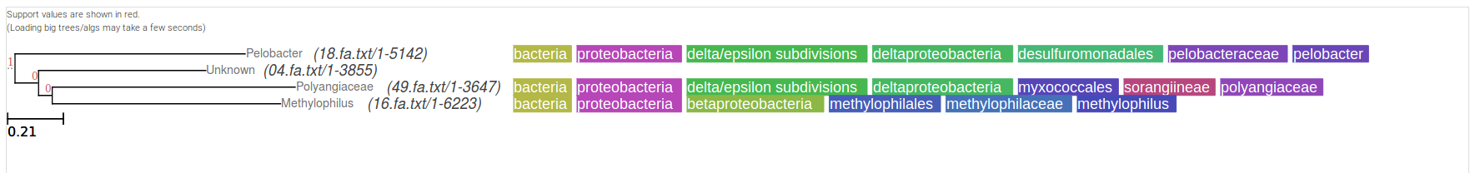

1.3.

belvu -b 100 metageneclusters

(18.fa.txt/1-5142:0.881,
(04.fa.txt/1-3855:0.640,
(49.fa.txt/1-3647:0.930,
16.fa.txt/1-6223:0.874)
56:0.048)
56:0.086);

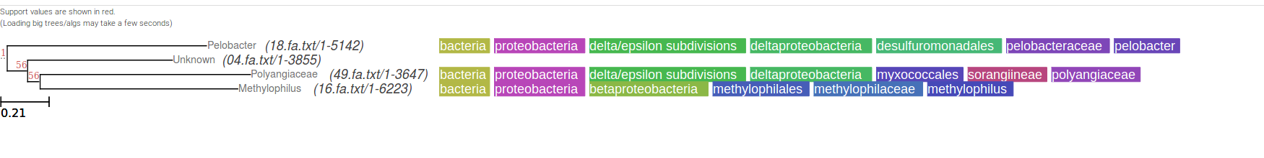
Comparing this metagene tree with each of the individual trees obtained below, we can see that some of the individual trees, such as the one obtained from aligned10cluster, are very similar to the metagene tree. This might occur because this specific cluster is the one that best gathers the general features represented by the metagene and this results in a tree with similar patterns and relationships between the genomes. On the other hand, other ortholog clusters’ trees are not that similar to the metagene tree and reveal different tree patterns between the genomes, because of the genes that are contained in these clusters.

EXERCISE 3

1.1.

belvu -o tree aligned01cluster > tree01newick and so on with the others…

aligned01cluster:

(49.fa.txt_orf01520/1-548:1.500,
(16.fa.txt_orf12181_rev/1-895:1.406,
(04.fa.txt_orf00002/1-687:0.965,
18.fa.txt_orf00669_rev/1-408:1.154)
0:0.346)
0:0.094);

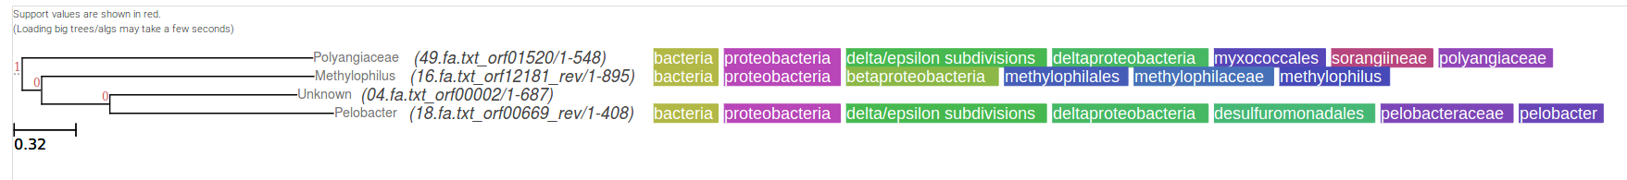
aligned02cluster:

(49.fa.txt_orf06025_rev/1-278:1.418,
((04.fa.txt_orf00005/1-88:0.776,
16.fa.txt_orf04259/1-173:0.800)
0:0.467,
18.fa.txt_orf00985/1-728:0.989)
0:0.296);

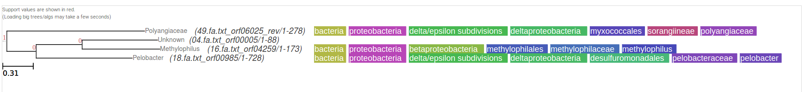

aligned03cluster:

(49.fa.txt_orf04033_rev/1-834:0.386,
(16.fa.txt_orf08379_rev/1-881:0.339,
(04.fa.txt_orf00008_rev/1-880:0.327,
18.fa.txt_orf02280/1-872:0.299)
0:0.041)
0:0.039);
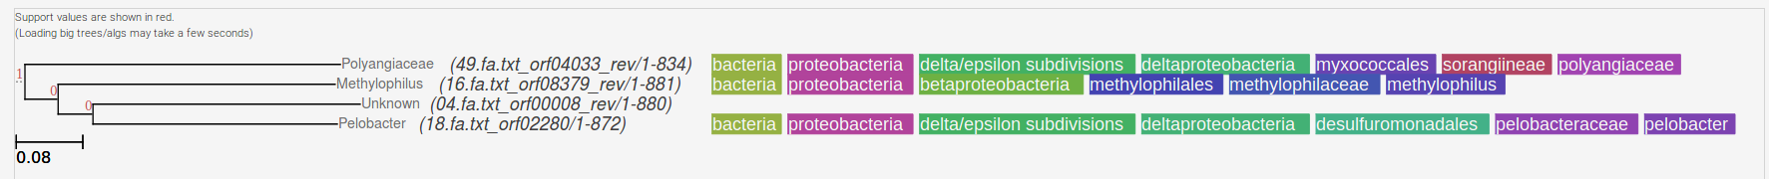

aligned04cluster:

(04.fa.txt_orf00009/1-262:1.250,
((49.fa.txt_orf03838_rev/1-436:1.522,
18.fa.txt_orf03319_rev/1-252:1.478)
0:0.094,
16.fa.txt_orf10384/1-704:0.713)
0:0.097);

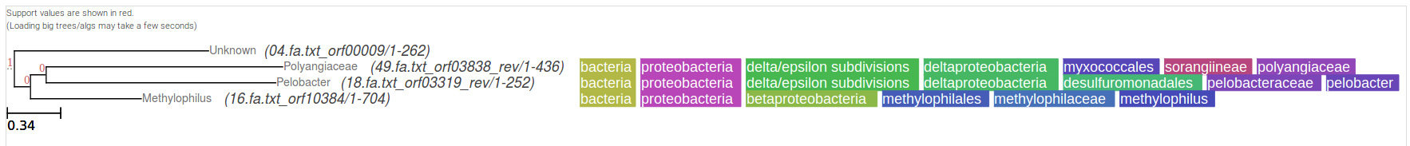

aligned05cluster:

((04.fa.txt_orf00011_rev/1-228:0.987,
16.fa.txt_orf00926_rev/1-890:1.013)
0:0.474,
(18.fa.txt_orf03181/1-241:1.268,
49.fa.txt_orf01634/1-322:1.201)
0:0.239);

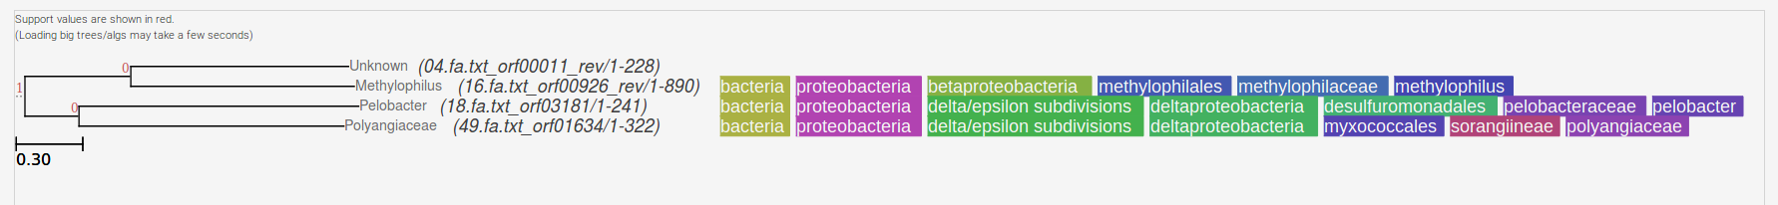
aligned06cluster:

((16.fa.txt_orf09956_rev/1-328:0.877,
18.fa.txt_orf00174/1-274:0.944)
0:0.087,
(04.fa.txt_orf00012/1-287:0.841,
49.fa.txt_orf00259_rev/1-250:1.081)
0:0.037);
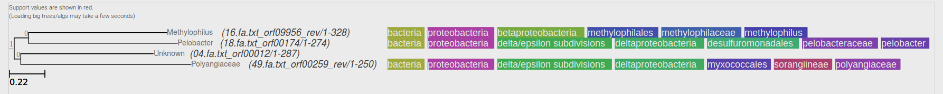

aligned07cluster:

(16.fa.txt_orf05790_rev/1-500:1.272,
(04.fa.txt_orf00013_rev/1-280:0.754,
(49.fa.txt_orf02050/1-413:1.511,
18.fa.txt_orf01694_rev/1-611:1.200)
0:0.309)
0:0.063);
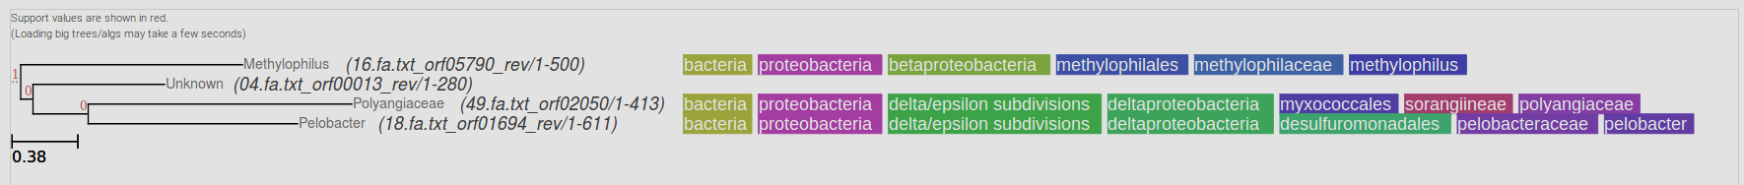

aligned08cluster:

(49.fa.txt_orf04984/1-138:1.500,
((04.fa.txt_orf00015_rev/1-525:0.887,
16.fa.txt_orf11426_rev/1-640:1.178)
0:0.307,
18.fa.txt_orf00844/1-399:1.340)
0:0.160);
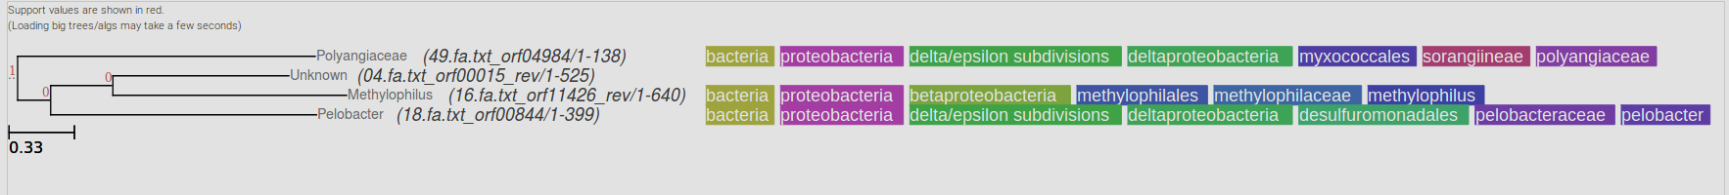

aligned09cluster:

(49.fa.txt_orf02409/1-48:1.075,
((04.fa.txt_orf00018_rev/1-218:0.569,
16.fa.txt_orf04544/1-606:0.870)
0:0.320,
18.fa.txt_orf01704/1-268:0.975)
0:0.068);
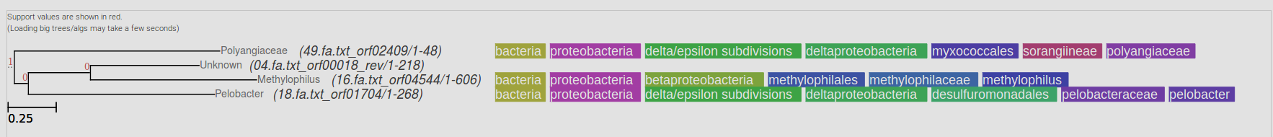

aligned10cluster:

(18.fa.txt_orf04550_rev/1-1089:1.371,
(04.fa.txt_orf00020_rev/1-400:0.407,
(16.fa.txt_orf04544/1-606:0.546,
49.fa.txt_orf02031/1-380:0.512)
0:0.093)
0:0.856);

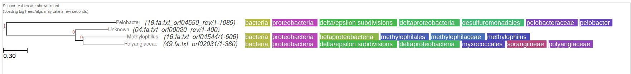

1.2., 1.3. and 1.4.

We obtain different trees depending on which cluster we are analyzing, as we can see in the ten trees above. For example, in the tree obtained from cluster 9, the genomes 04 and 16 are clustered together, whereas in the tree from cluster 10, the closest cluster happens between genomes 16 and 49. This makes sense, since in each cluster we are looking at different parts of the genome. Therefore, when we compare different genes from different genomes, it is normal that the genomes will be clustered differently depending on the relationship that exists between the genes in that specific cluster. For example, looking at the metagene tree, genomes 18 and 49 are the most distant ones, but if we look at the tree from cluster 7 we can see that this does not apply. On the other hand, looking at the tree from cluster 10 we can see how the tree is very similar to that of the metagene.

2.
2.1.
2.1.1.

cat tree01newick tree02newick tree03newick tree04newick tree05newick tree06newick tree07newick tree08newick tree09newick tree10newick > intree

2.1.2.
2.1.3.

EXPLAIN!!
Files outfile and outtree.

Consensus tree program, version 3.696

Settings for this run:
C Consensus type (MRe, strict, MR, Ml): Majority rule (extended)
O Outgroup root: No, use as outgroup species 1
R Trees to be treated as Rooted: No
T Terminal type (IBM PC, ANSI, none): ANSI
1 Print out the sets of species: Yes
2 Print indications of progress of run: Yes
3 Print out tree: Yes
4 Write out trees onto tree file: Yes

Are these settings correct? (type Y or the letter for one to change)
Y

Consensus tree written to file "outtree"

Output written to file "outfile"

Done.

