PRACTICAL 5

EXERCISE 1

Since we successfully generated the ortholog clusters in the previous Practical, we did not need to do this exercise and proceeded directly to the next one.

EXERCISE 2

1.

python3 getGeneOrder.py 04.fa.txt.pfa clusteredhits_names > order04
python3 getGeneOrder.py 16.fa.txt.pfa clusteredhits_names > order16
python3 getGeneOrder.py 18.fa.txt.pfa clusteredhits_names > order18
python3 getGeneOrder.py 49.fa.txt.pfa clusteredhits_names > order49

2.
a. Yes. For example, the gene encoded by 16.fa.txt_orf04544 appears in two different clusters in the cluster file. This happens because one gene might have several matches with the reference genome (04 in our case) and therefore belong to two different clusters. In this case, the script will only consider the first cluster in which this gene appears and give us its gene order, ignoring the other cluster this gene also belongs to.

b. MARINA

EXERCISE 3

3.

First we need to calculate the number of ORFs in each proteome. With the script count.py we calculated that the proteome 4 is the one with the highest number of ORFs:

Counter 4 is: 10396
Counter 16 is: 6414
Counter 18 is: 3791
Counter 49 is: 3375

Command: python3 rndseq.py 10396 20 > randomseqs

4.

MARINA

5.

We used the script makeIconicGenome.py with the following command:

python3 makeIconicGenome.py randomseqs order04 > pseudogenome04
python3 makeIconicGenome.py randomseqs order16 > pseudogenome16
python3 makeIconicGenome.py randomseqs order18 > pseudogenome18
python3 makeIconicGenome.py randomseqs order49 > pseudogenome49

This script creates a dictionary in which it stores each of the generated 20aa random sequences in a specific order (each of these sequences is assigned an id number). Then, it reads a gene order file and, for each number in this file, it finds its respective random amino acid sequence in the dictionary and prints it. This is done with all the values in the gene order files, so that we end up with a pseudogenome for each of the proteomes, which consists of random amino acid sequences whose order is determined by the values of the gene order files.

6.
a.

First we create the dotplot with this command:

dotter -b dotplot multifastapseudogenome multifastapseudogenome

Then, we load it with this command:

dotter -ldotplot multifastapseudogenome multifastapseudogenome

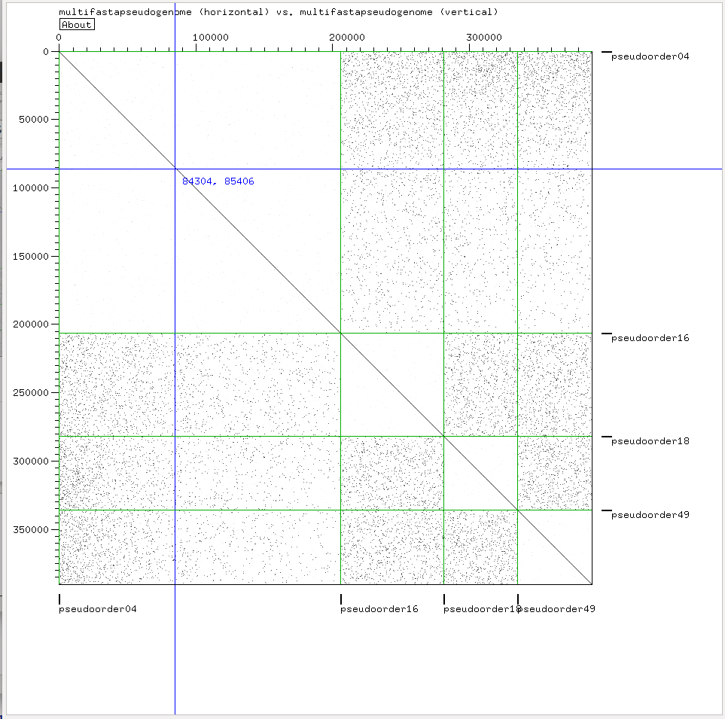

EXPLAIN WHAT IT’S DOING: MARINA

EXERCISE 4

1.

Command:

python getGeneOrderGrimm.py 10396 order04list order16list order18list order49list > grim_genomes

2.

With the command:

/afs/pdc.kth.se/misc/pdc/volumes/sbc/prj.sbc.dmessina.5/Comparative_Genomics/programs/grimm -f grim_genomes -o distance.grim -C -m

We get the following distance matrix between for our sequences:

Genome 1 : 0 997 1001 985
Genome 2 : 997 0 995 997
Genome 3 : 1001 995 0 999
Genome 4 : 985 997 999 0

3.

Command:

belvu -T R distance.grim

This is the tree that belvu renders:
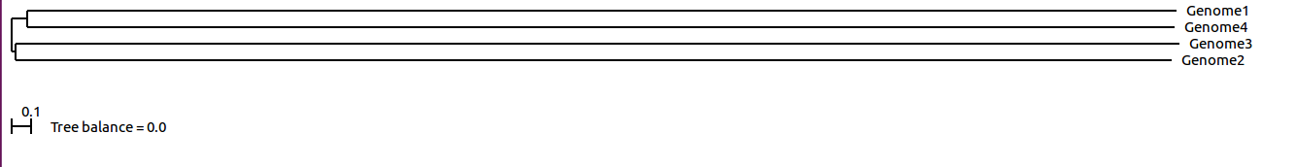
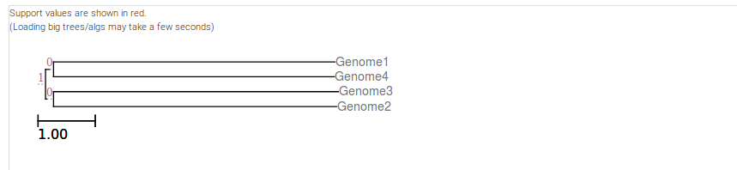
It is very similar to the one we visualize with ETE tree viewer.

4.

The tree from practical 4 is:

(49.fa.txt:10.0,((16.fa.txt:10.0,04.fa.txt:10.0):6.00,18.fa.txt:10.0):10.0);

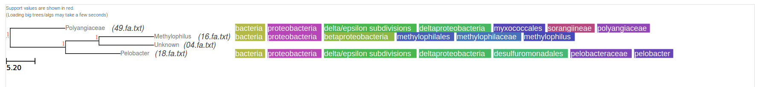
Comparing both trees we can see that they differ. In the tree from Practical 5, genomes 1 and 4 (which correspond to genomes 04 and 49, respectively) and genomes 3 and 2 (corresponding to genomes 16 and 18, respectively) have been clustered together, indicating that their gene order has been conserved similarly during evolution. On the other hand, the tree from practical 4 indicates that genomes 04 and 16 are clustered together and are very close to genome 18, with a far relationship with genome 49. This tree however represents how related the genomes are when it comes to the orthology of their proteins. Therefore, since both trees are representing different concepts, they do not need to be the same or similar to each other.

