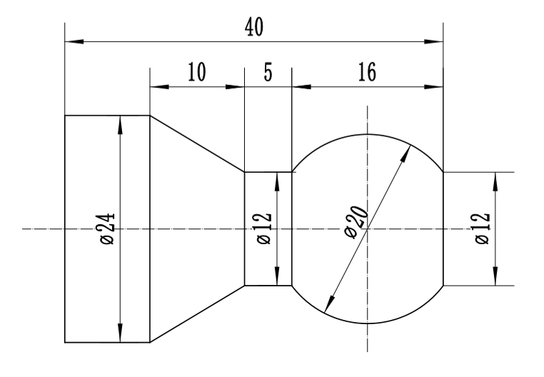
%0001
T0101
M03 S600
G00 X31 Z2
G71 U1.5 R1 P1 Q2 E0.2 F100
N1 G01 X12 Z0 F70 S800
G03 X12 Z-16 R10
G01 W-5
X24 W-10
Z-40
N2 X30.5
G00 X50
Z50
T0404 S450
G00 X31
Z-44
M98 P0002 L10
G00 X50
Z50
M05
M30

(子程序)
%0002
G01 F30 U-2.5
U2.5
W-3
U-5
U5
W3
M99

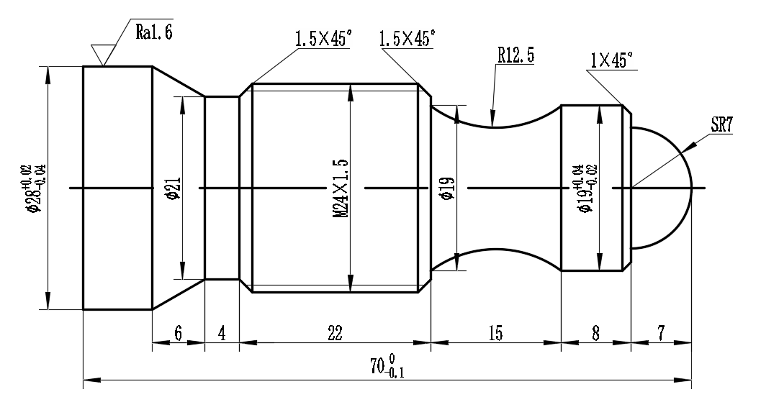
程序一 (外圆)
%0001
T0101
M03 S600
G00 X32
Z2
G71 U1 R1 P1 Q2 E0.2 F100
N1 G00 X0 Z0 F70 S800
G03 X14 Z-7 R7
G01 X19 C1
W-8
G02 X19 W-15 R12.5
G01 X23.85 C1.5
Z-51
X21.7 W-1
W-4
X28 W-6
Z-70
N2 G00 X30.5
G00 X50
Z50
M05
M30
程序二 (螺纹部分)
%0001
T0303
M03 S600
G00 X26
Z-28
G82 X23.85 Z-24 F1.5
X23.35
X22.85
X22.55
X22.376
G00 X50
Z50
M05
M30

程序三（切断）
%0001
T0404
M03 S400
G00 X31
Z-74
M98 P0002 L11
G00 X50
Z50
M05
M30
%0002
G01 F30 U-2.5
U2.5
W-3
U-5
U2.5
W3
M99

