实验3

实验目的：
- 熟悉对话框
- 熟悉基本界面及绘图

实验要求：
- 按照题目要求写代码，并上传到COURSE.XMU.EDUC.CN

实验题目：
1．Create a program that draws 10 random filled shapes in random positions. Method paintComponent should contain a loop that iterates 10 times. In each iteration, the loop should determine whether to draw a rectangle or an oval, and choose coordinates and dimensions at random. The coordinates should be chosen based on the panel's width and height. Lengths of sides should be limited to half the width or height of the window.
2．请编程显示以下窗口。
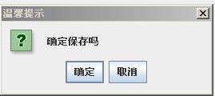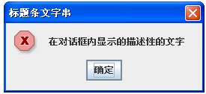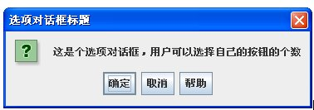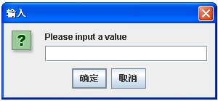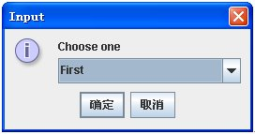

3．制作一个简单的计算器，能够实现加、减、乘、除、求余运算。
