INTERNAL AUDIT REPORT
Date: December 02, 2025
Scope: 12,000 Transactions

1. Executive Summary
The audit identified significant control deficiencies. A total of 12,000 transactions were scanned, revealing patterns of weekend spending abuse, duplicate claims, and structuring of high-value payments.

2. Visual Analysis
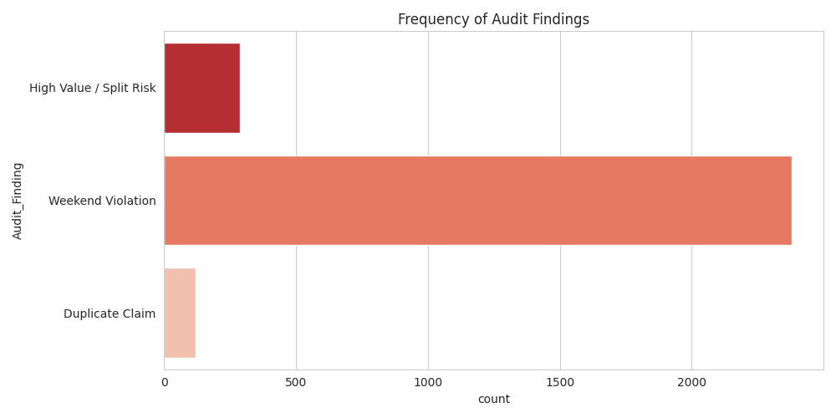

3. Detailed Findings
Date | Emp | Category | Amount | Finding
2025-04-19 | EMP086 | Software | $4,999 | High Value / Split Risk
2025-08-04 | EMP058 | Software | $4,996 | High Value / Split Risk
2025-05-20 | EMP080 | Software | $4,994 | High Value / Split Risk
2025-04-18 | EMP093 | Software | $4,989 | High Value / Split Risk
2025-02-18 | EMP055 | Software | $4,987 | High Value / Split Risk
2025-02-04 | EMP035 | Software | $4,984 | High Value / Split Risk
2025-06-29 | EMP001 | Software | $4,982 | High Value / Split Risk
2024-12-08 | EMP079 | Software | $4,977 | High Value / Split Risk
2025-01-01 | EMP139 | Software | $4,977 | High Value / Split Risk
2025-09-02 | EMP126 | Software | $4,971 | High Value / Split Risk
2025-05-25 | EMP062 | Software | $4,968 | High Value / Split Risk
2025-05-04 | EMP022 | Software | $4,965 | High Value / Split Risk
2025-02-03 | EMP014 | Software | $4,965 | High Value / Split Risk
2025-06-27 | EMP137 | Software | $4,963 | High Value / Split Risk
2025-09-29 | EMP091 | Software | $4,963 | High Value / Split Risk
2025-06-01 | EMP037 | Software | $4,961 | High Value / Split Risk
2025-03-02 | EMP039 | Software | $4,957 | High Value / Split Risk
2025-06-21 | EMP065 | Software | $4,955 | High Value / Split Risk
2025-07-11 | EMP049 | Software | $4,954 | High Value / Split Risk
2025-09-26 | EMP139 | Software | $4,950 | High Value / Split Risk
2024-12-16 | EMP052 | Software | $4,949 | High Value / Split Risk
2025-06-12 | EMP129 | Software | $4,948 | High Value / Split Risk
2025-02-18 | EMP101 | Software | $4,948 | High Value / Split Risk
2025-09-23 | EMP106 | Software | $4,947 | High Value / Split Risk
2025-09-05 | EMP020 | Software | $4,945 | High Value / Split Risk
2025-10-14 | EMP064 | Software | $4,944 | High Value / Split Risk
2025-04-22 | EMP135 | Software | $4,944 | High Value / Split Risk
2024-12-11 | EMP105 | Software | $4,940 | High Value / Split Risk
2025-11-10 | EMP067 | Software | $4,939 | High Value / Split Risk
2025-02-09 | EMP110 | Software | $4,934 | High Value / Split Risk
2025-07-25 | EMP024 | Software | $4,932 | High Value / Split Risk
2025-10-24 | EMP126 | Software | $4,929 | High Value / Split Risk
2023-11-11 | EMP148 | Meals | $4,927 | High Value / Split Risk
2025-02-19 | EMP102 | Software | $4,926 | High Value / Split Risk
2025-05-29 | EMP108 | Software | $4,925 | High Value / Split Risk
2025-07-22 | EMP091 | Software | $4,923 | High Value / Split Risk
2025-04-27 | EMP132 | Software | $4,923 | High Value / Split Risk
2025-11-04 | EMP018 | Software | $4,922 | High Value / Split Risk
2025-01-28 | EMP105 | Software | $4,919 | High Value / Split Risk
2025-02-24 | EMP119 | Software | $4,919 | High Value / Split Risk
2025-11-19 | EMP004 | Software | $4,918 | High Value / Split Risk
2025-10-30 | EMP069 | Software | $4,918 | High Value / Split Risk
2025-08-28 | EMP031 | Software | $4,917 | High Value / Split Risk
2025-11-30 | EMP008 | Software | $4,916 | High Value / Split Risk
2025-05-06 | EMP088 | Software | $4,915 | High Value / Split Risk
2025-02-28 | EMP059 | Software | $4,914 | High Value / Split Risk
2025-07-07 | EMP030 | Software | $4,913 | High Value / Split Risk
2025-05-06 | EMP135 | Software | $4,913 | High Value / Split Risk
2025-11-02 | EMP129 | Software | $4,907 | High Value / Split Risk
2025-02-21 | EMP022 | Software | $4,905 | High Value / Split Risk

