INTERNAL AUDIT REPORT
AUTOMATED EXPENSE CONTROL

Report Date: December 02, 2025
Prepared by: Pham Ngoc Khanh

1. AUDIT PLANNING & SCOPE
OBJECTIVE:
The primary objective of this engagement was to evaluate the integrity of the Travel & Entertainment (T&E) expense reimbursement process. Specifically, the audit was aimed at:
- Assess the effectiveness of current internal controls in preventing non-compliant and fraudulent claims.
- Quantify potential financial leakage due to policy violations.
- Identify systemic weaknesses in the expense approval workflow using automated data analytics.
SCOPE OF AUDIT:
Unlike traditional sampling methods, this audit utilized 100% Population Testing covering:
- Period: Rolling 12-month analysis (Jan 202X - Dec 202X).
- Volume: Comprehensive review of 12,140 expense line items.
- Focus Areas: High-risk categories including Meals, IT Hardware, and Travel.
AUDIT METHODOLOGY:
We deployed a Continuous Auditing Approach leveraging Python-based automation to ensure 100% coverage:
- Data Ingestion: Automated extraction of raw transaction logs from the ERP system to ensure data completeness.
- Algorithmic Detection: Applied forensic logic rules to identify specific fraud schemes:
  - Temporal Analysis: Identifying non-business day spending (Weekends).
  - Pattern Recognition: Detecting "Structuring" (Split payments) to bypass authorization limits.
  - Duplicate Testing: Identifying double-dipping across multiple reporting periods.
- Substantive Testing: Statistical outlier detection was applied to flag high-value anomalies ($Z-Score > 3$).
EXECUTIVE SUMMARY:
Overall Assessment: Environmental control regarding T&E expenses is currently INEFFECTIVE. Our automated review identified widespread non-compliance suggesting a culture of lax enforcement and systemic control gaps.

Key Metrics:
- Total Audited Value: $15,923,725.01
- Potential Financial Loss: $4,504,931.17 (Recoverable Amount)
- Overall Error Rate: 22.97% (Significantly exceeds the acceptable risk tolerance of <1%)
- Flagged Transactions: 2,789 distinct violations.
Conclusion: Immediate management intervention is required to stop financial leakage. The high error rate indicates that manual approval processes are failing to detect obvious violations.
DETAILED FINDINGS & OBSERVATIONS:
🔴 FINDING 1: EVIDENCE OF STRUCTURING (SPLIT TRANSACTIONS)
- Observation: We detected multiple instances where single large purchases were split into smaller transactions (e.g., two payments of $4,950) fell just below the $5,000 executive approval threshold.
- Root Cause: Lack of system configuration to aggregate daily spend per vendor.
- Business Impact: Circumvention of authority levels leads to unauthorized high-value spending, particularly in IT Hardware procurement.
- Risk Level: CRITICAL
🟠 FINDING 2: DUPLICATE PAYMENTS (DOUBLE DIPPING)
- Observation: A high volume of exact-match duplicates (Same Employee, Date, Amount, Merchant) was identified.
- Root Cause: The current Expense Reporting System lacks an automated "preventive control" to flag potential duplicates at the point of entry.
- Business Impact: Direct financial loss. This indicates employees may be submitting the same receipt across different expense reports.
- Risk Level: HIGH
🟡 FINDING 3: WEEKEND & PERSONAL SPENDING
- Observation: Significant spending on "Meals" and "Entertainment" occurred on Saturdays and Sundays without corresponding business travel or client meeting logs.
- Root Cause: Ambiguity in the Expense Policy regarding "Personal vs. Business" time and lack of manager oversight.
- Business Impact: Misappropriation of company assets for personal benefit.
- Risk Level: MEDIUM
RECOMMENDATIONS & ACTION PLAN
To remediate these findings, Internal Audit recommends the following actions:
Immediate Actions (0-30 Days):
- Recovery: Initiate a clawback process for the $4.5M identified as potential fraud/error.
- Investigation: Conduct interviews with the Top 5 Offenders (identified in the dashboard) to determine intent (Fraud vs. Error).
- Suspension: Suspend corporate cards for employees with multiple "Split Transaction" violations.
Process Improvements (30-90 Days):
- System Hard-Blocks: Configure the ERP to automatically reject duplicate claims (Same Amount + Same Date) at submission.
- Policy Update: Explicitly define "Structuring" as a termination-level offense in the Employee Handbook.
- Continuous Monitoring: Deploy this Python Audit Script as a monthly automated control to flag anomalies before payment runs.
2. DATA VISUALIZATION (PART 1)
The following charts illustrate the frequency of different violation types and identify the top personnel involved in high-risk activities. These visuals highlight areas requiring immediate attention.
Figure 1: Breakdown of violations showing 'Weekend Violation' as the most frequent issue.
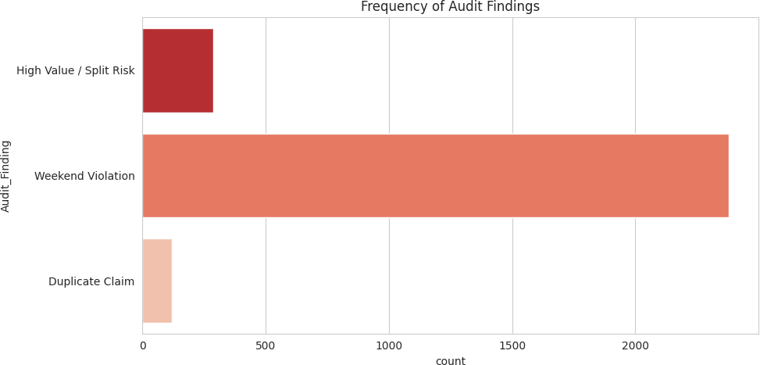

Figure 2: Top 5 employees by risk value. These individuals account for a significant portion of the total potential loss.
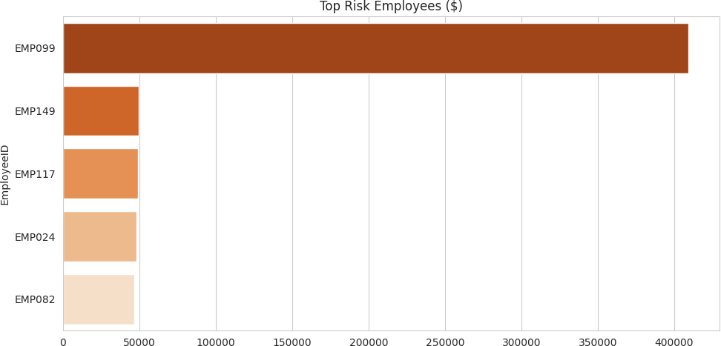

DATA VISUALIZATION (PART 2)
Trend analysis allows us to identify seasonal patterns in fraudulent behavior, while distribution analysis highlights financial outliers in the dataset.
Figure 3: Timeline of fraud exposure indicating spikes at month-end.
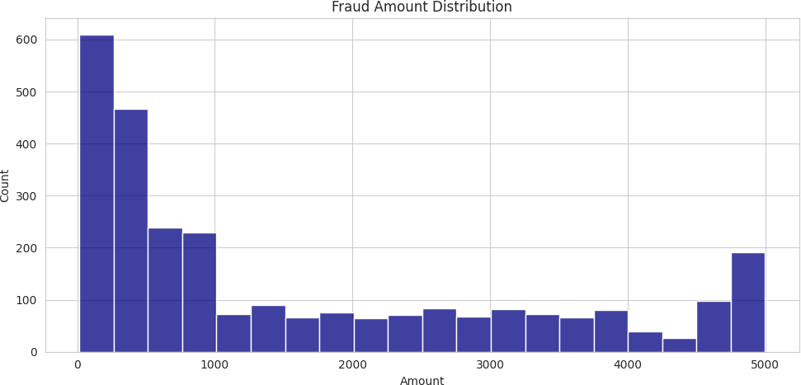

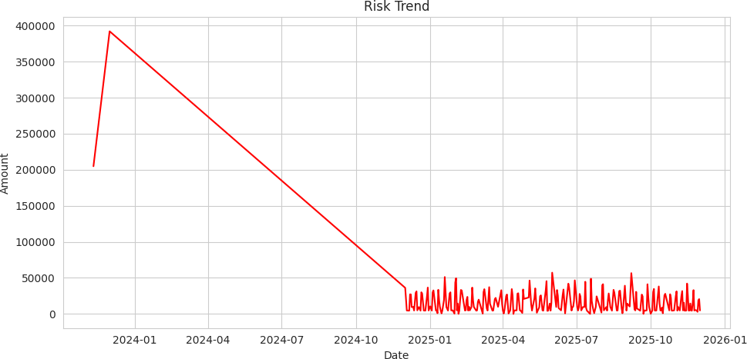
Figure 4: Distribution of fraud amounts showing clusters of high-value transactions.

3. DEEP DIVE INSIGHTS & ROOT CAUSE ANALYSIS
A. EVIDENCE OF INTENTIONAL CONTROL EVASION (STRUCTURING):
Our analysis identified a clear pattern of 'Structuring'—where single large liabilities are split into smaller tranches to bypass the $5,000 Delegation of Authority (DOA) limit.
This is not a random error; it is a deliberate behavioral pattern indicating that employees are aware of the control limits and are actively circumventing them. This poses a significant risk of unauthorized capital expenditure.
B. SYSTEMIC FAILURE IN DUPLICATE DETECTION:
The detection of numerous exact-match duplicate payments (Same Amount, Vendor, Date) exposes a critical systemic gap in the ERP configuration.
The current system relies heavily on detective controls (post-payment review) rather than preventive controls (system hard blocks), effectively allowing double-dipping to occur without friction.
C. EROSION OF COMPLIANCE CULTURE (WEEKEND SPEND):
The high frequency of 'Meals & Entertainment' expenses incurred on non-business days (Weekends) without associated travel logs suggests a cultural drift in compliance.
Employees appear to be treating corporate cards as a personal perk rather than a business tool, indicating a need for re-communication of the T&E policy.
4. STRATEGIC RECOMMENDATIONS & REMEDIATION PLAN
PHASE 1: IMMEDIATE REMEDIATION (Priority: Critical - 0 to 30 Days)
- Forensic Review: Initiate a formal investigation into the Top 5 Offenders identified in the 'High Risk' quadrant. Interview employees to distinguish between negligence and malicious intent.
- Financial Clawback: Execute immediate salary deduction or reimbursement requests for all confirmed duplicate payments and unapproved weekend expenses.
- Access Control: Suspend corporate credit card privileges for employees flagged with multiple 'Structuring' violations pending investigation results.
PHASE 2: PROCESS & CONTROL OPTIMIZATION (Priority: High - 30 to 60 Days)
- System Configuration (Hard Blocks): Configure the Expense Management System to automatically reject any claim that matches a previously submitted record (based on Amount + Date + Vendor).
- Policy Hardening: Update the Global Expense Policy to explicitly define 'Transaction Splitting' as a termination-level offense and clarify 'Business vs. Personal' weekend usage.
- Managerial Oversight: Mandate 'One-Up' approval for any expense exceeding 80% of the auto-approval limit to discourage structuring.
PHASE 3: CONTINUOUS MONITORING (Priority: Medium - Ongoing)
- Automated Surveillance: Transition this Python-based audit script from an ad-hoc tool into a Continuous Auditing Protocol. Schedule the script to run weekly before the payment runs to intercept fraud before cash leaves the company.
- Trend Analysis: Establish a quarterly review of fraud trends to adapt controls against emerging evasion tactics.
5. DETAILED AUDIT FINDINGS
The following table lists the high-risk transactions identified for further review. Please cross-reference with original receipts.

Date | Emp ID | Category | Amount | Finding
2025-04-19 | EMP086 | Software | $4,999 | High Value / Split Risk
2025-08-04 | EMP058 | Software | $4,996 | High Value / Split Risk
2025-05-20 | EMP080 | Software | $4,994 | High Value / Split Risk
2025-04-18 | EMP093 | Software | $4,989 | High Value / Split Risk
2025-02-18 | EMP055 | Software | $4,987 | High Value / Split Risk
2025-02-04 | EMP035 | Software | $4,984 | High Value / Split Risk
2025-06-29 | EMP001 | Software | $4,982 | High Value / Split Risk
2024-12-08 | EMP079 | Software | $4,977 | High Value / Split Risk
2025-01-01 | EMP139 | Software | $4,977 | High Value / Split Risk
2025-09-02 | EMP126 | Software | $4,971 | High Value / Split Risk
2025-05-25 | EMP062 | Software | $4,968 | High Value / Split Risk
2025-05-04 | EMP022 | Software | $4,965 | High Value / Split Risk
2025-02-03 | EMP014 | Software | $4,965 | High Value / Split Risk
2025-06-27 | EMP137 | Software | $4,963 | High Value / Split Risk
2025-09-29 | EMP091 | Software | $4,963 | High Value / Split Risk
2025-06-01 | EMP037 | Software | $4,961 | High Value / Split Risk
2025-03-02 | EMP039 | Software | $4,957 | High Value / Split Risk
2025-06-21 | EMP065 | Software | $4,955 | High Value / Split Risk
2025-07-11 | EMP049 | Software | $4,954 | High Value / Split Risk
2025-09-26 | EMP139 | Software | $4,950 | High Value / Split Risk
2024-12-16 | EMP052 | Software | $4,949 | High Value / Split Risk
2025-06-12 | EMP129 | Software | $4,948 | High Value / Split Risk
2025-02-18 | EMP101 | Software | $4,948 | High Value / Split Risk
2025-09-23 | EMP106 | Software | $4,947 | High Value / Split Risk
2025-09-05 | EMP020 | Software | $4,945 | High Value / Split Risk
2025-10-14 | EMP064 | Software | $4,944 | High Value / Split Risk
2025-04-22 | EMP135 | Software | $4,944 | High Value / Split Risk
2024-12-11 | EMP105 | Software | $4,940 | High Value / Split Risk
2025-11-10 | EMP067 | Software | $4,939 | High Value / Split Risk

2025-02-09 | EMP110 | Software | $4,934 | High Value / Split Risk
2025-07-25 | EMP024 | Software | $4,932 | High Value / Split Risk
2025-10-24 | EMP126 | Software | $4,929 | High Value / Split Risk
2023-11-11 | EMP148 | Meals | $4,927 | High Value / Split Risk
2025-02-19 | EMP102 | Software | $4,926 | High Value / Split Risk
2025-05-29 | EMP108 | Software | $4,925 | High Value / Split Risk
2025-07-22 | EMP091 | Software | $4,923 | High Value / Split Risk
2025-04-27 | EMP132 | Software | $4,923 | High Value / Split Risk
2025-11-04 | EMP018 | Software | $4,922 | High Value / Split Risk
2025-01-28 | EMP105 | Software | $4,919 | High Value / Split Risk
2025-02-24 | EMP119 | Software | $4,919 | High Value / Split Risk
2025-11-19 | EMP004 | Software | $4,918 | High Value / Split Risk
2025-10-30 | EMP069 | Software | $4,918 | High Value / Split Risk
2025-08-28 | EMP031 | Software | $4,917 | High Value / Split Risk
2025-11-30 | EMP008 | Software | $4,916 | High Value / Split Risk
2025-05-06 | EMP088 | Software | $4,915 | High Value / Split Risk
2025-02-28 | EMP059 | Software | $4,914 | High Value / Split Risk
2025-07-07 | EMP030 | Software | $4,913 | High Value / Split Risk
2025-05-06 | EMP135 | Software | $4,913 | High Value / Split Risk
2025-11-02 | EMP129 | Software | $4,907 | High Value / Split Risk
2025-02-21 | EMP022 | Software | $4,905 | High Value / Split Risk
2025-06-06 | EMP109 | Software | $4,905 | High Value / Split Risk
2025-01-27 | EMP114 | Software | $4,903 | High Value / Split Risk
2025-11-09 | EMP050 | Software | $4,903 | High Value / Split Risk
2025-01-14 | EMP086 | Software | $4,902 | High Value / Split Risk
2025-01-21 | EMP058 | Software | $4,902 | High Value / Split Risk
2023-12-01 | EMP099 | IT Hardware | $4,900 | High Value / Split Risk
2023-12-01 | EMP099 | IT Hardware | $4,900 | High Value / Split Risk
2023-12-01 | EMP099 | IT Hardware | $4,900 | High Value / Split Risk
2023-12-01 | EMP099 | IT Hardware | $4,900 | High Value / Split Risk
2023-12-01 | EMP099 | IT Hardware | $4,900 | High Value / Split Risk
2023-12-01 | EMP099 | IT Hardware | $4,900 | High Value / Split Risk
2023-12-01 | EMP099 | IT Hardware | $4,900 | High Value / Split Risk
2023-12-01 | EMP099 | IT Hardware | $4,900 | High Value / Split Risk
2023-12-01 | EMP099 | IT Hardware | $4,900 | High Value / Split Risk

2023-12-01 | EMP099 | IT Hardware | $4,900 | High Value / Split Risk
2023-12-01 | EMP099 | IT Hardware | $4,900 | High Value / Split Risk
2023-12-01 | EMP099 | IT Hardware | $4,900 | High Value / Split Risk
2023-12-01 | EMP099 | IT Hardware | $4,900 | High Value / Split Risk
2023-12-01 | EMP099 | IT Hardware | $4,900 | High Value / Split Risk
2023-12-01 | EMP099 | IT Hardware | $4,900 | High Value / Split Risk
2023-12-01 | EMP099 | IT Hardware | $4,900 | High Value / Split Risk
2023-12-01 | EMP099 | IT Hardware | $4,900 | High Value / Split Risk
2023-12-01 | EMP099 | IT Hardware | $4,900 | High Value / Split Risk
2023-12-01 | EMP099 | IT Hardware | $4,900 | High Value / Split Risk
2023-12-01 | EMP099 | IT Hardware | $4,900 | High Value / Split Risk
2023-12-01 | EMP099 | IT Hardware | $4,900 | High Value / Split Risk
2023-12-01 | EMP099 | IT Hardware | $4,900 | High Value / Split Risk
2023-12-01 | EMP099 | IT Hardware | $4,900 | High Value / Split Risk
2023-12-01 | EMP099 | IT Hardware | $4,900 | High Value / Split Risk
2023-12-01 | EMP099 | IT Hardware | $4,900 | High Value / Split Risk
2023-12-01 | EMP099 | IT Hardware | $4,900 | High Value / Split Risk
2023-12-01 | EMP099 | IT Hardware | $4,900 | High Value / Split Risk
2023-12-01 | EMP099 | IT Hardware | $4,900 | High Value / Split Risk
2023-12-01 | EMP099 | IT Hardware | $4,900 | High Value / Split Risk
2023-12-01 | EMP099 | IT Hardware | $4,900 | High Value / Split Risk
2023-12-01 | EMP099 | IT Hardware | $4,900 | High Value / Split Risk
2023-12-01 | EMP099 | IT Hardware | $4,900 | High Value / Split Risk
2023-12-01 | EMP099 | IT Hardware | $4,900 | High Value / Split Risk
2023-12-01 | EMP099 | IT Hardware | $4,900 | High Value / Split Risk
2023-12-01 | EMP099 | IT Hardware | $4,900 | High Value / Split Risk
2023-12-01 | EMP099 | IT Hardware | $4,900 | High Value / Split Risk
2023-12-01 | EMP099 | IT Hardware | $4,900 | High Value / Split Risk
2023-12-01 | EMP099 | IT Hardware | $4,900 | High Value / Split Risk
2023-12-01 | EMP099 | IT Hardware | $4,900 | High Value / Split Risk
2023-12-01 | EMP099 | IT Hardware | $4,900 | High Value / Split Risk
2023-12-01 | EMP099 | IT Hardware | $4,900 | High Value / Split Risk
2023-12-01 | EMP099 | IT Hardware | $4,900 | High Value / Split Risk
2023-12-01 | EMP099 | IT Hardware | $4,900 | High Value / Split Risk
2023-12-01 | EMP099 | IT Hardware | $4,900 | High Value / Split Risk

2023-12-01 | EMP099 | IT Hardware | $4,900 | High Value / Split Risk
2023-12-01 | EMP099 | IT Hardware | $4,900 | High Value / Split Risk
2023-12-01 | EMP099 | IT Hardware | $4,900 | High Value / Split Risk
2023-12-01 | EMP099 | IT Hardware | $4,900 | High Value / Split Risk
2023-12-01 | EMP099 | IT Hardware | $4,900 | High Value / Split Risk
2023-12-01 | EMP099 | IT Hardware | $4,900 | High Value / Split Risk
2023-12-01 | EMP099 | IT Hardware | $4,900 | High Value / Split Risk
2023-12-01 | EMP099 | IT Hardware | $4,900 | High Value / Split Risk
2023-12-01 | EMP099 | IT Hardware | $4,900 | High Value / Split Risk
2023-12-01 | EMP099 | IT Hardware | $4,900 | High Value / Split Risk
2023-12-01 | EMP099 | IT Hardware | $4,900 | High Value / Split Risk
2023-12-01 | EMP099 | IT Hardware | $4,900 | High Value / Split Risk
2023-12-01 | EMP099 | IT Hardware | $4,900 | High Value / Split Risk
2023-12-01 | EMP099 | IT Hardware | $4,900 | High Value / Split Risk
2023-12-01 | EMP099 | IT Hardware | $4,900 | High Value / Split Risk
2023-12-01 | EMP099 | IT Hardware | $4,900 | High Value / Split Risk
2023-12-01 | EMP099 | IT Hardware | $4,900 | High Value / Split Risk
2023-12-01 | EMP099 | IT Hardware | $4,900 | High Value / Split Risk
2023-12-01 | EMP099 | IT Hardware | $4,900 | High Value / Split Risk
2023-12-01 | EMP099 | IT Hardware | $4,900 | High Value / Split Risk
2023-12-01 | EMP099 | IT Hardware | $4,900 | High Value / Split Risk
2023-12-01 | EMP099 | IT Hardware | $4,900 | High Value / Split Risk
2023-12-01 | EMP099 | IT Hardware | $4,900 | High Value / Split Risk
2023-12-01 | EMP099 | IT Hardware | $4,900 | High Value / Split Risk
2023-12-01 | EMP099 | IT Hardware | $4,900 | High Value / Split Risk
2023-12-01 | EMP099 | IT Hardware | $4,900 | High Value / Split Risk
2023-12-01 | EMP099 | IT Hardware | $4,900 | High Value / Split Risk
2023-12-01 | EMP099 | IT Hardware | $4,900 | High Value / Split Risk
2023-12-01 | EMP099 | IT Hardware | $4,900 | High Value / Split Risk
2023-12-01 | EMP099 | IT Hardware | $4,900 | High Value / Split Risk
2023-12-01 | EMP099 | IT Hardware | $4,900 | High Value / Split Risk
2023-12-01 | EMP099 | IT Hardware | $4,900 | High Value / Split Risk
2023-12-01 | EMP099 | IT Hardware | $4,900 | High Value / Split Risk
2023-12-01 | EMP099 | IT Hardware | $4,900 | High Value / Split Risk
2023-12-01 | EMP099 | IT Hardware | $4,900 | High Value / Split Risk

2023-12-01 | EMP099 | IT Hardware | $4,900 | High Value / Split Risk
2025-02-22 | EMP126 | Software | $4,894 | High Value / Split Risk
2025-11-19 | EMP059 | Software | $4,893 | High Value / Split Risk
2025-08-17 | EMP013 | Software | $4,888 | High Value / Split Risk
2025-01-19 | EMP014 | Software | $4,883 | High Value / Split Risk
2023-11-11 | EMP117 | Meals | $4,881 | High Value / Split Risk
2025-09-12 | EMP084 | Software | $4,880 | High Value / Split Risk
2025-08-12 | EMP112 | Software | $4,877 | High Value / Split Risk
2025-01-04 | EMP119 | Software | $4,877 | High Value / Split Risk
2025-05-24 | EMP062 | Software | $4,877 | High Value / Split Risk
2025-05-11 | EMP022 | Software | $4,873 | High Value / Split Risk
2025-08-23 | EMP007 | Software | $4,872 | High Value / Split Risk
2025-01-01 | EMP102 | Software | $4,861 | High Value / Split Risk
2025-05-16 | EMP138 | Software | $4,858 | High Value / Split Risk
2025-06-22 | EMP125 | Software | $4,857 | High Value / Split Risk
2025-04-10 | EMP082 | Software | $4,853 | High Value / Split Risk
2025-01-13 | EMP139 | Software | $4,852 | High Value / Split Risk
2025-07-02 | EMP046 | Software | $4,852 | High Value / Split Risk
2025-07-09 | EMP050 | Software | $4,851 | High Value / Split Risk
2025-06-26 | EMP082 | Software | $4,844 | High Value / Split Risk
2025-08-17 | EMP045 | Software | $4,841 | High Value / Split Risk
2023-11-11 | EMP060 | Meals | $4,839 | High Value / Split Risk
2025-03-31 | EMP006 | Software | $4,836 | High Value / Split Risk
2025-05-29 | EMP093 | Software | $4,832 | High Value / Split Risk
2023-11-11 | EMP074 | Meals | $4,830 | High Value / Split Risk
2024-12-09 | EMP049 | Software | $4,829 | High Value / Split Risk
2025-12-01 | EMP082 | Software | $4,829 | High Value / Split Risk
2025-02-14 | EMP140 | Software | $4,827 | High Value / Split Risk
2025-02-24 | EMP017 | Software | $4,826 | High Value / Split Risk
2024-12-11 | EMP010 | Software | $4,824 | High Value / Split Risk
2025-04-05 | EMP016 | Software | $4,821 | High Value / Split Risk
2025-10-03 | EMP147 | Software | $4,819 | High Value / Split Risk
2024-12-18 | EMP130 | Software | $4,810 | High Value / Split Risk
2025-07-11 | EMP012 | Software | $4,809 | High Value / Split Risk
2025-02-04 | EMP046 | Software | $4,807 | High Value / Split Risk

2025-01-08 | EMP061 | Software | $4,804 | High Value / Split Risk
2025-04-15 | EMP149 | Software | $4,797 | High Value / Split Risk
2025-10-13 | EMP057 | Software | $4,794 | High Value / Split Risk
2025-08-21 | EMP132 | Software | $4,793 | High Value / Split Risk
2024-12-07 | EMP098 | Software | $4,789 | High Value / Split Risk
2025-01-13 | EMP130 | Software | $4,787 | High Value / Split Risk
2025-08-12 | EMP064 | Software | $4,787 | High Value / Split Risk
2025-10-06 | EMP091 | Software | $4,786 | High Value / Split Risk
2024-12-12 | EMP016 | Software | $4,784 | High Value / Split Risk
2025-01-09 | EMP116 | Software | $4,776 | High Value / Split Risk
2024-12-30 | EMP021 | Software | $4,772 | High Value / Split Risk
2025-07-25 | EMP015 | Software | $4,771 | High Value / Split Risk
2025-01-29 | EMP009 | Software | $4,771 | High Value / Split Risk
2023-11-11 | EMP109 | Meals | $4,771 | High Value / Split Risk
2025-08-07 | EMP133 | Software | $4,766 | High Value / Split Risk
2025-08-07 | EMP091 | Software | $4,766 | High Value / Split Risk
2024-12-18 | EMP057 | Software | $4,760 | High Value / Split Risk
2025-06-22 | EMP059 | Software | $4,759 | High Value / Split Risk
2025-03-31 | EMP036 | Software | $4,759 | High Value / Split Risk
2025-07-03 | EMP026 | Software | $4,754 | High Value / Split Risk
2025-06-06 | EMP040 | Software | $4,752 | High Value / Split Risk
2025-11-11 | EMP077 | Software | $4,752 | High Value / Split Risk
2025-11-06 | EMP003 | Software | $4,749 | High Value / Split Risk
2025-10-08 | EMP009 | Software | $4,748 | High Value / Split Risk
2025-04-12 | EMP118 | Software | $4,743 | High Value / Split Risk
2025-09-05 | EMP113 | Software | $4,739 | High Value / Split Risk
2024-12-24 | EMP047 | Software | $4,739 | High Value / Split Risk
2025-08-20 | EMP129 | Software | $4,738 | High Value / Split Risk
2025-11-24 | EMP101 | Software | $4,738 | High Value / Split Risk
2024-12-03 | EMP001 | Software | $4,738 | High Value / Split Risk
2025-06-09 | EMP047 | Software | $4,733 | High Value / Split Risk
2025-03-26 | EMP076 | Software | $4,732 | High Value / Split Risk
2025-03-08 | EMP087 | Software | $4,727 | High Value / Split Risk
2025-11-18 | EMP124 | Software | $4,725 | High Value / Split Risk
2025-02-17 | EMP038 | Software | $4,724 | High Value / Split Risk

2025-03-12 | EMP041 | Software | $4,723 | High Value / Split Risk
2025-02-06 | EMP088 | Software | $4,721 | High Value / Split Risk
2025-02-13 | EMP015 | Software | $4,716 | High Value / Split Risk
2024-12-04 | EMP034 | Software | $4,714 | High Value / Split Risk
2025-03-13 | EMP053 | Software | $4,714 | High Value / Split Risk
2025-09-02 | EMP068 | Software | $4,713 | High Value / Split Risk
2025-09-29 | EMP018 | Software | $4,713 | High Value / Split Risk
2025-06-25 | EMP145 | Software | $4,700 | High Value / Split Risk
2025-07-04 | EMP102 | Software | $4,699 | High Value / Split Risk
2025-03-20 | EMP079 | Software | $4,699 | High Value / Split Risk
2025-11-20 | EMP040 | Software | $4,694 | High Value / Split Risk
2023-11-11 | EMP082 | Meals | $4,693 | High Value / Split Risk
2025-11-04 | EMP006 | Software | $4,692 | High Value / Split Risk
2025-07-21 | EMP071 | Software | $4,691 | High Value / Split Risk
2025-11-27 | EMP101 | Software | $4,690 | High Value / Split Risk
2025-08-28 | EMP079 | Software | $4,690 | High Value / Split Risk
2025-01-21 | EMP142 | Software | $4,689 | High Value / Split Risk
2024-12-09 | EMP123 | Software | $4,688 | High Value / Split Risk
2025-07-09 | EMP046 | Software | $4,688 | High Value / Split Risk
2025-01-16 | EMP076 | Software | $4,687 | High Value / Split Risk
2025-09-02 | EMP097 | Software | $4,687 | High Value / Split Risk
2025-11-19 | EMP063 | Software | $4,685 | High Value / Split Risk
2025-02-08 | EMP044 | Software | $4,680 | High Value / Split Risk
2025-05-29 | EMP075 | Software | $4,678 | High Value / Split Risk
2025-07-14 | EMP056 | Software | $4,675 | High Value / Split Risk
2025-05-07 | EMP134 | Software | $4,675 | High Value / Split Risk
2025-05-10 | EMP128 | Software | $4,667 | High Value / Split Risk
2025-09-01 | EMP024 | Software | $4,666 | High Value / Split Risk
2025-08-08 | EMP082 | Software | $4,664 | High Value / Split Risk
2025-06-01 | EMP051 | Software | $4,656 | High Value / Split Risk
2025-01-23 | EMP123 | Software | $4,653 | High Value / Split Risk
2025-11-14 | EMP028 | Software | $4,650 | High Value / Split Risk
2025-01-25 | EMP089 | Software | $4,638 | High Value / Split Risk
2025-07-19 | EMP044 | Software | $4,636 | High Value / Split Risk
2025-06-01 | EMP026 | Software | $4,634 | High Value / Split Risk

2025-10-25 | EMP054 | Software | $4,632 | High Value / Split Risk
2025-01-03 | EMP044 | Software | $4,621 | High Value / Split Risk
2025-10-19 | EMP007 | Software | $4,618 | High Value / Split Risk
2023-11-11 | EMP088 | Meals | $4,616 | High Value / Split Risk
2025-11-25 | EMP025 | Software | $4,615 | High Value / Split Risk
2025-11-11 | EMP044 | Software | $4,613 | High Value / Split Risk
2025-02-08 | EMP124 | Software | $4,611 | High Value / Split Risk
2025-02-04 | EMP019 | Software | $4,609 | High Value / Split Risk
2025-10-27 | EMP088 | Software | $4,607 | High Value / Split Risk
2024-12-01 | EMP031 | Software | $4,605 | High Value / Split Risk
2025-03-19 | EMP011 | Software | $4,603 | High Value / Split Risk
2025-11-17 | EMP145 | Software | $4,601 | High Value / Split Risk
2025-10-05 | EMP047 | Software | $4,597 | High Value / Split Risk
2025-03-09 | EMP070 | Software | $4,591 | High Value / Split Risk
2025-05-10 | EMP023 | Software | $4,590 | High Value / Split Risk
2024-12-26 | EMP150 | Software | $4,589 | High Value / Split Risk
2025-10-15 | EMP111 | Software | $4,588 | High Value / Split Risk
2025-02-21 | EMP091 | Software | $4,587 | High Value / Split Risk
2025-10-28 | EMP073 | Software | $4,586 | High Value / Split Risk
2025-10-07 | EMP120 | Software | $4,584 | High Value / Split Risk
2025-08-17 | EMP018 | Software | $4,576 | High Value / Split Risk
2025-04-23 | EMP059 | Software | $4,569 | High Value / Split Risk
2025-11-21 | EMP073 | Software | $4,565 | High Value / Split Risk
2025-07-02 | EMP142 | Software | $4,565 | High Value / Split Risk
2025-08-24 | EMP035 | Software | $4,565 | High Value / Split Risk
2025-05-30 | EMP124 | Software | $4,564 | High Value / Split Risk
2025-08-30 | EMP108 | Software | $4,563 | High Value / Split Risk
2025-11-03 | EMP055 | Software | $4,561 | High Value / Split Risk
2025-08-09 | EMP109 | Software | $4,557 | High Value / Split Risk
2024-12-06 | EMP117 | Software | $4,556 | High Value / Split Risk
2025-07-05 | EMP137 | Software | $4,552 | High Value / Split Risk
2025-01-05 | EMP010 | Software | $4,551 | High Value / Split Risk
2025-05-27 | EMP149 | Software | $4,551 | High Value / Split Risk
2025-06-15 | EMP117 | Software | $4,550 | High Value / Split Risk
2025-07-04 | EMP075 | Software | $4,542 | High Value / Split Risk

2025-04-01 | EMP016 | Software | $4,541 | High Value / Split Risk
2025-09-24 | EMP050 | Software | $4,534 | High Value / Split Risk
2025-03-26 | EMP024 | Software | $4,522 | High Value / Split Risk
2025-09-21 | EMP014 | Software | $4,522 | High Value / Split Risk
2025-08-30 | EMP149 | Software | $4,519 | High Value / Split Risk
2024-12-20 | EMP019 | Software | $4,517 | High Value / Split Risk
2025-05-21 | EMP070 | Software | $4,516 | High Value / Split Risk
2025-02-27 | EMP074 | Software | $4,513 | High Value / Split Risk
2025-11-11 | EMP139 | Software | $4,512 | High Value / Split Risk
2025-11-12 | EMP112 | Software | $4,512 | High Value / Split Risk
2025-05-16 | EMP007 | Software | $4,507 | High Value / Split Risk
2025-08-14 | EMP143 | Software | $4,507 | High Value / Split Risk
2025-06-26 | EMP033 | Software | $4,505 | High Value / Split Risk
2025-10-05 | EMP024 | Software | $4,505 | High Value / Split Risk
2025-09-18 | EMP082 | Software | $4,501 | High Value / Split Risk
2025-07-20 | EMP116 | Software | $4,476 | Weekend Violation
2025-10-18 | EMP117 | Software | $4,468 | Weekend Violation
2025-11-02 | EMP098 | Software | $4,458 | Weekend Violation
2025-03-22 | EMP111 | Software | $4,457 | Weekend Violation
2025-07-12 | EMP148 | Software | $4,449 | Weekend Violation
2025-04-06 | EMP023 | Software | $4,443 | Weekend Violation
2025-05-17 | EMP045 | Software | $4,443 | Weekend Violation
2025-11-15 | EMP033 | Software | $4,431 | Weekend Violation
2025-06-29 | EMP123 | Software | $4,406 | Duplicate Claim
2025-06-29 | EMP123 | Software | $4,406 | Duplicate Claim
2025-03-23 | EMP127 | Software | $4,404 | Weekend Violation
2025-03-02 | EMP107 | Software | $4,385 | Weekend Violation
2025-04-20 | EMP052 | Software | $4,381 | Weekend Violation
2023-11-11 | EMP149 | Meals | $4,374 | Weekend Violation
2025-06-08 | EMP037 | Software | $4,373 | Weekend Violation
2025-07-12 | EMP015 | Software | $4,345 | Weekend Violation
2025-11-30 | EMP016 | Software | $4,344 | Weekend Violation
2025-06-01 | EMP033 | Software | $4,338 | Weekend Violation
2025-07-12 | EMP054 | Software | $4,335 | Weekend Violation
2025-09-27 | EMP126 | Software | $4,324 | Weekend Violation

2025-10-18 | EMP125 | Software | $4,314 | Weekend Violation
2025-06-01 | EMP026 | Software | $4,283 | Weekend Violation
2025-04-12 | EMP067 | Software | $4,279 | Weekend Violation
2025-09-07 | EMP021 | Software | $4,277 | Weekend Violation
2025-02-08 | EMP128 | Software | $4,272 | Weekend Violation
2025-01-19 | EMP065 | Software | $4,255 | Weekend Violation
2025-03-16 | EMP125 | Software | $4,246 | Weekend Violation
2025-02-22 | EMP090 | Software | $4,238 | Weekend Violation
2025-02-08 | EMP097 | Software | $4,236 | Weekend Violation
2024-12-21 | EMP032 | Software | $4,221 | Weekend Violation
2024-12-21 | EMP074 | Software | $4,214 | Duplicate Claim
2024-12-21 | EMP074 | Software | $4,214 | Duplicate Claim
2025-11-23 | EMP112 | Software | $4,210 | Weekend Violation
2025-07-19 | EMP117 | Software | $4,205 | Weekend Violation
2025-09-20 | EMP060 | Software | $4,196 | Weekend Violation
2025-03-15 | EMP067 | Software | $4,189 | Weekend Violation
2025-03-15 | EMP016 | Software | $4,177 | Weekend Violation
2025-10-19 | EMP091 | Software | $4,176 | Weekend Violation
2025-04-20 | EMP129 | Software | $4,167 | Weekend Violation
2025-09-20 | EMP028 | Software | $4,162 | Weekend Violation
2025-09-07 | EMP017 | Software | $4,160 | Weekend Violation
2025-09-13 | EMP021 | Software | $4,155 | Weekend Violation
2025-09-07 | EMP117 | Software | $4,152 | Weekend Violation
2025-01-05 | EMP026 | Software | $4,143 | Weekend Violation
2025-08-03 | EMP109 | Software | $4,142 | Weekend Violation
2025-06-01 | EMP074 | Software | $4,125 | Weekend Violation
2025-08-03 | EMP009 | Software | $4,121 | Weekend Violation
2025-06-21 | EMP144 | Software | $4,113 | Weekend Violation
2025-02-02 | EMP028 | Software | $4,111 | Weekend Violation
2025-02-01 | EMP129 | Software | $4,109 | Weekend Violation
2024-12-07 | EMP117 | Software | $4,108 | Weekend Violation
2025-11-01 | EMP026 | Software | $4,105 | Weekend Violation
2025-04-13 | EMP045 | Software | $4,101 | Weekend Violation
2025-07-05 | EMP078 | Software | $4,087 | Weekend Violation
2025-10-05 | EMP125 | Software | $4,084 | Weekend Violation

2025-08-23 | EMP044 | Software | $4,066 | Weekend Violation
2025-08-03 | EMP065 | Software | $4,062 | Weekend Violation
2025-01-12 | EMP103 | Software | $4,055 | Weekend Violation
2025-05-03 | EMP090 | Software | $4,045 | Weekend Violation
2025-07-19 | EMP103 | Software | $4,044 | Weekend Violation
2025-08-30 | EMP122 | Software | $4,044 | Weekend Violation
2025-08-24 | EMP084 | Software | $4,028 | Weekend Violation
2025-01-04 | EMP047 | Software | $4,009 | Weekend Violation
2025-08-02 | EMP054 | Software | $4,007 | Weekend Violation
2025-03-30 | EMP146 | Software | $4,006 | Weekend Violation
2025-10-19 | EMP119 | Software | $4,002 | Weekend Violation
2025-06-28 | EMP096 | IT Hardware | $3,998 | Weekend Violation
2025-10-18 | EMP133 | IT Hardware | $3,997 | Weekend Violation
2025-06-01 | EMP011 | IT Hardware | $3,991 | Weekend Violation
2025-10-04 | EMP144 | IT Hardware | $3,988 | Weekend Violation
2025-11-15 | EMP105 | IT Hardware | $3,986 | Weekend Violation
2025-09-07 | EMP125 | IT Hardware | $3,983 | Weekend Violation
2025-06-21 | EMP024 | Software | $3,983 | Weekend Violation
2025-08-23 | EMP044 | Software | $3,978 | Weekend Violation
2025-01-18 | EMP127 | IT Hardware | $3,977 | Weekend Violation
2024-12-21 | EMP027 | Software | $3,975 | Weekend Violation
2025-01-19 | EMP025 | Software | $3,968 | Weekend Violation
2024-12-29 | EMP019 | IT Hardware | $3,967 | Weekend Violation
2025-11-08 | EMP027 | Software | $3,963 | Weekend Violation
2024-12-21 | EMP051 | Software | $3,962 | Weekend Violation
2025-11-23 | EMP036 | IT Hardware | $3,958 | Weekend Violation
2025-07-05 | EMP099 | Software | $3,944 | Weekend Violation
2025-09-21 | EMP060 | IT Hardware | $3,943 | Weekend Violation
2025-02-02 | EMP122 | IT Hardware | $3,943 | Weekend Violation
2025-04-19 | EMP074 | IT Hardware | $3,943 | Weekend Violation
2025-02-01 | EMP034 | Software | $3,940 | Weekend Violation
2025-03-30 | EMP086 | Software | $3,936 | Weekend Violation
2025-01-11 | EMP071 | Software | $3,930 | Weekend Violation
2025-02-01 | EMP105 | Software | $3,919 | Weekend Violation
2025-01-05 | EMP120 | Software | $3,919 | Weekend Violation
2024-12-22 | EMP140 | Software | $3,917 | Weekend Violation
2025-10-11 | EMP149 | IT Hardware | $3,917 | Weekend Violation
2025-07-12 | EMP048 | Software | $3,913 | Weekend Violation
2025-03-23 | EMP132 | Software | $3,905 | Weekend Violation
2025-08-16 | EMP115 | Software | $3,902 | Weekend Violation
2025-08-30 | EMP126 | Software | $3,895 | Weekend Violation
2025-03-30 | EMP049 | IT Hardware | $3,892 | Weekend Violation
2025-08-30 | EMP029 | IT Hardware | $3,888 | Weekend Violation
2025-03-30 | EMP024 | IT Hardware | $3,885 | Weekend Violation
2024-12-14 | EMP096 | IT Hardware | $3,884 | Weekend Violation
2025-09-27 | EMP055 | Software | $3,881 | Weekend Violation
2025-01-25 | EMP087 | Software | $3,879 | Weekend Violation
2025-02-23 | EMP058 | Software | $3,878 | Weekend Violation
2025-03-15 | EMP107 | IT Hardware | $3,875 | Weekend Violation
2025-06-29 | EMP076 | IT Hardware | $3,873 | Weekend Violation
2024-12-29 | EMP040 | IT Hardware | $3,867 | Weekend Violation
2025-05-03 | EMP106 | IT Hardware | $3,866 | Weekend Violation
2025-10-25 | EMP143 | IT Hardware | $3,866 | Weekend Violation
2025-11-16 | EMP116 | Software | $3,856 | Weekend Violation
2025-08-26 | EMP130 | Software | $3,856 | Duplicate Claim
2025-08-26 | EMP130 | Software | $3,856 | Duplicate Claim

