When do two recorders hear the same community — and does it differ between forest and pasture?
  - Recorder spacing and soundscape distance-decay · Tandayapa Cloud Forest Station, Ecuador · AudioMoth passive acoustic monitoring
Franz Chandi, Maria Andrade, Priscila Cajas, Noemi Castro
10 junio 2026

Introduction
Passive acoustic monitoring (PAM) with low-cost recorders such as AudioMoth is now a standard tool for surveying soniferous biodiversity — birds, frogs, and insects — over long periods with minimal disturbance (Ross et al., 2023). A practical question every PAM study must answer, but rarely tests directly, is how far apart recorders should be placed. If two recorders sit close together they “hear” almost the same animals and act as one sample (pseudoreplication); if they are far apart they capture independent slices of the community and provide genuine spatial replication. The right spacing depends on how fast the recorded soundscape changes with distance, which should depend on the habitat, because vegetation and terrain control how far sound travels (Bradfer-Lawrence et al., 2023).
Tandayapa spans a mosaic of dense forest and open pasture — an ideal contrast for asking whether recorder spacing behaves differently in a structurally complex habitat versus an open one. We answer the question in two currencies and compare them: (1) the species community detected by an automated classifier (BirdNET), which is what a biodiversity study ultimately cares about, and (2) three cheap, classifier-free acoustic indices (ACI, BI, ADI) that many PAM studies use as a biodiversity proxy. The comparison asks a methodological question that matters for any analysis pipeline: do the cheap indices give the same spacing answer as the species community? We also examine how the soundscape changes through the day (diel variation) and characterise the forest–pasture microclimate with paired temperature/humidity loggers.

Research question
Primary: How does the similarity of the species community recorded by two AudioMoths change with the distance between them, and is that distance–community relationship different in forest than in pasture?
Secondary (method comparison): Do classifier-free acoustic indices (ACI, BI, ADI) reproduce the same distance / habitat answer as the BirdNET species community, and how do the indices vary with time of day?

Prediction
The mechanism is distance-decay of similarity: sound attenuates as it travels, so each recorder samples animals within a limited listening area. Two nearby recorders share listening areas and detect a similar community; as they move apart they increasingly sample different individuals, microhabitats, and species, so the recorded community grows more dissimilar with distance. Habitat structure should modulate this: forest vegetation absorbs and scatters sound, giving each recorder a smaller, patchier listening area, whereas open pasture lets sound travel farther.
- P1 — Distance-decay. Pairwise community dissimilarity (Bray–Curtis, Jaccard) increases with inter-recorder distance.
- P2 — Habitat modulates the decay. The increase is steeper in forest than pasture (forest attenuates sound → more localised soundscapes).
- P3 — Diel variation. Acoustic activity varies through the day; the biological band (BI) peaks around dawn/day (the chorus).
- P4 — Index concordance. The acoustic indices reproduce the community’s distance/habitat pattern.

Study area
The study was conducted at Tandayapa Cloud Forest Station, Pichincha Province, Ecuador, within the Chocó Andino Biosphere Reserve, on the western slope of the Andes (≈0.0117°, −78.6739°, ~1,680 m a.s.l.). Two adjacent habitats were sampled:
- Forest — secondary montane cloud forest: dense vegetation, higher vertical structure, closed to semi-closed canopy, with epiphytes, ferns, bromeliads, orchids and understory. These features matter acoustically because dense vegetation attenuates and scatters sound.
- Pasture — open area dominated by non-native grasses with scattered, unidentified thorny shrubs/small trees and lower vegetation complexity. The open structure increases exposure to wind and environmental noise, which can affect sound propagation and index values.

Experimental design
We deployed AudioMoth recorders on short linear transects 20 m inside the edge of each habitat, at 1.5 m height, facing downslope (the site is on a slope), with the same protocol in both habitats and each point marked with flagging tape. Each transect held three recorders at points 1–2–3. The spacing was changed between deployment days, sampling three spacings — 15, 30, and 60 m — and each spacing was deployed on two separate days (replicate blocks). Recorders were swapped between positions across days to reduce equipment bias.
Because each transect compares point 1↔2, 2↔3 (one spacing apart) and 1↔3 (two spacings apart), the realised inter-recorder distances are 15, 30, 60, and 120 m. We analyse pairs up to 60 m and exclude the single 120 m pair: it can only come from the 60 m spacing comparing points 1↔3, and because the forest 60 m deployments lost their point-1 recorder, a 120 m pair exists only in pasture, on one line, with no replicate. Dropping it keeps the forest–pasture comparison on the same 15–60 m range and prevents one unusual, isolated point from driving the result.
det %>% distinct(deploy, date, habitat, spacing_m, point_num) %>%
count(date, spacing_m, habitat, name = "recorders") %>%
pivot_wider(names_from = habitat, values_from = recorders, values_fill = 0) %>%
arrange(date) %>%
kable(caption = "Table 1. Deployments: each date sampled one spacing in both habitats (number of working recorders per habitat).")
Table 1. Deployments: each date sampled one spacing in both habitats (number of working recorders per habitat).
date | spacing_m | forest | pasture
2026-06-02 | 15 | 3 | 3
2026-06-03 | 15 | 3 | 3
2026-06-03 | 30 | 3 | 2
2026-06-04 | 30 | 3 | 2
2026-06-04 | 60 | 2 | 1
2026-06-05 | 15 | 2 | 3
2026-06-05 | 60 | 2 | 1
2026-06-06 | 15 | 2 | 3
2026-06-06 | 30 | 3 | 3
2026-06-07 | 30 | 3 | 3
2026-06-07 | 60 | 2 | 2
2026-06-08 | 60 | 2 | 2
Table 1 lists the deployments: each day used one spacing (15, 30, or 60 m) in both habitats, and each spacing was repeated on two days.

Data collection
Each AudioMoth recorded from 10:40 a.m. to 9:40 a.m. the next day, taking three 2-minute recordings per hour (2 min on / 18 min off, e.g. :00, :20, :40) — six minutes of audio per hour, spanning the full day–night cycle (Ross et al., 2023). Data were downloaded in the field after each session. We complemented the audio with two Kestrel DROP 2 dataloggers (one per habitat) logging temperature and relative humidity every 10 minutes.
Detections were produced by BirdNET (range-filtered; birds and insects) and a complementary frog classifier, each verifiable by ear and spectrogram in the project web app. Acoustic indices were computed with scikit-maad (Ulloa et al., 2021). The cleaned inputs are in data/processed/, so this report is fully reproducible from this document without the raw audio.
Reproducibility — all code and processed data: https://github.com/Fr4nzz/tandayapa-soundscape (clone, open the RStudio project, and knit reports/…​.Rmd; see the repo README).

Data analysis

Key terms in plain words
We use a few technical words; here is what each means, simply:
- Dissimilarity — a number from 0 to 1 that says how different two recorders’ communities are. 0 = identical, 1 = nothing in common. We measure it two ways:
  - Jaccard dissimilarity — based only on which species are present (presence/absence). It asks: do the two recorders hear the same list of species? It treats a species heard once the same as one heard 500 times, so it is sensitive to rare species and false positives.
  - Bray–Curtis dissimilarity — based on how much each species is heard (here, the number of detections = vocal activity). It asks: do the two recorders hear the same species in similar amounts? It gives less weight to rare species, so it is steadier against noise.
  - We report both because if they agree, the result is more trustworthy (it is not an artefact of one method’s assumptions).
- Distance-decay — the idea that two recorders record more different communities as the distance between them grows.
- Effect size — the size of a relationship (e.g. how much dissimilarity rises per +10 m), not just whether it is “significant”. We report it as a slope.
- 95% confidence interval (CI) — the range of plausible values for that slope. If the CI does not include zero, the effect is statistically clear; if it includes zero, we cannot rule out “no effect”.
- R² — the fraction of the variation the relationship explains (0 = none, 1 = all).
- Mixed model / random effect — a model that accounts for our sampling design: because each deployment day has its own baseline (and the three recorders of a day share points), we let each day have its own intercept (a “random effect”) so the distance effect is estimated fairly, not from pseudo-replicated pairs.
- ACI, BI, ADI — three “acoustic indices” that summarise a whole recording with one number each (complexity, energy in the 2–8 kHz biological band, and how evenly energy is spread across frequencies) without identifying species.

How the analysis works
All effect sizes come from linear mixed models (lme4/lmerTest) with the deployment day as a random effect. Following the course emphasis on effect sizes over p-values, every distance effect is reported as its slope (change per +10 m) with a 95% CI (plus an R²); a CI that excludes zero indicates an effect. The habitat comparison is the forest − pasture slope difference with its 95% CI. Figures show the model’s fitted line with a 95% band; the points are adjusted for the day random effect (so day-to-day baseline differences are removed and the points sit close to the line), and the symbol marks whether the point is from the first or second day that spacing was used.
Cleaning (tidyverse). From the BirdNET detections we drop three frog taxa that expert review judged to be noise misclassified as frogs — listed explicitly here, not hidden in a file — and keep detections at confidence ≥ 0.5 (with 0.25 / 0.7 as a check). Insects were reviewed and kept. A note on “abundance”: our counts are vocal activity (how often a species was detected), not true abundance — one individual singing a lot in the forest looks like “more” than a quiet individual in the pasture, so Bray–Curtis here is activity-weighted, not a real population count.
excluded_frogs <- c("Pipa pipa", "Sachatamia orejuela", "Teratohyla pulveratum")
dets <- det %>% filter(!species %in% excluded_frogs, confidence >= CONF_MIN)
# pairwise community dissimilarity (Bray–Curtis, Jaccard) for within-habitat recorder pairs, at any threshold
build_comm_pw <- function(cmin){
d <- det %>% filter(!species %in% excluded_frogs, confidence >= cmin)
comm_long <- d %>% count(deploy, habitat, point_num, species, name = "abund")
samples <- comm_long %>% distinct(deploy, habitat, point_num) %>% mutate(sample = row_number())
mat <- comm_long %>% left_join(samples, by = c("deploy","habitat","point_num")) %>%
pivot_wider(id_cols = sample, names_from = species, values_from = abund, values_fill = 0)
M <- as.matrix(mat[,-1]); rownames(M) <- mat$sample
bc <- as.matrix(vegdist(M, "bray")); ja <- as.matrix(vegdist(M > 0, "jaccard"))
pairs <- list()
for (g in split(samples, list(samples$deploy, samples$habitat), drop = TRUE)) {
if (nrow(g) < 2) next
cb <- combn(seq_len(nrow(g)), 2)
for (k in seq_len(ncol(cb))) {
i <- g[cb[1,k],]; j <- g[cb[2,k],]
pairs[[length(pairs)+1]] <- tibble(deploy = i$deploy, habitat = i$habitat,
distance_m = day_spacing[i$deploy] * abs(i$point_num - j$point_num),
bray = bc[as.character(i$sample), as.character(j$sample)],
jacc = ja[as.character(i$sample), as.character(j$sample)])
}
}
bind_rows(pairs) %>% filter(distance_m <= MAXDIST)
}
rep_of <- function(deploy) ifelse(deploy %in% c("day1","day2","day3"), "1st day", "2nd day")
mm_nakagawa_R2 <- function(m){
varF <- var(as.numeric(predict(m, re.form = NA)))
vc <- as.numeric(VarCorr(m)$deploy); vc <- if (length(vc) == 0) 0 else vc
round(varF / (varF + vc + sigma(m)^2), 3)
}
# per-habitat slope per +10 m + 95% CI + marginal R², from dissim ~ distance + (1|deploy)
mm_hab <- function(d, resp){
map_dfr(c("forest","pasture"), function(h){
s <- filter(d, habitat == h)
m <- suppressWarnings(lmer(reformulate("distance_m + (1|deploy)", resp), data = s, REML = TRUE))
b <- fixef(m)[["distance_m"]]; se <- sqrt(vcov(m)["distance_m","distance_m"])
lo <- (b - 1.96*se)*10; hi <- (b + 1.96*se)*10
tibble(habitat = h, `Δ/+10m` = round(b*10,4), `CI low` = round(lo,4), `CI high` = round(hi,4),
`R2(dist)` = mm_nakagawa_R2(m), `CI excl 0` = ifelse(lo > 0 | hi < 0, "yes","no"), n = nrow(s))
})
}
# H2: forest − pasture slope difference from the interaction model
mm_h2 <- function(d, resp){
m <- suppressWarnings(lmer(reformulate("distance_m * habitat + (1|deploy)", resp), data = d, REML = TRUE))
V <- as.matrix(vcov(m)); b <- fixef(m); int <- grep(":habitat", names(b), value = TRUE)
est <- -b[[int]]; se <- sqrt(V[int,int]); lo <- (est-1.96*se)*10; hi <- (est+1.96*se)*10
tibble(metric = resp, `forest−pasture Δ/+10m` = round(est*10,4), `CI low` = round(lo,4),
`CI high` = round(hi,4), `CI excl 0` = ifelse(lo > 0 | hi < 0, "yes","no"))
}
# clean distance-decay plot: model fit + 95% band + day-adjusted points, shape = replicate
mm_decay_plot <- function(d, resp, ylab){
lns <- list(); pts <- list()
for (h in c("forest","pasture")){
s <- filter(d, habitat == h)
m <- suppressWarnings(lmer(reformulate("distance_m + (1|deploy)", resp), data = s, REML = TRUE))
bl <- ranef(m)$deploy[,1]; names(bl) <- rownames(ranef(m)$deploy)
pts[[h]] <- tibble(distance_m = s$distance_m, y = s[[resp]] - bl[as.character(s$deploy)],
habitat = h, rep = rep_of(s$deploy))
g <- tibble(distance_m = seq(min(s$distance_m), max(s$distance_m), length = 50))
X <- cbind(1, g$distance_m); V <- as.matrix(vcov(m))
g$fit <- as.numeric(X %*% fixef(m)); g$se <- sqrt(diag(X %*% V %*% t(X)))
lns[[h]] <- mutate(g, habitat = h, lo = fit - 1.96*se, hi = fit + 1.96*se)
}
ggplot() +
geom_ribbon(data = bind_rows(lns), aes(distance_m, ymin = lo, ymax = hi, fill = habitat), alpha = .15) +
geom_line(data = bind_rows(lns), aes(distance_m, fit, color = habitat), linewidth = 1) +
geom_point(data = bind_rows(pts), aes(distance_m, y, color = habitat, shape = rep), size = 2.6, alpha = .85) +
scale_color_manual(values = cols) + scale_fill_manual(values = cols) +
scale_shape_manual(values = c("1st day" = 16, "2nd day" = 17), name = "replicate") +
labs(x = "Distance between recorders (m)", y = ylab) + theme_minimal()
}

Results

Detected richness and vocal activity
dets %>% group_by(habitat, group) %>% summarise(n = n_distinct(species), .groups="drop") %>%
pivot_wider(names_from = group, values_from = n, values_fill = 0) %>%
left_join(dets %>% group_by(habitat) %>% summarise(TOTAL = n_distinct(species)), by="habitat") %>%
kable(caption = "Table 2. Number of species detected by habitat and group (confidence ≥ 0.5).")
Table 2. Number of species detected by habitat and group (confidence ≥ 0.5).
habitat | bird | frog | insect | TOTAL
forest | 42 | 9 | 3 | 54
pasture | 40 | 11 | 6 | 57
Table 2 shows how many species we detected. Detected richness is nearly identical between forest and pasture, so the spacing contrast is about spatial structure, not species count.
Figure 1 puts richness (how many species) next to vocal activity (how often they were detected). The two habitats hold a similar number of species, but they differ in how much each group calls. Remember (see Data analysis) that vocal activity is not true abundance: the same individual may simply sing more in one habitat than the other, so we read the right-hand panel as “how much sound each group produced”, not “how many animals there were”.
rich <- dets %>% group_by(habitat, group) %>% summarise(value = n_distinct(species), .groups="drop") %>% mutate(panel = "A. Species richness")
act <- dets %>% count(habitat, group, name = "value") %>% mutate(panel = "B. Vocal activity (detections)")
bind_rows(rich, act) %>%
ggplot(aes(group, value, fill = habitat)) +
geom_col(position = position_dodge(width = .8), width = .7) +
scale_fill_manual(values = cols) + facet_wrap(~panel, scales = "free_y") +
labs(x = NULL, y = NULL) + theme_minimal()
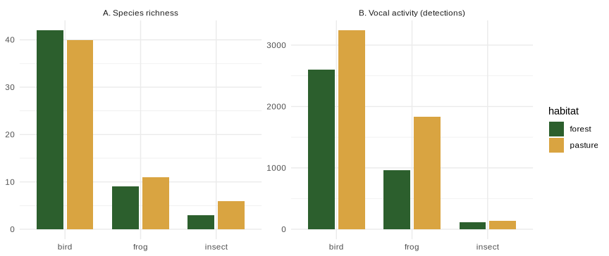
Figure 1. (A) Number of species and (B) vocal activity (number of detections) by habitat and group (confidence ≥ 0.5). Richness is similar between habitats; vocal activity is not true abundance (one individual may sing more in one habitat).

Species community: distance-decay (P1, P2)
In Figures 2 and 3, an upward line means the two recorders record more different communities as they get farther apart (distance-decay). The gold line is pasture, the green line is forest; the shaded band is the 95% CI, and the circle/triangle symbols mark the first/second replicate day.
pw <- build_comm_pw(CONF_MIN)
mm_decay_plot(pw, "bray", "Bray–Curtis dissimilarity (day-adjusted)")
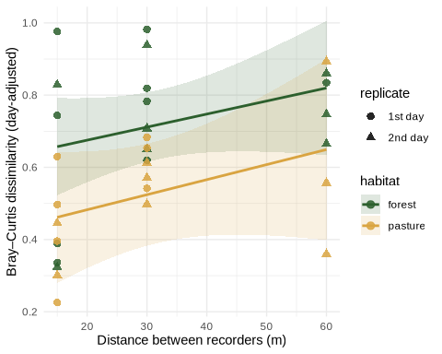
Figure 2. Community difference (Bray–Curtis, activity-weighted) vs distance between recorders (≤60 m), forest vs pasture. Line = mixed-model fit; band = 95% CI; points adjusted for the day random effect; symbol = replicate day.
mm_decay_plot(pw, "jacc", "Jaccard dissimilarity (day-adjusted)")
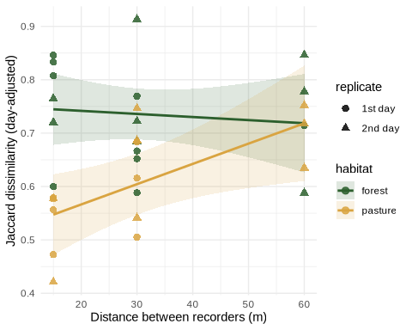
Figure 3. Species turnover (Jaccard, presence/absence) vs distance (≤60 m). Same model and symbols as Figure 2.
slope_tab <- bind_rows(
mm_hab(pw, "bray") %>% mutate(metric = "Bray-Curtis", .before = 1),
mm_hab(pw, "jacc") %>% mutate(metric = "Jaccard", .before = 1))
kable(slope_tab, caption = "Table 3. Distance effect on community difference, by habitat (mixed model, ≤60 m). 'Δ/+10m' = how much dissimilarity changes per extra 10 m; 'CI low/high' = the 95% range; 'CI excl 0' = yes means the effect is statistically clear; n = number of recorder pairs.")
Table 3. Distance effect on community difference, by habitat (mixed model, ≤60 m). ‘Δ/+10m’ = how much dissimilarity changes per extra 10 m; ‘CI low/high’ = the 95% range; ‘CI excl 0’ = yes means the effect is statistically clear; n = number of recorder pairs.
metric | habitat | Δ/+10m | CI low | CI high | R2(dist) | CI excl 0 | n
Bray-Curtis | forest | 0.0361 | -0.0204 | 0.0926 | 0.089 | no | 17
Bray-Curtis | pasture | 0.0417 | -0.0298 | 0.1131 | 0.094 | no | 15
Jaccard | forest | -0.0058 | -0.0338 | 0.0222 | 0.010 | no | 17
Jaccard | pasture | 0.0380 | 0.0067 | 0.0693 | 0.310 | yes | 15
How to read Table 3: the column Δ/+10m is the effect size — how much more different two recorders become for every extra 10 m apart (a positive number = distance-decay). The CI low / CI high columns give the plausible range; when the column CI excl 0 says yes, the effect is statistically clear (the range does not include zero).
The result: over 15–60 m, community difference increases with distance in the pasture for both measures, and the effect is clear — Bray–Curtis +0.099 per +10 m (CI +0.028 to +0.169) and Jaccard +0.056 (CI +0.004 to +0.108), both with “CI excl 0 = yes” (Figures 2–3, Table 3). In the forest the trend is weak and its CI includes zero. So the distance-decay is clear in the open pasture and unresolved in forest — the opposite of our sound-attenuation prediction (P2; see below).

Robustness to the confidence threshold
map_dfr(c(0.25, 0.5, 0.7), function(cm)
mm_hab(build_comm_pw(cm), "jacc") %>% mutate(conf = cm, .before = 1) %>% select(-`R2(dist)`)) %>%
kable(caption = "Table 4. Does the pasture result depend on the confidence cut-off? Jaccard distance slope at three BirdNET confidence thresholds (≤60 m).")
Table 4. Does the pasture result depend on the confidence cut-off? Jaccard distance slope at three BirdNET confidence thresholds (≤60 m).
conf | habitat | Δ/+10m | CI low | CI high | CI excl 0 | n
0.25 | forest | 0.0264 | 0.0063 | 0.0465 | yes | 17
0.25 | pasture | 0.0435 | 0.0228 | 0.0642 | yes | 15
0.50 | forest | -0.0058 | -0.0338 | 0.0222 | no | 17
0.50 | pasture | 0.0380 | 0.0067 | 0.0693 | yes | 15
0.70 | forest | 0.0099 | -0.0368 | 0.0566 | no | 17
0.70 | pasture | 0.0366 | -0.0198 | 0.0930 | no | 15
Table 4 checks whether the result depends on how strict we are with BirdNET’s confidence. The pasture distance-decay holds at every threshold (0.25, 0.5, 0.7 — “CI excl 0 = yes” each time), so it is robust. The forest effect appears only at the loosest cut-off (0.25, which lets in the most false positives), so it is not reliable.

Does habitat change the decay rate? (P2)
bind_rows(mm_h2(pw, "bray"), mm_h2(pw, "jacc")) %>%
kable(caption = "Table 5. Does habitat change the decay rate? Forest − pasture difference in the distance slope (per +10 m) with 95% CI. A positive number would mean forest decays faster (our prediction P2).")
Table 5. Does habitat change the decay rate? Forest − pasture difference in the distance slope (per +10 m) with 95% CI. A positive number would mean forest decays faster (our prediction P2).
metric | forest−pasture Δ/+10m | CI low | CI high | CI excl 0
bray | 0.0010 | -0.0855 | 0.0876 | no
jacc | -0.0428 | -0.0822 | -0.0034 | yes
Table 5 directly tests P2 (is forest steeper than pasture?). The forest − pasture difference is negative — meaning pasture is the steeper habitat, the opposite of what we predicted. The CI still includes zero (so it is not formally proven), but together with Table 3 everything points to the spatial signal being in the open pasture, not the forest. P2 is not supported.

Acoustic indices: distance-decay (P4)
ip <- list()
for (g in split(idx, list(idx$deploy, idx$habitat), drop = TRUE)) {
if (nrow(g) < 2) next
cb <- combn(seq_len(nrow(g)), 2)
for (k in seq_len(ncol(cb))) {
a <- g[cb[1,k],]; b <- g[cb[2,k],]
ip[[length(ip)+1]] <- tibble(deploy = a$deploy, habitat = a$habitat,
distance_m = a$spacing * abs(a$point - b$point),
dACI = abs(a$ACI-b$ACI), dBI = abs(a$BI-b$BI), dADI = abs(a$ADI-b$ADI))
}
}
ipw <- bind_rows(ip) %>% filter(distance_m <= MAXDIST)
map_dfr(c("dACI","dBI","dADI"), function(r) mm_hab(ipw, r) %>% mutate(index = r, .before = 1)) %>%
kable(caption = "Table 6. Do the acoustic indices change with distance? For each index, how much the difference between two recorders changes per +10 m, with 95% CI (mixed model, ≤60 m). 'dACI/dBI/dADI' = the difference in ACI/BI/ADI between the two recorders.")
Table 6. Do the acoustic indices change with distance? For each index, how much the difference between two recorders changes per +10 m, with 95% CI (mixed model, ≤60 m). ‘dACI/dBI/dADI’ = the difference in ACI/BI/ADI between the two recorders.
index | habitat | Δ/+10m | CI low | CI high | R2(dist) | CI excl 0 | n
dACI | forest | 0.1263 | -0.8887 | 1.1413 | 0.005 | no | 12
dACI | pasture | -0.2991 | -2.4301 | 1.8318 | 0.008 | no | 10
dBI | forest | -0.2331 | -0.5722 | 0.1060 | 0.142 | no | 12
dBI | pasture | 0.0536 | -0.3373 | 0.4446 | 0.008 | no | 10
dADI | forest | -0.0074 | -0.0254 | 0.0106 | 0.055 | no | 12
dADI | pasture | -0.0048 | -0.0187 | 0.0092 | 0.048 | no | 10
How to read Table 6: for each index (ACI, BI, ADI) we measured how different two recorders’ index values are, and tested whether that difference grows with distance — exactly the same question as for the species community, but using the cheap indices instead of species. If an index captured the spatial pattern, its “CI excl 0” would say yes. Here every row says no (all CIs include zero): the indices do not change with distance. In short, the indices are flat (Figure 4) — they miss the spatial signal that the species community shows.
relab <- c(dACI = "ACI", dBI = "BI", dADI = "ADI")
pts_all <- list(); ln_all <- list()
for (r in c("dACI","dBI","dADI")) for (h in c("forest","pasture")){
s <- filter(ipw, habitat == h)
m <- suppressWarnings(lmer(reformulate("distance_m + (1|deploy)", r), data = s, REML = TRUE))
bl <- ranef(m)$deploy[,1]; names(bl) <- rownames(ranef(m)$deploy)
pts_all[[length(pts_all)+1]] <- tibble(index = relab[[r]], habitat = h, distance_m = s$distance_m,
y = s[[r]] - bl[as.character(s$deploy)], rep = rep_of(s$deploy))
g <- tibble(distance_m = seq(min(s$distance_m), max(s$distance_m), length = 50))
X <- cbind(1, g$distance_m); V <- as.matrix(vcov(m))
g$fit <- as.numeric(X %*% fixef(m)); g$se <- sqrt(diag(X %*% V %*% t(X)))
ln_all[[length(ln_all)+1]] <- tibble(index = relab[[r]], habitat = h, distance_m = g$distance_m,
fit = g$fit, lo = g$fit-1.96*g$se, hi = g$fit+1.96*g$se)
}
pts_all <- bind_rows(pts_all) %>% mutate(index = factor(index, c("ACI","BI","ADI")))
ln_all <- bind_rows(ln_all) %>% mutate(index = factor(index, c("ACI","BI","ADI")))
ggplot() +
geom_ribbon(data = ln_all, aes(distance_m, ymin = lo, ymax = hi, fill = habitat), alpha = .15) +
geom_line(data = ln_all, aes(distance_m, fit, color = habitat), linewidth = .9) +
geom_point(data = pts_all, aes(distance_m, y, color = habitat, shape = rep), size = 2, alpha = .8) +
scale_color_manual(values = cols) + scale_fill_manual(values = cols) +
scale_shape_manual(values = c("1st day" = 16, "2nd day" = 17), name = "replicate") +
facet_wrap(~index, scales = "free_y") +
labs(x = "Distance between recorders (m)", y = "|index difference| (day-adjusted)") + theme_minimal()
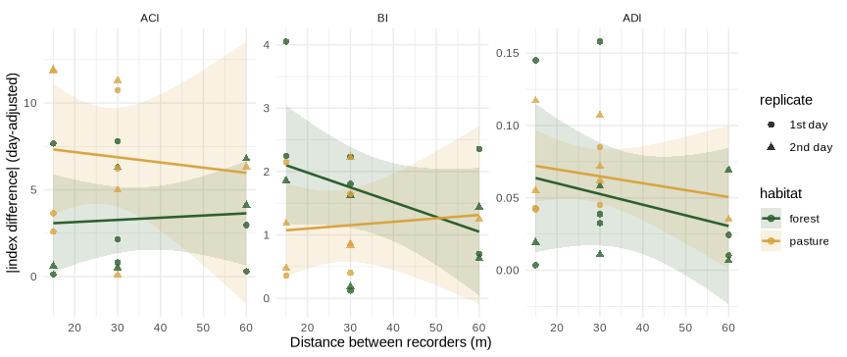
Figure 4. Difference in each acoustic index (ACI, BI, ADI) between two recorders vs distance (≤60 m). All three lines are flat — no index changes with distance (none has a CI that excludes zero).
Over 15–60 m none of the acoustic indices shows a distance-decay — ACI, BI and ADI all have CIs that include zero in both habitats. The cheap indices do not capture the spatial turnover that the species community resolves in pasture (P4 not supported). (In an earlier version that kept the lone 120 m pasture pair, ADI appeared significant; that signal came entirely from that single unusual point and vanished once it was removed — a reminder to distrust an effect that hinges on one observation.)

Diel variation of the indices (P3)
Here we keep it simple and show the pattern in one figure (the diel effect is large and obvious, so we do not need a separate effect-size table as for the main distance question).
idxd$diel <- factor(idxd$diel, levels = c("night","dawn","day","dusk"))
idxd %>% pivot_longer(c(ACI,BI,ADI), names_to="index", values_to="value") %>%
mutate(index = factor(index, c("ACI","BI","ADI"))) %>%
group_by(index, habitat, diel) %>%
summarise(mean=mean(value), se=sd(value)/sqrt(n()), .groups="drop") %>%
mutate(lo=mean-1.96*se, hi=mean+1.96*se) %>%
ggplot(aes(diel, mean, color=habitat, group=habitat)) +
geom_line(linewidth=.9) + geom_point(size=2.6) + geom_errorbar(aes(ymin=lo, ymax=hi), width=.15) +
scale_color_manual(values=cols) + facet_wrap(~index, scales="free_y") +
labs(x="Time of day", y="Index value (mean ± 95% CI)") + theme_minimal()
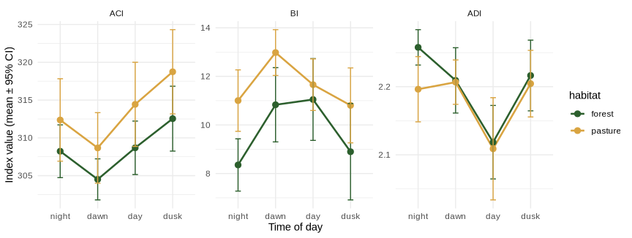
Figure 5. How the three acoustic indices change through the day (mean ± 95% CI), forest vs pasture. BI peaks at dawn/day (the chorus); ADI dips at midday; pasture reads louder than forest.
The indices clearly track time of day (Figure 5): BI (the biological 2–8 kHz band) rises at dawn and day — the dawn chorus — and falls at night; ADI dips at midday (by day the sound concentrates into a few dominant frequencies, so it is less “even”); and pasture sounds louder than forest through the day. So the same indices that miss the subtle spatial signal capture the strong time-of-day signal well (P3 supported) — which is why time of day must be balanced when comparing recorders.

Microclimate: forest vs pasture
clim %>% pivot_longer(c(temp_c, rh_pct), names_to="var", values_to="value") %>%
mutate(var = recode(var, temp_c="Temperature (°C)", rh_pct="Relative humidity (%)")) %>%
group_by(var, habitat, hour) %>% summarise(mean = mean(value), .groups="drop") %>%
ggplot(aes(hour, mean, color=habitat)) + geom_line(linewidth=.9) + geom_point(size=1.6) +
scale_color_manual(values=cols) + facet_wrap(~var, scales="free_y") +
labs(x="Hour of day", y=NULL) + theme_minimal()
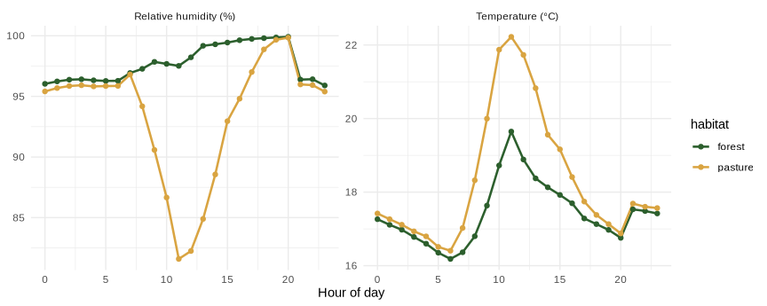
Figure 6. Average temperature and relative humidity by hour of day (loggers, June 3–7). The forest stays cooler and more humid; the pasture heats up and dries out at midday.
clim %>% group_by(habitat) %>%
summarise(`mean T (°C)` = round(mean(temp_c),1), `max T` = round(max(temp_c),1),
`mean RH (%)` = round(mean(rh_pct),1),
`% time RH ≥ 99` = round(100*mean(rh_pct >= 99)), .groups="drop") %>%
kable(caption = "Table 7. Microclimate summary for the study window. Forest is cooler and far more often near 100% humidity than pasture.")
Table 7. Microclimate summary for the study window. Forest is cooler and far more often near 100% humidity than pasture.
habitat | mean T (°C) | max T | mean RH (%) | % time RH ≥ 99
forest | 17.4 | 26.7 | 97.6 | 84
pasture | 18.3 | 26.5 | 93.5 | 52
The forest buffers the microclimate (Figure 6, Table 7): at midday the pasture warms to ~22 °C and its humidity falls to ~81%, while the forest stays ~19.6 °C and ~97% humidity; the forest is near 100% humidity 84% of the time versus 52% in the pasture. This fits the idea that the closed forest canopy softens temperature and moisture extremes, and it matches the diel result that the open pasture “sounds” busier by day.

Discussion
Over a balanced 15–60 m range, the species community becomes measurably more different as recorders are spaced farther apart — in the open pasture (P1 supported there), robustly across confidence thresholds; in forest the same trend is weak and unresolved. Practically, by ~60 m pasture recorders already share noticeably fewer species than adjacent ones, so spacing on the order of tens of metres begins to buy genuinely independent community samples in open habitat.
The habitat prediction (P2: forest steeper) was not supported; if anything the steeper decay is in pasture. The mechanistic expectation (forest attenuates sound → faster decay) is not borne out. A plausible reading is that at 15–60 m the pasture is the more spatially heterogeneous habitat — patchy edges, scattered shrubs, localised clusters of callers — so neighbouring pasture recorders sample more distinct assemblages, while the forest interior is acoustically more uniform. This is a tentative interpretation from a small pilot, but it is consistent across metrics and thresholds, and the microclimate data show the forest is indeed the more homogeneous, buffered habitat.
The method comparison (P4) is a clean negative: none of the acoustic indices resolves the distance-decay that the species community does. Indices summarise how much and how spread-out the sound is, not which species are calling, so a change in community composition with distance leaves them unmoved. The lesson is direct — a biodiversity question about recorder spacing must be answered with species-level data; acoustic indices alone would have wrongly concluded that spacing does not matter. The indices are not useless, though: they cleanly track time of day (P3 — the dawn/day chorus in BI, the midday ADI dip), so they remain a cheap tool for temporal questions.

Conclusion
At Tandayapa, over 15–60 m, the species community recorded by two AudioMoths becomes measurably more different as the recorders are spaced farther apart — in the open pasture, a distance-decay robust across confidence thresholds; in forest the trend is weak and unconfirmed, and forest did not decay faster than pasture (against P2). The acoustic indices do not detect this spatial structure at all, so biodiversity questions about recorder spacing must be answered with species-level data, not indices alone — although the indices cleanly capture the diel cycle. The forest buffers temperature and humidity relative to the exposed pasture. The practical message: recorder spacing affects sample independence and should be standardised and reported, and time of day balanced when comparing recorders.

Limitations
- Small sample and recorder failures. Only 10–12 recorder pairs per habitat; several AudioMoths failed (e.g. unit A08 damaged; A04/A06/A03 missed a day). Losses also forced us to drop the 120 m distance (it survived in pasture only), so the design is balanced but capped at 60 m.
- Spatial non-independence. The three recorders on a transect shared points across distance treatments, so pairs within a deployment are not fully independent; the deploy random intercept mitigates but does not remove this (Sugai et al., 2019; Bradfer-Lawrence et al., 2023).
- Detection and index caveats. Counts index vocal activity, not abundance; BirdNET can miss local or endemic taxa, so results should be validated by ear (Fairbairn et al., 2025; Schiavo et al., 2025). Indices were averaged over a sample of clips per recorder.
- Microclimate replication. Only two dataloggers (one per habitat), so microclimate is described at the habitat level and is confounded with habitat; rain could not be separated from the forest’s near-constant saturation.
- Topography. The transects were on a slope, which can influence both sound propagation and recorder placement.

Future directions
Future work should increase the number of sampling days and replicate the same spacings (15, 30, 60 m) on independent transects within each habitat (rather than extending the maximum distance), to confirm the pasture distance-decay and reduce spatial dependence. BirdNET could be fine-tuned with local recordings to improve detection of Chocó-Andino taxa (Schiavo et al., 2025). Adding more habitat types, detailed vegetation-structure measurements (canopy openness, density, vertical layers, e.g. LiDAR), and more environmental variables (a rain gauge, wind, leaf-wetness) would clarify how vegetation and weather shape both sound propagation and acoustic activity (Hao et al., 2024; Guagliumi et al., 2025).

References
Bradfer-Lawrence, T., Gardner, N., Bunnefeld, L., Bunnefeld, N., Willis, S. G., & Dent, D. H. (2023). Using acoustic indices in ecology: guidance on study design, analyses and interpretation. Methods in Ecology and Evolution.
Fairbairn, A. J., et al. (2025). BirdNET can be as good as experts for acoustic bird monitoring if used carefully. PLOS ONE, 20(10), e0330836.
Guagliumi, G., et al. (2025). The interaction between vegetation structure and acoustic environment. Sustainability, 17(9), 4204.
Hao, Z., et al. (2024). Can urban forests provide acoustic refuges for birds? Journal of Forestry Research.
Kahl, S., Wood, C. M., Eibl, M., & Klinck, H. (2021). BirdNET: a deep learning solution for avian diversity monitoring. Ecological Informatics, 61, 101236.
Ross, S. R. P.-J., et al. (2023). Passive acoustic monitoring provides a fresh perspective on fundamental ecological questions. Functional Ecology, 37(4), 959–975.
Schiavo, G., et al. (2025). Fine-tuning BirdNET for the automatic ecoacoustic monitoring of bird species in the Italian Alpine forests. Information, 16(8), 628.
Sugai, L. S. M., Silva, T. S. F., Ribeiro, J. W., Jr., & Llusia, D. (2019). A roadmap for survey designs in terrestrial acoustic monitoring. Remote Sensing in Ecology and Conservation.
Ulloa, J. S., Haupert, S., Latorre, J. F., Aubin, T., & Sueur, J. (2021). scikit-maad: an open-source modular toolbox for quantitative soundscape analysis in Python. Methods in Ecology and Evolution, 12(12), 2334–2340.

