When do two recorders hear the same community, and does it differ between forest and pasture?
  - Recorder spacing and soundscape distance-decay · Tandayapa Cloud Forest Station, Ecuador · AudioMoth passive acoustic monitoring
Franz Chandi, Maria Andrade, Priscila Cajas, Noemi Castro
11 junio 2026

Introduction
Tropical montane cloud forests are among the most biodiverse ecosystems on Earth, with high richness and endemism (Bruijnzeel et al., 2011); Ecuador’s Chocó Andino is a global biodiversity hotspot, now a mosaic of forest remnants and human-modified habitats such as pasture (UNESCO, 2024). Soundscape ecology holds that the sounds of an environment carry information about its biological communities and ecological processes (Pijanowski et al., 2011; Farina, 2014), and passive acoustic monitoring (PAM) is now widely used to track biodiversity across space and time (Shonfield & Bayne, 2017; Sugai et al., 2019). Acoustic indices such as the Acoustic Complexity Index (ACI), Bioacoustic Index (BI) and Acoustic Diversity Index (ADI) summarise soundscape structure and allow comparisons among habitats and conditions (Sueur et al., 2014; Metcalf et al., 2021).
A recorder samples only a portion of the surrounding soundscape, and how large that portion is depends on sound propagation and detectability, which vary with call frequency, noise, weather and habitat structure (Haupert et al., 2023; Winiarska et al., 2024). Recorders placed close together may repeatedly detect the same sources, while recorders far apart sample different parts of the soundscape, so the distance at which recordings begin to diverge is central to designing representative monitoring and remains poorly known in tropical montane systems (Sugai et al., 2019). Habitat structure should modulate this: the acoustic adaptation hypothesis holds that habitat physically shapes how signals propagate (Morton, 1975), and forest vegetation absorbs and scatters sound, shortening detection distances relative to open habitat (Entling et al., 2025).
We therefore ask: at what distance do two AudioMoth recorders begin to capture different acoustic information, and does this distance differ between forest and pasture? We measure acoustic difference primarily with the indices (ACI, BI, ADI) and complement them with the species community recovered by an automated classifier (BirdNET), to test whether the cheap indices capture the same spatial structure as species turnover. We hypothesise that (H1) acoustic difference increases with inter-recorder distance; (H2) the increase is steeper (a larger slope) in forest than pasture, because dense vegetation attenuates sound more strongly; and (H3) differences are largest during periods of high biological activity (the dawn/day chorus). Accordingly we predict that $|Δ$ACI$|$, $|Δ$BI$|$ and $|Δ$ADI$|$ rise with distance, more so in forest, and that between-site differences peak during the chorus.

Study area
The study was conducted at Tandayapa Cloud Forest Station, Pichincha Province, Ecuador, within the Chocó Andino Biosphere Reserve, on the western slope of the Andes (≈0.0117°, −78.6739°, ~1,680 m a.s.l.). Two adjacent habitats were sampled: forest (secondary montane cloud forest, dense vegetation with closed to semi-closed canopy, epiphytes, ferns and understory, which attenuates and scatters sound) and pasture (open, dominated by non-native grasses with scattered unidentified shrubs, more exposed to wind and environmental noise).

Experimental design
We deployed AudioMoth recorders on short linear transects 20 m inside the edge of each habitat, at 1.5 m height, facing downslope, with the same protocol in both habitats and each point marked with flagging tape. Each transect held three recorders at points 1–2–3. The spacing was changed between deployment days, sampling 15, 30 and 60 m, and each spacing was deployed on two separate days (replicate blocks). Recorders were swapped between positions across days to reduce equipment bias. Because each transect compares points 1–2 and 2–3 (one spacing apart) and 1–3 (two spacings apart), the realised distances are 15, 30, 60 and 120 m; we analyse pairs up to 60 m and exclude the single 120 m pair, which existed in pasture only, on one line, with no replicate (forest lost its 60 m point-1 recorder). This keeps the forest–pasture comparison on the same 15–60 m range.
Table 1. Deployments and working recorders per habitat.
date | spacing_m | forest | pasture
2026-06-02 | 15 | 3 | 3
2026-06-03 | 15 | 3 | 3
2026-06-03 | 30 | 3 | 2
2026-06-04 | 30 | 3 | 2
2026-06-04 | 60 | 2 | 1
2026-06-05 | 15 | 2 | 3
2026-06-05 | 60 | 2 | 1
2026-06-06 | 15 | 2 | 3
2026-06-06 | 30 | 3 | 3
2026-06-07 | 30 | 3 | 3
2026-06-07 | 60 | 2 | 2
2026-06-08 | 60 | 2 | 2

Data collection
For analysis we used the window from 11:00 a.m. to 9:40 a.m. the next day, discarding the surrounding period when recorders were placed, collected, and swapped between positions, so that handling was not counted as data. Within this window each recorder took three 2-minute recordings per hour (2 min on / 18 min off), six minutes of audio per hour, covering the full day–night cycle (Ross et al., 2023). We also ran two Kestrel DROP 2 dataloggers (one per habitat) logging temperature and humidity every 10 minutes. Acoustic indices were computed with scikit-maad (Ulloa et al., 2021), and species detections with BirdNET (range-filtered; birds and insects) and a frog classifier (Kahl et al., 2021), each verifiable by ear and spectrogram. Cleaned inputs are in data/processed/, so this report is fully reproducible without the raw audio. All code and data: https://github.com/Fr4nzz/tandayapa-soundscape.

Data analysis
We measure the acoustic difference between two recorders two ways. For the indices, the response is the absolute difference in each index, $|Δ$ACI$|$, $|Δ$BI$|$, $|Δ$ADI$|$. For the species community (BirdNET birds, frogs, insects; three suspected false-positive frog taxa removed after listening and checking spectrograms, kept at confidence ≥ 0.5), the response is the pairwise Bray–Curtis dissimilarity (activity-weighted, where activity = detection count, not true abundance) or Jaccard dissimilarity (presence/absence). All effect sizes come from linear mixed models (lme4/lmerTest). We report effect sizes (slopes with 95% confidence intervals) rather than p-values, because the size and direction of an effect are more informative than significance alone, especially in a small study; a CI that excludes zero indicates an effect.
Two complementary models are used. For distance, we use one value per recorder pair so the pair-level distance is tested cleanly:
$$\text{Difference}∼\text{Distance}×\text{Habitat}+\left(1∣\text{day}\right)$$
Why the difference? Distance is a property of a pair of recorders, not of a single recorder. A recorder at 15 m has no distance on its own; distance only exists when you compare two recorders. Therefore, a distance-decay model must use the pairwise difference between the two recordings, just as a Bray–Curtis or Jaccard dissimilarity is also computed pairwise. The raw indices are used, but in the complementary model that asks how the absolute level of each index changes with time of day and habitat, not with distance.
For time of day, we compute the difference per pair within each period (dawn, day, dusk, night) and add the pair as a random effect, which is what makes time of day estimable within pairs:
$$\text{Difference}∼\text{Time of day}+\left(1∣\text{pair}\right)+\left(1∣\text{day}\right)$$
Table 1b. Model comparison: additive vs interactive distance model for combined acoustic dissimilarity (≤60 m). Lower AIC/BIC = better fit.
Model | AIC | BIC | Preferred?
Additive (Distance + Habitat) | 54.2 | 59.7 | yes
Interactive (Distance × Habitat) | 55.9 | 62.5 | no

Results

Acoustic indices and recorder distance
For every within-habitat recorder pair we took the absolute difference in each index and asked whether it grows with distance. In Figure 1 the lines are the mixed-model fits with 95% bands; points are adjusted for the day random effect, and the symbol marks the first or second replicate day. All three indices are flat: none of the slopes differs from zero (Table 2). The cheap indices do not change with recorder distance over 15–60 m (H1 not supported for the indices).
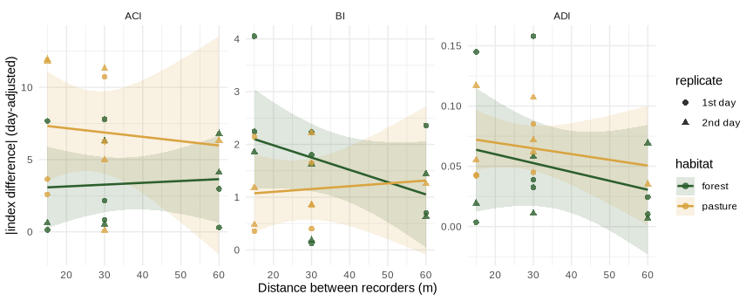
Figure 1. Difference in each acoustic index (ACI, BI, ADI) between two recorders vs distance, forest vs pasture (≤60 m). Mixed-model fit + 95% band; points day-adjusted, shape = replicate day.
Table 2. Distance effect on each acoustic-index difference (mixed model, ≤60 m). 'CI excl 0 = yes' would mean the index changes with distance; here every row is 'no'.
index | habitat | Δ/+10m | CI low | CI high | R2 | CI excl 0 | n
dACI | forest | 0.1263 | -0.8887 | 1.1413 | 0.005 | no | 12
dACI | pasture | -0.2991 | -2.4301 | 1.8318 | 0.008 | no | 10
dBI | forest | -0.2331 | -0.5722 | 0.1060 | 0.142 | no | 12
dBI | pasture | 0.0536 | -0.3373 | 0.4446 | 0.008 | no | 10
dADI | forest | -0.0074 | -0.0254 | 0.0106 | 0.055 | no | 12
dADI | pasture | -0.0048 | -0.0187 | 0.0092 | 0.048 | no | 10

Acoustic indices and time of day
The indices do, however, change strongly through the day. Figure 2 shows each index by period: BI (the biological 2–8 kHz band) peaks at dawn and day (the chorus) and is lowest at night; ADI dips at midday; ACI varies little; and pasture reads louder than forest through the day.
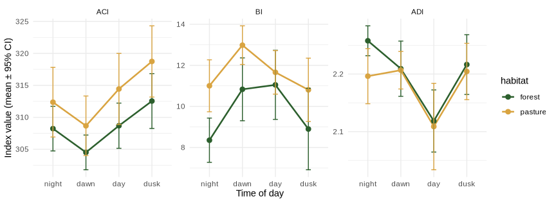
Figure 2. Acoustic indices by time of day, forest vs pasture (mean ± 95% CI). BI peaks at the dawn/day chorus; ADI dips at midday.
We also asked at which time of day two recorders differ most, computing the index difference per pair within each period and modelling it as difference ~ time of day + (1 | pair) + (1 | day). For BI, pairs are significantly more different at dawn, day and dusk than at night (Table 3): sites diverge most when the community is acoustically active, supporting H3. ACI and ADI show no clear time-of-day pattern in the difference.
Table 3. Between-recorder difference in BI by time of day (vs night). Positive 'vs night' with 'CI excl 0 = yes' means pairs are more different at that time.
period | vs night | CI low | CI high | CI excl 0
dawn | 1.149 | 0.164 | 2.134 | yes
day | 1.352 | 0.367 | 2.337 | yes
dusk | 1.015 | 0.030 | 2.000 | yes

Species community (BirdNET): a complementary view
Indices summarise how much and how spread out the sound is, not which species call. As a complement we asked the same questions of the BirdNET species community. Unlike the indices, the community shows a distance-decay in pasture: pairs of pasture recorders share fewer species as they move apart (Figure 3), and the effect is statistically clear and robust across confidence thresholds (Table 4). Forest shows only a weak, unresolved trend, and the forest − pasture difference is if anything negative (dissimilarity rises faster with distance in pasture, the opposite of H2). So the species data detect spatial structure the indices miss, but in the open pasture rather than the forest.
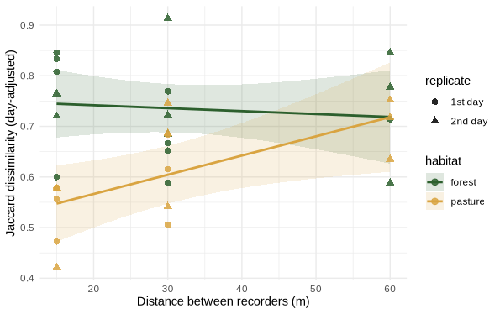
Figure 3. Species turnover (Jaccard) between two recorders vs distance, forest vs pasture (≤60 m). Mixed-model fit + 95% band; points day-adjusted, shape = replicate day.
Table 4. Distance effect on community dissimilarity by habitat (mixed model, ≤60 m). Pasture excludes zero (a real distance-decay); forest does not.
metric | habitat | Δ/+10m | CI low | CI high | R2 | CI excl 0 | n
Bray-Curtis | forest | 0.0361 | -0.0204 | 0.0926 | 0.089 | no | 17
Bray-Curtis | pasture | 0.0417 | -0.0298 | 0.1131 | 0.094 | no | 15
Jaccard | forest | -0.0058 | -0.0338 | 0.0222 | 0.010 | no | 17
Jaccard | pasture | 0.0380 | 0.0067 | 0.0693 | 0.310 | yes | 15
The pasture distance-decay is robust to the BirdNET confidence threshold (the Jaccard slope excludes zero at 0.25, 0.5 and 0.7); the forest trend appears only at the most permissive cutoff. By time of day, community pairs differ most during the day (Jaccard difference vs night is clearly positive), echoing the indices: sites diverge most when the community is active.

Richness, vocal activity and microclimate
Detected richness is nearly identical between habitats (forest and pasture hold similar numbers of bird, frog and insect species), so the spacing contrast is about spatial structure, not species count. Pasture recorders logged more detections (vocal activity) than forest ones, especially frogs and birds (Figure 4); this is not evidence of higher biodiversity (richness is similar) but likely reflects more calling in the open and sound carrying farther where there is less vegetation to absorb it, so it is not a reason to place recorders only in open areas.
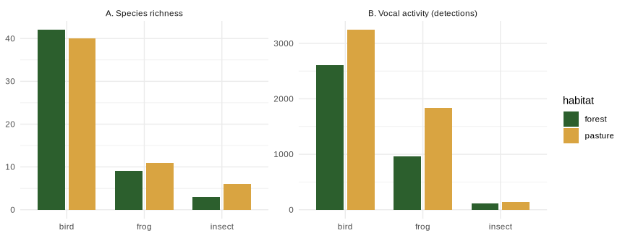
Figure 4. (A) Species richness and (B) vocal activity (detections) by habitat and group (confidence ≥ 0.5).
The paired dataloggers show the forest buffers the microclimate: at midday the pasture warms to ~22 °C and its humidity falls to ~81%, while the forest stays ~19.6 °C and ~97% humidity, and the forest is near 100% humidity 84% of the time versus 52% in the pasture. This is consistent with the closed forest canopy moderating extremes, and with the more homogeneous forest soundscape.
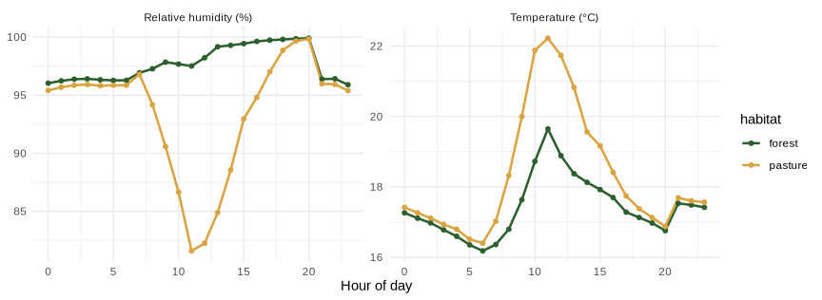
Figure 5. Mean temperature and humidity by hour, forest vs pasture (loggers, June 3–7).

Discussion
Over 15–60 m, the acoustic indices did not change with recorder distance (Figure 1, Table 2): two recorders 15 m or 60 m apart produced equally similar ACI, BI and ADI. The cheap indices therefore did not, on their own, reveal a spacing effect at this scale, and H1 was not supported for the indices. The indices instead tracked time of day strongly (Figure 2): BI rose at the dawn/day chorus and between-site BI differences were largest during the active periods (Table 3), supporting H3. This makes sense, indices summarise the overall amount and spread of sound, which changes far more between night and a dawn chorus than between two recorders a few tens of metres apart.
The species community told a different and complementary story. Where the indices were flat, the BirdNET community showed a clear, threshold-robust distance-decay in the pasture (Figure 3, Table 4): open-habitat recorders sampled increasingly different species with distance, while forest was weak and unresolved. This is the opposite of H2 (we expected forest to decay faster because it attenuates sound); a plausible reading is that the pasture is more spatially heterogeneous at this scale (patchy edges, scattered shrubs, localised callers), while the forest interior, which the microclimate data show is the more buffered, homogeneous habitat (Figure 5), is acoustically more uniform. The key methodological message is that a biodiversity question about recorder spacing needs species-level data, because the indices alone would have concluded that spacing does not matter, missing the compositional turnover that the classifier-based analysis reveals. Both currencies agreed, though, that sites differ most during the day, when most animals are calling.

Conclusion
At Tandayapa, acoustic indices (ACI, BI, ADI) measured at two AudioMoths did not diverge with recorder spacing over 15–60 m, but they did vary strongly with time of day (the dawn/day chorus), and between-site differences were largest during the active periods. The species community, by contrast, became measurably more different with distance in the open pasture (robustly across thresholds), not in forest, so forest did not decay faster than pasture. Practically: acoustic indices are useful for temporal questions but insensitive to recorder spacing at this scale, so biodiversity-driven spacing decisions should use species-level data; recorder spacing affects sample independence in open habitat and should be standardised and reported, and time of day must be balanced when comparing recorders.

Limitations
Only 10–12 recorder pairs per habitat and several recorder failures limit power (units A08, A04, A06, A03 lost data), and losses forced us to cap the analysis at 60 m. The three recorders on a transect shared points across distance treatments, so pairs within a deployment are not fully independent; the day random effect mitigates but does not remove this (Sugai et al., 2019; Bradfer-Lawrence et al., 2023). Detection counts index vocal activity, not abundance, and BirdNET can miss local or endemic taxa (Fairbairn et al., 2025; Schiavo et al., 2025). Microclimate had only one logger per habitat, so it is described at the habitat level. The transects were on a slope, which can affect both sound propagation and placement.

Future directions
Future work should increase the number of sampling days and replicate the same spacings on independent transects within each habitat (rather than extending the maximum distance) to confirm the pasture distance-decay and reduce spatial dependence. BirdNET could be fine-tuned with local recordings to improve detection of Chocó-Andino taxa (Schiavo et al., 2025), more habitat types and detailed vegetation-structure measurements (canopy openness, density, LiDAR) would clarify how vegetation shapes sound propagation (Guagliumi et al., 2025), and adding a rain gauge and wind sensor would separate weather effects from spacing and habitat.

References
Bradfer-Lawrence, T., et al. (2023). Using acoustic indices in ecology: guidance on study design, analyses and interpretation. Methods in Ecology and Evolution.
Bruijnzeel, L. A., Mulligan, M., & Scatena, F. N. (2011). Hydrometeorology of tropical montane cloud forests. Hydrological Processes, 25(3), 465–498.
Entling, M. H., et al. (2025). Sound attenuation in forest versus open habitats measured with AudioMoth recorders. (as cited in the group’s reference list.)
Fairbairn, A. J., et al. (2025). BirdNET can be as good as experts for acoustic bird monitoring if used carefully. PLOS ONE, 20(10), e0330836.
Farina, A. (2014). Soundscape Ecology: Principles, Patterns, Methods and Applications. Springer.
Guagliumi, G., et al. (2025). The interaction between vegetation structure and acoustic environment. Sustainability, 17(9), 4204.
Haupert, S., et al. (2023). Sound propagation and detection distance in passive acoustic monitoring. (as cited in the group’s reference list.)
Kahl, S., Wood, C. M., Eibl, M., & Klinck, H. (2021). BirdNET: a deep learning solution for avian diversity monitoring. Ecological Informatics, 61, 101236.
Metcalf, O. C., et al. (2021). Acoustic indices for biodiversity assessment. Methods in Ecology and Evolution.
Morton, E. S. (1975). Ecological sources of selection on avian sounds. The American Naturalist, 109(965), 17–34.
Pijanowski, B. C., et al. (2011). Soundscape ecology: the science of sound in the landscape. BioScience, 61(3), 203–216.
Ross, S. R. P.-J., et al. (2023). Passive acoustic monitoring provides a fresh perspective on fundamental ecological questions. Functional Ecology, 37(4), 959–975.
Schiavo, G., et al. (2025). Fine-tuning BirdNET for the automatic ecoacoustic monitoring of bird species in the Italian Alpine forests. Information, 16(8), 628.
Shonfield, J., & Bayne, E. M. (2017). Autonomous recording units in avian ecological research. Avian Conservation and Ecology, 12(1), 14.
Sueur, J., Farina, A., Gasc, A., Pieretti, N., & Pavoine, S. (2014). Acoustic indices for biodiversity assessment and landscape investigation. Acta Acustica united with Acustica, 100(4), 772–781.
Sugai, L. S. M., Silva, T. S. F., Ribeiro, J. W., Jr., & Llusia, D. (2019). A roadmap for survey designs in terrestrial acoustic monitoring. Remote Sensing in Ecology and Conservation.
Ulloa, J. S., et al. (2021). scikit-maad: an open-source modular toolbox for quantitative soundscape analysis in Python. Methods in Ecology and Evolution, 12(12), 2334–2340.
UNESCO (2024). Chocó Andino de Pichincha Biosphere Reserve. UNESCO Man and the Biosphere Programme.
Winiarska, D., et al. (2024). Factors affecting detection distance in passive acoustic monitoring. (as cited in the group’s reference list.)

