Word to TEI
This is a sample document to test conversion of word docx to TEI using the TEI processing model. It was generated by uploading the word document located in data/doc/test.docx in your local TEI Publisher installation. You can also download it from the TEI Publisher git repository, edit it and upload it via the upload panel on the start page of your local TEI Publisher.
The following sections document and provide examples for all features and conventions implemented by the default ODD transformation.

Style Conversion
Rather than trying to convert everything, the default ODD transformation attempts to preserve the semantics of the text. Most style properties are thus ignored. This is by intention: trying to preserve as much as possible would likely just add noise and result in low-quality TEI.
Users are free to extend the default ODD with additional heuristics. For example, a paragraph being entirely bold could also be treated as a heading, or a left text indent may indicate a quote. The default ODD being used for Word to TEI transformations is called docx.odd.
Empty paragraphs like the one below will be removed from the docx before it is being passed to the ODD for transformation.

Inline Styles
Text styled as italic, underline or bold will be transformed into a tei:hi with a corresponding @rend attribute. Other types of formatting will be ignored.
Inline styles whose name starts with „tei:“ are transformed into TEI elements with the same name. So if a character sequence uses a style called „tei:persName”, it will be wrapped into a TEI persName element in the output, e.g. Johann Wolfgang Goethe. A place name can be marked with a style „tei:placeName” and should be transformed accordingly: Frankfurt, Berlin, München. And damaged text could be encoded by applying a style „tei:supplied“.
There’s also a default convention for encoding additional attributes: text in angle brackets will be interpreted as a list of attribute=value pairs. Multiple items should be separated with a “;”. For example, to set a @rend and provide a @ref for a placeName, you can write Frankfurt<rend=smallcaps;ref=Frankfurt am Main>.
This notation requires quite some typing. You may always extend the ODD with additional rules for easier conventions though. For example, if persName does always need a @ref attribute in your edition, you could have a simplified rule which parses: Friedrich Dürrenmatt<118527908>.
Because Word has a tendency to split character ranges at random points, some pre-processing is applied before the docx is passed to the ODD for processing: subsequent ranges referencing the same character style are combined by nesting them into an additional w:r range element, which references the common character style and the style is then removed from the individual ranges.
You can thus safely assume within the ODD that the content of a range includes all sibling text using the same character style.
By design, Word does not support nested character styles. It is thus not possible to e.g. mark up a persName inside a supplied. The standard character styles for bold, italics and underline are preserved though – like in the following paragraph which is marked up as supplied:
This is supplied text containing bold, italics and underline. We may also encounter local formatting inside a persName like Friedrich Dürrenmatt<118527908>.

Paragraph Styles

Headings
Word does not have a concept for text divisions, so we have to reconstruct them:
- Paragraph styles starting with „heading“, „title“ or „subtitle“ generate a tei:head. The outline level assigned to the heading is recorded as well.
- In a second pass through the generated output, divs are generated based on the outline level:
  - A div spans all text from the heading to the next heading on the same outline level
  - Repeat the process for all headings within this division on a lower outline level

Footnotes
Footnotes are translated into TEI note elements and inlined in the text.
You may also want to distinguish between editorial footnotes, original footnotesa which were present in the sourceb, and text-critical notes.
By default, footnotes with a custom mark are encoded with note n=”custom mark” type=”original”. Instead of being numbered automatically in the output, they appear with the custom mark.
Text-critical notes usually enclose a span of text: to encode them in Word, we can abuse comments. Word comments insert a start and end marker, which can be easily converted to TEI and output accordingly later.

Lists
Lists are tricky, because Word essentially just stores list items in a flat sequence. Reconstructing nesting thus requires looking at the list level associated with every item. Simple lists are easy:
- A list item
- Another list item
We can also have numbered lists, which are translated into a list type=“ordered“:
- First item in a numbered list
- Second item in a numbered list
Nested lists are quite tricky:
- A bullet list item
- A nested list item
- Another nested list item
  - Nested in a nested list
  - More …
- A second bullet list item
Paragraph styles starting with „tei:“ are converted to TEI elements with the same name. For example, the lines of the following poems are assigned the style “tei:l”:
I love to heare her speake, yet well I know,
That Musicke hath a farre more pleasing sound:
I graunt I never saw a goddesse goe,
My Mistres when shee walkes treads on the ground.

Tables
We can do simple tables very well. Spanning multiple colums is also easy, but things become more difficult for row spans, which are not implemented yet.
Item | Hours | Hourly rate | Price
Customize ODD | 3 | 120 | 360
Generate App | 4 | 120 | 480
Test and Deploy | 2 | 120 | 240
Total |  |  | 1080

Embedded Images
Below image will be embedded:
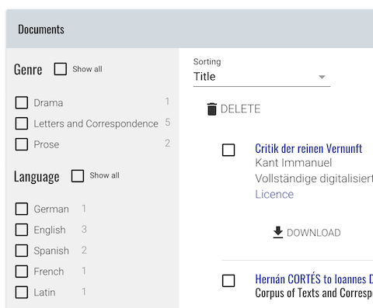
Inside eXist, images are copied into a subcollection starting with the name of the docx file being processed and suffixed with .media.

Text content in angle brackets will be automatically stripped from an inline element by the post-processing step, so you do not need to handle this within the ODD.
A footnote may contain inline formatting.
a A footnote which was found in the source text
b Another footnote written by the original author of the text
And here we have a footnote with a link to another place in the document.
And here we have a footnote with a link to an external URL.

