 **Websolute B2C Project**

**Architecture Low Level Design**

**Version:** <0.1 27/07/2022>

**Customer**: Websolute

**Objective:** the goal of this document is to describe the infrastructural architecture realized for the customer by Criticalcase on AWS Cloud.

**Limits**: the application environment is out of the scope of this document.

Summary

1 Project scope 3

2 Cloud and Infrastructure Services 4

2.1 Infrastructural Scope 4

2.2 Environments 5

2.2.1 Virtual Private Cloud (VPC) 5

2.3 Stage Environment 6

2.3.1 Architecture 6

2.3.2 Cloudfront 6

2.3.3 WAF 6

2.3.4 Application Load Balancer 6

2.3.5 RDS 7

2.3.6 EC2 7

2.3.7 Redis 7

2.3.8 Elasticsearch 7

2.3.9 EFS 7

2.3.10 System Manager Parameter Store 7

2.4 Production Environment 8

2.4.1 Architecture 8

2.4.2 Cloudfront 8

2.4.3 WAF 8

2.4.4 Application Load Balancer 8

2.4.5 RDS 8

2.4.6 EC2 9

2.4.7 Redis 9

2.4.8 Elasticsearch 9

2.4.9 EFS 9

2.4.10 System Manager Parameter Store 9

2.5 DNS 10

2.6 Backup 10

2.7 Cloudwatch 10

2.7.1 Cloudwatch Alarms 10

3 Users and Accesses 11

3.1 VM users 11

3.2 Pipeline 12

# Project scope

The main goal of Websolute is to activate the Magento services on AWS Cloud.

The Environments realized are three:

* Stage
* Production

# Cloud and Infrastructure Services

## Infrastructural Scope

Criticalcase boundary:

* Delivery of VMs and services (Firewall, Load Balancer, Storage, CDN, VPC, Backup)
* User and access management to the Cloud Infrastructure and to the VMs and services
* Setup, configuration and tuning of all the infrastructure services:
  + Firewall
  + Routing Rules, Subnetting e Networking in general
  + Load Balancer
  + CDN – Implementation according to the web layer specs.
  + Backup
  + Cloudwatch Alarms and Logs
  + EFS
  + WAF
  + Elasticsearch
  + Redis
  + RDS
  + Route53
* Setup and configuration of the Middleware (Nginx, Varnish…) based on customer requirements
* Create all the Environments via Automation

## Environments

**Environments.** There are two different Environments, very similar each other:

* **Stage (Stg)** environment, that is the only one deployed as of July 2022.
* **Production (Prd)** environment, to be deployed within July 2022.

**Cloud providers.** The whole infrastructure is deployed on an AWS Cloud account dedicated to Websolute

**Regions.** Within AWS, everything is inside Frankfurt region

### Virtual Private Cloud (VPC)

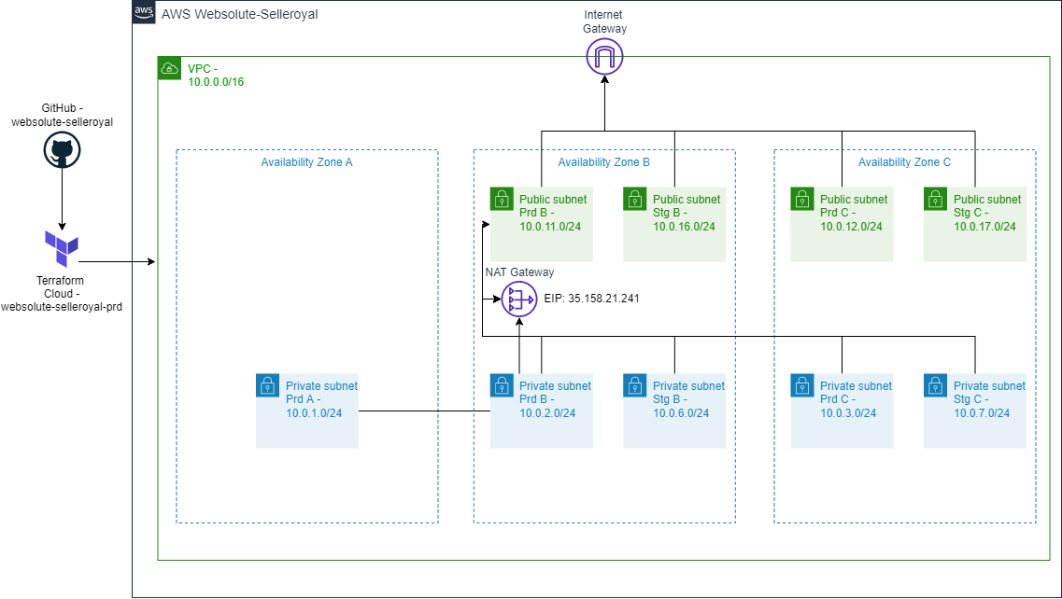

The VPC is configured with **CIDR 10.0.0.0/16** CIDR in Frankfurt region

3 private subnets and 2 public subnets have been created for production environment, 2 private subnets and 2 public subnets for staging:

|  |  |  |  |  |
| --- | --- | --- | --- | --- |
| Name | Type | Availability Zone | CIDR | Subnet ID |
| Private_PROD_A | Private | eu-central-1a | 10.0.1.0/24 | subnet-04f9996420520afe3 |
| Private_PROD_B | Private | eu-central-1b | 10.0.2.0/24 | subnet-08dc043eac36ecebd |
| Private_PROD_C | Private | eu-central-1c | 10.0.3.0/24 | subnet-073871995b4fffcce |
| Public_PROD_B | Public | eu-central-1b | 10.0.11.0/24 | subnet-0c0b028e8aa96f0c3 |
| Public_PROD_C | Public | eu-central-1c | 10.0.12.0/24 | subnet-0a8184d16433be4b4 |
| Private_STG_B | Public | eu-central-1b | 10.0.6.0/24 | subnet-032c8d7e357904cbb |
| Private_STG_C | Private | eu-central-1c | 10.0.7.0/24 | subnet-00c9381ffe6615cc1 |
| Public_STG_B | Private | eu-central-1b | 10.0.16.0/24 | subnet-034187133814d950e |
| Public_STG_C | Private | eu-central-1c | 10.0.17.0/24 | subnet-0bf4e0708faa32b71 |

This configuration allows for maximum reliability in the case of highly critical systems, configuring resources on Availability Zone and a greater number of IPs available in the event of future developments. The resources in Stage are created on a single AZ not being critical, currently production on 2 AZ

The reachability of the resources is guaranteed by the security groups, by default the doors are blocked and open in case of lack of communication with other resources and problems of reachability

The private subnets of both environments to communicate with the internet use a single NAT Gateway in availability zone B with IP 35.158.21.241. If there is a need to increase reliability, we can add another one in availability zone C

## Stage Environment

### Architecture

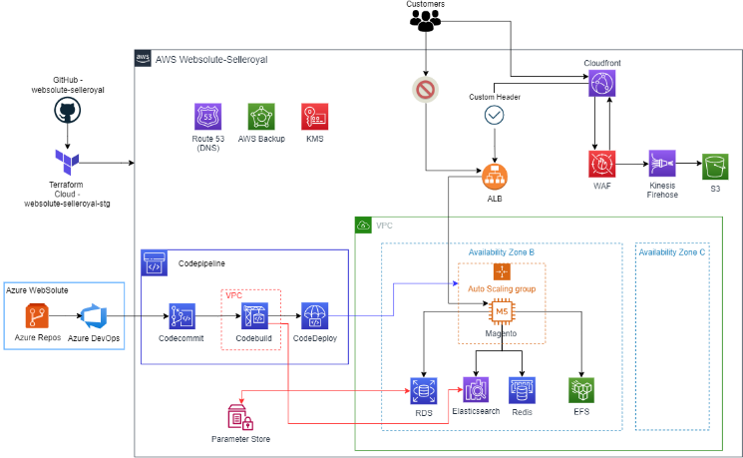

The stage environment has been deployed in a single Availability Zone being a non-critical system, also allowing to reduce costs. Where possible, the default at rest encryption and protection against accidental deletion of resources have been set

### Cloudfront

It will oversee distributing content around the world and will have a caching feature for static content. Cloudfront route requests to the load balancer, which will forward them to EC2 frontend Magento. The static content of the following paths is cached: /media/* and /statics/*. A custom domain with a certificate was chosen: **stage-m2.selleroyal.com**

### WAF

Cloudfront shares an Amazon firewall, called WAF, with staging environment which has the task of blocking both malicious requests and IPs deemed not reliable. Malicious ips are automatically updated by Criticalcase. All the information of the actions taken by the WAF are uploaded to a S3 bucket

### Application Load Balancer

The balancer accepts only the traffic coming from the Cloudfront (in HTTPS), allowed by a particular header that only the two resources involved know. The traffic will then be forwarded to the Magento EC2 frontend instance

|  |  |  |  |  |
| --- | --- | --- | --- | --- |
| Name | Availability Zone | Type | Listener | Security Group ID |
| Magento-stg-alb | eu-central-1b, eu-central-1c | Application | HTTPS | sg-0a74ac5026ec2446a |

### RDS

Database used from Magento frontend servers

|  |  |  |  |  |  |  |  |
| --- | --- | --- | --- | --- | --- | --- | --- |
| Name | Availability Zone | Instance Type | CPU | RAM | Engine | Subnet | Security Group ID |
| magento-stg | eu-central-1b | db.r6g.large | 2 | 16 GB | Aurora MySQL (8.0) | subnet-032c8d7e357904cbb,  subnet-00c9381ffe6615cc1 | sg-047edcbc570613b80 |

### EC2

Frontend server where Magento application is installed is under autoscaling group. The VMs that will be created will have this configuration

|  |  |  |  |  |  |  |  |  |  |  |
| --- | --- | --- | --- | --- | --- | --- | --- | --- | --- | --- |
| Name | Min Size | Max Size | Availability Zone | Instance Type | CPU | RAM | Engine | Disk | Subnet | Security Group ID |
| magento-stg | 1 | 2 | eu-central-1b | m5.large | 2 | 8 GB | Ubuntu 20.04 | 50 GB | subnet-032c8d7e357904cbb | sg-08f616fbb0ac7e670 |

### Redis

Used for cache in front the RDS and to store user sessions

|  |  |  |  |  |  |  |  |
| --- | --- | --- | --- | --- | --- | --- | --- |
| Name | Availability Zone | Instance Type | CPU | RAM | Engine | Subnet | Security Group |
| magento-stg | eu-central-1b | cache.t3.small | 2 | 1,37 GB | Redis 6.2.6 | subnet-032c8d7e357904cbb, subnet-00c9381ffe6615cc1 | sg-0b8f2f5825c7b0349 |

### Elasticsearch

It is used as Dashboard from Magento application

|  |  |  |  |  |  |  |  |  |
| --- | --- | --- | --- | --- | --- | --- | --- | --- |
| Name | Availability Zone | Instance Type | CPU | RAM | Engine | Disk | Subnet | Security Group |
| magento-stg-es | eu-central-1b | t3.medium.elasticsearch | 2 | 4 GB | 7.10 | 10 GB | subnet-032c8d7e357904cbb | sg-014617518714fc8b1 |

### EFS

It is used to share magento upload/media between Magento instances.

|  |  |  |  |  |
| --- | --- | --- | --- | --- |
| Name | File System ID | Availability Zone | Subnet | Security Group |
| magento-stg-efs | fs-06c459ea8403852cf | eu-central-1b,  eu-central-1c | subnet-032c8d7e357904cbb, subnet-00c9381ffe6615cc1 | sg-014617518714fc8b1 |

### System Manager Parameter Store

Sensitive data used by CodeBuild during the code compilation phase are stored in these encrypted parameters

|  |  |  |  |  |
| --- | --- | --- | --- | --- |
| Name | Tier | Type | Encrypted | Description |
| /magento/stg/auth.json | Standard | SecureString | Yes | Credentials used to download Magento plugins |
| /magento/stg/env.php | Standard | SecureString | Yes | PHP file used by Magento to interact with other AWS resources (RDS, EFS, Redis, etc ...) |
| /magento/stg/rds_database_magento | Standard | SecureString | Yes | Database RDS Magento |
| /magento/stg/rds_hostname | Standard | SecureString | Yes | Database Hostname Magento |
| /magento/stg/rds_password_magento | Standard | SecureString | Yes | Database Password Magento |
| /magento/stg/rds_username_magento | Standard | SecureString | Yes | Database Username Magento |

## Production Environment

### Architecture

### 

The production environment has been deployed in a two Availability Zone (it is possible to add a third AZ). Where possible, the default at rest encryption and protection against accidental deletion of resources have been set

### Cloudfront

It will oversee distributing content around the world and will have a caching feature for static content. Cloudfront route requests to the load balancer, which will forward them to EC2 frontend Magento. The static content of the following paths is cached: /media/* and /statics/*. A custom domain with a certificate was chosen: **[www.selleroyal.com](http://www.selleroyal.com), selleroyal.com**

### WAF

Cloudfront shares an Amazon firewall, called WAF, with stage environment which has the task of blocking both malicious requests and IPs deemed not reliable. Malicious ips are automatically updated by Criticalcase. All the information of the actions taken by the WAF are uploaded to an S3 bucket

### Application Load Balancer

The balancer accepts only the traffic coming from the Cloudfront (in HTTPS), allowed by a particular header that only the two resources involved know. The traffic will then be forwarded to the Magento EC2 frontend instance

|  |  |  |  |  |
| --- | --- | --- | --- | --- |
| Name | Availability Zone | Type | Listener | Security Group ID |
| Magento-prd-alb | eu-central-1b, eu-central-1c | Application | HTTPS | sg-0a74ac5026ec2446a |

### RDS

Database used from Magento frontend and admin servers

|  |  |  |  |  |  |  |  |
| --- | --- | --- | --- | --- | --- | --- | --- |
| Name | Availability Zone | Instance Type | CPU | RAM | Engine | Subnet | Security Group ID |
| magento-prd | eu-central-1b | db.r6g.large | 2 | 16 GB | Aurora MySQL (8.0) | subnet-073871995b4fffcce,  subnet-08dc043eac36ecebd | sg-049e19fbf63d86740 |

### EC2

Frontend servers where Magento application is installed is under autoscaling group. The VMs that will be created will have this configuration

|  |  |  |  |  |  |  |  |  |  |  |  |
| --- | --- | --- | --- | --- | --- | --- | --- | --- | --- | --- | --- |
| Name | Min Size | Max Size | Scaling Policy | Spot instance | Instance Type | CPU | RAM | Engine | Disk | Subnet | Security Group ID |
| magento-prd | 2 | 6 | Yes | Yes | m5.large | 2 | 8 GB | Ubuntu 20.04 | 100 GB | subnet-073871995b4fffcce, subnet-08dc043eac36ecebd | sg-004df19a2f42cf916 |

The scaling policy allows you to increase the number of servers in case the CPU usage exceeds 80% usage

The minimum number of servers present in auto scaling are 2 On Demand instances. The servers that are created in the event of peak traffic are spot servers

### Admin server is out of the autoscaling group. This is the configuration:

|  |  |  |  |  |  |  |  |
| --- | --- | --- | --- | --- | --- | --- | --- |
| Name | Instance Type | CPU | RAM | Engine | Disk | Subnet | Security Group ID |
| magento-admin-prd-1 | m5.large | 2 | 8 GB | Ubuntu 20.04 | 50 GB | subnet-08dc043eac36ecebd | sg-0f538f3309178064d |

### Bastion Host is the only way to reach the internal infrastructure via Teleport. Bastion Host has its own public IP address (3.73.93.198).

|  |  |  |  |  |  |  |  |  |
| --- | --- | --- | --- | --- | --- | --- | --- | --- |
| Name | EIP | Instance Type | CPU | RAM | Engine | Disk | Subnet | Security Group ID |
| bastion-host-1 | 3.73.93.198 | t3.medium | 2 | 4 GB | Ubuntu 20.04 | 20 GB | subnet-0c0b028e8aa96f0c3 | sg-0f965f0d0c230d7f5 |

### Redis

Used for cache in front the RDS and to store user sessions

|  |  |  |  |  |  |  |  |
| --- | --- | --- | --- | --- | --- | --- | --- |
| Name | Availability Zone | Instance Type | CPU | RAM | Engine | Subnet | Security Group |
| magento-prd | eu-central-1b, eu-central-1c | cache.m5.large | 2 | 6,38GB | Redis 6.2.6 | subnet-08dc043eac36ecebd, subnet-073871995b4fffcce | sg-0b8f2f5825c7b0349 |

### Elasticsearch

magento-prd-es is used as Dashboard from Magento application

|  |  |  |  |  |  |  |  |  |
| --- | --- | --- | --- | --- | --- | --- | --- | --- |
| Name | Availability Zone | Instance Type | CPU | RAM | Engine | Disk | Subnet | Security Group |
| magento-prd-es | eu-central-1b, eu-central-1c, eu-central-1a | m5.large.search | 2 | 8 GB | 7.10 | 50 GB | subnet-04f9996420520afe3, subnet-073871995b4fffcce, subnet-08dc043eac36ecebd | sg-093f3fe1ddd400d20 |

### EFS

It is used to share magento upload/media between Magento instances

|  |  |  |  |  |
| --- | --- | --- | --- | --- |
| Name | File System ID | Availability Zone | Subnet | Security Group |
| magento-prd-efs | fs-001cf65a0cda11c62 | eu-central-1b,  eu-central-1c | subnet-08dc043eac36ecebd, subnet-073871995b4fffcce | sg-0d4774095c350197c |

### System Manager Parameter Store

Sensitive data used by CodeBuild during the code compilation phase are stored in these encrypted parameters

|  |  |  |  |  |
| --- | --- | --- | --- | --- |
| Name | Tier | Type | Encrypted | Description |
| /magento/prd/auth.json | Standard | SecureString | Yes | Credentials used to download Magento plugins |
| /magento/prd/env.php | Advanced | SecureString | Yes | PHP file used by Magento to interact with other AWS resources (RDS, EFS, Redis, etc ...) |
| /magento/prd/rds_database_magento | Standard | SecureString | Yes | Database RDS Magento |
| /magento/prd/rds_hostname | Standard | SecureString | Yes | Database Hostname Magento |
| /magento/prd/rds_password_magento | Standard | SecureString | Yes | Database Password Magento |
| /magento/prd/rds_username_magento | Standard | SecureString | Yes | Database Username Magento |

## DNS

AWS internal DNS is managed by Route53 to allow you to resolve AWS IPs / DNS in a more understandable way. There is a zone that manages the selleroyal.internal domain with the following records:

Public domains are associated with Cloudfront in order to be reachable by end customers:

|  |  |  |
| --- | --- | --- |
| stage-m2.selleroyal.com | CNAME | d1b1vy67oemtjr.cloudfront.net |
| selleroyal.com, www.selleroyal.com | CNAME | ds3lu3cfgznbc.cloudfront.net |

## Backup

All resources (except ElasticSearch and Redis which have a standalone backup), are backed up through the AWS Backup service. Backups work like this:

* Daily backup: Expire after 1 week
* Weekly backup (performed Monday): Expire after 4 weeks
* Daily backup (performed on the first day of the month): Expire after 3 months

## Cloudwatch

### Cloudwatch Alarms

All production resources are monitored by checking the resource metrics defaults. If the set thresholds are exceeded, Criticalcase will receive an email so that you can activate and check the problem

|  |  |  |
| --- | --- | --- |
| Name Alarm | Resource type | Description |
| **magento-prd-2-rds-cpu-utilization**-SELLEROYAL-564037702494-AWS | RDS | Usage of the RDS CPU |
| **magento-prd-1-rds-cpu-utilization**-SELLEROYAL-564037702494-AWS | RDS | Usage of the RDS CPU |
| **magento-prd-1-rds-free-memory**-SELLEROYAL-564037702494-AWS | RDS | Available RDS memory |
| **magento-prd-2-rds-free-memory**-SELLEROYAL-564037702494-AWS | RDS | Available RDS memory |
| **magento-prd-1-rds-max-connections**-SELLEROYAL-564037702494-AWS | RDS | Maximum connections that RDS can accept |
| **magento-prd-2-rds-max-connections**-SELLEROYAL-564037702494-AWS | RDS | Maximum connections that RDS can accept |
| **status-check-failed-instance-i-0eb76f5fc158cdff6**-selleroyal-web-564037702494 | EC2 | Check that the instance works from a hardware and os point of view |
| **status-check-failed-instance-i-05b2dbec84b83bdb2**-selleroyal-web-564037702494 | EC2 | Check that the instance works from a hardware and os point of view |
| **TARGETGROUP-Magento-prd-magento-LOADBALANCER-Magento-prd-alb-UnHealthy**-selleroyal-web-564037702494 | Loadbalancer | Availability of instances attached to the balancer |
| **TARGETGROUP-Magento-prd-admin-LOADBALANCER-Magento-prd-alb-UnHealthy**-selleroyal-web-564037702494 | Loadbalancer | Availability of instances attached to the balancer |
| **magento-prd-efs-permitted-throughput**-SELLEROYAL-564037702494-AWS | EFS | EFS permitted throughput |
| **status-check-failed-system-i-0eb76f5fc158cdff6**-selleroyal-web-564037702494 | EC2 | Check that the instance works from a hardware point of view |
| **status-check-failed-system-i-05b2dbec84b83bdb2**-selleroyal-web-564037702494 | EC2 | Check that the instance works from an os point of view |
| **magento-prd-elasticSearch-free-storage-space**-SELLEROYAL-564037702494-AWS | Elasticsearch | Available Elasticsearch storage |
| **magento-prd-elasticSearch-jvm-memory-pressure**-SELLEROYAL-564037702494-AWS | Elasticsearch | Available Elasticsearch JVM memory |
| **magento-prd-elasticSearch-automated-snapshot-failure**-SELLEROYAL-564037702494-AWS | Elasticsearch | Elasticsearch snapshots failed |
| **magento-prd-elasticSearch-cpu-utilization**-SELLEROYAL-564037702494-AWS | Elasticsearch | Usage of the Elasticsearch CPU |
| **magento-prd-elasticSearch-red-status**-SELLEROYAL-564037702494-AWS | Elasticsearch | Red state of Elasticsearch |
| **magento-prd-elasticSearch-ClusterIndexWritesBlocked**-SELLEROYAL-564037702494-AWS | Elasticsearch | Cluster Index Writes Blocked |
| **magento-prd-Redis_DatabaseMemoryUsagePercentage-Node-1**-SELLEROYAL-564037702494-AWS | Redis | Database Memory Usage Percentage |
| **magento-prd-Redis_CurrConnections-node-1**-SELLEROYAL-564037702494-AWS | Redis | Maximum connections that Redis can accept |
| **magento-prd-Redis_CurrConnections-node-2**-SELLEROYAL-564037702494-AWS | Redis | Maximum connections that Redis can accept |
| **magento-prd-Redis_EngineCPUUtilization-Node1**-SELLEROYAL-564037702494-AWS | Redis | CPU Utilization |
| **magento-prd-Redis_EngineCPUUtilization-Node2**-SELLEROYAL-564037702494-AWS | Redis | CPU Utilization |
| **magento-prd-Redis_DatabaseMemoryUsagePercentage-Node-2**-SELLEROYAL-564037702494-AWS | Redis | Database Memory Usage Percentage |

# Users and Accesses

Bastion Access is a VM used to allow SSH access to the private VPC, which can be accessed via traditional ssh or via Teleport with this URL:

<https://tp.websolute-selleroyal.criticalcasecloud.com/>

**Teleport** is an open-source tool for providing zero trust access to servers and cloud applications using SSH, Kubernetes and HTTPS. It is installed on Bastion host and eliminates the need for VPNs by providing a single gateway to access computing infrastructure via SSH.

The user to login is “**selleroyal**”, with the pwd provided via email. Once logged in Magento servers will be accessed selectin in the list of machines taking in count of the “env tag” to select the proper environment

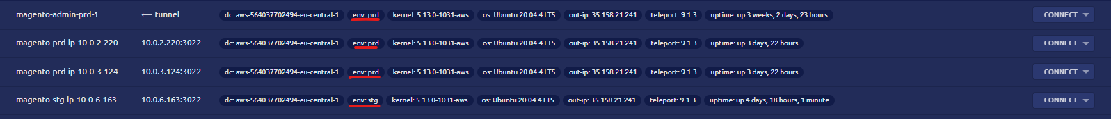

All the access sessions are recorded by teleport and saved on an encrypted dedicated private Bucket inside AWS Criticalcase account

## VM users

Inside every VM in both the Prod and dev environment the following users:

* **selleroyal**: user used to run the Magento application
* **ssm-user**: user used by AWS to access machines
* **ubuntu**: system default user

## Pipeline

For the automatic deployment of the code on the Magento servers, the AWS CodePipeline service was used. The code is located inside an Azure Repos owned by Websolute. When a push occurs on the staging or master branches (in the case of production), an Azure DevOps pipeline takes care of cloning the code to the CodeCommit repository by starting the pipeline in AWS. The next stage is CodeBuild in VPC which has the task of running the Magento code, downloading external plugins and interacting with other services such as RDS. The credentials and sensitive data are encrypted and stored within the Parameter Store. When the Build phase is finished, CodeDeploy takes care of releasing the code on the servers.

