Description

Content
The idea behind this setup is that when the short-term average is above the long-term average then prices are supposed to be in an uptrend (long position is opened). When the positioning is reversed, with the intermediate-term below the long-term average, prices are in a downtrend (short position opened)

This however may lead to whispays issues as the price volatility is low. Hysteresis aims at reducing whispays. The reasoning is the following :
- Whispay are indicative of not really strong trend, easily reversible leading to fast signal
- Adding a hysteresis/threshold will start the trade only as the fast MA is significantly above the slow one.
- We can see a difference being both MA significant if :
  - The current difference between both MA exceed some past maximum difference
  - The current difference between both MA exceed some volatility
We should therefore see a significant decrease in trading activity.
Hysteresis adds prudence to the entry signal. Entry occurs when the difference between both MA exceed the hysteresis.
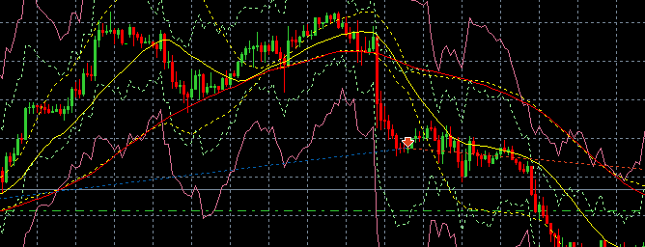
Figure 1 : Entering Short (red arrow) when Slow MA (yellow) significantly lower than Long ma (red)

Precautions
All moving averages have a significant drawback in that they are lagging indicators. Since moving averages are based on prior data, they suffer a time lag before they reflect a change in trend. A stock price may therefore move sharply before a moving average can show a trend change. A shorter moving average suffers from less lag than a longer moving average.

Parameters
Input_pairs
End_date_time | TBD
Magic | 12345
Slippage | 30
Lots | 0.01
FastPeriod | 20
SlowPeriod | 65
HysteresisMaxBackWardUse | 7

Securities

- EURUSD
- GBPUSD
- AUDUSD
- AUDJPY
- USDCAD
- GBPAUD
- GBPJPY
- EURUSD;GBPUSD;AUDUSD;AUDJPY;GBPAUD;GBPJPY

Strategy
Define the hysteresis at some epoch t > 0 as $\text{Hyst}\text{(t)} =\max_{i=t-1,…,t-N}|{MA_{fast}(i)-MA_{long}\left(i\right)|}$
- $N$being the number of period backwards (HysteresisMaxBackWardUse input parameters)
The hysteresis is the maximum of the backward wedge between the fast and slow MA

SMA Hysteresis with no stop loss, no take profits

Implementation

Long

Open Long
Open long if : $(SMA_{short }>\left(SMA_{long}+\text{hyst}\right))$

Close Long
Close Long if $( \left(SMA_{short }+hyst\right))< SMA_{long})$

Short
        - Open Short
Open Short if $( \left(SMA_{short }+hyst\right))< SMA_{long})$
        - Close Short
Close Short if : $(SMA_{short }>\left(SMA_{long}+\text{hyst}\right))$

Misc
Always active on the market as :
- Close Long => Open Short
- Close Short => Open Long

Observations
- Leaving it early due to price compression, we will try going forward to maximize the duration time
- Use a threshold to prevent price compression creating whipsaws
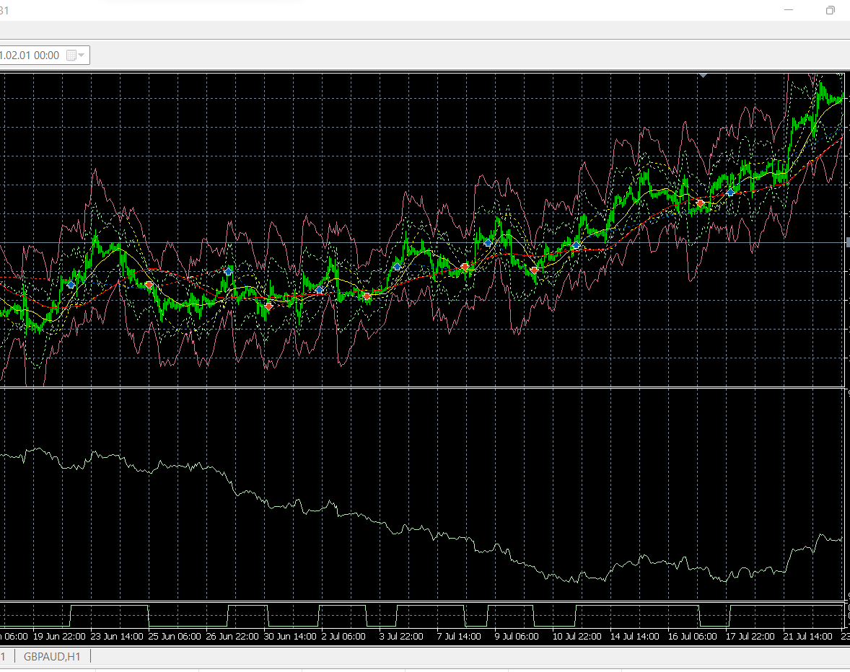
Figure 2 Entering with too small trend (low price volatility)
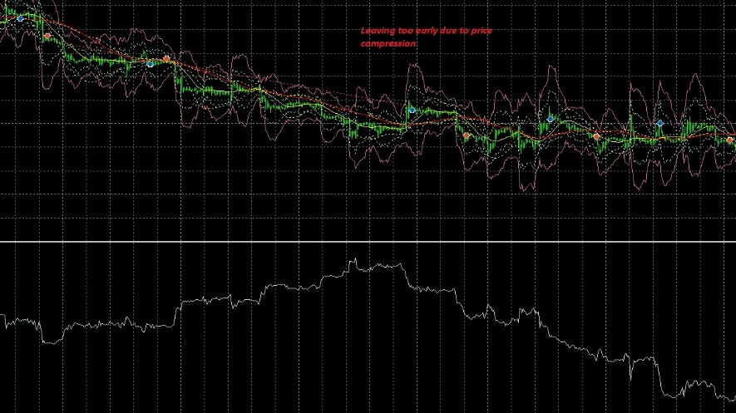
Figure 3 Leaving too early due to prie compression
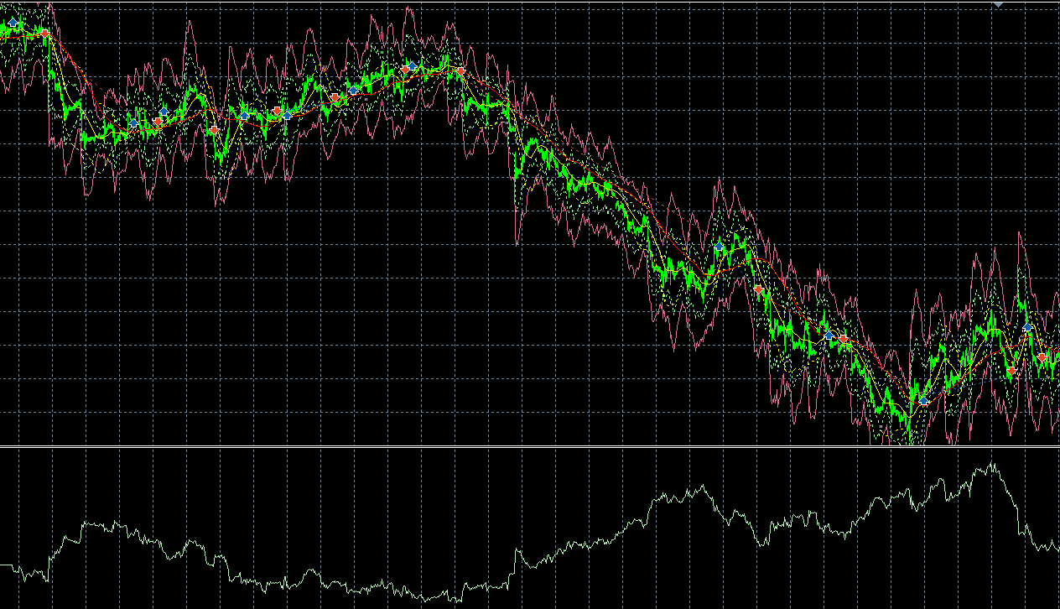
Figure 4 False signals and good signals

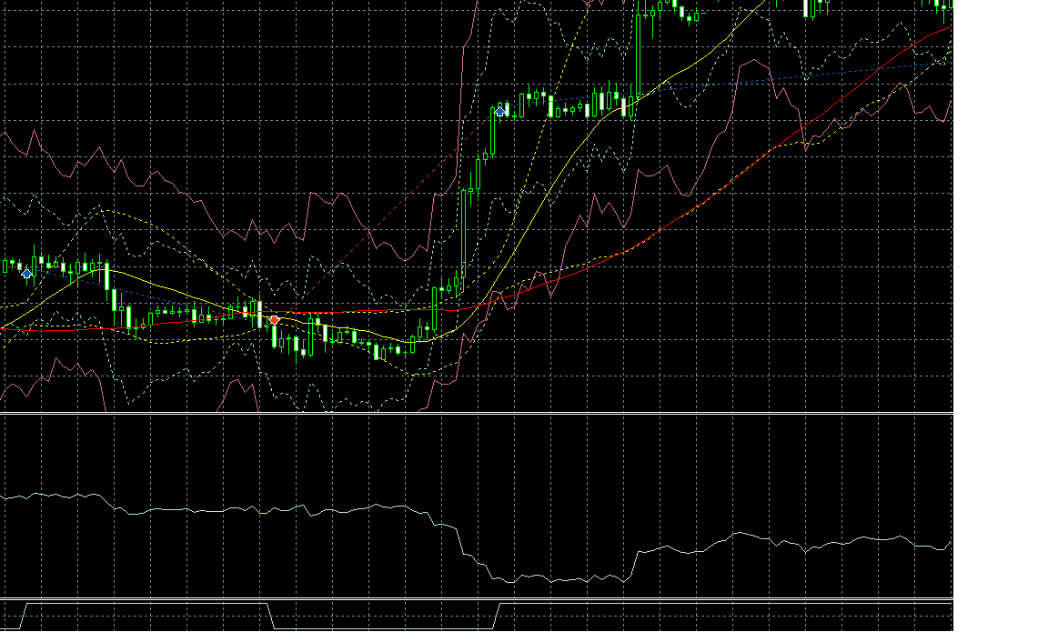
Figure 5 Need to use a hysteresis threshold
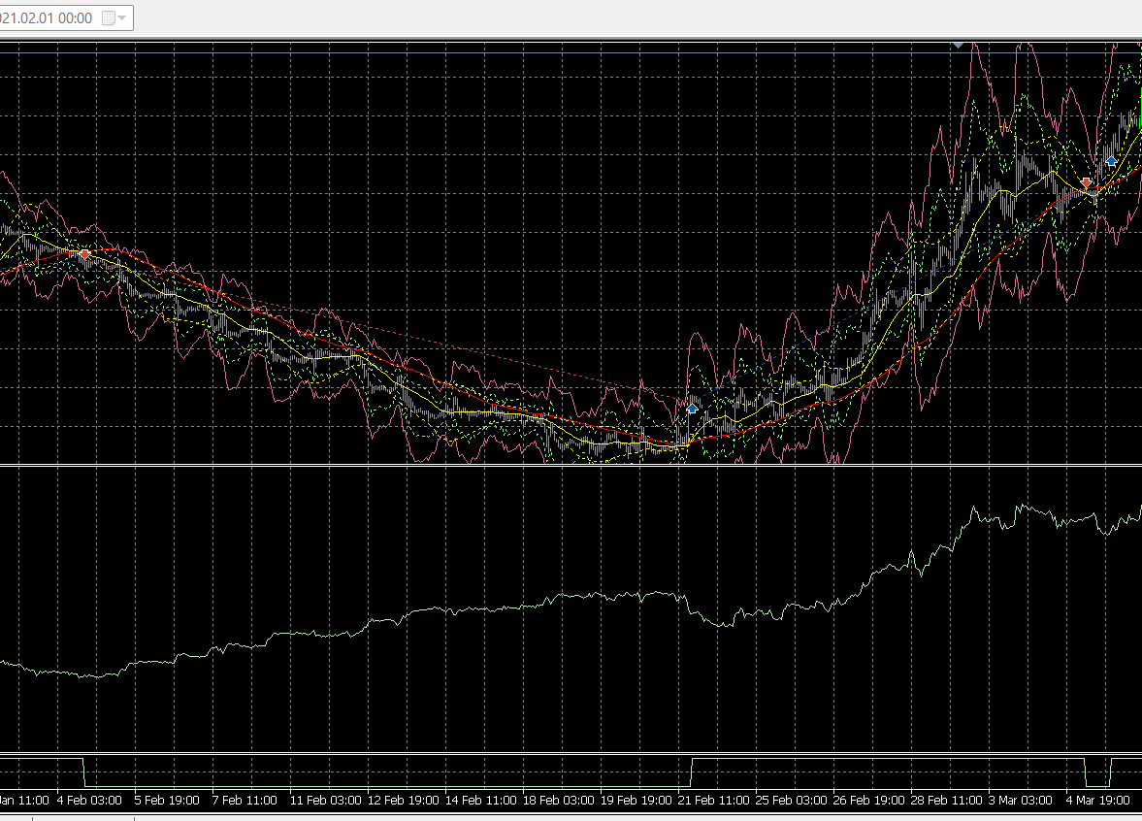
Figure 6 Nice catch

Returns

H1

Mql5 returns
Not available

Python returns

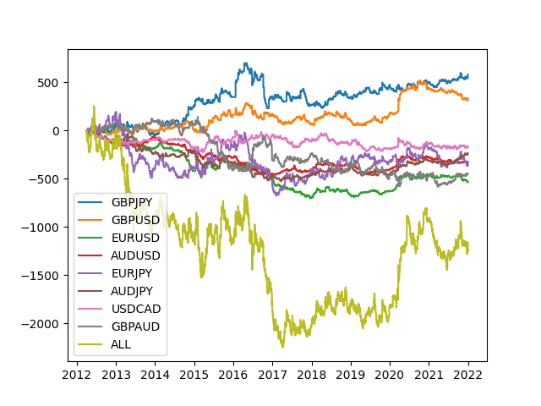
Figure 7 : SMA Hysteresis NO_SL TP
Negative profitability ( big crash in 2016-2017)

Python correlations
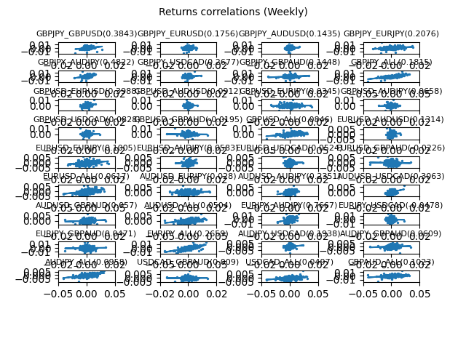
Figure 8 SMA Hysteresis NO_SL TP NO_SL TP H1

Python SL/TP Histogram
Not applicable (NO SL/TP)

Python trade duration
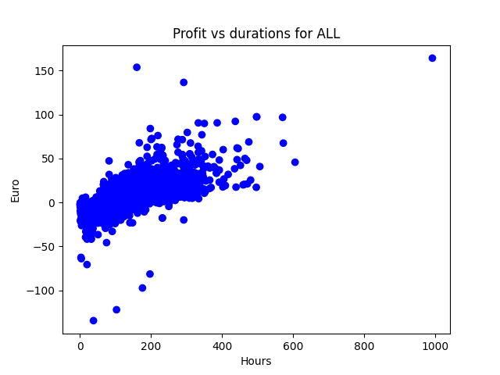
Figure 9 SMA Hysteresis _NoSLTP H1 Profit vs duration (H1)

MFE
Not available

MAE
Not available

Hours/Period
Not available

H4

Mql5 returns
Not available

Python retunrs
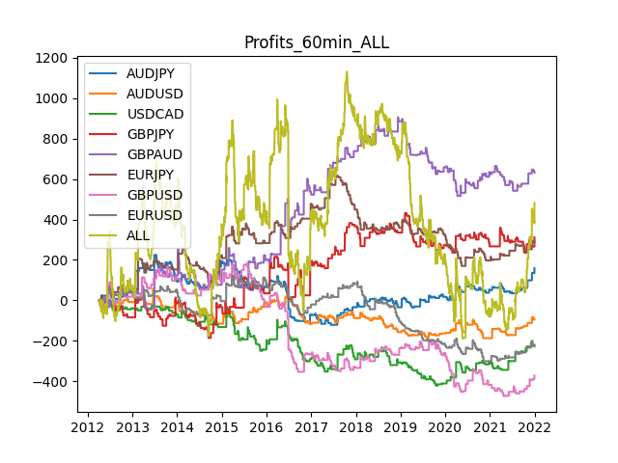
Figure 10SMA HYSTERESIS _NOSLTP H4 RETURNS
Figure above shows that returns are :
- Are randomly distributed around 0
- Whole returns is correlated

Excursions
Correlation (Profits,MFE): | 0.82 | Correlation (Profits,MAE): | 0.57 | Correlation (MFE,MAE): | 0.1904

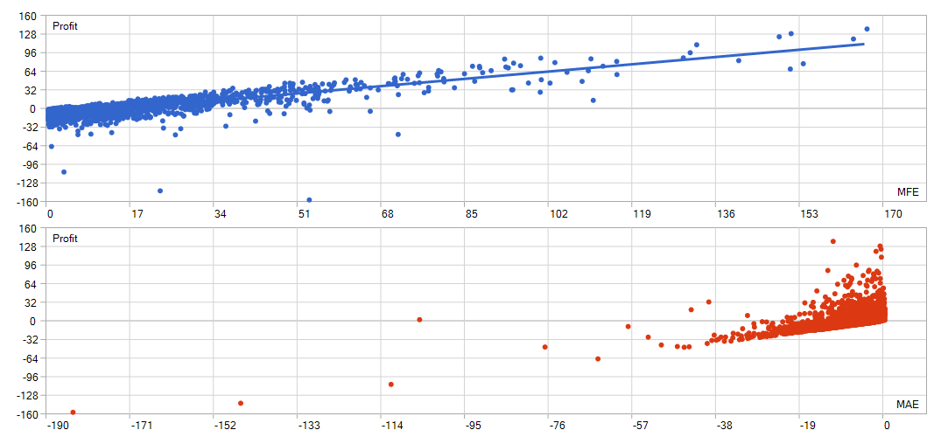
Figure 11 : SMA Hysteresis _NoSLTP Excursions H4

Python returns

Python correlations
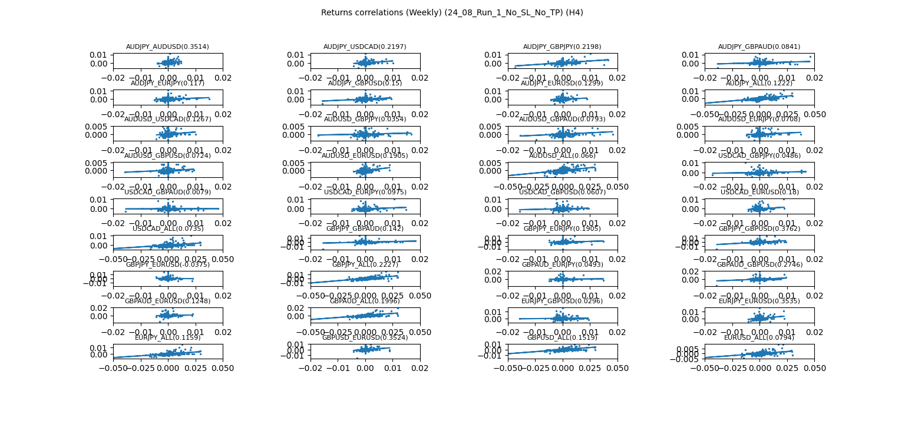
Figure 13 : SMA Hysteresis _NoSLTP H4 correlations

Python SL/TP Histogram
Not available

Python trade duration
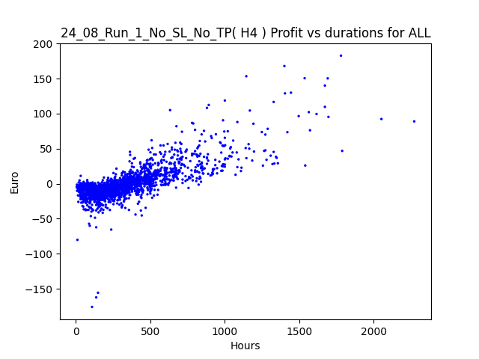
Figure 14 SMA Hysteresis _NoSLTP Profit durations (H4)

D1

Mql5 returns
Not available

Python returns

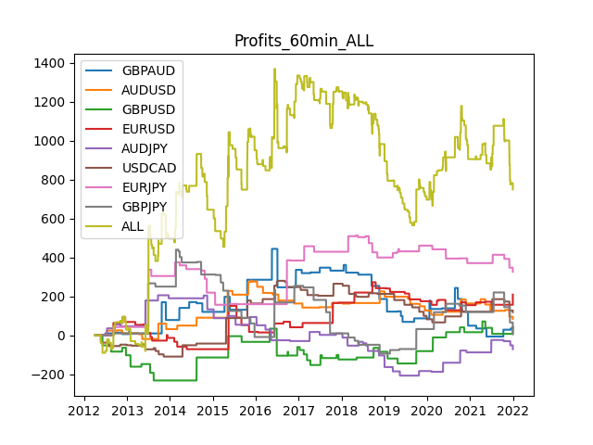
Figure 15 SMA Hysteresis _NoSLTP D1 returns
Figure 14 shows a positive returns driven by :

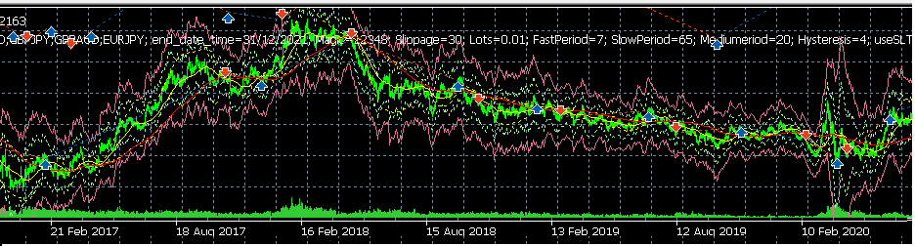
Figure 16 : EUR USD....not trending periods makes for losses

Excursion
Correlation (Profits,MFE): | 0.85 | Correlation (Profits,MAE): | 0.56 | Correlation (MFE,MAE): | 0.2364
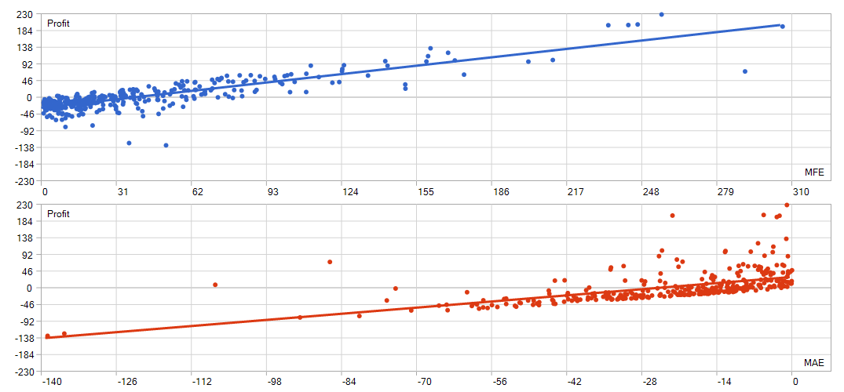
Figure 17: SMA HYSTERESIS _NOSLTP D1 Excursions

Python correlations
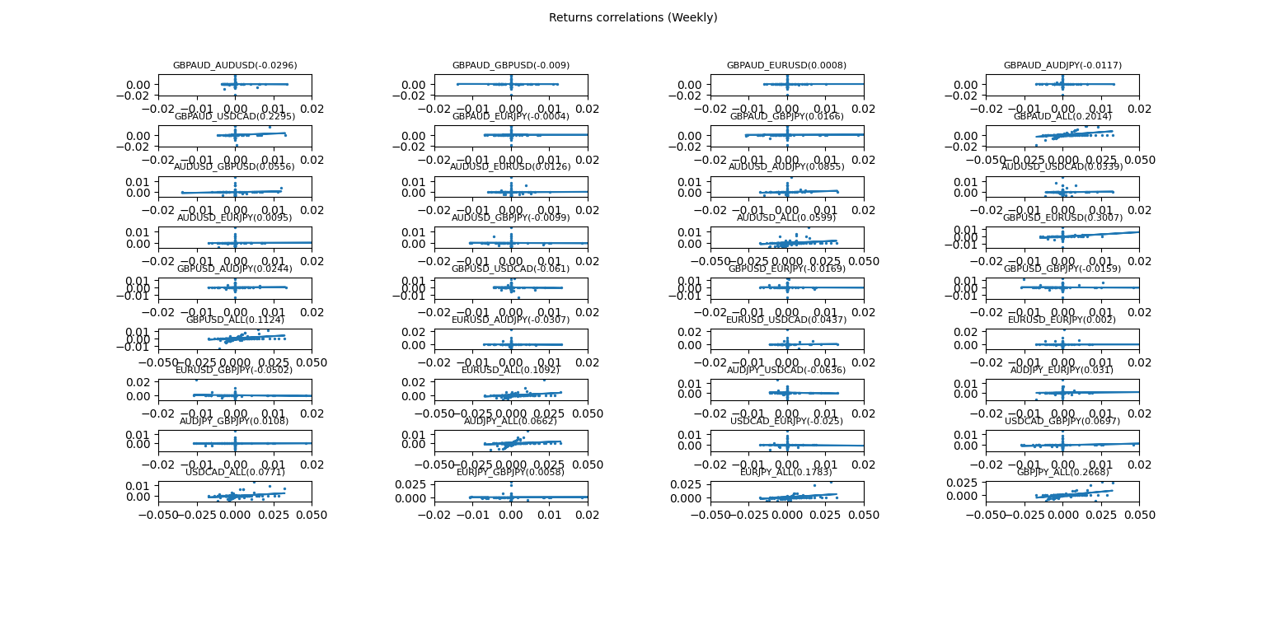
Figure 18 SMA HYSTERESIS _NOSLTP d1 CORRELATIONS

Python SL/TP Histogram
Not applicable

Python trade duration
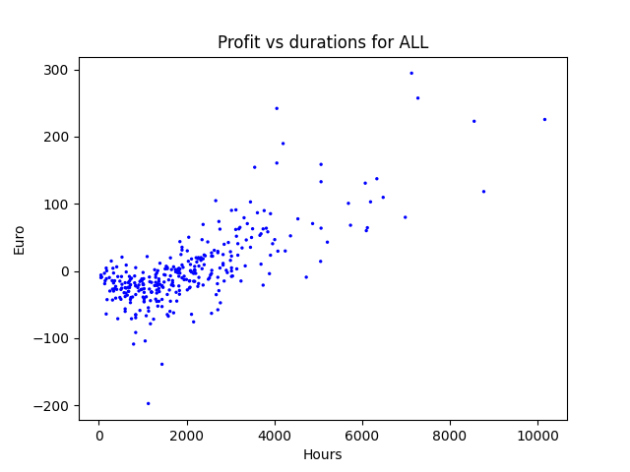
Figure 19 SMA HYSTERESIS Profit vs durations (D1)

W1

Mql5 returns
Not available

Python returns

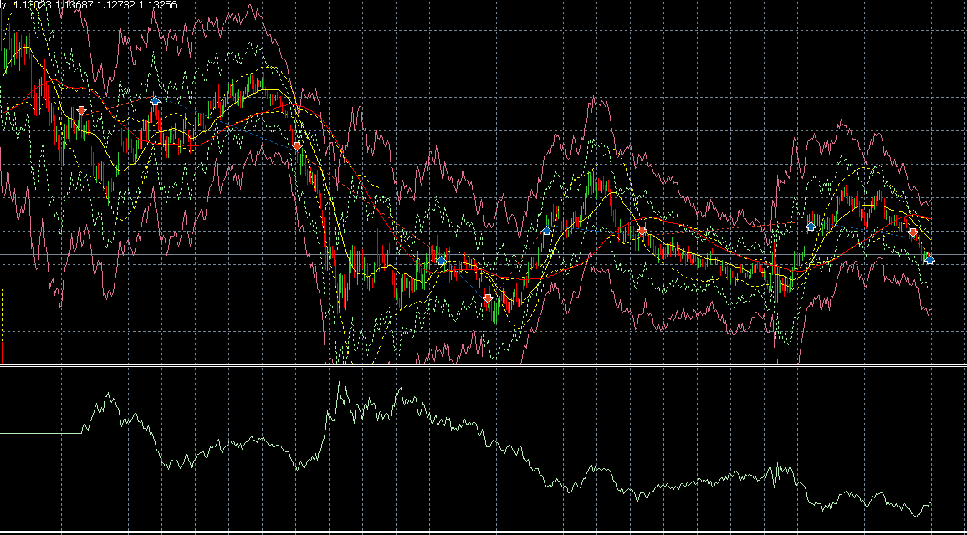
Figure 20 : EUR-USD W1 : not enough trending does not allow for this strategy

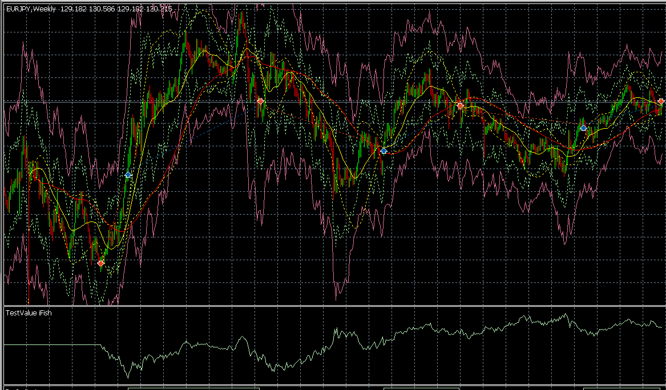
Figure 21 : Two trends on the JPY PAIR makes a profit ( here EUR JPY displayed)

excursion
 |  |  |  |  |  | Correlation (Profits,MFE): | 0.87 | Correlation (Profits,MAE): | 0.63 | Correlation (MFE,MAE): | 0.3572
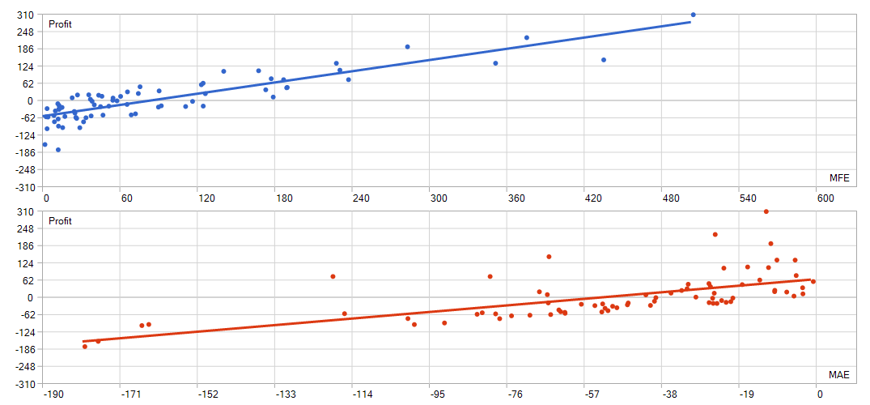
Figure 22 SMA HYSTERESIS _NOSLTP W1 Excursion

Python correlations

Python SL/TP Histogram
Not applicable

Python trade duration

Conclusions
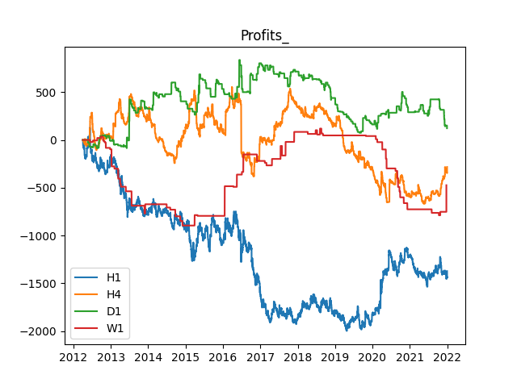
Figure 23 SMA HYSTERESIS NO_SLTP Profits By timeframe
Conclusions

- The strategy trendes and can stay up on it
- There may not have enough big trendes in H1, too many range periods
- We may this by adding a fixed hysteresis spread
- performance for large periods (D1)
- JPY to extend on W1

SMA Hysteresis with volatile weights

EMA Hysteresis with no stop loss, no take profits
Because an exponential moving average (EMA) uses an exponentially weighted multiplier to give more weight to recent prices, some believe it is a better indicator of a trend compared to a WMA or SMA. Some believe that the EMA is more responsive to changes in trends. On the other hand, the more basic smoothing provided by the SMA may render it more effective for finding simple support and resistance areas on a chart. In general, moving averages smooth price data that can otherwise be visually noisy.

And the EMA is even faster than the WMA because it gives weight to the latest periods in an exponential way. To simplify: the most recent periods or candles are given more importance. That means, the most recent price action will be more important, and that is why it moves “faster”.

Implementation
See X

Observations

Returns
      - Mql5 returns
      - Python returns
      - excursion

      - Python correlations
      - Python SL/TP Histogram
      - Python trade duration

Conclusions

Static hysteresis with no stop loss, no take profits
n the previous section, we saw dynamic hysteresis (i.e based on the maximum of MA differences) is often not enough to avoid whispays

Figure 24 : time long trades are winner, short often losers
We decided to add, on top of the dynamic hysteresis a static one. The static hysteresis will be such that x% of the trades will be excluded.
Define hysteresis as the following
$\text{Hyst}\text{(t)} =\max_{i=t-1,…,t-N}|{MA_{fast}(i)-MA_{long}\left(i\right)|}$ + ${\left(static hys\right)}_{Year(t)}$
Static hysteresis will be calibrated by year
- Use static hysteresis of the previous year
- Use cumulative static hysteresis
Calibration can be found at
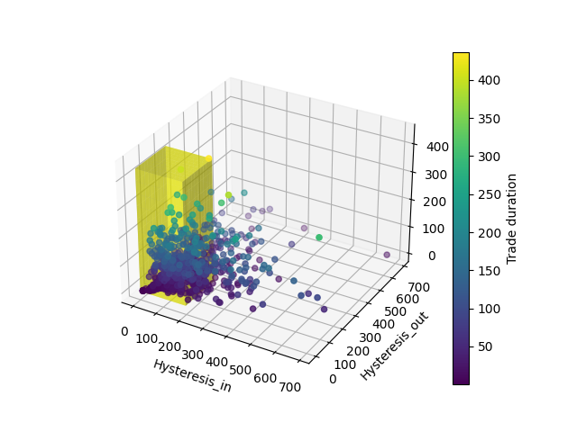
Figure 25EUR USD 2016

60 procent reject with previous year

Implementation
See Implementation with $\text{Hyst}\text{(t)} =\max_{i=t-1,…,t-N}|{MA_{fast}(i)-MA_{long}\left(i\right)|}$ + ${\left(static hys\right)}_{Year(t)}$

H1
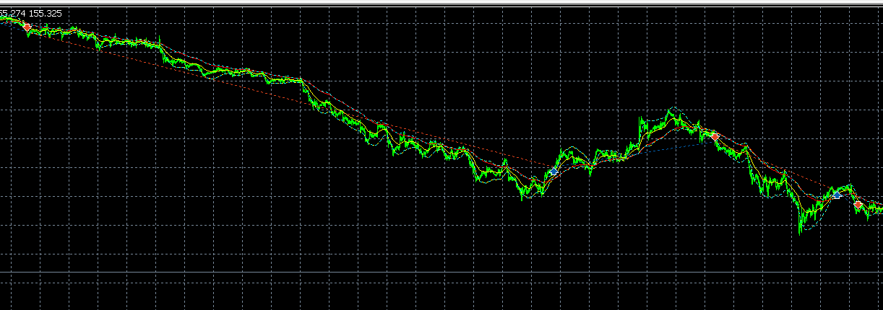
Figure 26Avoinding Whispay
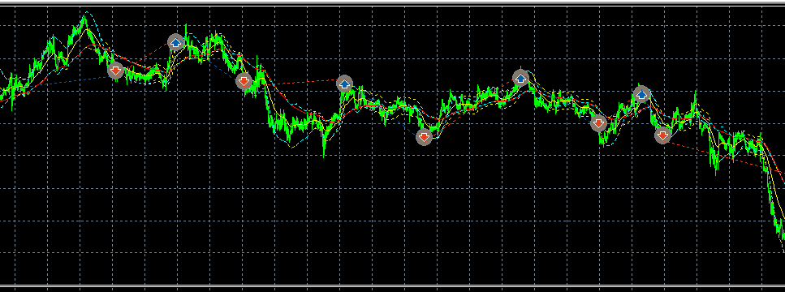
Figure 27 how i lose my returns with severe whispays
        - Mql5 returns

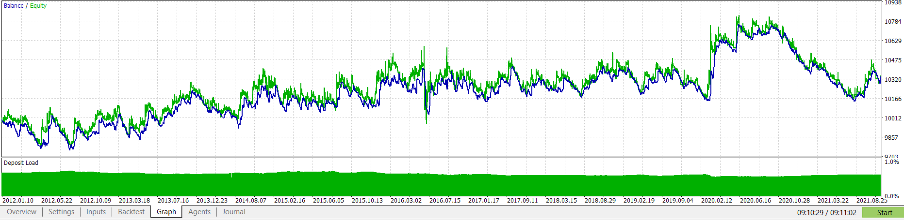
Figure 28 MQL5 Returns : H1 60% reject with previous year
        - Python returns
Graph by Currencies

        - Excursion
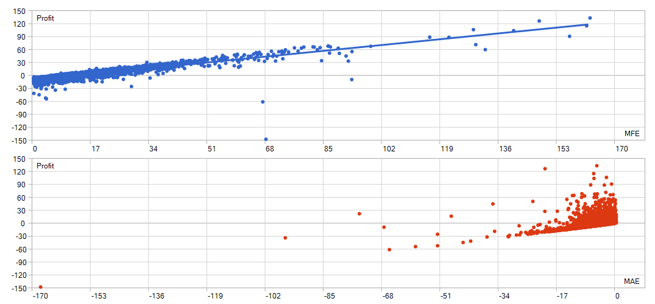
Figure 29 H1 60% reject with previous year EXCURSION
        - Python correlations

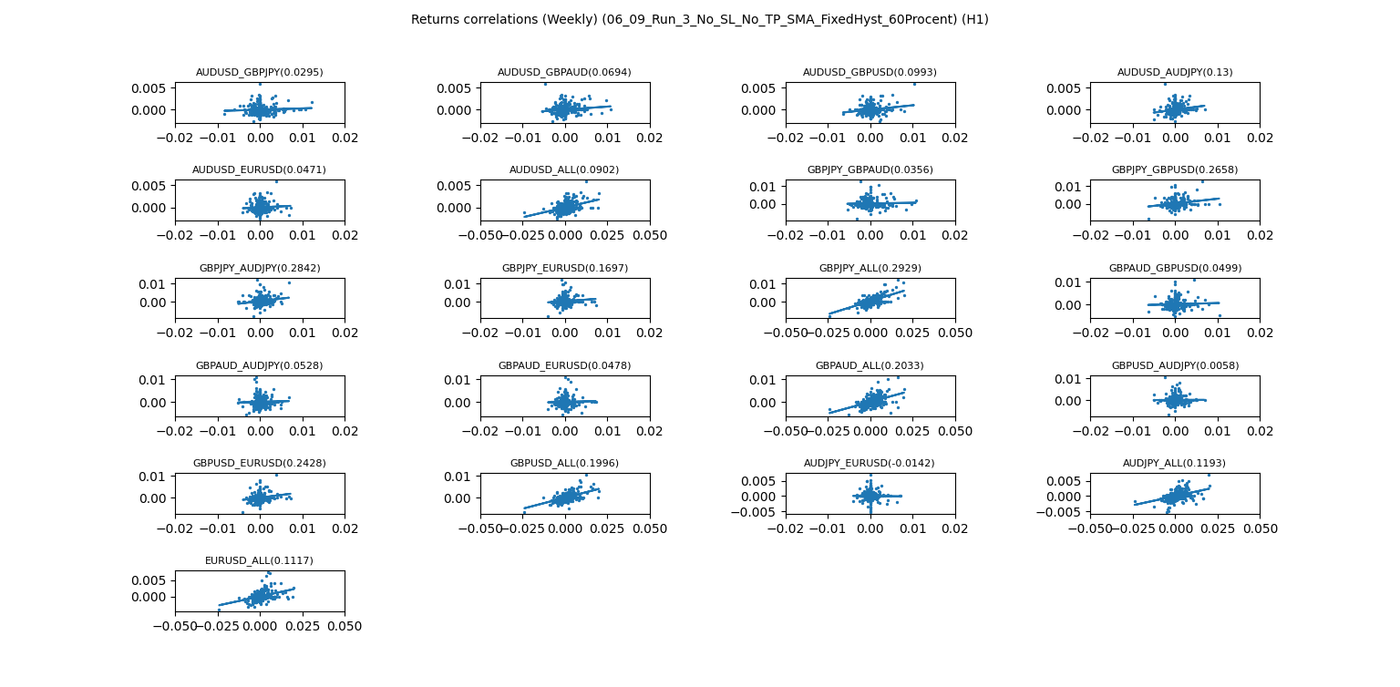
Figure 30H1 60% REJECT WITH PREVIOUS YEAR correlations
        - Python SL/TP Histogram
        - Python trade duration
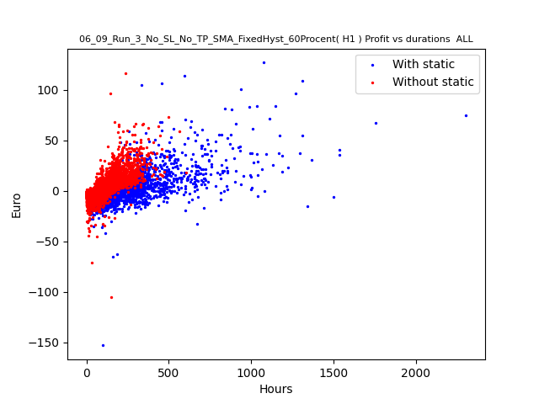
Figure 31 : H1 60% reject with previous year Trade durations comparisons
Figure 27 shows the impact of adding some fixed hysteresis. We can obviously see :
- More durations on trade as exit conditions are tougher when adding the fixed hysteresis
- More losses on short trades as we pick up the trend more lately and get out of bad trades also more lately

H4
        - Mql5 returns
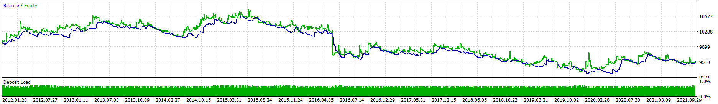
Figure 32MQL5 RETURNS : H4 60% REJECT WITH PREVIOUS YEAR
        - Python returns
        - Excursion

Correlation (Profits,MFE): | 0.87 | Correlation (Profits,MAE): | 0.56 | Correlation (MFE,MAE): | 0.2384

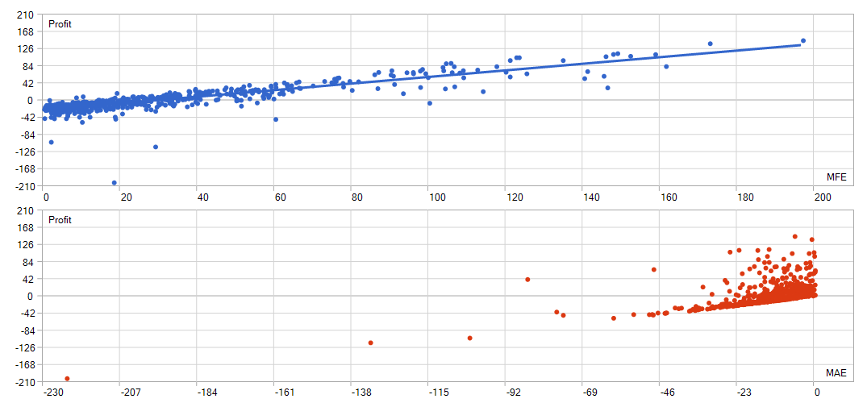
Figure 33MQL5 excursions : H4 60% REJECT WITH PREVIOUS YEAR
        - Python correlations
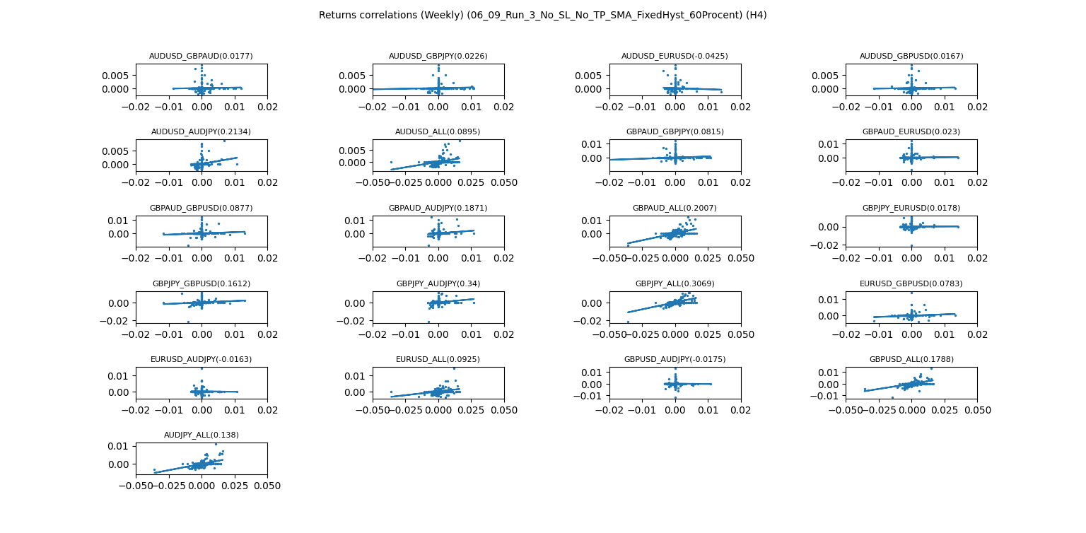
Figure 34 H4 60% REJECT WITH PREVIOUS YEAR Correlations
        - Python SL/TP Histogram
        - Python trade duration
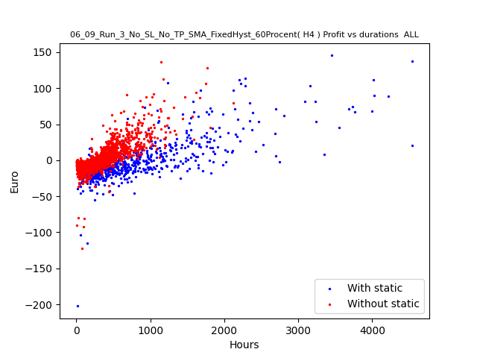
Figure 35 H4 60% REJECT WITH PREVIOUS YEAR Trade durations comparisons
        - Comments

D1

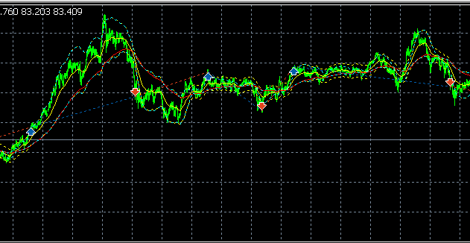
Figure 36 Unforgivable Loss

MQL5 Returns
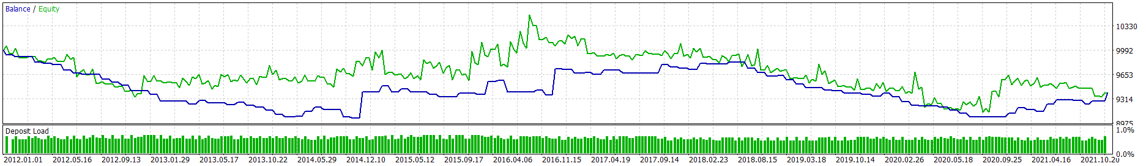
Figure 37MQL5 RETURNS : D1 60% REJECT WITH PREVIOUS YEAR
        - Python returns
        - Excursions
Correlation (Profits,MFE): | 0.92 | Correlation (Profits,MAE): | 0.49 | Correlation (MFE,MAE): | 0.3019

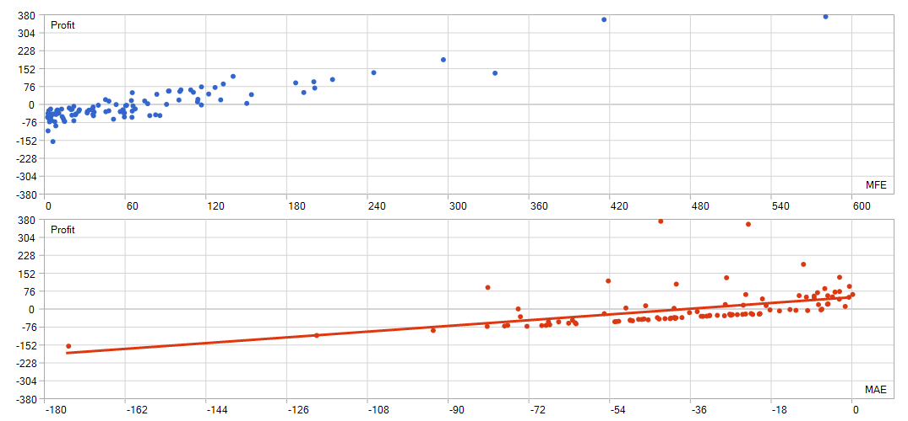
Figure 38EXCURSIONS : D1 60% REJECT WITH PREVIOUS YEAR
        - Python correlations
        - Python SL/TP Histogram
        - Python trade duration
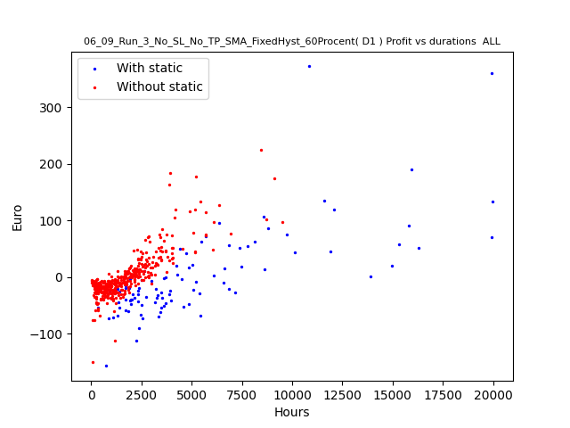
        - Comments

30 procent non cumulative without SL/TP

Implementation
See X

H1
        - Mql5 returns
        - Python returns
        - Excursions

        - Python correlations

        - Python SL/TP Histogram
        - Python trade duration

H4

Figure 39Still too many whispays for any profitability
        - Mql5 returns

Figure 40 : 30 procent non cumulative without SL/TP Returns MQL5 H4
        - Python returns
        - Excursions

Figure 41 excursions H4 30% PROCENT NON CUMULATIVE WITHOUT SL/TP
        - Python correlations
        - Python SL/TP Histogram
        - Python trade duration
We can see Brexit positionnning plays a huge role with an upfront loss of 5 %
Too many va et viens makes an ultimate loss

D1
        - Mql5 returns

        - Python returns
        - Excursions

        - Python correlations

        - Python SL/TP Histogram
        - Python trade duration

W1
        - Mql5 returns
        - Python returns
        - Python correlations
        - Python SL/TP Histogram

30 procent cumulative with SL/no TP

PLOT Profits vs Maximum excursion

30 procent cumulative with SL/wide TP

PLOT Profits vs Maximum excursion
Sensitivity analysis how to ?

Implementation
See X

H1
        - Returns
        - Mql5 returns
        - Python returns
        - Python correlations
        - Python SL/TP Histogram
        - Python trade duration

H4

Returns
        - Mql5 returns
        - Python returns
        - Python correlations
        - Python SL/TP Histogram
        - Python trade duration

D1

Returns
        - Mql5 returns
        - Python returns
        - Python correlations
        - Python SL/TP Histogram
        - Python trade duration

W1

Returns
        - Mql5 returns
        - Python returns
        - Python correlations
        - Python SL/TP Histogram

onclusions

Tight stop loss :
- allows getting out quickly of unfavorable trade
- May get you of a trade too early due to a bad start
Tight take profit :
- allows you to quickly collect you r profit : Figure 9
- May you make miss the ‘big trend: Figure 6,Figure 7,Figure 8

Long

Open Long
Open long if : $(SMA_{short }>\left(SMA_{long}+\text{hyst}\right))$

Close Long
Close Long if $( \left(SMA_{short }+hyst\right))< SMA_{long})$

Short
        - Open Short
Open Short if $( \left(SMA_{short }+hyst\right))< SMA_{long})$
        - Close Short
Close Short if : $(SMA_{short }>\left(SMA_{long}+\text{hyst}\right))$

Misc
Always active on the market as :
- Close Long => Open Short
- Close Short => Open Long

Strategy Three MM crossover

Implementation

H1
      - Returns
      - Mql5 returns
      - Python returns
      - Python correlations
      - Python SL/TP Histogram
      - Python trade duration

H4

Returns
      - Mql5 returns
      - Python returns
      - Python correlations
      - Python SL/TP Histogram
      - Python trade duration

D1

Returns
      - Mql5 returns
      - Python returns
      - Python correlations
      - Python SL/TP Histogram
      - Python trade duration

W1

Returns
      - Mql5 returns
      - Python returns
      - Python correlations
      - Python SL/TP Histogram
      - Python trade duration
      - Python trade duration

Conclusions

References

