Description

Content
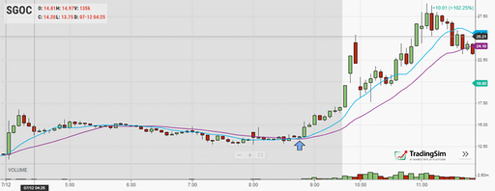

Precautions ()

Parameters
Name | Description
Fast_MA | Period of the fast_MA
Long_MA | Period of the long_MA
Hysteresis_PeriodBackWards | Number of periods considered when established the hysteresis

Securities
Trend securities i.e :
- EURUSD
- GBPUSD
- AUDUSD
- EURJPY
- AUDJPY
- GBPJPY
- USDCAD
- GBPAUD

Strategy

Results

Hysteresis with no stop loss, no take profits

      - Implementation
        - Buy
        - Sell
        - Miscellaneous
      - Observations

      - Returns
        - Mql5 returns
        - Python returns
        - Python correlations
        - Python SL/TP Histogram
        - Python trade duration
      - Conclusions

Hysteresis with no stop loss, no take profits

Conclusions

References

