- 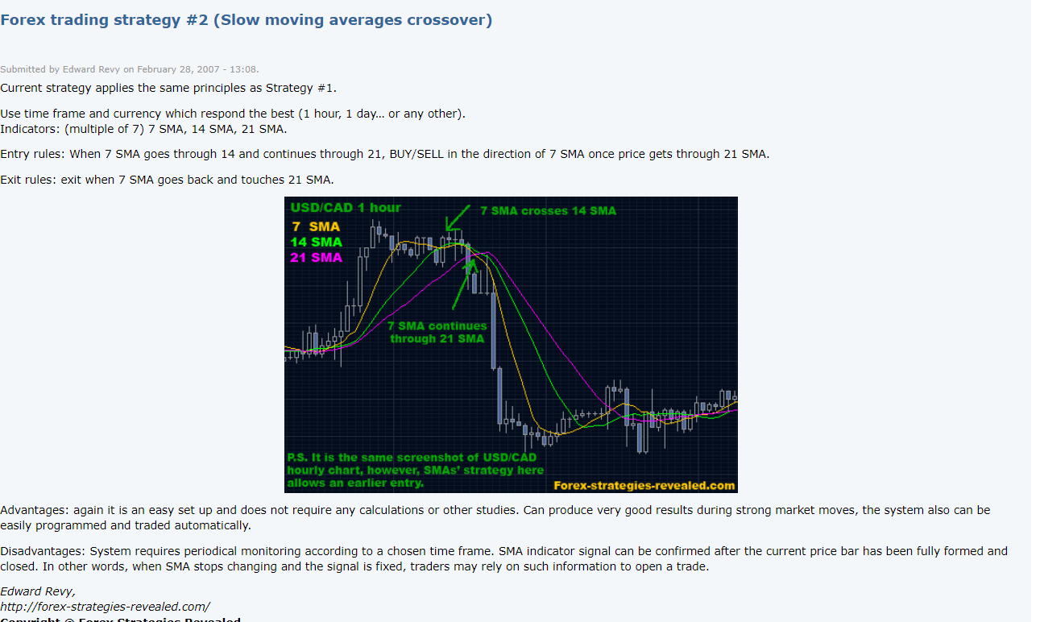
- Stategy 0:
Plot(time,return)
Plot(time,nTrades)
Plot(return,régime)
- Stategy 1:
  - $Buy : MA_{fast}>MA_{slow}+hysteresis$
  - Sell : $MA_{fast}<MA_{slow}- hysteresis$
No SL & TP
Plot(time,return)
Plot(time,nTrades)
Plot(return,régime)
Plot BySymbol
Strategy II:
With trend regime :
  - $Buy : MA_{fast}>MA_{slow}+hysteresis$ (adx > 25) && (Ravi>0.03) && (ADX_Slope > 0);
  - Sell : $MA_{fast}<MA_{slow}- hysteresis$ (adx > 25) && (Ravi>0.03) && (ADX_Slope > 0);
No SL & TP
Plot(time,return)
Plot(time,nTrades)
Plot(return,régime)

