Introduction
The stochastic
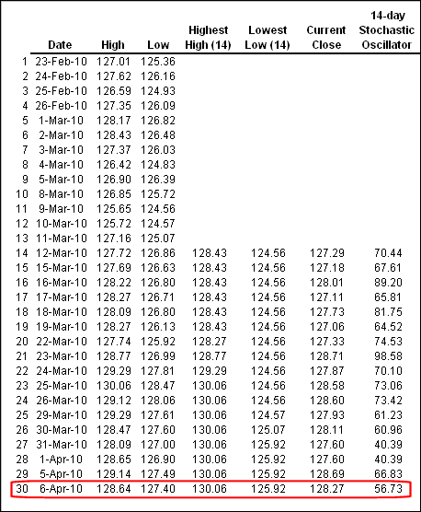

%K = 100 
Close at End of Period n – Low for Entire Period n
High for Entire Period n – Low for Entire Period n

%D is Percentile of End on n timesteps
%D = MA(K;3)
- So, for example, a stochastic reading of 55 simply means that the price is in the 55th
percentile of its range or just about in the middle.
- 80 indicates that the tradable is overbought and a reading of
20 suggests an oversold price state.

The divergence
George Lane contended that one of the most useful ways to utilize stochastics is by spotting divergence between the price action and the indicator readings. Specifically, he found the setup where the %D line would
make lower highs while the price made higher highs a very useful short
setup, and on the opposite side when the dynamic reversed itself with %D

making higher lows while the price continued to make lower lows, this
setup represented a potent long trade. He found that these types of trades
were most reliable when divergence occurred as %D was between 10 and
15 on the downside and 85 and 90 on the upside (see Figure 6.2).

The RSI
$$100-(\frac{100}{\frac{E\left(r \right|r>0) }{E\left(-r \right|r< 0) }})$$

If the RSI :
- registers readings above 70 the currency pair is considered to be overbought a
- and if the reading is below 30 it is oversold
One of the most common methods of trading the RSI is by uncovering
divergence patterns. If price is continually making new highs but the RSI
does not, then a trend reversal or trend consolidation is highly likely (see
Figure 6.3)
Because the RSI so effectively smooths price action, some traders
even prefer to trade patterns off the RSI itself rather than off price action.
In fact, a very strong argument can be made that trend lines and their concomitant breaks can be traded far more effectively off the RSI rather than
off price action.
STRATEGY)
One interesting way to trade the RSI is as a proxy for the volume indicator. One of my colleagues, Adam Rosen, who serves as a senior Powercourse instructor at my firm, invented the following setup using the RSI to
fade short-term spikes in the FX market. It is a trick he brought over from
his days of prop trading New York Stock Exchange (NYSE) stocks using
the volume indicator.
The rules of the setup are as follows. On an hourly chart look for
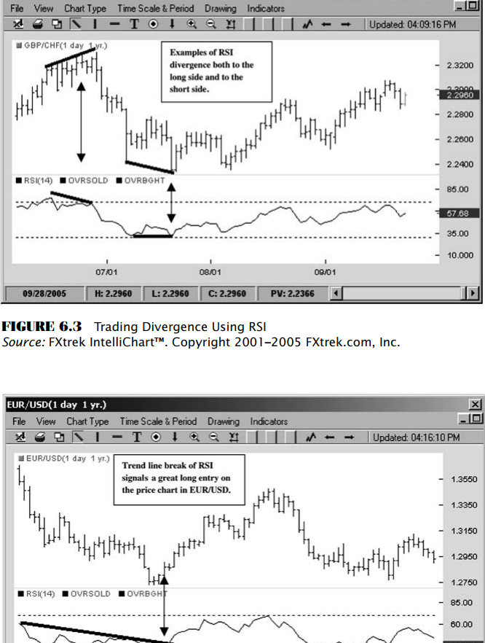
Once the price highs or price lows of the session are set and the RSI
reading retreats from its oversold or overbought conditions and the active
session hours are over, the trader would then measure the full amplitude
(from the highs to the lows) of the active session range. The key factor in
this setup is the RSI move off its extremes. If it maintains those levels,
then the possibility of further price movement in the original direction is
strong and the trader would stand aside. If the price rallied during the active session, then the trader would demarcate a sell zone at the top 20 percent of that day’s range and further set a stop at 20 percent above the high

of the range. As the price tries to retest the highs, the trader would short
the move. Once the profit target reaches the same amount of points as
risked on the trade, then half the position would be covered and the stop
would be moved to break even. Figure 6.5 illustrates the RSI fade setup on
the EUR/USD.
The RSI is one of the most robust oscillator tools in technical analysis.
Its price-smoothing function frequently offers better clues to direction
than price action itself. By applying trend line analysis right on the RSI itself, traders can generate accurate entry signals on both shorts and longs.
Although ostensibly the indicator generates overbought or oversold signals, like all oscillators its real value is in spotting divergence between
momentum and price.
One novel way that some traders have utilized the RSI in the currency
market is as a proxy for volume. RSI readings above 70 and below 30 are
equated to volume spikes seen in exchange-based markets and, depending
on the immediate price action following those readings, can either be
traded as trend-based volume breakouts or faded as signs of price exhaustion. Regardless of how one utilizes this tool, it is as versatile and as useful to a technically oriented trader as the Swiss army knife is to the
traveling businessperson.
