Conversion of Ethos models from 1.6.3 to 1.7.0
As from Ethos 1.7.0 the new model wizards assign channels starting from the left and alternating from the outside in, bringing it into line with FrSky receiver documentation.

During the upgrade to Ethos 1.7 existing models may be converted to suit the new scheme of counting from the left.

There are 3 scenarios:

a) Existing models with the default 1.6.x channel order counting from the right will have their mixes rearranged to suit the new scheme of counting from the left. However the output channel allocation is kept the same so no wiring changes are required in the model. Only the mixes will be rearranged into a the new sequence, but the original output channel allocations are kept for the model to continue operating correctly. Please refer to section A below.

b) Existing models that have had their channels swapped to count from the left will not be modified, because the model is already counting from the left. Please refer to section B below.

c) Existing models that have had their channels swapped by inverting the Aileron mix and renaming the output channels will work correctly after the upgrade but will suffer a conflict in the channel naming. Details for resolving this are given in section C below.

In the examples below a channel order of AETR is used.

A. Models with default channel usage, i.e. CH1 is Ail Right.

In Ethos 1.6.3 by default channel 1 is Aileron Right.

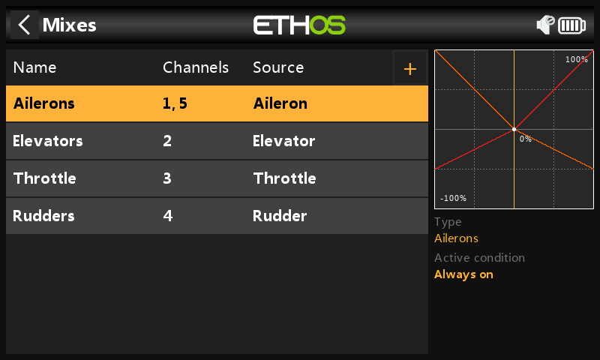

1. In 1.6.3, before the conversion, the above Mixes screen shows the Ailerons as channels 1, 5.

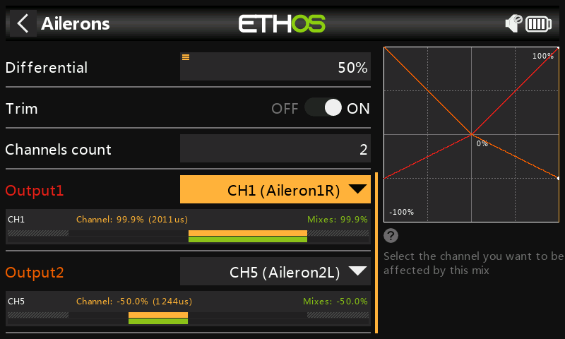

2. Before the conversion, the Aileron mix shows Output1 going to CH1 (Aileron1) or Aileron Right. Note that the CH1 has been renamed to Aileron1R and CH5 has been renamed Ailerons2L in Outputs. The Aileron stick is being held to the right.

In the model CH1 is wired to the Aileron Right servo.

3. Before the conversion, the Output page shows CH1 going to (Aileron1R) or Aileron Right and CH5 going to (Aileron2L). The Aileron stick is being held to the right.

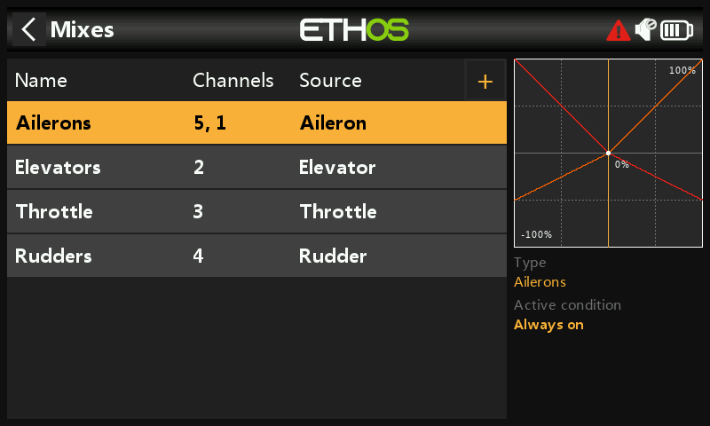

4. After conversion to 1.7.0, in the Mixes the Ailerons are shown as 5,1.

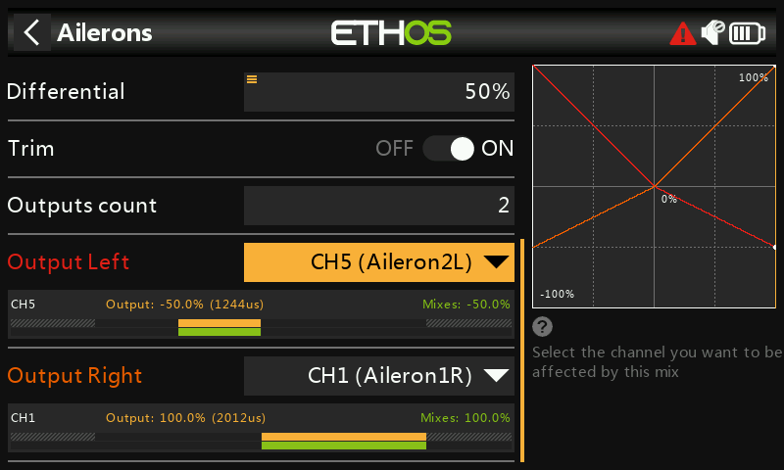

5. After conversion to 1.7.0, the Ailerons mix shows Output Left as mapped to CH5 (Aileron2L) or Aileron Left, and Output Right is mapped to CH1 (Aileron1R) or Aileron Right.

The Aileron stick is being held to the right. The CH1 (Aileron1R) correctly shows the mix weight of +100%, and CH5 (Aileron2L) correctly shows the weight of -50% with a positive differential value of 50%.

In the conversion Ethos rearranged the mixes to suit the new channel order, but did not make any changes to channel output assignments.

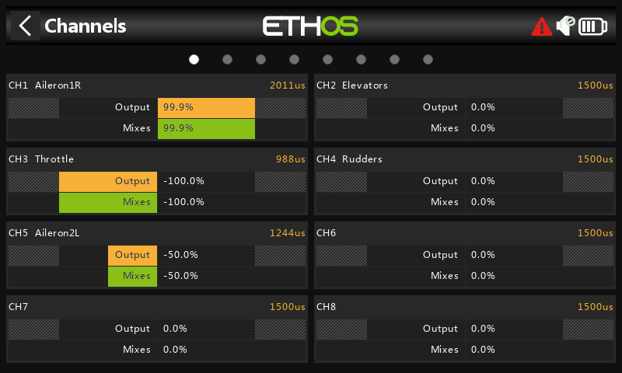

6. After the conversion, the Output page shows CH1 going to (Aileron1R) or Aileron Right and CH5 going to (Aileron2L). This shows that the channel assignments are the same as before (see step 3 above). The Aileron stick is being held to the right.

In the model CH1 is wired to the Aileron Right servo, so the conversion has been done correctly. No wiring changes are required in the model.

B. Models with opposite channel usage, i.e. CH1 is used as Ail Left by swapping mix output channels.

In Ethos 1.6.3 channel 1 is Aileron Right, but some users elected to swap the Aileron mix output channels so that CH1 is wired to Aileron Left. This is achieved by using the ‘Swap Channels’ function in the Outputs (now Channels).

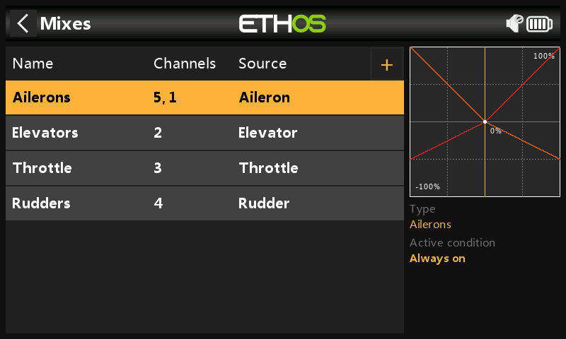

1. In 1.6.3, before the conversion, this model has had its Aileron channels swapped so that CH1 is Ail Left and CH5 is Ail Right. The Mixes screen shows the Ailerons as channels 5,1.

2. Before the conversion, the Aileron mix shows Output1 (i.e. Aileron Right) going to CH5 (Aileron1R). Note that the CH1 has been renamed to Aileron1R and CH5 has been renamed Ailerons2L in Outputs. The Aileron stick is being held to the right.

3. Before the conversion, the Output page shows CH1 going to (Aileron2L) or Aileron Right and CH5 going to (Aileron1R). The Aileron stick is being held to the right.

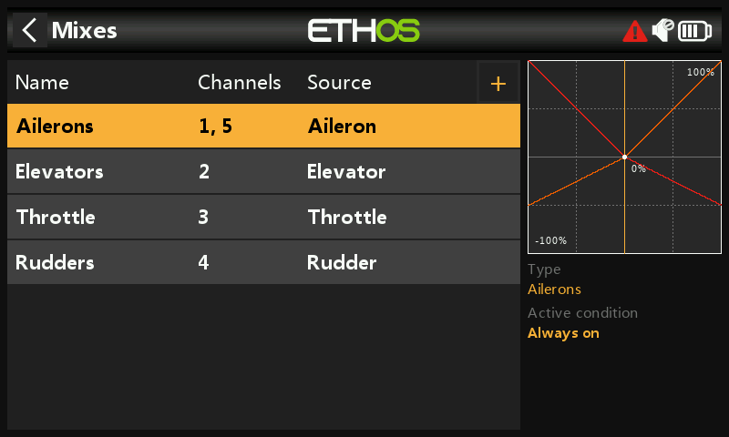

4. After conversion to 1.7.0, in the Mixes the Ailerons are shown as 1,5.

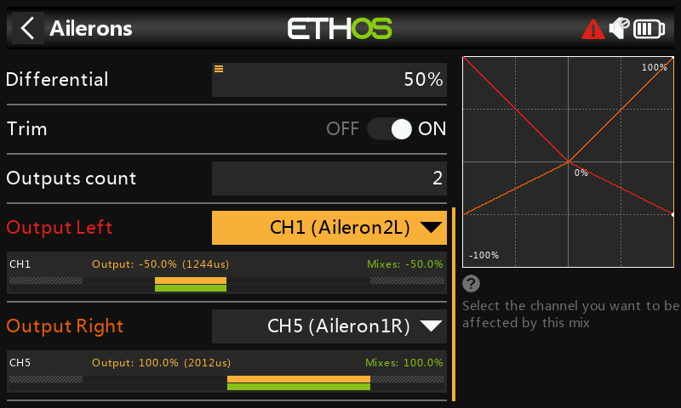

5. After the conversion to 1.7.0, the Ailerons mix shows that Output Left still goes to CH1 (Aileron2L), and Output Right goes to CH5 (Aileron1R).

The CH5 (Aileron1R) correctly shows the mix weight of 100%, and CH1 (Ailerons2L) correctly shows the weight of -50% with a positive differential value of 50%.

In this case Ethos did not need to rearrange the mixes to suit the new channel order, because the model was already counting from the left.

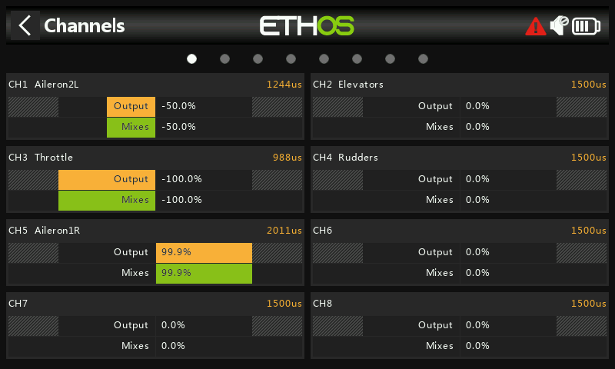

6. After the conversion, the Channels page shows CH1 going to (Aileron2L) or Aileron Left and CH5 going to (Aileron1R). This shows that the channel assignments are the same as before (see step 3 above). The Aileron stick is being held to the right.

C. Models with opposite channel usage, i.e. CH1 is used as Ail Left by inverting the mix and renaming the output channels.

In Ethos 1.6.3 channel 1 is Aileron Right, but instead of swapping the mix output channels as described in section B above, some users elected to invert the mix itself by using a negative Weight value. As a result these models also needed a negative differential value.

Please note that Ethos does not look at the user naming for the conversion, so it still considers channel 1 as Aileron Right.

Please also note that the model will operate correctly after conversion to 1.7.0, but due to the naming conflicts described below it is recommended that this is addressed using the steps outlined below.

1. In 1.6.3, before the conversion, the Mixes screen shows the Ailerons as channels 1,5.

2. Before the conversion, the Aileron mix has been inverted by changing the Weight from a positive to a negative value, and likewise the Differential to a negative value. The Ailerons mix above shows Output1 going to CH1 (Aileron1L). Note that the CH1 has been renamed to Aileron1L and CH5 has been renamed Aileron2R in Outputs. The Aileron stick is being held to the right.

3. Before the conversion, the Output page shows CH1 going to (Aileron1L) or Aileron Left and CH5 going to (Aileron2R). The Aileron stick is being held to the right.

4. After conversion to 1.7.0, in the Mixes the Ailerons are shown as 1,5.

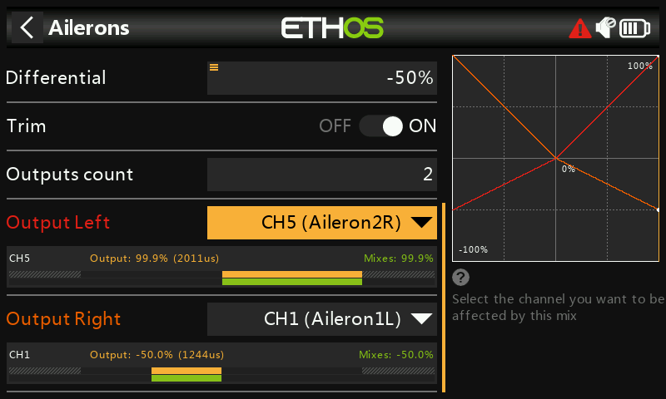

5. After conversion to 1.7.0, we see that Ethos has swapped the channel it considered as Aileron Right to the Output Right position. This brings about the naming conflict between ‘Output Left’ and CH5 (Aileron2R) as well as between ‘Output Right’ and CH1 (Aileron1L). Remember that in the model CH1 is wired to Aileron Left.

The Aileron stick is being held to the right, so we can see that ‘Output Right’ is incorrectly showing a mix value of -50% and ‘Output Left’ is incorrectly showing a mix value of +100%.

The solution is to undo the mix inversion performed in 1.6.3.

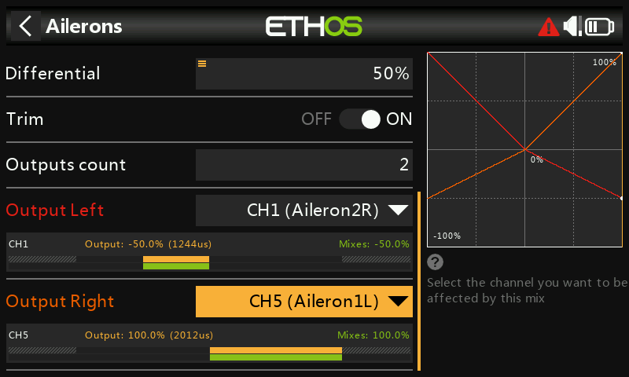

6. We have re-inverted the mix by changing both the Weight and Differential to positive values, and have used the ‘Swap channels’ function in Channels to swap CH1 and CH5.

The Aileron stick is being held to the right, so we can see that ‘Output Right’ is now correctly showing a mix value of +100% and ‘Output Left’ is now correctly showing a mix value of -50%.

All that remains is to rename the output channels.

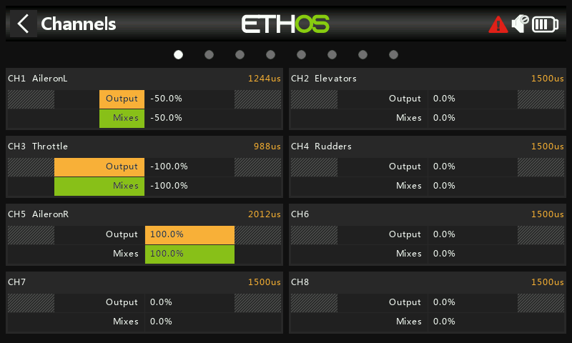

7. In the Channels screen rename CH1 to ‘AileronL’, and CH5 to ‘AileronR’.

The Aileron stick is being held to the right, so we can see that the output left and right channels are correct.

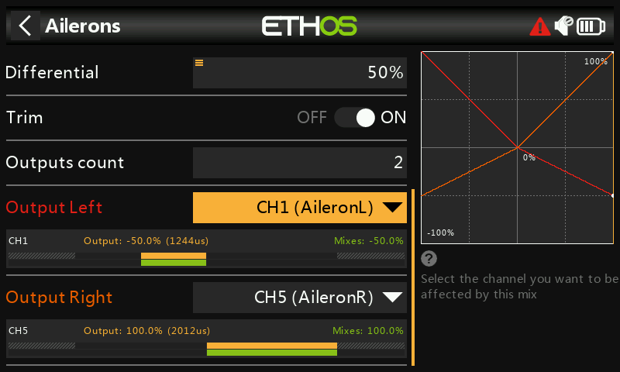

8. Back in the Aileron mix everything also now looks correct.

By making these changes you have brought the model into line with the new 1.7.0 way of doing things, i.e. channels starting from the left and alternating from the outside in.

The conversion is now working correctly, with output channels starting from the left, and the naming conflicts resolved. No wiring changes are required in the model.

