|  |  |
| --- | --- |
| Project 1  TinyOS, Cooja, Node-RED, IFTTT |  |
|  | **Diego Costanzelli**  [diego.costanzelli@mail.polimi.it](mailto:diego.costanzelli@mail.polimi.it)  ID number: 10527966 - 928941  **Francesco Maffezzoli**  [francesco.maffezzoli@gmail.com](mailto:francesco.maffezzoli@gmail.com)  ID number: 10576556 - 944914  **Marco Passera**  [passera.marco@alice.it](mailto:passera.marco@alice.it)  ID number: 10531470 - 944947 |

**TinyOS**

In Cooja we created a topology with six sky motes. Each mote broadcasts a message every 500ms, containing its ID. When two motes are close enough, each one will send a TCP message (on his own socket) to Node-RED, containing the ID of the nearby sensed mote.

**Node-RED**

Every mote is associated to a different flow, slightly different from the others but overall similar. For every mote, the flow contains:

* TCP CONNECTION: the node creates a connection to the serial server of the motes
* (port 60001-60006).
* SPLIT: a split node is used to isolate different fields of the message, in order to keep only the useful information for later.
* SWITCH1: this switch is used to select only the right message field (the one containing the sensed mote ID).
* SWITCH2: this switch divides messages containing different mote IDs on different flows in order to correctly enable the function of RBE. In this way 5 new flows are created, each one containing always the same message associated with the same mote ID.
* RBE: this function forwards a message only if it is different from the previous one. In this way every further message that contains the same mote ID is ignored.
* INJECT: this inject is used to send a “reset” message in every RBE. This message will refresh the buffer of RBE node, enabling him to send a new message again. The purpose of this function is to let Node-RED be able to send a new notification message when two motes are pulled together again a second time after the first.
* SWITCH: this switch is used to ignore “reset” messages that will be fired every 30 seconds, since their purpose is only to enable the RBE node again.
* FUNCTION: the function node assembles the message to be sent to the IFTTT applet. The message contains two values: sender mote ID and sensed mote ID.
* WEB REQUEST: creates a web request to our IFTTT applet.

In this way we have a total of 6 flows, one per mote, that handles motes messages independently.

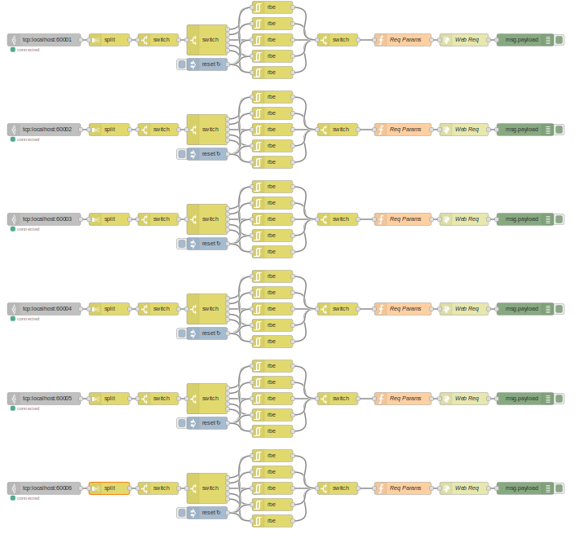

**IFTTT Applet**

The IFTTT applet sends a smartphone notification every time a new message is received from Node-RED. The applet is composed of:

* Webhook: receives POST messages.
* Notification: push a notification to IFTTT mobile app.

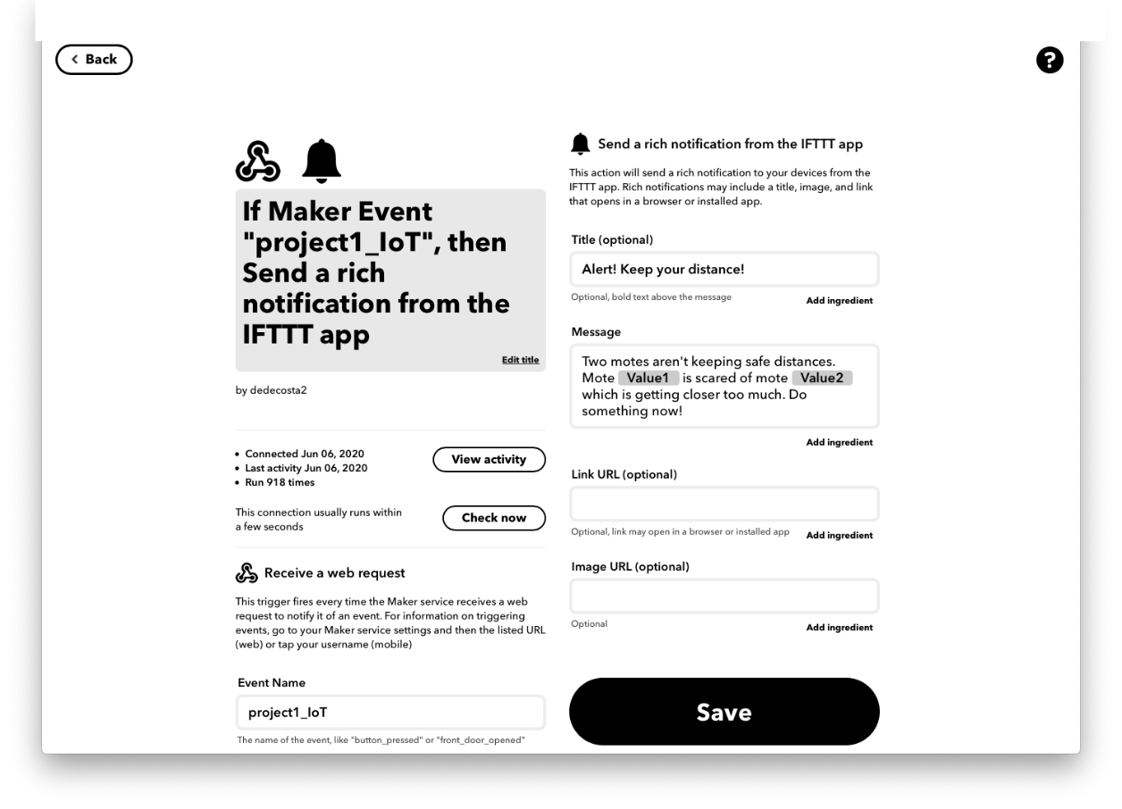

GitHub repository with all the activities + project: <https://github.com/FraMaffezzoli/IoT_Project>