**GROUP NUMBER:** 36

**GROUP MEMBERS:** Francesco Visonà, Alessandro Dario, Luca Pellegrini

**AVAILABLE INPUTS:** Input files are available in the hdfs file system: /data/BDC2425/artificial1M7D100K.txt and /data/BDC2425/artificial4M7D100K.txt

**PART 1:** The goal of this test is to assess the scalability of the standard and fair implementations. The test must be performed on file artificial4M7D100K.txt. However, if your implementation is slow (i.e., taking more than 10 minutes for the slowest run), you can use the smaller file artificial1M7D100K.txt. You must use the following parameters: L=16, K=100, M=10.

Fill in the following table.

**Name of used file:** /data/BDC2425/artificial4M7D100K.txt

|  |  |  |  |
| --- | --- | --- | --- |
| **SCALABILITY WITH RESPECT TO NUMBER OF EXECUTORS** | | | |
| **Number of executors** | **Spark Lloyd’s implementation** | **MRFairLloyd** | **MRComputeFairObjective** |
| 2 | 11802 | 41330 | 1905 |
| 4 | 10010 | 28395 | 1263 |
| 8 | 6822 | 16986 | 795 |
| 16 | 6821 | 7802 | 346 |

**General hints:**

* Remember that Spark uses the lazy evaluation for constructing an RDD. Therefore, be sure to include an action on the final RDD when you take running times.
* Any used RDD in your program should be cached.
* Do not include the reading of the input in your running times.

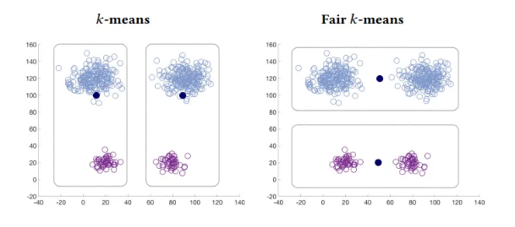**PART 2:** Describe the program GxxGEN.java or GxxGEN.py that you have implemented for point 5 of the specifications. Include a brief high-level description of your program and the constraints, if any, on the input parameters (e.g., the minimum number of points *N*).

Figure 1. Example of difference between k-means standard algorithm and fair k-means algorithm when clustering 4 clusters with K=2

Our generator follows closely what was described in the paper that introduced Fair K-Means [1], which is represented in *Figure 1*.  
First of all, our program replicates the image shown in *Figure 1* for times (moving the centers a little bit), at distance 1000 from one image to the next*.* Then, if the number K is odd, it creates another cluster that resembles half of the clusters of *Figure 1* as described below.

More in detail, we first divide N for the number of clusters, obtaining:   
 points for every cluster (notice that the points that are left out by this division, exactly , will be put in the first image or in the final cluster that resembles half of the image).

We create times the following balls, for (in the following we will use an approximate radius as we will sample from a Normal distribution):

* One “big” ball centered in of points only of group A with radius approximately 5
* One “small” ball centered in of points only of group B with radius approximately 1
* One “big” ball centered in of points only of group A with radius approximately 5
* One “small” ball centered in of points only of group B with radius approximately 1

These four balls will be clustered in 2 clusters by the algorithms. The centers will probably be the ones represented in *Figure 1* with the standard k-means that treats the 2 small balls as outliers as they don’t weight much and the fair k-means that puts the centers between the clusters.

Then the last cluster, if needed (if K is odd), will consist of:

* One big ball centered in of points only of group A with radius approximately 5
* One small ball centered in of points only of group B with radius approximately 1

The idea is the same as above: the standard k-means will treat the “small” ball as outliers.

Requirements: N >= K+1 (if smaller, then every point will be a center and the cost will be zero in both cases).  
If N < 2*K then the cost could change a lot, since we are not able to generate all the clusters we need. If N = 2*K then the cost will be the same.  
Increasing N, in general, the ratio between the costs will increase and stabilize around 2.7.

**REFERENCES**

Mehrdad Ghadiri, Samira Samadi, and Santosh Vempala. 2021. Socially Fair k-Means Clustering. <https://doi.org/10.1145/3442188.3445906>